Project | IEEE 802.16 Broadband Wireless Access Working Group <http://ieee802.org/16>
Title | Temporary Identifier Assignment Scheme and Proposed Text
Date Submitted | 2009-04-27
Source(s) | Ming-Hung Tao  Ying-Chuan Hsiao  ITRI  Yih-Shen Chen  MediaTek | MHTao@itri.org.tw
Re: | Category: AWD-Comments /Area: Chapter 15.2.1 (Addressing)  “Comments on AWD 15.2.1 Addressing”
Abstract | The contribution proposes modifications to the current text on temporary identifier design in the 802.16m amendment working document.
Purpose | To be discussed and adopted by TGm for 802.16m amendment working document.
Notice | This document does not represent the agreed views of the IEEE 802.16 Working Group or any of its subgroups. It represents only the views of the participants listed in the “Source(s)” field above. It is offered as a basis for discussion. It is not binding on the contributor(s), who reserve(s) the right to add, amend or withdraw material contained herein.
Release | The contributor grants a free, irrevocable license to the IEEE to incorporate material contained in this contribution, and any modifications thereof, in the creation of an IEEE Standards publication; to copyright in the IEEE’s name any IEEE Standards publication even though it may include portions of this contribution; and at the IEEE’s sole discretion to permit others to reproduce in whole or in part the resulting IEEE Standards publication. The contributor also acknowledges and accepts that this contribution may be made public by IEEE 802.16.
Patent Policy | The contributor is familiar with the IEEE-SA Patent Policy and Procedures:  <http://standards.ieee.org/guides/bylaws/sect6-7.html#6> and <http://standards.ieee.org/guides/opman/sect6.html#6.3>.  Further information is located at <http://standards.ieee.org/board/pat/pat-material.html> and <http://standards.ieee.org/board/pat>.

Temporary Identifier Assignment Scheme and Proposed Text

Ming-Hung Tao, Ying-Chuan Hsiao,
ITRI
Yih-Shen Chen
MediaTek

- Introduction

This contribution proposes the amendment text on how to assign MS temporary identifiers during idle mode entry. By applying the proposed assignment scheme, the paging message overhead as well as control signaling overhead can be significantly reduced.

- References

[1] IEEE P802.16 Rev2/D9, “Draft IEEE Standard for Local and Metropolitan Area Networks: Air Interface
for Broadband Wireless Access,” Jan. 2009.
[2] IEEE 802.16m-07/002r8, “802.16m System Requirements”
[3] IEEE 802.16m-08/003r8, “The Draft IEEE 802.16m System Description Document”
[4] IEEE 802.16m-09/0010r1a, “IEEE 802.16m Amendment Working Document (AWD)”
[5] IEEE 802.16m-08/043, “Style guide for writing the IEEE 802.16m amendment”

- Temporary Identifier Assignment Scheme

In WirelessMAN-OFDMA Reference system, idle mode MSs are identified by their MAC hashed address during either paging procedure or location update procedure. Since MAC hashed address occupies 16 bits, it is a big overheads while used as the index parameter in the paging message. Therefore, IEEE 802.16m SDD [3] introduces “temporary identifier” which is assigned to idle AMSs for the purposes of reducing signaling overhead and providing location privacy. The AMS’s temporary identifier remains valid as long as AMS stays in the same paging group. The temporary identifier assignment may happen during idle mode entry or during location update due to paging group change.

To minimize the size of temporary identifier, the uniqueness of temporary identifier shall only exist in the same paging cycle and paging offset configuration. In other words, two or more AMSs can be assigned the same temporary identifier if they have different paging cycle or paging offset configurations.

When an AMS enters idle mode, it negotiates with the paging controller to decide its paging cycle configuration and paging offset configuration. The paging controller maintains temporary identifiers for each combined paging cycle and paging offset configuration and assigns the AMS a temporary identifier from a list of available temporary identifiers. The assignment of the temporary identifier from the list is based on the paging cycle and the paging offset information used by the AMS. Once assigned to the AMS, the temporary identifier is removed from the list so as to prevent repeated assignments of what are intended to be temporary identifiers that are unique to the paging cycle and paging offset configuration.

Paging controller shall embed the temporary identifier and paging cycle parameter into the paging message to identify an AMS in the paging message. As shown in Figure 1, the index parameter in the paging message is composed of paging cycle configuration bits and temporary identifier. Therefore, the same index value can be reused by the AMSs who have the same paging cycle but different paging offset. However, during location update procedure, both paging controller and AMS shall use temporary identifier, paging cycle parameter, paging offset parameter as a completed identifier which can provide global uniqueness within the paging group.

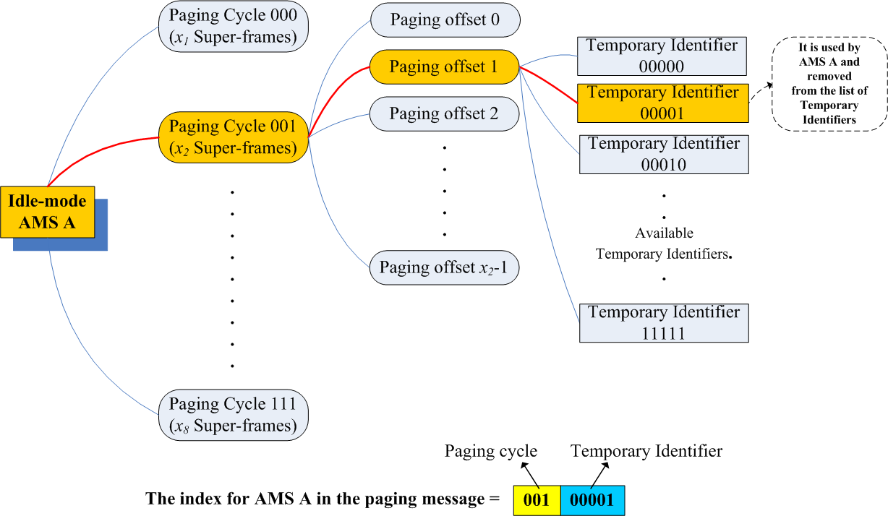
Figure 1. The index of AMS A is composed of its paging cycle configuration bits and temporary identifier.
We conducted a simulation where seven ABSs are in the same paging group. Each ABS initially obtains 50 Idle-Mode AMSs, and each AMS randomly picks one of the paging cycle configurations: 25, 50, or 75 supreframes, then randomly picks its paging offset. If we assume temporary identifier occupies 5 bits and paging cycle parameter occupies 3 bits, the paging overhead improvement can be observed as shown in Figure 2 (the term “location-based paging” means paging group assigning is based on the mobility of AMS).

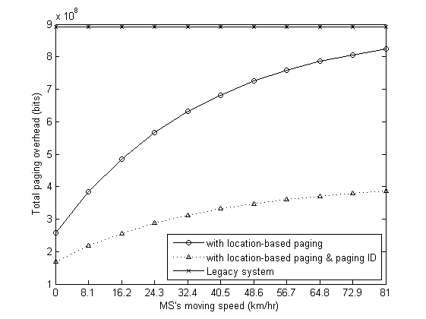
Figure 2. The proposed scheme provides significant paging overhead improvement.

- Text proposal for inclusion in the 802.16m amendment working document

------------------------------- Text Start ---------------------------------------------------

15. Advanced Air Interface
15.2 Medium access control
15.2.1 Addressing
15.2.1.2 Logical Identifiers
15.2.1.2.3 Temporary Identifier

The network may assign a Temporary Identifier and combines it with paging cycle and paging offset configurations to uniquely identify an AMS in the idle mode in a particular paging group. The temporary identifier is assigned during idle mode entry or location update due to paging group change. Such identifier remains valid as long as the AMS stays in the same paging group. The temporary identifier and paging cycle configuration bits is are used in paging messages to identify the AMS. It is also The temporary identifier together with the paging cycle and paging offset configuration bits is used by the AMS to identify itself during its network re-entry procedure as response to paging or location update when paging group is not changed.

------------------------------- Text End ---------------------------------------------------

