Project | IEEE 802.16 Broadband Wireless Access Working Group <http://ieee802.org/16>
Title | Proposed Text of CTC Bit grouping for IEEE 802.16m Amendment
Date Submitted | 2009-04-27
Source(s) | Seunghoon Choi, Chiwoo Lim, Songnam Hong, Sung-Eun Park  Samsung Electronics, Co., Ltd.  Zheng Zhao  Samsung China Telecom R&D center | Voice: +82-31-279-5890  E-mail: seunghoon.choi@samsung.com
Re: | Category: AWD comments / Area: Chapter 15.3.12 (Channel coding HARQ-PHY)  “Comments on AWD 15.3.12 Channel coding HARQ-PHY”
Abstract | We propose new CTC Bit grouping schemes for IEEE 802.16m amendment.
Purpose | For discussion and approval by TGm. for the 802.16m amendment
Notice | This document does not represent the agreed views of the IEEE 802.16 Working Group or any of its subgroups. It represents only the views of the participants listed in the “Source(s)” field above. It is offered as a basis for discussion. It is not binding on the contributor(s), who reserve(s) the right to add, amend or withdraw material contained herein.
Release | The contributor grants a free, irrevocable license to the IEEE to incorporate material contained in this contribution, and any modifications thereof, in the creation of an IEEE Standards publication; to copyright in the IEEE’s name any IEEE Standards publication even though it may include portions of this contribution; and at the IEEE’s sole discretion to permit others to reproduce in whole or in part the resulting IEEE Standards publication. The contributor also acknowledges and accepts that this contribution may be made public by IEEE 802.16.
Patent Policy | The contributor is familiar with the IEEE-SA Patent Policy and Procedures:  <http://standards.ieee.org/guides/bylaws/sect6-7.html#6> and <http://standards.ieee.org/guides/opman/sect6.html#6.3>.  Further information is located at <http://standards.ieee.org/board/pat/pat-material.html> and <http://standards.ieee.org/board/pat>.
Proposed Text of CTC Bit Grouping
for the IEEE 802.16m Amendment
Seunghoon Choi, Chiwoo Lim, Songnam Hong, Sung-Eun Park
Samsung Electronics, Co., Ltd.
Zheng Zhao
Samsung China Telecom R&D center

Introduction
In IEEE 802.16m SDD (IEEE 802.16m-08/003r6) [1], IEEE 802.16m uses the CTC (Convolutional Turbo Code) of code rate 1/3 defined in the IEEE 802.16e standard [2]. In IEEE 802.16e, CTC subpacket generation is used to generate a subpacket with various code rates for HARQ packet transmission. Procedures for CTC subpacket generation consist of symbol separation, subblock interleaving, bit grouping and bit selection. The following figure shows interleaving scheme for CTC subpacket generation in IEEE 802.16e.

Figure 1 The block diagram of 16e interleaving scheme

In higher modulation, there are multiple protection classes and mapping the interleaved bit into QAM constellation isn’t optimized. Systematic bits and their parity mapped into worst layer are always mapped into worst or good layer in form of burst. Turbo decoder performance is degraded as a pair bits (systematic, parity) are always mapped into same layer position in 64QAM constellation. Input burst mapped into worst layer make the decoder performance worse

Proposed CTC bit grouping for IEEE 802.16m
In order to prevent the contiguous bits from to be allocated into same level in constellation bits at higher modulation, new interleaving scheme is proposed as below figure.

Figure 2 The block diagramof the proposed interleaving scheme
In new interleaving scheme for IEEE 802.16m, an interleaved B subblock and an interleaved W1 subblock after subblock interleaving are further permuted by new permutation block and referred to as an permutated B subblock and an permutated W1 subblock respectively.
The details of new permutation are as follows.

Permutation(i) = 6*floor(i/6) + 5 - (i mod 6), i = 0, … , 6*floor(N/6)
, where i is running index and N is the half of burst size(Nep).

An interleaved A subblock and an permutated B subblock are multiplexed a bit by bit and an interleaved Y1 and Y2 subblock are multiplexed a bit by bit while an interleaved W2 subblock and an permutated W1 subblock are multiplexed a bit by bit. In other words, The bit-by-bit multiplexed sequence of an interleaved A subblock and an permutated B subblock sequences shall consist of the first output bit from the A subblock interleaver, the first output bit from new permutation of the B subblock interleaver, the second output bit from the A subblock interleaver, the second output bit from new permutation of the B subblock interleaver, etc. The bit-by-bit multiplexed sequence of interleaved Y1 and Y2 subblock sequences shall consist of the first output bit from the Y1 subblock interleaver, the first output bit from the Y2 subblock interleaver, the second output bit from the Y1 subblock interleaver, the second output bit from the Y2 subblock interleaver, etc. The bit-by-bit multiplexed sequence of an interleaved W2 and an permutated W1 subblock sequences shall consist of the first output bit from the W2 subblock interleaver, the first output bit from new permutation of the W1 subblock interleaver, the second output bit from the W2 subblock interleaver, the second output bit from new permutation of the W1 subblock interleaver, etc.

Comparing to results of bit grouping for IEEE 802.16e, those of new scheme have about up to 2.2dB gain at FER 10⁻² in higher modulation as shown in Figure 3 to 6. The following simulation results are based on AWGN. According to simulation results, we propose the new bit grouping for CTC in IEEE 802.16m.

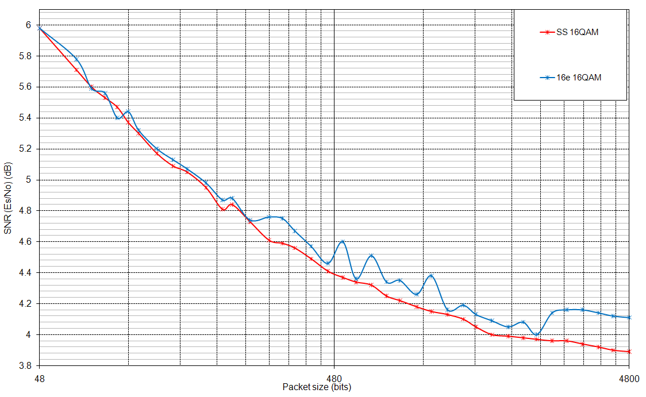
Figure 3 The performance comparison of the proposed and 16e interleaving scheme in case of AWGN, R=1/3, 16QAM
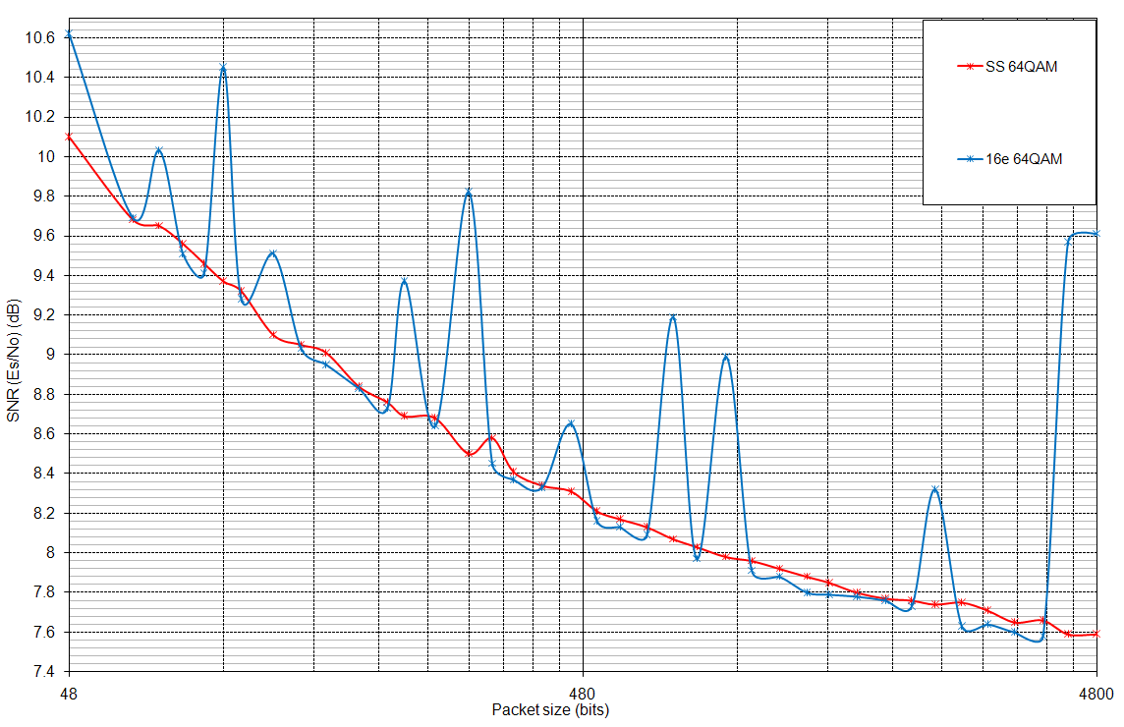
Figure 4 The performance comparison of the proposed and 16e interleaving scheme in case of AWGN, R=1/3, 64QAM
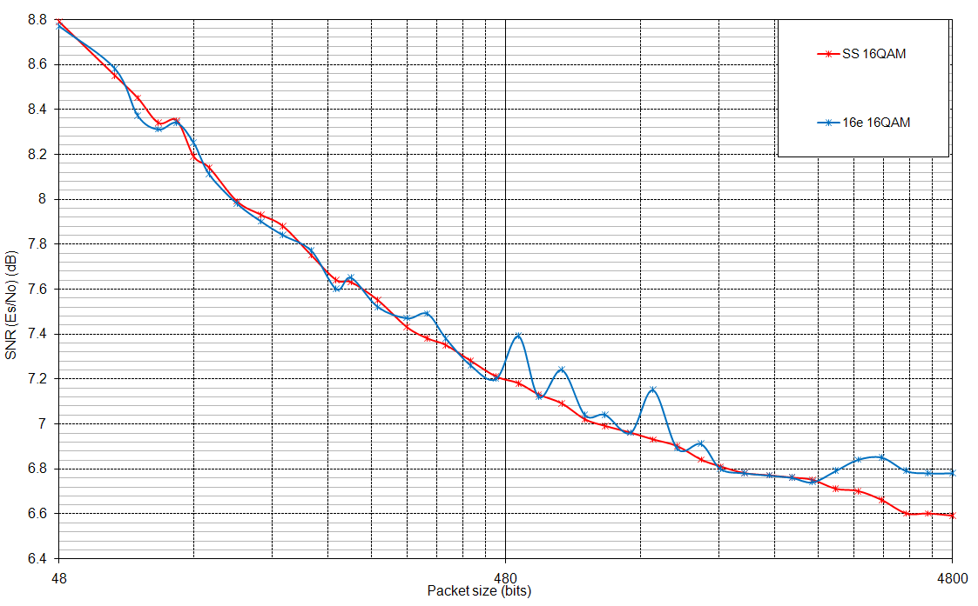
Figure 5 The performance comparison of the proposed and 16e interleaving scheme in case of AWGN, R=1/2, 16QAM

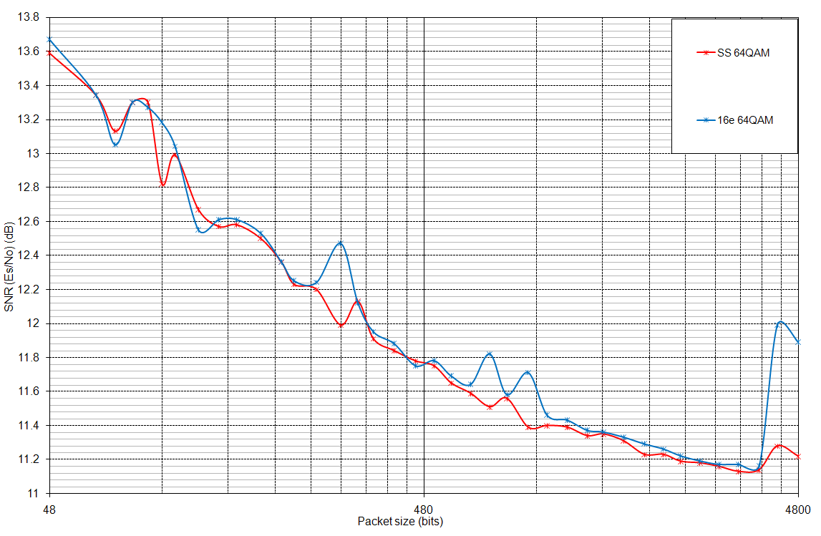
Figure 6 The performance comparison of the proposed and 16e interleaving scheme in case of AWGN, R=1/2, 64QAM

Figure 7 The performance comparison of the proposed and 16e interleaving scheme in case of AWGN, R=2/3, 16QAM

Figure 8 The performance comparison of the proposed and 16e interleaving scheme in case of AWGN, R=2/3, 64QAM

Reference
[1] IEEE 802.16m-08/003r6, “The Draft IEEE 802.16m System Description Document”
[2] IEEE P802.16Rev2/D8, “Draft IEEE Standard for Local and Metropolitan Area Networks: Air interface for
Broadband Wireless Access” Dec. 2008

Text Proposal for 802.16m amendment
------------------------------------Start text proposal------------------------------------

15.x.1.5.1.6. Bit Grouping
an interleaved B subblock and an interleaved W1 subblock after subblock interleaving are further permuted by new permutation block and referred to as an permutated B subblock and an permutated W1 subblock respectively.
The details of new permutation are as follows.

Permutation(i) = 6*floor(i/6) + 5 - (i mod 6), i = 0, … , 6*floor(N/6)
, where i is running index and N is the half of burst size(Nep).

An interleaved A subblock and an permutated B subblock are multiplexed a bit by bit and an interleaved Y1 and Y2 subblock are multiplexed a bit by bit while an interleaved W2 subblock and an permutated W1 subblock are multiplexed a bit by bit. In other words, The bit-by-bit multiplexed sequence of an interleaved A subblock and an permutated B subblock sequences shall consist of the first output bit from the A subblock interleaver, the first output bit from new permutation of the B subblock interleaver, the second output bit from the A subblock interleaver, the second output bit from new permutation of the B subblock interleaver, etc. The bit-by-bit multiplexed sequence of interleaved Y1 and Y2 subblock sequences shall consist of the first output bit from the Y1 subblock interleaver, the first output bit from the Y2 subblock interleaver, the second output bit from the Y1 subblock interleaver, the second output bit from the Y2 subblock interleaver, etc. The bit-by-bit multiplexed sequence of an interleaved W2 and an permutated W1 subblock sequences shall consist of the first output bit from the W2 subblock interleaver, the first output bit from new permutation of the W1 subblock interleaver, the second output bit from the W2 subblock interleaver, the second output bit from new permutation of the W1 subblock interleaver, etc.
The channel interleaver output sequence shall consist of the interleaved A subblock sequence, followed by a permutated sequence of interleaved B subblock sequence, followed by a bit-by-bit multiplexed sequence of the interleaved Y1 and Y2 subblock sequences, followed by by a bit-by-bit multiplexed sequence of the interleaved W2 and the permutated sequence of interleaved W1 subblock sequence..
Figure xxx shows interleaving scheme as explained above.

Figure xxx Block diagram of interleaving scheme
------------------------------------End text proposal------------------------------------

