Project | IEEE 802.16 Broadband Wireless Access Working Group <http://ieee802.org/16>
Title | Proposed OL MIMO Codebook Subsets for the IEEE 802.16m Amendment
Date Submitted | 2009-04-27
Source(s) | David Mazzarese, Bruno Clerckx, Sangwoo Lee, Jerry Pi, Kaushik Josiam, Heewon Kang, Hokyu Choi  Samsung Electronics | d.mazzarese@samsung.com
Re: | Category: AWD comments / Area: Chapter 15.3.7 (DL-MIMO)  “Comments on AWD 15.3.7 DL-MIMO”
Abstract | The contribution proposes text for the MIMO section of the 802.16m amendment.
Purpose | To be discussed and adopted by TGm for the 802.16m amendment.
Notice | This document does not represent the agreed views of the IEEE 802.16 Working Group or any of its subgroups. It represents only the views of the participants listed in the “Source(s)” field above. It is offered as a basis for discussion. It is not binding on the contributor(s), who reserve(s) the right to add, amend or withdraw material contained herein.
Release | The contributor grants a free, irrevocable license to the IEEE to incorporate material contained in this contribution, and any modifications thereof, in the creation of an IEEE Standards publication; to copyright in the IEEE’s name any IEEE Standards publication even though it may include portions of this contribution; and at the IEEE’s sole discretion to permit others to reproduce in whole or in part the resulting IEEE Standards publication. The contributor also acknowledges and accepts that this contribution may be made public by IEEE 802.16.
Patent Policy | The contributor is familiar with the IEEE-SA Patent Policy and Procedures:  <http://standards.ieee.org/guides/bylaws/sect6-7.html#6> and <http://standards.ieee.org/guides/opman/sect6.html#6.3>.  Further information is located at <http://standards.ieee.org/board/pat/pat-material.html> and <http://standards.ieee.org/board/pat>.

Proposed OL MIMO Codebook Subsets for the IEEE 802.16m Amendment

David Mazzarese et Al.
Samsung Electronics

- Introduction
This contribution proposes amendment text for MIMO, to be included in the IEEE 802.16m Amendment Working Document [1], subclause 15.3.7 and subclause 15.3.10. We define the OL SU MIMO codebook subsets used for non-adaptive precoding on DL and UL, as well as the OL MU MIMO codebook subsets used for non-adaptive precoding on DL and UL.

The subsets of the base codebooks for OL SU MIMO are optimized for performance in diversity allocations for mobile users, in both spatially correlated and uncorrelated channels, with the additional constraints to be small sets with a nested property among the codebooks of different ranks and to contain matrices with elements of constant modulus, in order to reduce the implementation complexity at the MS and BS. The subsets of the base codebooks for OL MU MIMO are selected to provide subband selection gain, and to be composed of matrices with elements of constant modulus.

- References
[1] IEEE 802.16m-09/0010r1a, “IEEE 802.16m Amendment Working Document (AWD)”, 2009-03-31.
[2] IEEE 802.16m-07/002r8, “802.16m System Requirements”, 2009-01-15.
[3] IEEE 802.16m-08/003r8, “The Draft IEEE 802.16m System Description Document”, 2009-04-10.
[4] IEEE 802.16m-08/004r5, “The IEEE 802.16m Evaluation Methodology Document”, 2009-01-15.
[5] IEEE 802.16m-08/043, “Style guide for writing the IEEE 802.16m amendment”, 2008-09-18.
[6] IEEE C802.16m-08/1346r3, “Codebook comparison for OL and CL MIMO”.

- Performance evaluation of the proposed OL codebook subsets

The AWD [1] specifies that a precoder of size N_{t}×M_{t} shall be used for OL MIMO transmission with M_{t} streams, and this precoder shall belong to the base codebooks defined in [1]. It was also shown in [6] that the choice of the precoders from the base codebook has an impact on the performance, especially in correlated channels with distributed allocations with transmissions using a single stream. Optimization of the OL precoders is required for the 802.16m standard. Contrary to CL MIMO, the best precoder cannot be chosen by feedback from the MS. The MS only has the possibility to choose the transmission rank (the number of streams) on a long-term basis.

We provide performance evaluation to justify the OL codebook subsets proposed in this contribution. We focus on the optimization in distributed allocations, since the primary target of OL MIMO schemes is for the mobility cases where subband scheduling is not effective. Moreover, optimization of the subsets for 1-stream and 2-streams transmissions is most critical. Transmissions of higher ranks are not much influenced by the choice of the unitary precoder.

The simulation conditions are summarized in Table 1.

Table 1 – Link-level simulations assumptions
OFDM parameters | 10 MHz (1024 subcarriers)
Number of OFDM symbols per subframe | 6
Data burst size | The burst size is assumed to be:  - Miniband-based CRU  - 4 PRUs distributed over 48 PRUs  - DRU (mandatory)  - 4 LRUs: subcarriers distributed over 48 distributed PRUs  Defintions of DRU, CRU and miniband are available in [4].
Permutation | DRU and miniband-based CRU (distributed minibands)
Number of total RU in one subframe | 48
Number of Antennas | 2 transmitter, 2 receiver [2Tx, 2Rx] (for rates 1 and 2)  4 transmitter, 2 receiver [4Tx, 2Rx] (for rates 1 and 2)  4 transmitter, 4 receiver [4Tx, 4Rx] (for rate 3)
Antenna configuration | Uniform linear array (ULA)
Modulation/Coding | QPSK 1/2 (priority), 16QAM 1/2 with LTE FEC  8 Turbo decoding iterations
Channel model | - Uncorrelated (ULA 10 lambda 15 degree AS)  - Modified Veh A 30 km/h (mandatory)  - Semi-correlated (ULA 4 lambda 15 degree AS)  - Modified Veh A 30 km/h (mandatory)  - Highly correlated (ULA 0.5 lambda 3 degree AS)  - Modified Veh A 30 km/h (mandatory)  Modified Ped B and modified Veh A are defined in section 3.2.9 of IEEE 802.16m-08/004r3. The baseline scenario has 3 km/h (60%), 30 km/h (30%), 120 km/h (10%).
Channel estimation | MMSE channel estimator (Wiener filter) is assumed, and the r.m.s. delay of channel model is assumed to be known. There’s no unbiased operation. No pilot boosting. Channel estimation is done within one PRU over precoded (dedicated or shared) pilots.
MIMO transmission scheme | SM + open-loop precoding with 1, 2, 3 or 4 streams
MIMO detector | MRC for rate 1 scheme  LMMSE (for ranks 2, 3 and 4)
Scenarios | Noise limited

The performance of rank-1 precoding in DL 4x2 correlated channels with distributed minibands allocation is shown in Figure 1. We compare 3 choices of precoders from the base codebook. It can be seen that choosing 4 precoders from a DFT matrix is a poor choice. Using the entire base codebook for cycling is slightly better but still suffers from the presence of some DFT vectors in the full set. The proposed set of 4 codewords is significantly more robust to spatial correlations.

Figure 1 – DL 4x2 rank-1 precoding with distributed allocation in correlated channels
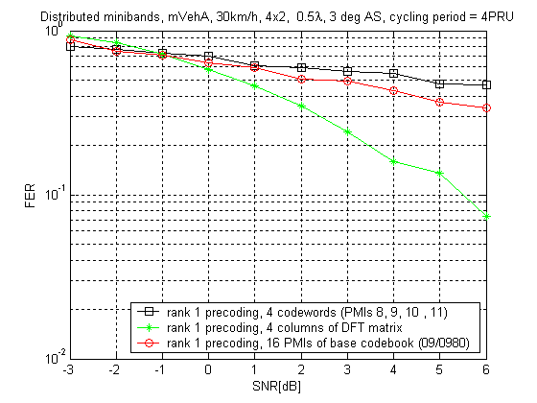

The performance of DL 2x2 rank-2 precoding with SFBC in uncorrelated channels with distributed DRU allocation is shown in Figure 2. In this case, the number of codewords is not very critical to the performance, so it makes sense to limit it to a small number in order to reduce the implementation complexity.

Figure 2 – DL 2x2 rank-2 precoding with SFBC in DRU
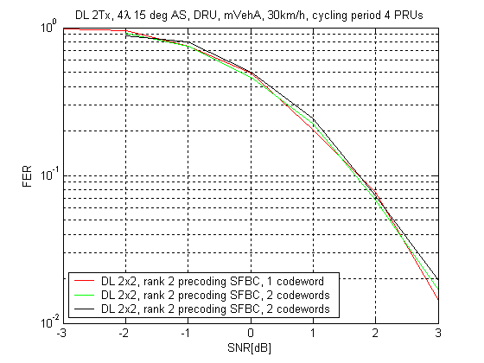

The performance of DL 4x2 rank-2 precoding with SFBC in correlated channels and uncorrelated channels with distributed DRU allocation is shown in Figure 3. The choice of the number of precoders does not have a significant impact in uncorrelated channels. In correlated channels, however, using the first 12 codewords in the base codebook shows about 2 dB degradation at 10% FER compared with the use of 4 codewords chosen by optimization for robustness in uncorrelated and correlated channels. Selecting just 2 codewords is not sufficient in terms of spatial multiplexing gain, as shown by the slope of the FER curve.

Figure 3 – DL 4x2 rank-2 precoding with SFBC in DRU
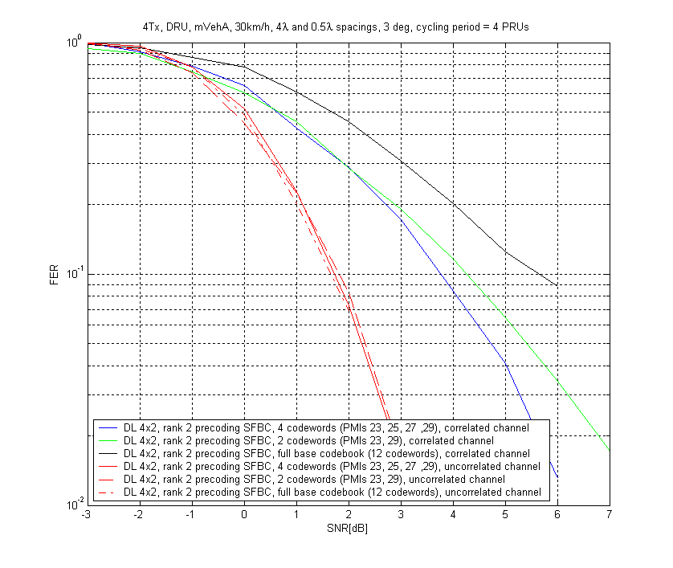

The codebook subsets we propose have the further benefit of exhibiting a nested property among precoders of different ranks for DL 2Tx, DL 4Tx, UL 4Tx, and partially for ranks 2 to 8 in DL 8Tx. This property allows rank adaptation to be implemented with lower complexity.

For OL MU MIMO, it is preferable to use the entire base codebook for OL precoding, since this scheme is only used in localized allocation in CRU, and as such it is preferable to maximize the subband selection gain.

- Text proposal for inclusion in the 802.16m amendment

<Insert the following clauses on line 10 page 89 under section 15.3.7.2.6.6.2.4.1 OL MIMO subset>
------------------------------- Text Start ---------------------------------------------------
15.3.7.2.6.6.2.4.1. OL SU-MIMO subset
The OL SU-MIMO codebook subset shall be used for non-adaptive precoding with MIMO mode 0 and MIMO mode 1.
The notation C_{DL,OL,SU}(N_{t}, M_{t}, N_{w}) denotes the DL OL SU-MIMO codebook subset, which consists of N_{w} complex matrices of dimension N_{t} by M_{t}, and M_{t} denotes the number of streams. The notation C_{DL,OL,SU}(N_{t}, M_{t}, N_{w}, i) denotes the i-th codebook entry of C_{DL,OL,SU}(N_{t}, M_{t}, N_{w}).
15.3.7.2.6.6.2.4.1.1. OL SU-MIMO subset for two transmit antennas
Table 1 gives the number of codewords N_{w} for each rank of the OL SU-MIMO codebook subset for 2Tx.
Table 1 – Size of the DL 2Tx OL SU-MIMO codebook subset
Rank | 1 | 2
N_{w} | 2 | 1

The codewords of the OL SU-MIMO codebook subset for two transmit antennas are given in Table 2 for each rank. The corresponding codewords of the DL base codebook for two transmit antennas are also given in Table 2.

Table 2 – C_{DL,OL,SU}(2,1,2) and C_{DL,OL,SU}(2,2,1)
C_{DL,OL,SU}(2,1,2,n) |  | C_{DL,OL,SU}(2,2,1,n)
n | PMI m in UL base codebook of rank 1 | n | PMI m in UL base codebook of rank 2
0 | 2 | 0 | 2
1 | 6

The PMI m in the base codebook of rank M_{t} with N_{t} = 2 is given by v_{m+1} as in equation (203).

15.3.7.2.6.6.2.4.1.2. OL SU-MIMO subset for four transmit antennas
Table 3 gives the number of codewords N_{w} for each rank of the OL SU-MIMO codebook subset for 4Tx.
Table 3 – Size of the DL 4Tx OL SU-MIMO codebook subset
Rank | 1 | 2 | 3 | 4
N_{w} | 4 | 4 | 2 | 1
The codewords of the OL SU-MIMO codebook subset for four transmit antennas are given in Table 4 for each rank. The corresponding codewords of the DL base codebook for four transmit antennas are given in Table 4.

Table 4 – C_{DL,OL,SU}(4,1,4), C_{DL,OL,SU}(4,2,4), C_{DL,OL,SU}(4,3,2) and C_{DL,OL,SU}(4,4,1)
C_{DL,OL,SU}(4,1,4,n) |  | C_{DL,OL,SU}(4,2,4,n) |  | C_{DL,OL,SU}(4,3,2,n) |  | C_{DL,OL,SU}(4,4,1,n)
n | C(4,1,6,m) in base codebook | n | C(4,2,6,m) in base codebook | n | C(4,3,6,m) in base codebook | n | C(4,4,6,m) in base codebook
0 | C(4,1,6,8) | 0 | C(4,2,6,23) | 0 | C(4,3,4,12) | 0 | C(4,4,3,4)
1 | C(4,1,6,10) | 1 | C(4,2,6,29) | 1 | C(4,3,4,13)
2 | C(4,1,6,9) | 2 | C(4,2,6,27)
3 | C(4,1,6,11) | 3 | C(4,2,6,25)

15.3.7.2.6.6.2.4.1.3. OL SU-MIMO subset for eight transmit antennas
Table 5 gives the number of codewords N_{w} for each rank of the OL SU-MIMO codebook subset for 8Tx.
Table 5 – Size of the DL 8Tx OL SU-MIMO codebook subset
Rank | 1 | 2 | 3 | 4 | 5 | 6 | 7 | 8
N_{w} | 8 | 4 | 4 | 2 | 2 | 2 | 2 | 1

The codewords of the OL SU-MIMO codebook subset for eight transmit antennas are given in Table 6 and Table 7 for each rank. The corresponding codewords of the DL base codebook for eight transmit antennas are given in Table 6 and Table 7.

Table 6 – C_{DL,OL,SU}(8,1,8), C_{DL,OL,SU}(8,2,4), C_{DL,OL,SU}(8,3,4) and C_{DL,OL,SU}(8,4,2)
C_{DL,OL,SU}(8,1,8,n) |  | C_{DL,OL,SU}(8,2,4,n) |  | C_{DL,OL,SU}(8,3,2,n) |  | C_{DL,OL,SU}(8,4,2,n)
n | C(8,1,4,m) in base codebook | n | C(8,2,4,m) in base codebook | n | C(8,3,4,m) in base codebook | n | C(8,4,4,m) in base codebook
0 | C(8,1,4,0) | 0 | C(8,2,4,0) | 0 | C(8,3,4,0) | 0 | C(8,4,4,0)
1 | C(8,1,4,3) | 1 | C(8,2,4,1) | 1 | C(8,3,4,1) | 1 | C(8,4,4,1)
2 | C(8,1,4,5) | 2 | C(8,2,4,2) | 2 | C(8,3,4,2)
3 | C(8,1,4,7) | 3 | C(8,2,4,3) | 3 | C(8,3,4,5)
4 | C(8,1,4,9)
5 | C(8,1,4,11)
6 | C(8,1,4,13)
7 | C(8,1,4,15)
Table 7 – C_{DL,OL,SU}(8,5,2), C_{DL,OL,SU}(8,6,2), C_{DL,OL,SU}(8,7,2) and C_{DL,OL,SU}(8,8,1)
C_{DL,OL,SU}(8,5,2,n) |  | C_{DL,OL,SU}(8,6,2,n) |  | C_{DL,OL,SU}(8,7,2,n) |  | C_{DL,OL,SU}(8,8,1,n)
n | C(8,5,4,m) in base codebook | n | C(8,6,4,m) in base codebook | n | C(8,7,4,m) in base codebook | n | C(8,8,4,m) in base codebook
0 | C(8,5,4,0) | 0 | C(8,6,4,0) | 0 | C(8,7,4,0) | 0 | C(8,8,4,0)
1 | C(8,5,4,1) | 1 | C(8,6,4,1) | 1 | C(8,7,4,1)

15.3.7.2.6.6.2.4.2 OL MU-MIMO subset
The OL MU-MIMO codebook subset shall be used for non-adaptive precoding with MIMO mode 3.
The notation C_{DL,OL,MU}(N_{t}, M_{t}, N_{w}) denotes the DL OL MU-MIMO codebook subset, which consists of N_{w} complex matrices of dimension N_{t} by M_{t}, and M_{t} denotes the number of streams. The notation C_{DL,OL,MU}(N_{t}, M_{t}, N_{w}, i) denotes the i-th codebook entry of C_{DL,OL,MU}(N_{t}, M_{t}, N_{w}).
15.3.7.2.6.6.2.4.2.1. OL MU-MIMO subset for two transmit antennas
The N_{w} = 4 codewords of the DL OL MU-MIMO rank-2 codebook subset for 2Tx are:
C_{DL,OL,MU}(2,2,4,n) = C(2,2,2,n), for n = 0, 1, 2, 3.

15.3.7.2.6.6.2.4.2.2. OL MU-MIMO subset for four transmit antennas
The N_{w} = 16 codewords of the DL OL MU-MIMO rank-2 codebook subset for 4Tx are:
C_{DL,OL,MU}(4,2,16,n) = C(4,2,6,n), for n = 0,…,15.

The N_{w} = 16 codewords of the DL OL MU-MIMO rank-3 codebook subset for 4Tx are:
C_{DL,OL,MU}(4,3,16,n) = C(4,3,4,n), for n = 0,…,15.

The N_{w} = 6 codewords of the DL OL MU-MIMO rank-4 codebook subset for 4Tx are:
C_{DL,OL,MU}(4,4,6,n) = C(4,4,3,n), for n = 0,…,5.

15.3.7.2.6.6.2.4.2.3. OL MU-MIMO subset for eight transmit antennas
The N_{w} = 16 codewords of the DL OL MU-MIMO rank-2 codebook subset for 8Tx are:
C_{DL,OL,MU}(8,2,16,n) = C(8,2,4,n), for n = 0,…,15.

The N_{w} = 16 codewords of the DL OL MU-MIMO rank-3 codebook subset for 8Tx are:
C_{DL,OL,MU}(8,3,16,n) = C(8,3,4,n), for n = 0,…,15.

The N_{w} = 16 codewords of the DL OL MU-MIMO rank-4 codebook subset for 8Tx are:
C_{DL,OL,MU}(8,4,1,n) = C(8,4,4,n), for n = 0,…,15.

------------------------------- Text End ---------------------------------------------------

<Correct the numbering of the two sub-clauses on lines 11 and 13 on page 89>
------------------------------- Text Start ---------------------------------------------------
15.3.7.2.6.6.2.4.3. CL SU-MIMO subset
15.3.7.2.6.6.2.4.3.1. CL SU-MIMO subset for four transmit antennas

------------------------------- Text End ---------------------------------------------------

<Insert the following clauses on line 1 page 126>
------------------------------- Text Start ---------------------------------------------------
15.3.10.4 Codebook subsets for open-loop non-adaptive transmit precoding
15.3.10.4.1 OL SU-MIMO subset
The UL OL SU-MIMO codebook subset shall be used for non-adaptive precoding with MIMO mode 0 and MIMO mode 1.
The notation C_{UL,OL,SU}(N_{t}, M_{t}, N_{w}) denotes the UL OL SU-MIMO codebook subset, which consists of N_{w} complex matrices of dimension N_{t} by M_{t}, and M_{t} denotes the number of streams. The notation C_{UL,OL,SU}(N_{t}, M_{t}, N_{w}, i) denotes the i-th codebook entry of C_{UL,OL,SU}(N_{t}, M_{t}, N_{w}).
C_{UL,OL,SU}(N_{t}, M_{t}, N_{w}) shall be used for precoding with N_{t} transmit antennas and M_{t} streams with MIMO mode 0 and MIMO mode 1.
15.3.10.4.1.1 OL SU-MIMO subset for two transmit antennas
The UL OL SU-MIMO codebook subset for 2Tx is the same as the DL OL SU-MIMO codebook subset for 2Tx. C_{UL,OL,SU}(2, M_{t}, N_{w}) = C_{DL,OL,SU}(2, M_{t}, N_{w}), and it shall be used for precoding with 2 transmit antennas and M_{t} streams with MIMO mode 0 and MIMO mode 1.
15.3.10.4.1.2 OL SU-MIMO subset for four transmit antennas
Table 26 gives the number of codewords N_{w} for each rank of the OL SU-MIMO codebook subset for 4Tx.
Table 26 – Size of the DL 4Tx OL SU-MIMO codebook subset
Rank | 1 | 2 | 3 | 4
N_{w} | 4 | 4 | 4 | 4

The codewords of the OL SU-MIMO codebook subset for four transmit antennas are given in Table 27 for each rank. The corresponding codewords of the uplink base codebook for four transmit antennas are given in Table 27.

Table 27 – C_{UL,OL,SU}(4,1,4), C_{UL,OL,SU}(4,2,4), C_{UL,OL,SU}(4,3,2) and C_{UL,OL,SU}(4,4,1)
C_{UL,OL,SU}(4,1,4,n) |  | C_{UL,OL,SU}(4,2,4,n) |  | C_{UL,OL,SU}(4,3,2,n) |  | C_{UL,OL,SU}(4,4,1,n)
n | PMI m in UL base codebook of rank 1 | n | PMI m in UL base codebook of rank 2 | n | PMI m in UL base codebook of rank 3 | n | PMI m in UL base codebook of rank 3
0 | 9 | 0 | 9 | 0 | 9 | 0 | 9
1 | 15 | 1 | 15 | 1 | 15 | 1 | 15
2 | 49 | 2 | 49 | 2 | 49 | 2 | 49
3 | 55 | 3 | 55 | 3 | 55 | 3 | 55

The PMI m in the base codebook of rank M_{t} with N_{t} = 4 is given by v_{m+1} as in equation (203).

15.3.10.4.2 OL MU-MIMO subset
The UL OL MU-MIMO codebook subset shall be used for non-adaptive precoding with MIMO mode 3.
The notation C_{UL,OL,MU}(N_{t}, M_{t}, N_{w}) denotes the UL OL SU-MIMO codebook subset, which consists of N_{w} complex matrices of dimension N_{t} by M_{t}, and M_{t} denotes the number of streams. The notation C_{UL,OL,MU}(N_{t}, M_{t}, N_{w}, i) denotes the i-th codebook entry of C_{UL,OL,MU}(N_{t}, M_{t}, N_{w}).
The UL OL MU-MIMO codebook subset is the same as the UL OL SU-MIMO codebook subset. C_{UL,OL,MU}(N_{t}, M_{t}, N_{w}) = C_{UL,OL,SU}(N_{t}, M_{t}, N_{w}), and it shall be used for precoding with N_{t} transmit antennas and M_{t} streams with MIMO mode 3.

------------------------------- Text End ---------------------------------------------------

