Project | IEEE 802.16 Broadband Wireless Access Working Group <http://ieee802.org/16>
Title | Proposed Signaling Overhead reduction and Text Refinements to Sections 15.3.8 (Uplink Physical Structure) of IEEE 802.16m AWD -- AWD-IMDG
Date Submitted | 2009-07-06
Source(s) | Debdeep Chatterjee, Jong-Kae Fwu, Hujun Yin  Intel Corporation  HanGyu Cho  LG Electronics | E-mail: (debdeep.chatterjee, jong-kae.fwu, hujun.yin)@intel.com  E-mail: hgcho@lge.com  *<http://standards.ieee.org/faqs/affiliationFAQ.html>
Re: | Category: AWD comments / Area: Chapter 15.3.8 (UL-PHY) “Comments on AWD 15.3.8 UL-PHY” 802.16m amendment working document
Abstract | Proposed text for the UL Physical Structure in the draft P802.16m amendment
Purpose | Discussion and adoption by TGm
Notice | This document does not represent the agreed views of the IEEE 802.16 Working Group or any of its subgroups. It represents only the views of the participants listed in the “Source(s)” field above. It is offered as a basis for discussion. It is not binding on the contributor(s), who reserve(s) the right to add, amend or withdraw material contained herein.
Release | The contributor grants a free, irrevocable license to the IEEE to incorporate material contained in this contribution, and any modifications thereof, in the creation of an IEEE Standards publication; to copyright in the IEEE’s name any IEEE Standards publication even though it may include portions of this contribution; and at the IEEE’s sole discretion to permit others to reproduce in whole or in part the resulting IEEE Standards publication. The contributor also acknowledges and accepts that this contribution may be made public by IEEE 802.16.
Patent Policy | The contributor is familiar with the IEEE-SA Patent Policy and Procedures:  <http://standards.ieee.org/guides/bylaws/sect6-7.html#6> and <http://standards.ieee.org/guides/opman/sect6.html#6.3>.  Further information is located at <http://standards.ieee.org/board/pat/pat-material.html> and <http://standards.ieee.org/board/pat>.
Proposed Signaling Overhead reduction and Text Refinements to Sections 15.3.8 (UL PHY Structure) of IEEE 802.16m AWD -- AWD-IMDG
Debdeep Chatterjee, Jong-Kae Fwu, Hujun Yin
Intel
HanGyu Cho
LG Electronics

Introduction

As a decision from the IM DG, a seperate subteam is formed to address the PHY and FFR jointly related issues with the goal to produce a clean-up version of AWD PHY Structure proposal. The proposal will refine the current AWD PHY structure related text and include decisions made by the group related to the PHY signaling, overhead reduction, text clean up, etc.

Plenty of discussions in the IM DG related to the PHY Structure related signaling by both emails and conference calls. Those signalings are mainly related to different frequency partitions, CRU/DRU partition, signaling overhead reduction, etc. The final decisions are captured in this proposal.

This contribution provides updated amendment text for the UL physical structure in the Advanced Air Interface to be included in Section 15 of the IEEE 802.16m Amendment Working Document [1]. The proposed update is developed so that it can be readily combined with IEEE 802.16m-09/0010r2 [1], it is compliant to the 802.16m SRD [2] and the 802.16m SDD [3], and it follows the style and format guidelines in [4].

References
[1] IEEE 802.16m-09/0010r2, “Part 16: Air Interface for Fixed and Mobile Broadband Wireless Access Systems,” Jun. 2009.
[2] IEEE 802.16m-07/002r8, “IEEE 802.16m System Requirements Document,” Jan. 2009.
[3] IEEE 802.16m-08/003r9a, “IEEE 802.16m System Description Document,” May 2009.
[4] IEEE 802.16m-08/043, “Style guide for writing the IEEE 802.16m amendment”

Proposed Amendment Text
The following text (including tables and figures) is proposed to replace the current contents of Chapter 15.3.8, until the beginning of Section 15.3.8.3.3, of the IEEE 802.16m Amendment Working Document [1].

[ ------------------- Proposed Text Starts --------------------]

15.3.8 Uplink physical structure
Each uplink subframe is divided into 4 or fewer frequency partitions; each partition consists of a set of physical resource units across the total number of OFDMA symbols available in the subframe. Each frequency partition can include contiguous (localized) and/or non-contiguous (distributed) physical resource units. Each frequency partition can be used for different purposes such as fractional frequency reuse (FFR). Figure 484 illustrates the uplink physical structure in the example of two frequency partitions with frequency partition 2 including both contiguous and distributed resource allocations, where Sc stands for Subcarrier.

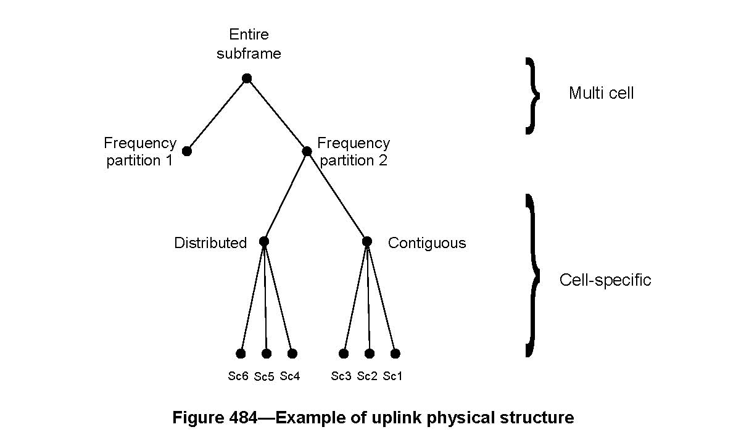

15.3.8.1 Physical and logical resource unit
A physical resource unit (PRU) is the basic physical unit for resource allocation that comprises P_{sc} consecutive subcarriers by N_{sym} consecutive OFDMA symbols. P_{sc} is 18 and N_{sym} is 6, 7, 5, and 9 OFDMA symbols for type-1, type-2, type-3, and type-4 subframes, respectively. A logical resource unit (LRU) is the basic logical unit for distributed and localized resource allocations. An LRU has P_{sc} x N_{sym} subcarriers.
The LRU size for control channel transmission should be same as for data transmission. Multiple users are allowed to share one control LRU. The effective number of data subcarriers in an LRU depends on the number of allocated pilots and control channel presence.

15.3.8.1.1 Distributed logical resource unit
The distributed logical resource unit (DLRU) contains a group of subcarriers that are spread across the distributed resource allocations within a frequency partition. The size of the DLRU equals the size of a PRU, i.e., P_{sc} subcarriers by N_{sym} OFDMA symbols. The minimum unit for forming the DRU is a tile. The uplink tile size is 6 x N_{sym}, where the value of N_{sym} depends on the subframe type.

15.3.8.1.2 Contiguous logical resource unit
The localized logical resource unit, also known as contiguous logical resource unit (CLRU) contains a group of subcarriers that are contiguous across the resource allocations. The size of the CLRU equals the size of a PRU, i.e., P_{sc} subcarriers by N_{sym} OFDMA symbols.

15.3.8.2 Multi-cell resource mapping
The UL multi-cell resource mapping consists of subband partitioning, miniband permutation and frequency partitioning and is defined in the following sub clauses.

15.3.8.2.1 Subband Partitioning
The PRUs are first divided into subbands and minibands; a subband comprises of N₁ adjacent PRUs and a miniband comprises of N₂ adjacent PRUs where N₁=4 and N₂=1. Subbands are suitable for frequency selective allocations as they provide a continuous allocation of PRUs in frequency. Minibands are suitable for frequency diverse allocation and are permuted in frequency.
The number of subbands is denoted by K_{SB}. The number of PRUs allocated to subbands is L_{SB} = N₁· K_{SB}. A 5, 4 or 3-bit field called Uplink Subband Allocation Count (USAC) determines the value of K_{SB} depending on system bandwidth. The USAC is transmitted in the SFH. The remaining PRUs are allocated to minibands. The number of minibands in an allocation is denoted by K_{MB}. The number of PRUs allocated to minibands is L_{MB} = N₂· K_{MB}. The total number of PRUs is N_{PRU} = L_{SB} + L_{MB}. The maximum number of subbands that can be formed is denoted as N_{sub} where . Mappings between USAC and K_{SB} are shown in Tables 714 through 716 for system bandwidths of 20MHz, 10MHz, and 5MHz, respectively.

Table 714—Mapping between USAC and K_{SB} for 20MHz

USAC | # of subbands allocated (K_{SB}) | USAC | # of subbands allocated (K_{SB})
0 | 0 | 16 | 16
1 | 1 | 17 | 17
2 | 2 | 18 | 18
3 | 3 | 19 | 19
4 | 4 | 20 | 20
5 | 5 | 21 | 21
6 | 6 | 22 | N. A.
7 | 7 | 23 | N. A.
8 | 8 | 24 | N. A.
9 | 9 | 25 | N. A.
10 | 10 | 26 | N. A.
11 | 11 | 27 | N. A.
12 | 12 | 28 | N. A.
13 | 13 | 29 | N. A.
14 | 14 | 30 | N. A.
15 | 15 | 31 | N. A.

Table 715—Mapping between USAC and K_{SB} for 10MHz

USAC | # of subbands allocated (K_{SB}) | USAC | # of subbands allocated (K_{SB})
0 | 0 | 8 | 8
1 | 1 | 9 | 9
2 | 2 | 10 | N. A.
3 | 3 | 11 | N. A.
4 | 4 | 12 | N. A.
5 | 5 | 13 | N. A.
6 | 6 | 14 | N. A.
7 | 7 | 15 | N. A.

Table 716—Mapping between USAC and K_{SB} for 5MHz

USAC | # of subbands allocated (K_{SB}) | USAC | # of subbands allocated (K_{SB})
0 | 0 | 4 | N. A.
1 | 1 | 5 | N. A.
2 | 2 | 6 | N. A.
3 | 3 | 7 | N. A.

The PRUs are partitioned and reordered into two groups: subband PRUs (PRU_{SB}), and miniband PRUs (PRU_{MB}). The set of PRU_{SB} is numbered from 0 to (L_{SB}-1) and the set of PRU_{MB} from 0 to (L_{MB}-1).
Equation (223) defines the mapping of PRUs into PRU_{SB}s. Equation (225) defines the mapping of PRUs to PRU_{MB}s. Figure 485 illustrates the PRU to PRU_{SB} and PRU_{MB} mapping for a 10 MHz bandwidth with K_{SB} equal to 7.
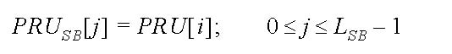 (223)
where
(224)
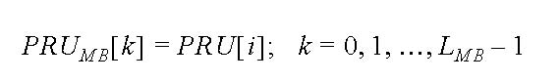 (225)
where

(226)
Figure 485 - PRU to PRU_{SB} and PRU_{MB} mapping for BW=10 MHz, K_{SB}=7

15.3.8.2.2 Miniband permutation
The miniband permutation maps the PRU_{MB}s to permuted-PRU_{MB}s (PPRU_{MB}s) to insure allocation of frequency diverse PRUs to each frequency partition. Equation (227) describes the mapping from PRU_{MB}s to PPRU_{MB}s.
(227)
where:
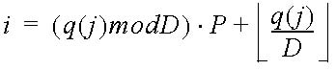
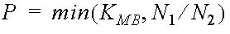
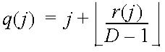
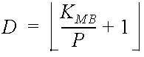
Figure 486 depicts the mapping from PRUs to PRU_{SB} and PPRU_{MB}.
Figure 486 - Mapping from PRUs to PRU_{SB} and PPRU_{MB} for BW=10 MHz, K_{SB}=7

15.3.8.2.3 Frequency partitioning
The PRU_{SB}s and PPRU_{MB}s are allocated to one or more frequency partitions. By default, only one partition is present. The maximum number of frequency partitions is 4. The frequency partition configuration is transmitted in the SFH in a 4, 3-bit composite field called the Uplink Frequency Partition Configuration (UFPC), depending on system bandwidth. The Frequency Partition Count (FPCT) defines the number of frequency partitions. The Frequency Partition Size (FPS_{i}) defines the number of PRUs allocated to FP_{i}. FPCT and FPS_{i} are determined from UFPC as shown in Tables 717 through 719.
A 3, 2, or 1-bit called the Uplink Frequency Partition Subband Count (UFPSC) defines the number of subbands allocated to FP_{i} for i>0.

Table 717—Mapping between DFPC and frequency partitioning for 20MHz

UFPC | Freq. Partitioning  (FP₀:FP₁:FP₂:FP₃) | FPCT | FPS₀ | FPS_{i} (i>0)
0 | 1 : 0 : 0 : 0 | 1 | N_{PRU} | 0
1 | 0 : 1 : 1 : 1 | 3 | 0 | N_{PRU} * 1/3
2 | 1 : 1 : 1 : 1 | 4 | N_{PRU} * 1/4 | N_{PRU} * 1/4
3 | 3 : 1 : 1 : 1 | 4 | N_{PRU} * 1/2 | N_{PRU} * 1/6
4 | 5 : 1 : 1 : 1 | 4 | N_{PRU} * 5/8 | N_{PRU} * 1/8
5 | 9 : 1 : 1 : 1 | 4 | N_{PRU} * 9/12 | N_{PRU} * 1/12
6 | 9 : 5 : 5 : 5 | 4 | N_{PRU} * 3/8 | N_{PRU} * 5/24
7-15 | Reserved

Table 718—Mapping between DFPC and frequency partitioning for 10MHz

UFPC | Freq. Partitioning  (FP₀:FP₁:FP₂:FP₃) | FPCT | FPS₀ | FPS_{i} (i>0)
0 | 1 : 0 : 0 : 0 | 1 | N_{PRU} | 0
1 | 0 : 1 : 1 : 1 | 3 | 0 | N_{PRU} * 1/3
2 | 1 : 1 : 1 : 1 | 4 | N_{PRU} * 1/4 | N_{PRU} * 1/4
3 | 3 : 1 : 1 : 1 | 4 | N_{PRU} * 1/2 | N_{PRU} * 1/6
4 | 5 : 1 : 1 : 1 | 4 | N_{PRU} * 5/8 | N_{PRU} * 1/8
5 | 9 : 5 : 5 : 5 | 4 | N_{PRU} * 3/8 | N_{PRU} * 5/24
6-7 | Reserved

Table 719—Mapping between DFPC and frequency partitioning for 5MHz

UFPC | Freq. Partitioning  (FP₀:FP₁:FP₂:FP₃) | FPCT | FPS₀ | FPS_{i} (i>0)
0 | 1 : 0 : 0 : 0 | 1 | N_{PRU} | 0
1 | 0 : 1 : 1 : 1 | 3 | 0 | N_{PRU} * 1/3
2 | 1 : 1 : 1 : 1 | 4 | N_{PRU} * 1/4 | N_{PRU} * 1/4
3 | 3 : 1 : 1 : 1 | 4 | N_{PRU} * 1/2 | N_{PRU} * 1/6
4-7 | Reserved

The number of subbands and minibands in the i^{th} frequency partition are denoted by K_{SB,FPi} and K_{MB,FPi}, respectively, as shown in Equation (228) and Equation (229) for the cases when FPCT = 1 or FPCT = 4,
(228)
(229)
When UFPC = 1 and FPCT = 3, the number of subbands and minibands in FP_{i} (for i>0) are given by K_{SB,FPi} = UFPSC, and K_{MB,FPi} = (FPS_{i} – K_{SB,FPi}·N₁)/N₂, respectively.

The numbers of subband PRUs and miniband PRUs in each frequency partition are given by L_{SB,FPi} = N₁·K_{SB,FPi} and L_{MB,FPi} = N₂·K_{MB,FPi} respectively.
The mapping of subband PRUs and miniband PRUs to the frequency partition i is given by the following equations:
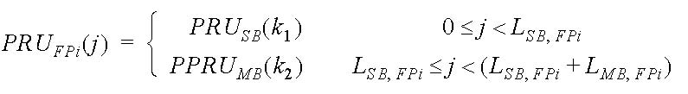 (230)
Where 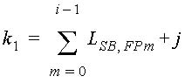 and 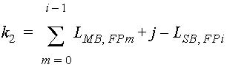.
Figure 487 depicts the frequency partitioning for BW of 10 MHz, K_{SB} = 7, FPCT = 4, FPS₀ = FPS_{i} = 12, and UFPSC = 2.

Figure 487 - Frequency partition for BW=10 MHz, K_{SB}=7, FPCT=4, FPS₀= FPS_{i}=12, UFPSC=2

15.3.8.3 Cell-specific resource mapping
PRU_{FPi}s are mapped to LRUs. All further PRUs and tile permutations are constrained to the PRUs within a frequency partition.

15.3.8.3.1 CRU/DRU allocation
The partition between CRUs and DRUs is done on a sector specific basis. The number of allocated subband-based CRUs for FP_{i} (for i ≥ 0) is given by uplink subband-based CRU allocation size, UCAS_{SB,i}. For FP₀, the value of UCAS_{SB,0} is explicitly signaled in the SFH as a 5, 4 or 3-bit field. For FP_{i} (for i>0), UCAS_{SB,i} = K_{SB,FPi}. That is, all subbands for the reuse-3 frequency partitions are assigned for CRU allocation. A 5, 4, or 3-bit uplink miniband-based CRU allocation size (UCAS_{MB}) is sent in the SFH only for partition FP₀ depending on system bandwidth. UCAS_{MB} indicates the number of allocated miniband-based CRUs for partition FP₀.
The mapping between UCAS_{MB} and the number of miniband-based CRUs for FP₀ is shown in the Tables 720 through 722 for system bandwidths of 20MHz, 10MHz, and 5MHz, respectively.

Table 720 - Mapping between UCAS_{MB} and number of miniband-based CRU for FP₀ for 20MHz

UCAS_{MB} | # of miniband-based CRU for FP₀ | UCAS_{MB} | # of miniband-based CRU for FP₀
0 | 0 | 16 | 16
1 | 1 | 17 | 17
2 | 2 | 18 | 18
3 | 3 | 19 | 19
4 | 4 | 20 | 20
5 | 5 | 21 | 21
6 | 6 | 22 | 22
7 | 7 | 23 | 23
8 | 8 | 24 | 24
9 | 9 | 25 | 28
10 | 10 | 26 | 32
11 | 11 | 27 | 36
12 | 12 | 28 | 40
13 | 13 | 29 | 44
14 | 14 | 30 | 48
15 | 15 | 31 | 52

Table 721 - Mapping between UCAS_{MB} and number of miniband-based CRUs for FP₀ for 10MHz

UCAS_{MB} | # of miniband-based CRU for FP₀ | UCAS_{MB} | # of miniband-based CRU for FP₀
0 | 0 | 8 | 8
1 | 1 | 9 | 9
2 | 2 | 10 | 10
3 | 3 | 11 | 11
4 | 4 | 12 | 12
5 | 5 | 13 | 16
6 | 6 | 14 | 20
7 | 7 | 15 | 24

Table 722 - Mapping between UCAS_{MB} and number of miniband-based CRUs for FP₀ for 5MHz

UCAS_{MB} | # of miniband-based CRU for FP₀ | UCAS_{MB} | # of miniband-based CRU for FP₀
0 | 0 | 4 | 4
1 | 1 | 5 | 6
2 | 2 | 6 | 8
3 | 3 | 7 | 10

The number of CRUs in each frequency partition is denoted by L_{CRU,FPi} calculated as shown in Equation (231)

(231)
The number of DRUs in each frequency partition is denoted by L_{DRU,FPi}, calculated as shown in Equation (232)

(232)
The mapping of PRU_{FPi} to CRU_{FPi} (for 0 ≤ i < FPCT) is given by Equation (233):

(233)
where . s[] is the CRU/DRU-allocation sequence defined below and :
where PermSeq() is the permutation sequence of length (FPS_{i}-UCAS_{SB,i}·N₁) and is determined by SEED={IDcell*343} mod 2¹⁰. The permutation sequence is generated by the random sequence generation algorithm specified in 15.3.5.3.3. UL_PermBase is an interger ranging from 0 to 31(TBD), which is set to preamble IDcell.
The mapping of PRU_{FPi} to DRU_{FPi} is given by Equation (234):
(234)
where k = s[j + L_{CRU,FPi} - UCAS_{SB,i} · N₁].

Figure xxx presents an example to illustrate the various steps of subband partitioning, miniband permutation, frequency partitioning, and cell-specific resource mapping (CRU/DRU allocation) for the case of 10MHz system bandwidth. For this example, K_{SB} = USAC = 7, FPCT = 4, FPS_{i} = 12 (for i≥0), UFPSC = 2, and UCAS_{MB} = 2.

Figure xxx - CRU/DRU allocation for BW=10 MHz, K_{SB} = USAC = 7, FPCT = 4, FPS_{i} = 12 (for i≥0), UFPSC = 2, and UCAS_{MB} = 2

15.3.8.3.2 Tile permutation
Each of the DRUs of an UL frequency partition is divided into 3 tiles of 6 adjacent subcarriers over N_{sym} symbols. The tiles within a frequency partition are collectively tile-permuted to obtain frequency-diversity across the allocated resources.
The tile permutation that allocates physical tiles of DRUs to logical tiles of subchannels is performed in the following manner:
(235)
where:
Tiles(s,n,t) is the tile index of the n^{th} tile in the s^{th} distributed LRU of the t^{th} subframe,
n is the tile index, 0 to 2, in a distributed LRU,
t is the subframe index with respect to the frame,
s is the distributed LRU index, 0 to L_{DRU,FPi}-1,
PermSeq() is the permutation sequence of length L_{DRU,FPi} and is determined by SEED={IDcell*343} mod 2¹⁰. The permutation sequence is generated by the random sequence generation algorithm specified in Section 15.3.5.3.3,
and g(PermSeq(),s,n,t) = {PermSeq[(n + 107 * s + t) mod _{LDRU,FPi}]+UL_PermBase} mod L_{DRU,FPi}.

[ ------------------- Proposed Text Ends --------------------]

