Project | IEEE 802.16 Broadband Wireless Access Working Group <http://ieee802.org/16>
Title | Interference Mitigation for CSG Femtocells (AWD-Femto)
Date Submitted | 2009-07-09
Source(s) | Luciano Sarperi, Yanling Lu, Keiichi Nakatsugawa  Fujitsu  Zhaohua Lu, Feng Xie, Yang Liu, Kaiying Lv  ZTE Corporation | luciano.sarperi@uk.fujitsu.com  yanling.lu@cn.fujitsu.com  nakatsugawa@jp.fujitsu.com  lu.zhaohua@zte.com.cn
Re: | 802.16m Amendment Working Document  Call for contributions on “Support for Femtocell BS”
Abstract | This contribution proposes an interference mitigation mechanism for Closed Subscriber Group (CSG) Femtocells.
Purpose | Discussion and approval by TGm.
Notice | This document does not represent the agreed views of the IEEE 802.16 Working Group or any of its subgroups. It represents only the views of the participants listed in the “Source(s)” field above. It is offered as a basis for discussion. It is not binding on the contributor(s), who reserve(s) the right to add, amend or withdraw material contained herein.
Release | The contributor grants a free, irrevocable license to the IEEE to incorporate material contained in this contribution, and any modifications thereof, in the creation of an IEEE Standards publication; to copyright in the IEEE’s name any IEEE Standards publication even though it may include portions of this contribution; and at the IEEE’s sole discretion to permit others to reproduce in whole or in part the resulting IEEE Standards publication. The contributor also acknowledges and accepts that this contribution may be made public by IEEE 802.16.
Patent Policy | The contributor is familiar with the IEEE-SA Patent Policy and Procedures:  <http://standards.ieee.org/guides/bylaws/sect6-7.html#6> and <http://standards.ieee.org/guides/opman/sect6.html#6.3>.  Further information is located at <http://standards.ieee.org/board/pat/pat-material.html> and <http://standards.ieee.org/board/pat>.

Interference Mitigation for CSG Femtocells
Luciano Sarperi, Yanling Lu, Keiichi Nakatsugawa
Fujitsu

Zhaohua Lu, Feng Xie, Yang Liu, Kaiying Lv
ZTE Corporation

Introduction
In order to mitigate interference between Closed Subscriber Group (CSG) femtocells and AMSs which are not members of the CSG, the SDD [1] defines in Section 15.9:

- “Large interference from an inaccessible Femtocell BS may trigger a nearby MS to report the interference to the serving BS, and the report information should include system information of the inaccessible Femtocell BS (e.g., BS_ID of the femtocell BS). The serving BS and/or the network may request the interfering Femtocell BS to mitigate the interference by reducing transmission power, and/or blocking some resource region.”

This contribution proposes AWD text for the above mechanism, by defining AMS signaling and discussing inter-BS coordination between BSs under the network operator’s control and CSG femtocell ABSs for the purpose of interference reduction/avoidance.

Proposed Interference Mitigation Procedure
In order to reduce interference between CSG femtocells and macrocells, it is proposed that:

- The interfered AMS can request interference mitigation to the serving macrocell when it experiences high levels of interference from a CSG femtocell of which it is not a member.
- The macrocell in which the femtocell is overlaid can subsequently impose scheduling restrictions on CSG closed user group femto ABSs.
- The restrictions may either be signaled from the macrocell BS to the femtocell ABS via the backbone connection or they may be configured in the femtocell ABS statically or semi-statically.

The proposed scheduling restrictions protect the A-MAP and data resource allocations.

Interference Analysis
In the following, the received long term signal power from an interfering CSG femtocell and the serving macrocell are analyzed. The parameters listed in Table 1 were used, which are based on the baseline case in the EMD [2] (where applicable). It is assumed that both macrocells and CSG femtocell use the same radio resources and the AMS is not a member of the CSG.
Table 1 Parameters
Parameter | Setting
Carrier Frequency | 2.5Ghz
Ptx macro ABS | 46dBm
Ptx femto ABS | 25dBm
Path loss urban/suburban baseline | 130.19+37.6*log10(d[km])
Path Loss NLOS Room to Corridor, Sec. 3.2.3.4 Indoor Small Office | 43.8+36.8*log10(d[m])+20*log10(f[GHz]/ 5.0)
Antenna Gain macro ABS | 17dBi
Cable loss macro ABS | 2dB
Penetration loss | 10dB

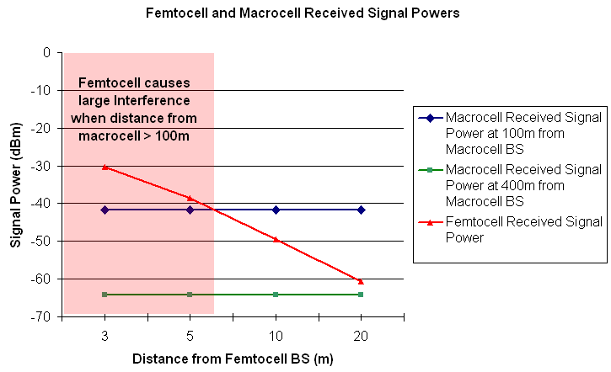
Figure 1 Received Signal Powers at AMS

Figure 1 shows the received macrocell signal powers at D=100m and D=400m distance from the macrocell ABS and the received femtocell signal power at distances 3…20m from the femtocell ABS. It can be seen that even at a distance of 100m from the macrocell ABS, the femtocell signal can be considerably stronger than the macrocell signal (red shaded area). The analysis indicates that a non-CSG AMS operated in the vicinity of a femtocell will experience high interference, resulting in low throughput or higher outage. Note that the signal strength differences can be close to the typical dynamic range of an AMS (40…50dB), in which case the AMS will experience large interference even if it operates on a different frequency partition than the femtocell. Therefore, the AMS should be able to request interference mitigation by signaling the serving ABS when it experiences strong interference from a CSG femtocell. Subsequently, resource allocation coordination between the serving ABS under the network operator’s control and the CSG femtocell ABS can be performed in order to reduce such interference.

Proposed new text in the 802.16 Amendment Working Document (IEEE 802.16m-09/0010r2)
--------------------------------------------------------Start of Text-----------------------------------------------------------

15.3.X Support for Femtocell BS

15.3.X.Y Interference Avoidance and Interference Mitigation
An AMS shall send the AAI_CSG_IM-REQ message specified in Table Y1 with Action set to “0b0” to its serving ABS when it detects strong interference from a CSG femtocell of which it is not a member. The serving ABS shall then respond to the AMS with the AAI_CSG_IM-RSP message specified in Table Y2. If the serving ABS accepts the request, then it shall indicate to the interfering CSG femtocell to activate some scheduling restrictions by transmitting a Femtocell Interference Mitigation Control Primitive over the backbone network. The Femtocell Interference Mitigation Control Primitives are a set of primitives for supporting the signalling of scheduling restrictions from the serving ABS to the CSG femtocell ABS. The details are TBD.

Table Y1 – AAI_CSG_IM-REQ message format
Syntax | Size(bits) | Notes
AAI_CSG_IM-REQ_Message_Format(){ | - | -
Management Message Type | 8 | [TBD]
Cel-ID-number | 2 | The number of cell IDs provided in this message
For (i=0; i<Cell-ID-number; i++){
IDcell | 10 | IDcell of interfering CSG Femtocell, range from 0 to 767
Action | 1 | 0b0: Start interference mitigation  0b1: Stop interference mitigation
}
Padding | Variable | Padding to reach byte boundary
}

Table Y2 - AAI_CSG_IM-RSP message format
Syntax | Size(bits) | Notes
AAI_CSG_IM-RSP_Message_Format(){ | - | -
Management Message Type | 8 | [TBD]
For (i=0; i<Cell-ID-number; i++)
Response Bitmap | 1 | Bitmap in the same order as reported IDcell in CSG_IM-REQ message  0b0: Reject the IM request from the AMS  0b1: Confirm the IM request from the AMS
Padding | Variable | Padding to reach byte boundary
}

When an AMS experiences that the interference from a CSG femtocell of which it is not a member is falling below a certain level, it shall send the AAI_CSG_IM-REQ message with Action set to “0b1” to request termination of the interference mitigation.
--------------------------------------------------------End of Text-----------------------------------------------------------

References
[1] IEEE 80216m-08/003r9a “IEEE 802.16m System Description Document”, 31 May 2009.
[2] IEEE 802.16m-08/004r5 “IEEE 802.16m Evaluation Methodology Document (EMD)”, 15 January 2009.

