Project | IEEE 802.16 Broadband Wireless Access Working Group <http://ieee802.org/16>
Title | Proposed Text changes of Constellation Rearrangement related to HARQ (AWD-15.3.12.2.1.1)
Date Submitted | 2009-07-06
Source(s) | Suchang Chae, Rong Ran, Bumsoo Park, Jihyung Kim, Wooram Shin, Dong Seung Kwon  ETRI | schae@etri.re.kr
Re: | TGm AWD
Abstract | The contribution proposes the text for the constellation rearrangements related to HARQ.
Purpose | To be discussed and adopted by TGm for the IEEE 802.16m amendment
Notice | This document does not represent the agreed views of the IEEE 802.16 Working Group or any of its subgroups. It represents only the views of the participants listed in the “Source(s)” field above. It is offered as a basis for discussion. It is not binding on the contributor(s), who reserve(s) the right to add, amend or withdraw material contained herein.
Release | The contributor grants a free, irrevocable license to the IEEE to incorporate material contained in this contribution, and any modifications thereof, in the creation of an IEEE Standards publication; to copyright in the IEEE’s name any IEEE Standards publication even though it may include portions of this contribution; and at the IEEE’s sole discretion to permit others to reproduce in whole or in part the resulting IEEE Standards publication. The contributor also acknowledges and accepts that this contribution may be made public by IEEE 802.16.
Patent Policy | The contributor is familiar with the IEEE-SA Patent Policy and Procedures:  <http://standards.ieee.org/guides/bylaws/sect6-7.html#6> and <http://standards.ieee.org/guides/opman/sect6.html#6.3>.  Further information is located at <http://standards.ieee.org/board/pat/pat-material.html> and <http://standards.ieee.org/board/pat>.
Proposed Text changes of Constellation Rearrangement related to HARQ (AWD-15.3.12.2.1.1)
Suchang Chae, Rong Ran, Bumsoo Park, Jihyung Kim, Wooram Shin, Dong Seung Kwon
ETRI

- Introduction
The contribution proposes the text changes of constellation rearrangement related to HARQ in the 802.16m amendment[1].
- Suggested remedy
In the AWD, It means that the same CoRe version is used in the subpacket as described in Figure-1. But It must be some of the performances degradation because there exist some bits using such a same CoRe version as used in the previous subpacket. It should be modified by applying the different CoRe Version to every symbol in the subpacket according to the transmission subpacket as figure-2.
Figure-1 Example of symbols in the subpacket mapped to different CRV in AWD(C80216m-09_0010r2)
Figure-2. Example of symbols in the subpacket mapped to different CRV(proposed)

- Verifications

Figure-3 shows that BLER performances of proposal is 0.2dB better than that of AWD.

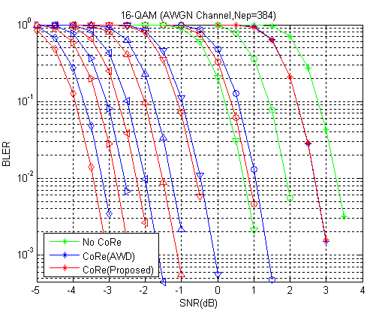

Figure-3. BLER performances of CoRe related to HARQ

- References
[1] IEEE 802.16m-09/0010r2, “802.16m Amendment Working Document (AWD)”

- Text changes
15.3.12.2 HARQ
15.3.12.2.1 IR HARQ
15.3.12.2.1.1 Constellation rearrangement
Two constellation re-arrangement versions shall be supported. Constellation rearrangement only applies to 16QAM and 64QAM. In case of QPSK, it is transparent.
<<table>> describes the operations that produce different CoRe versions for 16QAM and 64QAM respectively, so that the four bits in a 16QAM symbol (the six bits in a 64 QAM) are of the same resilience. In other words, the two bits of higher quality at CoRe-version 0 are of lower quality at CoRe-version 1 while the two bits of lower quality at CoRe-version 0 are of higher quality at CoRe-version 1.
A 16QAM or 64QAM symbols of the subpacket shall be mapped by CoRe version from which it used in the symbols of the previous subpacket is different as described in Figure-xxx.
In the figure-xxx, it shows that front part with CRV=1 of the 3rd subpacket shall be applied to CoRe-Version1 different from CoRe-Version0 used in 1st subpacket according to the transmission subpackets.
Figure-xxx. Example of symbols in the subpacket mapped to different CRV

15.3.6.5.2.2 DL basic assignment A-MAP IE

Table 668—DL basic assignment A-MAP IE
Syntax | Size in bits | Description/notes
SPID/CoRe Version | [3][2] | HARQ subpacket identifier for IR and constellation rearrangement version

SPID/CoRe Version: Signaling for HARQ IR including HARQ subpacket identifier for IR and Constellation Rearrangement version.

