Project | IEEE 802.16 Broadband Wireless Access Working Group <http://ieee802.org/16>
Title | E-MBS Zone Specific Pliot Patterns for MBSFN
Date Submitted | 2009-07-06
Source(s) | Ting Liang  Dengkui Zhu  Bo Sun  Huiying Fang  Kaiying Lv  Ying Liu  Zirong Li  Dihao Ning  ZTE Corporation | liang.ting12@zte.com.cn  zhu.dengkui@zte.com.cn  sun.bo1@ zte.com.cn
Re: | “Comment on SDD 11 PHY”
Abstract | The contribution proposes the text of downlink reference signal section to be included in the 802.16m SDD.
Purpose | To be discussed and adopted by TGm for the 802.16m SDD.
Notice | This document does not represent the agreed views of the IEEE 802.16 Working Group or any of its subgroups. It represents only the views of the participants listed in the “Source(s)” field above. It is offered as a basis for discussion. It is not binding on the contributor(s), who reserve(s) the right to add, amend or withdraw material contained herein.
Release | The contributor grants a free, irrevocable license to the IEEE to incorporate material contained in this contribution, and any modifications thereof, in the creation of an IEEE Standards publication; to copyright in the IEEE’s name any IEEE Standards publication even though it may include portions of this contribution; and at the IEEE’s sole discretion to permit others to reproduce in whole or in part the resulting IEEE Standards publication. The contributor also acknowledges and accepts that this contribution may be made public by IEEE 802.16.
Patent Policy | The contributor is familiar with the IEEE-SA Patent Policy and Procedures:  <http://standards.ieee.org/guides/bylaws/sect6-7.html#6> and <http://standards.ieee.org/guides/opman/sect6.html#6.3>.  Further information is located at <http://standards.ieee.org/board/pat/pat-material.html> and <http://standards.ieee.org/board/pat>.
E-MBS Zone Specific Pilot Pattern for MBSFN
Ting Liang, Dengkui Zhu, Bo Sun, Huiying Fang, Kaiying Lv, Ying Liu
Zirong Li, Dihao Ning
ZTE Corporation

Introduction
In current SDD description, E-MBS zone specific pilot is transmitted for MBSFN transmissions. The pilot structures of E-MBS should be supported up to two streams. In SFN transmission , the Delay spread is higher than typical unicast scenarios, and the unicast pilot patterns are not sufficient. So a new pilot pattern designs is needed for E-MBS zone.

This contribution proposes one pilot pattern for E-MBS zone. And the performance of this pilot patterns is evaluated.

The structure of MIMO measurement pilot
A physical structure of E-MBS pilot which supported up to two streams for MBSFN transmisstion is proposed.

Figure 1 Proposed E-MBS pilot patterns in a RU for 2 Stream

Figure1(a) shows the proposed E-MBS pilot patterns of us for 2 streams. The blue squares stand for E-MBS pilot for stream1 and the red squares stand for E-MBS pilot for stream2. Figure1(b) is the E-MBS pilot patterns of LGE.

The Performance of Proposal E-MBS pilot
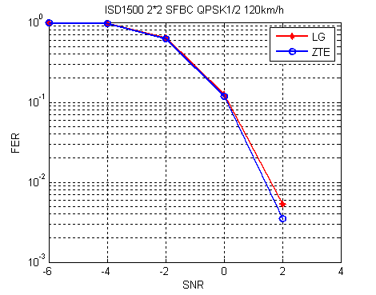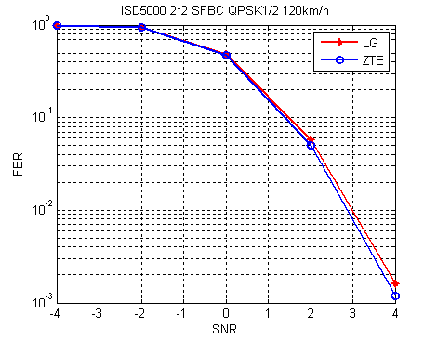
Figure 5 2Tx measurement pilot performance in QPSK1/2( PB3km/h )

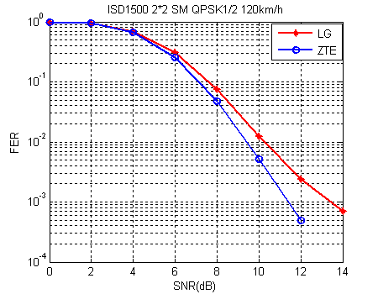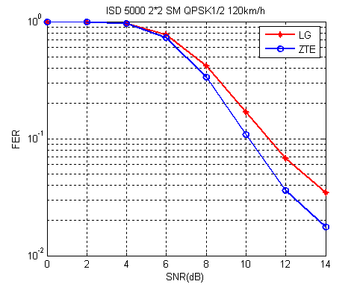

The simulation results show that the E-MBS pilot pattern of us achieves better FER-SNR performance than LGE in the SFN transmission scenarios of ISD 1500 and ISD 5000 while the pilot density of us is the same as that of LGE in table1. Especially, in the scenario of ISD5000 the FER-SNR performance has about 1～2dB gain than the pilot pattern of LG.

Table 1 Comparisons of E-MBS pilot density per antenna
Scenarios | ISD 1500 | ISD 5000
ZTE | 8.33% | 8.33%
LGE | 8.33% | 8.33%
Intel | 5.56% | 11.1%

Above all, the E-MBS pilot pattern of us, which each antenna has the pilot density of 8.33% achieves a balance between the pilot overhead and user performance. So we recommend to take it into the SDD text.

Appendix
The simulation parameters is bellow.

Parameter | Values
Channel Bandwidth | 10MHz
Over-sampling Factor | 28/25
FFT Size | 1024
Cyclic Prefix (CP) ratio | 1/8
Resource Unit | RU (18x6)
Channel condition | ISD 1500 120km/h, ISD 5000 120km/h
The number of antennas | 2Tx, 2Rx
Channel estimation for demodulation | 2D-MMSE
Receiver | MMSE receiver
CL-SU-MIMO schemes | SM/SFBC
Scenarios | Noise limited

References
[1] IEEE 802.16m-08/003r9, “The Draft IEEE 802.16m System Description Document”
[2] “Performance evaluation of MIMO measurement pilot”, IEEE C802.16m-09/408

Text proposal for inclusion in the 802.16m SDD
------------------------------- Text Start ------------------------------------------------------------------------------------
11.5.3.2 E-MBS zone specific pilot for MBSFN
E-MBS zone specific pilot is transmitted for MBSFN transmissions. An E-MBS zone is a group of ABSs involved in an SFN transmission. The E-MBS zone specific pilot, that’s, common inside one E-MBS zone but different between neighboring E-MBS zones, is configured. Synchronous transmissions of the same contents with common pilot from multiple ABS in one MBS zone would result in correct MBSFN channel estimation. The E-MBS zone specific pilot streams depends on the maximum number of streams within the E-MBS zone.
Pilot structures/patterns should be supported up to two streams.
The definitions of the E-MBS zone specific pilots are FFS.

The E-MBS pilot patterns for ISD 1500 and ISD 5000 is shown in Figure xxx.
Figure xxx Proposed E-MBS pilot patterns in a RU for 2 Stream
------------------------------- Text End ------------------------------------------------------------------------------------

