Project | IEEE 802.16 Broadband Wireless Access Working Group <http://ieee802.org/16>
Title | Proposal for Interference Avoidance and Interference Mitigation of Femtocell BSs (AWD-Femto)
Date Submitted | 2009-07-14
Source(s) | Rong-Terng Juang, Yu-Tao Hsieh, Pang-An Ting, Ming-Hung Tao, Yung-Han Chen, Fang-Ching Ren  ITRI  Yih-Shen Chen  MediaTek Inc.  Hsin-Piao Lin and Kun-Yi Lin  NTUT | Voice: + 886 3 5919024  E-mail: rtjuang@itri.org.tw  Yihshen.chen@mediatek.com
Re: | Call for Contribution on 80216m-09_0028r1
Abstract | The contribution proposes text for the Interference Avoidance and Interference Mitigation of Femtocell BSs to be included in 802.16m amendment.
Purpose | To be discussed and adopted by TGm for the 802.16m amendment.
Notice | This document does not represent the agreed views of the IEEE 802.16 Working Group or any of its subgroups. It represents only the views of the participants listed in the “Source(s)” field above. It is offered as a basis for discussion. It is not binding on the contributor(s), who reserve(s) the right to add, amend or withdraw material contained herein.
Release | The contributor grants a free, irrevocable license to the IEEE to incorporate material contained in this contribution, and any modifications thereof, in the creation of an IEEE Standards publication; to copyright in the IEEE’s name any IEEE Standards publication even though it may include portions of this contribution; and at the IEEE’s sole discretion to permit others to reproduce in whole or in part the resulting IEEE Standards publication. The contributor also acknowledges and accepts that this contribution may be made public by IEEE 802.16.
Patent Policy | The contributor is familiar with the IEEE-SA Patent Policy and Procedures:  <http://standards.ieee.org/guides/bylaws/sect6-7.html#6> and <http://standards.ieee.org/guides/opman/sect6.html#6.3>.  Further information is located at <http://standards.ieee.org/board/pat/pat-material.html> and <http://standards.ieee.org/board/pat>.

Proposal for Interference Avoidance and Interference Mitigation of Femtocell BSs (AWD-Femto)
Rong-Terng Juang, Yu-Tao Hsieh, Pang-An Ting, Ming-Hung Tao, Yung-Han Chen, Fang-Ching Ren
ITRI
Yih-Shen Chen
MediaTek Inc.
Hsin-Piao Lin and Kun-Yi Lin
NTUT

Abstract
This contribution provides amendment text for the Support for Femtocell BS in the Advanced Air Interface to be included in Section 15 of the IEEE 802.16m Amendment Working Document [1]. The amendment text was developed using baseline text from the Draft IEEE 802.16m System Description Document (SDD) [2], and follow the amendment text style guide [3]. Further details of the signaling procedure between Femtocell BS and AMS to support Interference Avoidance and Interference Mitigation are provided.

Introduction
Excluding the reuse-1 frequency partition, FP₀, Fig. 1 shows an example of macrocell ABS FFR configuration. To investigate the impact of co-channel femtocells on macrocells, this contribution assumes each macrocell overlays on top of N femtocells. The transmit power of each co-channel femtocell BS is set to a value that on average equals the power received from the overlaid macrocell at a target cell radius of r=10 meters. The femtocell transmit power, p_{f}, here is calculated as

$p_{f}={\text{10}}^{\left(\text{10}{\text{log}}_{\text{10}}p_{m}+G(θ)−L_{m}(d_{m})+L_{f}(d_{f})\right)/\text{10}}$ (1)

where p_{m} is the macrocell transmit power, $G(θ)$ is the antenna gain of the macrocell at user direction $θ$, $L_{m}(d_{m})=\text{35}\text{.}2+\text{35}{\text{log}}_{\text{10}}d_{m}+\text{26}{\text{log}}_{\text{10}}(f_{c}/2)$ with f_{c} being the carrier frequency in GHz is the urban macrocell path-loss at distance d_{m} in meters, and $L_{f}(d_{f})=\text{46}\text{.}4+\text{20}{\text{log}}_{\text{10}}d_{f}+\text{20}{\text{log}}_{\text{10}}(f_{c}/5)+L_{\text{walls}}$with L_{walls} being the loss due to external/internal walls denotes the femtocell path-loss at distance d_{f} in meters [17]. The antenna gain for macrocell BS is calculated as $G(θ)=G_{\text{max}}−\text{min}[\text{12}(θ/θ_{3\text{dB}})^{2},G_{m}]$, where $−\text{180}≤θ≤\text{180}$, $G_{\text{max}}=\text{17}$dBi, $θ_{3\text{dB}}=\text{70}$degrees, $G_{m}=\text{20}$dB [17].

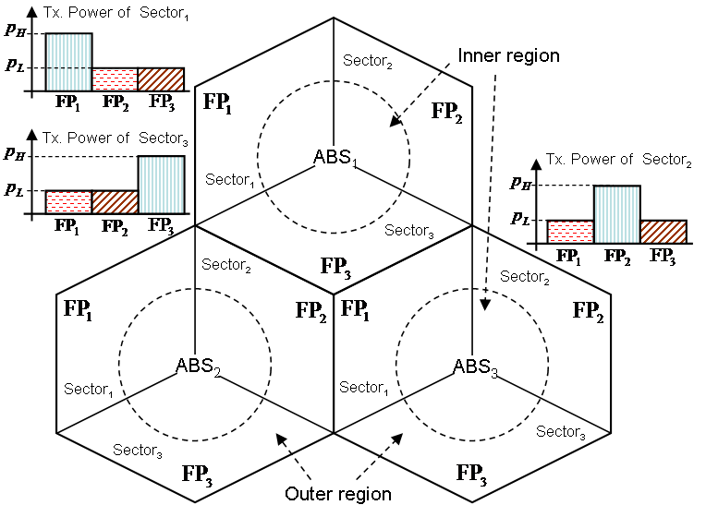
Fig 1. Conventional configuration of fractional frequency reuse.

Femtocells in the inner region of macrocells are assigned frequency partitions PF₁ , PF ₂ and PF ₃, while those in the outer region are assigned the identical sub-channel with their overlaid macrocell. Given an AMS connected to macrocell i, the received downlink SINR (signal-to-interference-plus-noise ratio) can be expressed as

$\text{SINR}=\frac{p_{m,i}g_{i}q_{m,i}}{\sum_{k=0,k≠i}^{M}{p_{m,k}g_{m,i}q_{m,k}}+\sum_{k=0}^{N}{p_{f,k}q_{f,k}}+σ^{2}}$ (2)

where M is the number of macrocells, p_{m,i} and p_{f,i} are respectively the transmit powers of ith macrocell and femtocell, g_{i} is the antenna gain of ith macrocell at the AMS, q_{m,i} and q_{f,i} are respectively the path gains between the AMS and ith macrocell and femtocell, and $σ^{2}$ represents the variance of additive white Gaussian noise.
In the simulations, 19 macro-BS sites with a transmit power of 46 dBm and a site-to-site distance of $2R=1\text{.}5$ km were deployed. Femtocells were randomly located in two different zones. One is inner zone, which defines a circle with radius $R^{'}<R/3$, and the other is outer zone defining a circular ring with radius $2R/3≤R^{'}<R$. Figure 2 show the SINR statistics of random-located macrocell AMSs. Femtocells located at outer zone do not rise a significant impact when the density is increased from 50 to 200 femtocells per macro-sector. This means inter-macrocell interference dominates the performance of cell-edge users because of the lower requirement of transmit power for femtocells at edges of macrocells. With a density of 50 femtocells at inner zone per macro-sector, however, femtocells have a great impact on macrocell users. Therefore, the following discusses focus on interference management for femtocells in the vicinity of macrocell ABS.

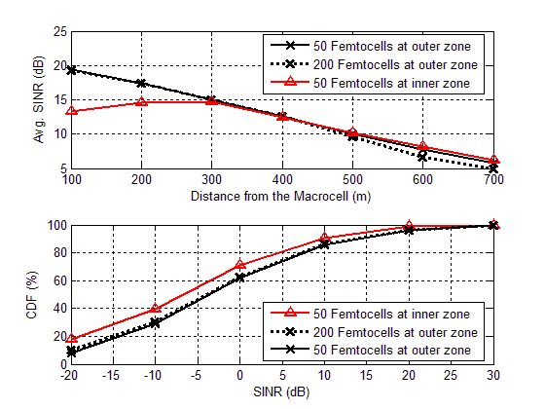
Figure 2. SINR statistics of macrocells.

Intercell interference can be avoided by allocating ABSs orthogonal frequency partitions. However, the elimination of frequency collisions is at the cost of spectrum efficiency. To overcome this drawback in a lower femtocell-density scenario, this contribution hops the FFR frequency partition of femtocells to whiten the interference. Femtocells in the inner regions pick one FFR frequency partition every certain period of time, while the overlaid macrocell uses all the other reuse-3 FFR frequency partitions. Thus, the interference to macrocell users is expected to be averaged. Additionally, the proposed FFR hopping provides frequency diversity gain. Figure 3 compares the performance for macrocells using difference FFR policies. The data rate is calculated at an 3dB operation point from the Shannon capacity limit. Macrocells employing the proposed FFR hopping achieve an higher spectrum efficiency because they uses all the sub-channels with interference averaged.

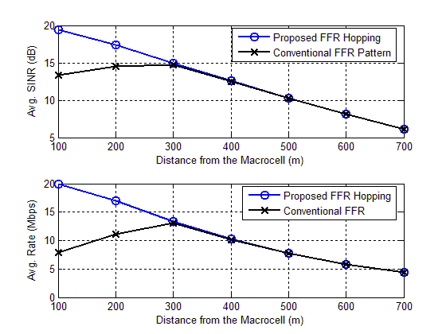
Figure 3. Performance of macrocell with 50 femtocells at inner zone per macro-sector.

References
[1] P802.16m Amendment Working document, 802.16m-09/0010r2, June 2009.
[2] IEEE 802.16m System Description Document (SDD) [Draft], IEEE 802.16m-08/003r9a.
[3] Style guide for writing the IEEE 802.16m amendment, IEEE 802.16m-08/043

Proposed Text
------------------------------------------------------ Start of the proposed text ------------------------------------------------

15.x.x Interference Avoidance and Interference Mitigation

To mitigate interference from femtocell BSs, some restrictions on radio resource utilization may be applied to femtocell BSs. A femtocell BS is instructed to utilize a fractional frequency partition for data transmissions by either the overlaid macrocell BS or the SON server. The maximum amount of schedulable resource is carried in an IE, which is TBD. By default, a femtocell is allowed to use all the radio resource. Upon receiving the radio resource restriction message, each femtocell BS allocates data channels on selected radio resource, subject to the maximum schedulable resource size. Alternatively, each femtocell BS switches between pre-defined frequency partitions to average the interference.

------------------------------------------------------- End of the proposed text ------------------------------------------------

