Project | IEEE 802.16 Broadband Wireless Access Working Group <http://ieee802.org/16>
Title | Shared Multi-Channel HARQ
Date Submitted | 2009-07-06
Source(s) | Zhuoqun Li  Walter Featherstone  Stavros Tzavidas  Motorola Ltd. | Voice: 0044 1793 568703  E-mail:  zhuoqun.li@motorola.com  stavros.tzavidas@motorola.com
Re: | 802.16m amendment working document
Abstract | This contribution proposes to support a shared multi-Channel HARQ process using equally informative subpackets that are produced with Random Network Coding. The outcome of the implementation of this approach is a significantly increased throughput in high FER scenarios.
Purpose | For review and adoption
Notice | This document does not represent the agreed views of the IEEE 802.16 Working Group or any of its subgroups. It represents only the views of the participants listed in the “Source(s)” field above. It is offered as a basis for discussion. It is not binding on the contributor(s), who reserve(s) the right to add, amend or withdraw material contained herein.
Release | The contributor grants a free, irrevocable license to the IEEE to incorporate material contained in this contribution, and any modifications thereof, in the creation of an IEEE Standards publication; to copyright in the IEEE’s name any IEEE Standards publication even though it may include portions of this contribution; and at the IEEE’s sole discretion to permit others to reproduce in whole or in part the resulting IEEE Standards publication. The contributor also acknowledges and accepts that this contribution may be made public by IEEE 802.16.
Patent Policy | The contributor is familiar with the IEEE-SA Patent Policy and Procedures:  <http://standards.ieee.org/guides/bylaws/sect6-7.html#6> and <http://standards.ieee.org/guides/opman/sect6.html#6.3>.  Further information is located at <http://standards.ieee.org/board/pat/pat-material.html> and <http://standards.ieee.org/board/pat>.

Shared Multi-Channel HARQ
Zhuoqun Li, Walter Featherstone and Stavros Tzavidas
Motorola Ltd

1. Introduction
In order to adapt to various link conditions and to efficiently utilize available bandwidth, in the present design of Multi-Channel (or N-process) HARQ operation, the MAC Service Data Unit (MSDU) as well as the PHY Service Data Unit (PSDU) are often divided into several fragments. With Multi-channel HARQ, the transmission and retransmission of the fragments are taken care of in multiple HARQ channels that run in parallel. Figure 1 demonstrates the conventional design of multi-channel HARQ process as defined in IEEE 802.16e [1].
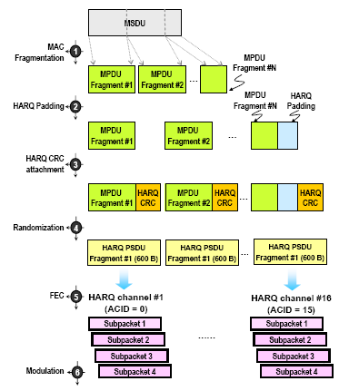
Figure 1 An illustration of the Multi-Channel HARQ as defined in IEEE 802.16e

A major flaw of this design of multi-channel HARQ is that each HARQ channel (or each subpacket) is dedicated to the recovery of a single data unit (e.g. MPDU). Since it is fundamentally difficult to predict (be it HARQ-CC or HARQ-IR) the exact amount of data carried in a subpacket that would be just enough to recover a corrupted MPDU, some portions of a subpacket in a retransmission will not be utilized for error recovery at all, which results in a non-optimal bandwidth utilization, especially in high BER scenarios. This contribution proposes to support a shared multi-channel HARQ process using equally informative subpackets that are produced with Random Network Coding. With the shared multi-channel HARQ, a maximized utilization of a subpacket can be achieved for error recovery. As a result, throughput in the wireless access network is increased significantly in the face of frequent bit corruptions.

2. The Concept of Shared Multi-Channel HARQ
In this section, we provide a detail description of the proposed process of shared multi-channel HARQ. As shown in Figure 2, a HARQ MPDU fragment can be further split into two or more blocks. By applying a linear combinations on a group of blocks from several MPDU segments with various coefficient vectors that are linearly independent with each other, we will be able to generate new blocks (e.g. Y₁= C_{1,1}*X₁ + C_{1,2}*X₂ +C_{1,3}*X₃+ C_{1,4}*X₄) that contain the information of all of the raw MPDU blocks involved. These new blocks (e.g. Y₁ and Y₂₎ can be organized to form a subpacket for TX or ReTX.

If packet corruption occurs to the any of the HARQ channels (e.g. CH1 and CH2 in Figure 2), subpackets received from one channel can be used to recover corrupted MPDU fragments in other channels. Based on the concept of Randomized Network Coding, the process is similar to that of solving a linear equation systems with the raw blocks being the unknowns. Utilization of subpackets is maximized with this method since portions (i.e. blocks) of one subpacket that are redundant for one HARQ channel can be reused for error recovery in the other. Based on theoretical analysis and computer simulations, it is estimated that the shared multi-channel HARQ will improve throughput by up to 105% in comparison to the legacy multi-channel HARQ-CC or HARQ-IR (see Figure 3 and Figure 4).
TX in CH 1
Receiver
Transmitter
X₃
×
=
X₄
x₁
X₂
C_{1,1, ...} C_{1,4}
C_{2,1, …} C_{2,4}

C_{3,1, ,...} C_{3,4}

C_{4,1, …} C_{4,4}

C_{5,1, …} C_{5,4}

×
-1
=
Y₅
Y₆
Y₂
Y₃
Y₁
Y₂
Y₃
Y₄
Y₅
Y₆
C_{6,6, …} C_{6,4}

X₃
X₄
X₁
X₂
C_{2,1, …} C_{2,4}

C_{3,1, ,...} C_{3,4}

C_{5,1, …} C_{5,4}

C_{6,6, …} C_{6,4}

TX in CH 2
Shared-ReTX in CH 1
ReTX effort shared by 2 CHs
MPDU Fragments
Sub-packets
Received Sub-packets
Recovered MPDU Fragments
2 blocks per fragment
Co-efficient matrix
Figure 2 Concept Description: Generation and (Re)Transmission of Subpackets in the shared multi-channel HARQ process
In Figure 5, we illustrate a block diagram of the protocol functions incorporating the multi-channel HARQ process in a sender. As shown in Figure 3, the conventional “HARQ CRC attachment” function/stage is now revised to be the “Network Coding Transformation” function. This splits MPDU fragments into M (M>=2) blocks, then linearly combines them to form new blocks with the coefficient matrix and then attaches (a smaller number of) CRC bits to each block before organizing them to form new fragments. In order to produce 4 subpackets for (Re)Transmissions in each HARQ process from the original N MPDU fragments (one fragment per channel), a matrix of 4MN×MN coefficients is needed. The coefficient matrix can be hard-coded so that no communication of coefficients is needed between the transmitter and the receiver. A reverse process is carried out in the receiver, a diagram of which is omitted from this document. The process and protocol functions of the shared Multi-channel HARQ will be similar between Down Link and Up Link.
Figure 3 Throughput Vs. Residual frame error rate, 6 blocks per fragment
75% improvement against legacy @ 0.8 RFER
Figure 4 Throughput vs. Residual frame error rate, fixed 6 CH sharing
105% improvement against legacy @ 0.9 RFER
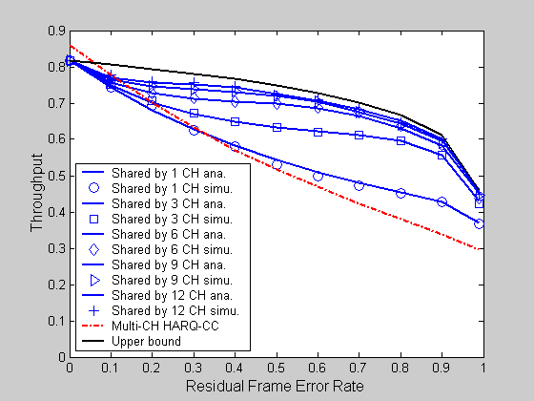
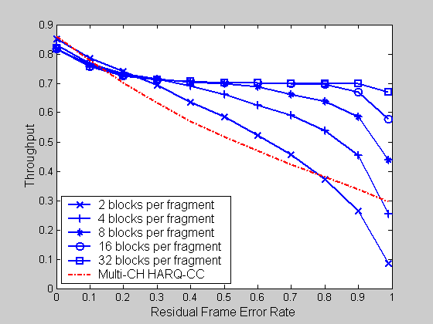
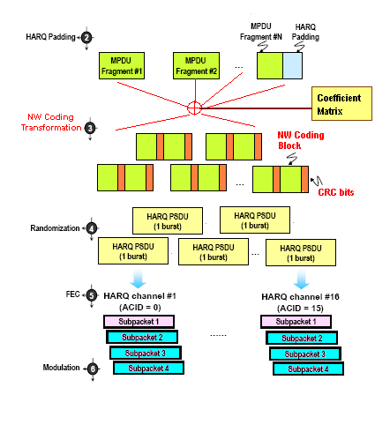
Figure 5 Block diagram of Protocol Functions of the Shared Multi-channel HARQ Process

3. Text proposal
-----------------------------------------------------------Start of the Text---------------------------------------------------------

Modify the text in paragraph 15.2.14.1 “HARQ subpacket generation and transmission” in [IEEE 802.16m-09/0010r2] as follows:

15.2.14.1 HARQ subpacket generation and transmission

Generating the HARQ subpackets shall follow 15.3.x [channel coding section] if shared multi-channel HARQ operation is not enabled. The In this case, the received subpackets shall be combined by the FEC decoder as part of the decoding process. If shared multi-channel HARQ operation is enabled, generation of subpackets shall follow the rules outlined in 15.2.14.1.1.

Incremental redundancy (IR) is mandatory, with Chase combining as a special case of IR. For IR, each subpacket contains the part of codeword determined by a subpacket identifier (SPID).

The rule of subpacket transmission is as follows:
……

15.2.14.1.1 Subpacket generation within Shared Multi-Channel HARQ
Within the optional shared multi-channel HARQ scheme, which is another special case of Incremental Redundancy, generation of subpackets shall be carried out according to the following rules:
- Each of the N raw fragments, to be transmitted in the N parallel HARQ channels, shall be split into M blocks (N×M in total).
- To linearly combine these blocks with a 4NM×NM matrix of coefficients (any two rows in the matrix are linearly independent) to generate a number of 4×N subpackets (M blocks per subpacket) that can be transmitted on any of the N channels.

A small number of CRC bits can be attached to each block for the receiver to identify the corrupted blocks. Channel coding can be applied to each subpacket to provide extra redundancy.

Decoding for the N channels is successful if a total of N blocks out of the subpackets received from any of the N channels have been decoded. The receiver shall apply an inverted version of the coefficient matrix to these blocks to extract the original N fragments.

Insert the following subsection in section 15.3.12.2 “HARQ”:

15.3.12.2 HARQ

15.3.12.2.2 Shared-Multi-Channel HARQ
If shared multi-channel HARQ is enabled, the generation of sub-packets corresponds to the rules described in <<15.2.14.1 >>.
------------------------------------------------------------End of the Text---------------------------------------------------------

References:
[1] IEEE Std. 802.16e − Air Interface for Fixed Broadband Wireless Access Systems, Amendment 2: Physical and Medium Access Control Layers for Combined Fixed and Mobile Operation in Licensed Bands, February 2006.
[2] IEEE 802.16m-09/0010r2, “The Draft IEEE 802.16m System Description Document”, March 2008

