Project | IEEE 802.16 Broadband Wireless Access Working Group <http://ieee802.org/16>
Title | Vector Quantization of the Transmit Correlation Matrix for Codebook Transformation (AWD 15.3.7.2.6.6.3)
Date Submitted | 2009-07-06
Source(s) | Ron Porat, Simon Pun, Phil Orlik, Zhifeng (Jeff) Tao  Mitsubishi Electric Research Labs  Toshiyuki Kuze  Mitsubishi Electric Corporation  5-1-1 Ofuna Kamakura, Kanagawa 2478501, JAPAN | Voice:  E-mail: poratron@yahoo.com; {mpun, porlik, tao}@merl.com  E-mail : kuze.Toshiyuki@ah.MitsubishiElectric.co.jp  *<http://standards.ieee.org/faqs/affiliationFAQ.html>
Re: | Category: AWD comments: 15.3.7.2.6.6.3 Transformation codebook based feedback mode
Abstract | This document describes a proposal to reduce the overhead associated with the feedback of the transmit correlation matrix for transformation codebook MIMO operations.
Purpose | To be discussed and adopted by 802.16m
Notice | This document does not represent the agreed views of the IEEE 802.16 Working Group or any of its subgroups. It represents only the views of the participants listed in the “Source(s)” field above. It is offered as a basis for discussion. It is not binding on the contributor(s), who reserve(s) the right to add, amend or withdraw material contained herein.
Release | The contributor grants a free, irrevocable license to the IEEE to incorporate material contained in this contribution, and any modifications thereof, in the creation of an IEEE Standards publication; to copyright in the IEEE’s name any IEEE Standards publication even though it may include portions of this contribution; and at the IEEE’s sole discretion to permit others to reproduce in whole or in part the resulting IEEE Standards publication. The contributor also acknowledges and accepts that this contribution may be made public by IEEE 802.16.
Patent Policy | The contributor is familiar with the IEEE-SA Patent Policy and Procedures:  <http://standards.ieee.org/guides/bylaws/sect6-7.html#6> and <http://standards.ieee.org/guides/opman/sect6.html#6.3>.  Further information is located at <http://standards.ieee.org/board/pat/pat-material.html> and <http://standards.ieee.org/board/pat>.

Vector Quantization of the Transmit Correlation Matrix for Codebook Transformation
Ron Porat, Simon Pun, Phil Orlik
Mitsubishi Electric Research Labs

Background

This contribution follows [1] where several vector quantization schemes of the transmit correlation matrix were proposed and analyzed. The fundamental idea simply follows the logic behind general codebooks construction.
In this contribution a vector quantization scheme for the transformation mode is proposed and shown to perform well in MU-MIMO.
It is shown in the simulations that vector quantization provides comparable performance and sometimes even better performance than element-wise quantization at a much lower feedback overhead.

2. Proposed Scheme

The proposed scheme uses rank-1 codebooks to quantize the two strongest singular vectors of the transmit correlation matrix. Using the rank-2 codebook didn’t perform nearly as well in simulations due to reduced accuracy.

Algorithm 1:

- Find the strongest singular vector by maximizing where is a rank-1 singular vector taken from a codebook and is the approximated strongest singular value of . Denote by m the index of the winning codeword.
- Find the second strongest singular vector by maximizing where is the orthogonalized rank-1 singular vector with respect to .
- Quantize the ratio into a predefined set of thresholds. Denote by q that value.

Alternatively, the metric in stage 2 can be replaced by minimization of the error between and its vector quantized estimation by following this algorithm 2:

- As in algorithm1
- Compute the orthogonalized singular vector , the singular vector and the quantized ratio q as in algorithm 1. Find the codeword that minimizes

The specific algorithm is left for vendor implementation.
The feedback includes the two indices of the winning singular vectors and the index of the quantized singular value.

Codebook choice

The fundamental choice of codebook is somewhat different than the typical codeword construction. First, only rank-1 is used and second, the adaptive mode is used for correlated arrays, hence codebooks that are designed to perform better in correlated antennas are preferable.
In addition, it was found by simulations that the strongest singular vector has much more importance in providing accurate vector quantization of R than the second. This is to be expected since correlated arrays where the adaptive more is useful tend to have low ratio of the singular values .
Hence, an optimal ‘bit allocation’ will require larger codebook for the first singular vector.
As is shown in [2], the 6bit rank-1 codebook chosen for 802.16m exhibits good performance in correlated and uncorrelated and is therefore a good choice. The 4bit subset codebook didn’t perform sufficiently well in simulations.
However, as can be seen in the plots below, a 4 bit steering vector (defined in the proposed text) performs very well for ULA and is therefore proposed in order to educe computation and feedback overhead eve further.
The BS can send a message to the MS indicating that a closely spaced ULA is used and asking to use the steering vector as the baseline codebook. Alternatively or additionally the MS can compute the vector quantized R using the steering vector and if the MSE is below a threshold use that instead of the 802.16m codebook.

3. Simulation Assumptions

MUZF simulations based on rank-1 feedback are used. DL spectral efficiencies are calculated assuming an MMSE receiver at the MS and assuming the interference is perfectly known.

- DL channel – SCM Suburban Macro and Urban Macro (15 degrees angular spread).
- Antenna Configuration –
  - 4 lambda/2 spaced antennas [| | | |]
  - 2 lambda/2 spaced cross-pols [XX]
- DL Band BW – 4 PRB (assuming one precoder per band)
- DL speed and feedback delay – 3kmph, 5mS
- DL midamble estimation – perfect
- User selection: 4 random users with exhaustive selection

Histograms of the ratio of the second to first singular values of the transmit correlation for the antenna configurations and environments used is shown in the appendix. Note that the Suburban Macro environment exhibits almost rank-1which is due to the narrow angular spread.

4. Simulation Results

The simulations use the 802.16m rank-1 codebook. The ratio of the second to first singular values was quantized to the nearest point in [0.25, 0.5] and requires 1bit feedback.

A comparison is made relative to the 4bit subset of the rank-1 4-antenna codebook or 4bit 8-antenna codebook.

4.1 4Tx Results

In the legends:
- ‘6 bit’ uses the 6bit PMI
- ‘4bit+R’ uses the 4bit subset transformed by the unquantized R,
- ‘4bit+Quantized R’ uses 16m element wise quantization (28 bits),
- ‘4bit +VQ(6+6+1)’ uses vector quantization of R using the 6bit 16m rank-1 PMI,
- ‘4bit+(4+4+1)’ uses vector quantization of R using a steering vector (defined in the proposed text) and similar to the 8-antenna rank-1 codebook
- ‘Perfect SV’ uses the strongest unquantized singular vector of the average narrowband transmit correlation matrix.

The poor performance seen in Suburban Macro of the element wise quantization of can be attributed to figure 3 in [1] where it is shown that the MSE of this method is highest for rank-1.

On the other hand, it can be seen that in this scenario and antenna configuration, a 4bit steering vector performs slightly better while reducing the feedback overhead.

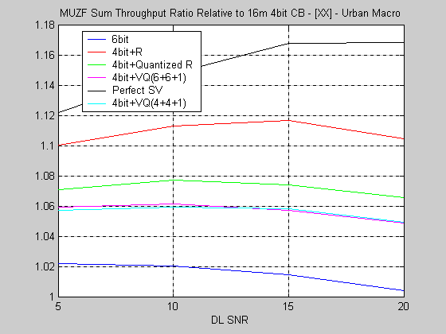

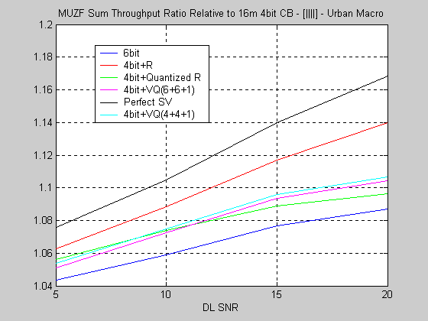

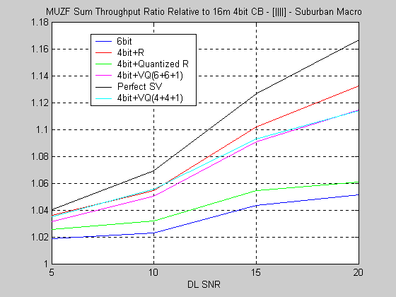

4.2 8Tx Results

In the legends:

- ‘4bit+R’ uses the 4bit subset transformed by the unquantized R,
- ‘4bit+Quantized R’ uses 16m element wise quantization for 8Tx (120 bits),
- ‘4bit +VQ(4+4+1)’ uses vector quantization of R using the 4bit 16m rank-1 PMI,
- ‘Perfect SV’ uses the strongest unquantized singular vector of the average narrowband transmit correlation matrix.

The first two plots show results for a closely spaced ULA using the 4bit rank-1 8Tx codebook to quantize R.
It can be seen that a similar performance to element by element quantization is achievable with just 9 total bits saving 92.5% overhead.

The next plot for [XXXX] configuration requires better rank-1 codebooks to achieve closer to optimal performance. Shown are

- 4bit+VQ(Perfect+4+1) – this dashed black line assumes that the strongest singular vector of R was perfectly fed back and serves as an upper bound on the performance achieved with 4bit rank-1 8Tx 16m codebook quantizing the second singular vector and 1bit quantization of the singular values.
- 4bit+VQ(4+2+2)+4+1) – this dashed red line uses a 4Tx steering vector applied to the co-polarized antennas and a gain and phase offset between them quantized to two bits each
- 4bit+VQ(4+1+1)+4+1) – this dashed blue line uses a 4Tx steering vector applied to the co-polarized antennas and a gain and phase offset between them quantized to one bit each. Using this configuration, a total of 11bits are required to quantize R with performance that exceeds that of 16m element wise quantization. A savings of 91% is achieved.

The proposed rank-1 vector used to quantize the strongest singular vector of R is therefore
where it was assumed that the co-polarized antennas occupy the first and second half of the singular vector.

The last plot for [XX XX] requires more bits for vector quantization since this configuration has the least correlation out of all previous configurations.
As before, we can see that if the strongest singular vector of R is perfectly quantized, the performance is close to optimal.
The codebook used is a combination of a two antenna steering vector common to all 4 groups of closely spaced co-polarized antennas and the 6bit rank-1 4Tx codebook which is designed for good performance with uncorrelated antennas.
Shown are:

- 4bit+VQ(Perfect+4+1) – this dashed black line assumes that the strongest singular vector of R was perfectly fed back and serves as an upper bound on the performance achieved with 4bit rank-1 8Tx 16m codebook quantizing the second singular vector and 1bit quantization of the singular values.
- 4bit+VQ(6+3)+4+1) – this dashed blue line uses a 2Tx 3bit steering vector and a 4Tx 6bit rank-1 codebookapplied to the co-polarized antennas and a gain and phase offset between them quantized to two bits each
- 4bit+VQ(6+3)+(6+3)+1) – this dashed red line uses the same rank-1 precoder as before but applies it to the second singular vector as well. This helps compensating for the performance loss from the ‘inaccurate’ quantization of the strongest singular vector. It can be seen that using this configuration, performance similar to the element wise quantization can be achieved at 84% overhead savings.

The proposed rank-1 codebook is therefore of the structure:

Where M4(j,i) is the j’th element of the i’th codeword of the 6bit 4Tx codebook and where the following antenna numbering was assumed .

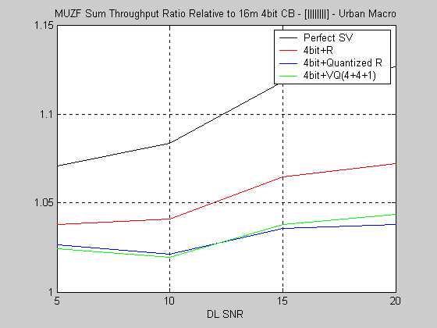

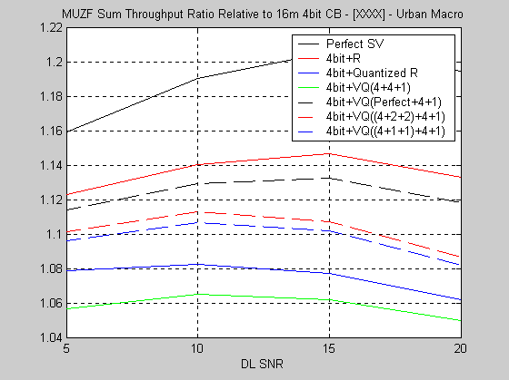

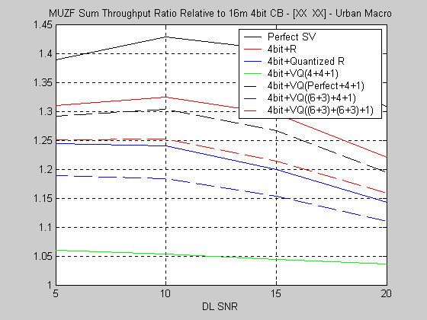

References

- C802.16m-09/516r1 – “Reduced-Overhead Covariance Matrix Feedback”
- C802.16m-09/588 –“ Performance Evaluation of Codebooks Proposed for IEEE 802.16m Amendment”

Appendix

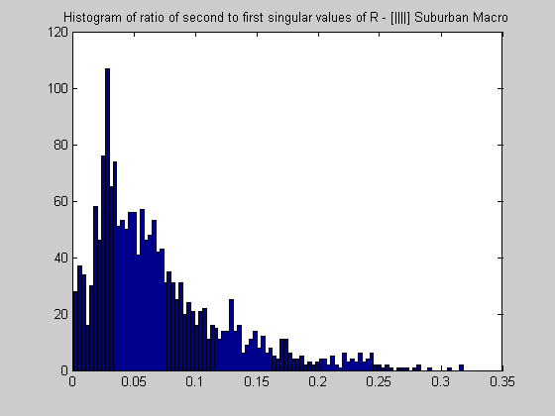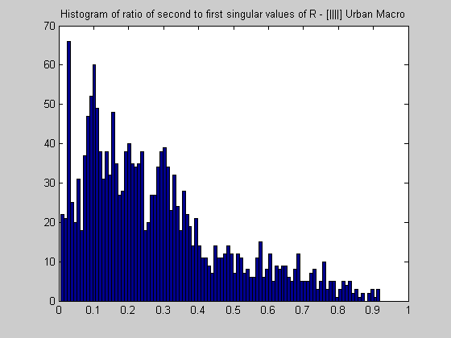

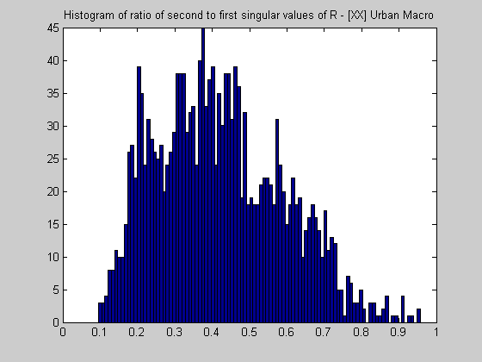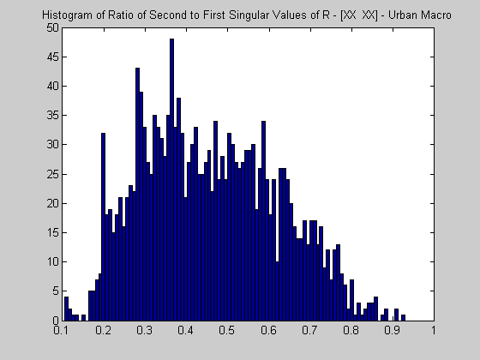

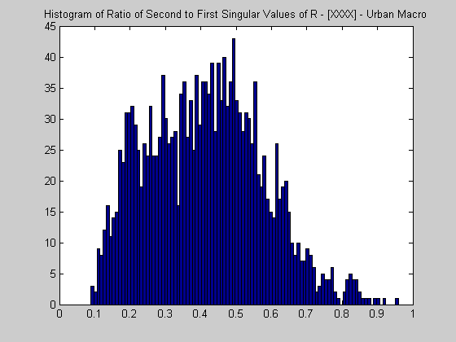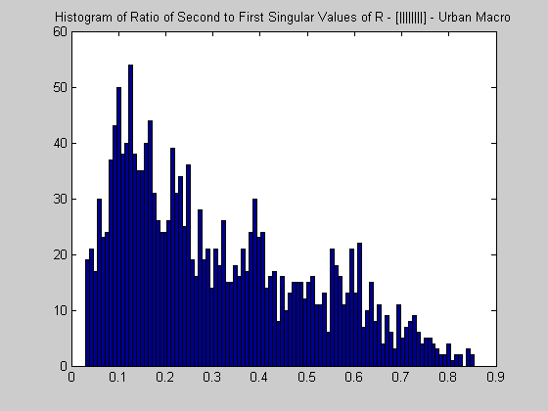

Proposed text

15.3.7.2.6.6.3 Transformation codebook based feedback mode

Add at the end of the section:

Thematrix can be vector quantized into its singular vectors and values. The two strongest singular vectors and the ratio of the second to first singular values are fed back.
The singular vectors are quantized using the rank-1 codebooks defined in sections 15.3.7.2.6.6.2.2.1 and 15.3.7.2.6.6.2.2.1.
The ratio of singular values is quantized to the nearest element in [0.25, 0.5].
A 4-antenna BS can signal the MS to use a 4-bit steering vector based approach.
The steering vector is defined as:

