Project | IEEE 802.16 Broadband Wireless Access Working Group <http://ieee802.org/16>
Title | Proposal for non-user specific A-MAP design in the 802.16m AWD (AWD-15.3.6)
Date Submitted | 2009-07-06
Source(s) | Yi Hsuan, Ping Wang, Debdeep Chatterjee and Hujun Yin  Intel Corporation | yi.hsuan@intel.com
Re: | Category: AWD comments / Area: Chapter 15.3.6 (DL-CTRL)  “Comments on AWD 15.3.6 DL-CTRL”
Abstract | The contribution proposes text on non-user specific A-MAP transmission format and IE design.
Purpose | To be discussed and adopted by TGm for the 802.16m amendment.
Notice | This document does not represent the agreed views of the IEEE 802.16 Working Group or any of its subgroups. It represents only the views of the participants listed in the “Source(s)” field above. It is offered as a basis for discussion. It is not binding on the contributor(s), who reserve(s) the right to add, amend or withdraw material contained herein.
Release | The contributor grants a free, irrevocable license to the IEEE to incorporate material contained in this contribution, and any modifications thereof, in the creation of an IEEE Standards publication; to copyright in the IEEE’s name any IEEE Standards publication even though it may include portions of this contribution; and at the IEEE’s sole discretion to permit others to reproduce in whole or in part the resulting IEEE Standards publication. The contributor also acknowledges and accepts that this contribution may be made public by IEEE 802.16.
Patent Policy | The contributor is familiar with the IEEE-SA Patent Policy and Procedures:  <http://standards.ieee.org/guides/bylaws/sect6-7.html#6> and <http://standards.ieee.org/guides/opman/sect6.html#6.3>.  Further information is located at <http://standards.ieee.org/board/pat/pat-material.html> and <http://standards.ieee.org/board/pat>.

Proposal for Non-User Specific A-MAP Design in the 802.16m AWD

Yi Hsuan, Ping Wang, Debdeep Chatterjee and Hujun Yin
Intel Corporation

1. Non-User Specific A-MAP Content
It has been agreed in Session #61 to indicate the number of assignment A-MAPs in each assignment A-MAP group in non-user specific A-MAP. Assignment A-MAPs in an assignment A-MAP group have the same A-MAP IE size and MCS. The number of bits required to indicate the number of assignment A-MAPs in each assignment A-MAP group depends on the following factors:
- The total resource that can be allocated to assignment A-MAP.
- The number of different assignment A-MAP IE sizes.
- MCS levels.
- FFR support.
In C802.16m-09/1356, we describe design details and analysis of assignment A-MAP group size indication based on
- No more than 48 MLRUs, which is assumed the largest amount of assignment A-MAP resource in 20 MHz system bandwidth.
- One assignment A-MAP IE size. For assignment A-MAP IEs requiring more than 1 MLRU using QPSK 1/2, the IE is segmented to multiple segments where each segment takes 1 MLRU.
- Two MCS levels are considered as in the current AWD text. Either QPSK (½, ¼) or QPSK(½, 1/8) are used in a subframe.
- In the case of FFR deployment, two MCS like the above item 3 can be used in the frequency reuse 1 partition and QPSK ½ can be used in the power boosted frequency reuse 3 partition. Therefore non-user specific A-MAP needs to indicate the sizes of three assignment A-MAP groups.
Our analysis in C802.16m-09/1356 shows that we can use 8 bits to indicate the sizes of assignment A-MAP groups in each subframe with good performance, which is measured as resource waste and extra number of blind detection required.
In addition to the assignment A-MAP group size indication, we need one bit in non-user specific A-MAP for DL Ack/Nack indexing as shown in C802.16m-09/1365. One more bit is needed to indicate one of the two possible MCS sets used in assignment A-MAP. With two more reserved bits, non-user specific AMAP should have 12 bits in each DL subframe.

2. Non-User Specific A-MAP Transmission Format
With 12 bits in the non-user specific A-MAP IE, we can use the TBCC code in 16m to provide error correction capability for the non-user specific A-MAP. Table 1 details the link level simulation parameters used to generate PER curves in Figure 1 and 2.

Total available bandwidth | 10 MHz (1024 subcarriers)
Carrier Frequency | 2.5GHz
Number of OFDM symbols per subframe | 6
Number of information bits in a block | 12
Number of total RU in one subframe | 48
Number of Antennas | 2 transmitter antennas, 2 receiver antennas [2Tx,2Rx]
MIMO mode | 2x2 SFBC
Tone selection | Fully distributed (uniformly) over the entire band in units of tone-pairs (SFBC)
Modulation/Coding | QPSK, ½ TBCC (no repetition) and ¼ TBCC with no repetition, and 2, 3, and 4 repetitions
MIMO Receiver | MMSE-CNC (MMSE with Colored Noise Consideration)
Traffic model | eITU-VehA 120 km/h
Pilot patterns | 2-stream pilot pattern as in SDD, Pilot Boosting = 5dB
Channel estimation | 2-D MMSE single-PRU-based channel estimator
Scenarios | Interference-limited (IL): INR = 10dB, 3 interferers with path loss profile: (0dB, -3dB, -6dB)Interference-limited (IL): INR = 5dB, 3 interferers with path loss profile: (0dB, -3dB, -6dB)
Table 1: Link level simulation parameters for non-user specific A-MAP

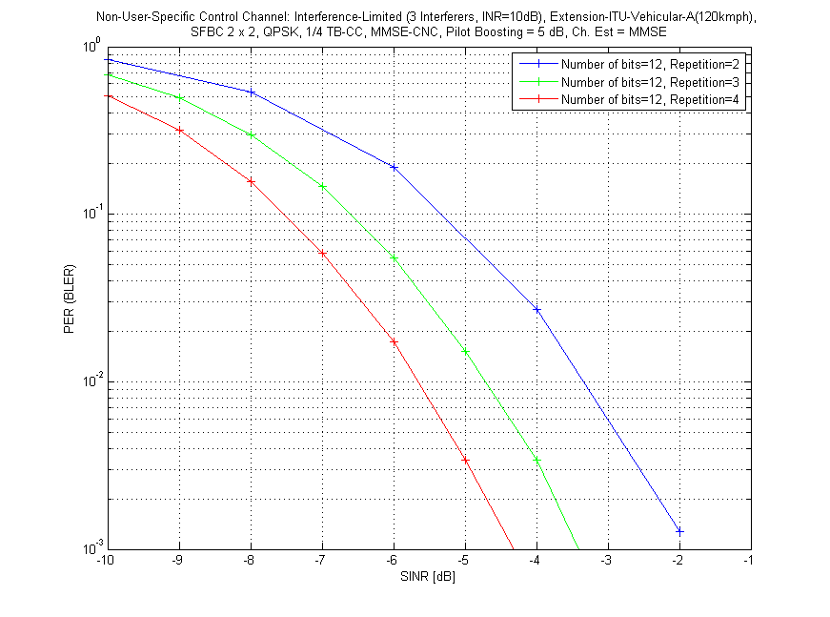

Figure 1: Non-user specific PER curves with code rates 1/8, 1/12 and 1/16

Figure 1 shows the PER curves of non-user specific AMAP with different code rates. 10 dB INR in the simulation is chosen to mimic the interference limited scenario. Based on the 95% coverage requirement, non-user A-MAP PER should be lower than 1% at SINR at -4 dB. The 95% SINR value is derived from EMD baseline cell configurations. From Figure 1 a code rate of 1/12 can achieve the requirement with a margin of 0.7 dB.

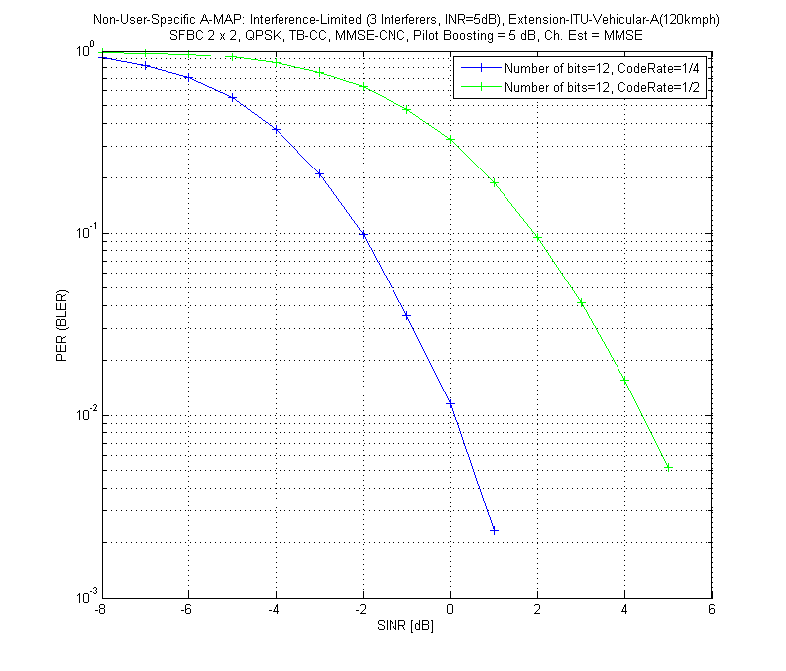

Figure 2: Non-user specific PER curves with code rates ½ and 1/4

Figure 2 shows the PER curves with less interference (INR=5 dB) and higher code rates. This figure is used to determine the code rate when non-user specific A-MAP is in the power boosted reuse 3 partition in FFR deployment. When the power boosting amount of the power boosted reuse 3 partition in FFR is more than 6 dB, the 95% SINR is between 0 dB to 2.5 dB. Therefore a code rate of ¼ can be used to achieve the requirement. Note that power boosting on a particular A-MAP channel can be applied to further improve the coverage and reliability of the channel.

Amendment text proposal for inclusion in 802.16m-09/0010r2

------------------------------- Start Text Proposal ---------------------------------------------------

[ ------ Recommended AWD Text Proposal #1 (page 189, line 1) ------]

The non-user specific A-MAP bit sequence shall be encoded with a fixed MCS.

The encoded sequences shall be repeated N_{Rep,NS-A-MAP} times.

The repeated bit sequences shall be modulated using QPSK.

The non-user specific A-MAP IE is encoded with a code rate of 1/12 using TBCC described in 15.xxx. In FFR configurations, the non-user specific A-MAP is also encoded with a code rate of 1/12 when it is in the frequency reuse 1 partition. When the non-user specific A-MAP is in the power boosted frequency reuse 3 partition, it should be encoded with a code rate of 1/4. The encoded sequence is modulated using QPSK.

[ ------ Recommended AWD Text Proposal #2 (page 198) ------]
15.3.6.5.2.1 Non-user-specific A-MAP IE
Non-user-specific A-MAP IE consists of information that is not dedicated to a specific user or a specific group of users. It includes information required to decode assignment A-MAP IE. The number of assignment A-MAPs in each assignment A-MAP group is indicated in the Non-user-specific A-MAP IE. The detailed information included in non-user specific information is TBD. The non-user specific A-MAP IE is shown in Table 666. Non-user specific A-MAP IE has [12] bits in total.

[ ------ Recommended AWD Text Proposal #3 (page 198) ------]

Table 666—Non-user specific A-MAP IE

Syntax | Size [bits] | Notes
Assignment A-MAP size | TBD | Indicate the number of assignment A-MAPs in each assignment A-MAP group as shown in Table 667.
HF-A-MAP Index Parameter [TBD] | 1 | Indicate which transmission parameter is used to calculate HF-A-MAP index.
A-A-MAP MCS set indicator | 1 | Indicate which A-A-MAP MCS set should be used in the subframe.
Reserved bits | TBD

[ ------ Recommended AWD Text Proposal #4 (page 198) ------]

Table 667 [Detailed entry is TBD] shows the number of the assignment A-MAPs in each assignment A-MAP group.
Table 667—The number of assignment A-MAPs in each assignment A-MAP group

Index | Assignment A-MAP group-1 | Assignment A-MAP group-2 | ...
... | ... | ...

------------------------------- End Text Proposal ---------------------------------------------------

