Project | IEEE 802.16 Broadband Wireless Access Working Group <http://ieee802.org/16>
Title | Proposal for SFH physical structure and permutation in the 802.16m AWD (AWD-15.3.6.2.1)
Date Submitted | 2009-07-15
Source(s) | Yi Hsuan, Jong-kae Fwu and Hujun Yin  Intel Corporation | yi.hsuan@intel.com
Re: | Category: AWD comments / Area: Chapter 15.3.6 (DL-CTRL)  “Comments on AWD 15.3.6 DL-CTRL”
Abstract | The contribution proposes text a resource indexing scheme for the DL and UL and proposed text to be included in 802.16m amendment.
Purpose | To be discussed and adopted by TGm for the 802.16m amendment.
Notice | This document does not represent the agreed views of the IEEE 802.16 Working Group or any of its subgroups. It represents only the views of the participants listed in the “Source(s)” field above. It is offered as a basis for discussion. It is not binding on the contributor(s), who reserve(s) the right to add, amend or withdraw material contained herein.
Release | The contributor grants a free, irrevocable license to the IEEE to incorporate material contained in this contribution, and any modifications thereof, in the creation of an IEEE Standards publication; to copyright in the IEEE’s name any IEEE Standards publication even though it may include portions of this contribution; and at the IEEE’s sole discretion to permit others to reproduce in whole or in part the resulting IEEE Standards publication. The contributor also acknowledges and accepts that this contribution may be made public by IEEE 802.16.
Patent Policy | The contributor is familiar with the IEEE-SA Patent Policy and Procedures:  <http://standards.ieee.org/guides/bylaws/sect6-7.html#6> and <http://standards.ieee.org/guides/opman/sect6.html#6.3>.  Further information is located at <http://standards.ieee.org/board/pat/pat-material.html> and <http://standards.ieee.org/board/pat>.

Proposal for SFH Physical Structure and Permutation in the 802.16m AWD

Yi Hsuan, Jong-kae Fwu and Hujun Yin
Intel Corporation

1. Resource allocation of SFH
This contribution proposes to change the resource allocation of SFH from no more than 5 MHz physical band to 5 MHz logical band. The intentions to have SFH in 5 MHz physical band are as follows.
- MS doesn’t need to know the system bandwidth information before decoding SFH.
- MS may use PA-Preamble to improve the channel estimation quality.
- Bandwidth outside the 5 MHz physical band can be further partitioned into more frequency partitions.
For the first point, PA-Preamble carries bandwidth information so MS will know system bandwidth before decoding SFH. If bandwidth information is not acquired from PA-Preamble, SA-Preamble cannot be decoded correctly either, and SFH cannot be decoded without SA-Preamble. In any case, bandwidth information is needed to decode SFH.
For the second point, our study shows that PA-Preamble helps in noise limited case. In interference limited case it actually hurts SFH performance because PA-Preamble is transmitted in the reuse 1 fashion and PA-preamble based channel estimates are worse than pilot based channel estimates. Besides SFH follows SA-Preamble in the current AWD. SA-Preamble spans the entire system bandwidth so there is no reason to limit SFH in the 5 MHz physical band.
Finally it requires high signaling overhead to configure the SFH subframe to have multiple frequency partitions. Signaling overhead similar to FFR configuration is needed just for one subframe per superframe. An alternative is to fix the frequency partition in the subframe to avoid signaling overhead. However it’s very restrictive and makes the resource less usable.
The disadvantages of using physical 5 MHz is
1) It creates a special case for outer permutation. The 5 Mhz band needs to be a separate frequency partition, which is composed of the central 5 MHz PRUs. The current permutation equations do not support such frequency partition.
2) To allocate remaining resource in the 5 MHz physical band, AMAP may not fit into the remaining resource, making the remaining resource difficult to use.
On the other hand, if SFH is limited to a logical 5 MHz band, no frequency partition for the SFH subframe is needed. The entire system band can be in one frequency partition. There is no need to create a special permutation rule. Same permutation design can be used. Moreover it’s highly flexible to allocate the remaining resources to AMAP or data transmission.

2. Permutation of the SFH subframe
Due to the existence of SFH, the first subframe of a superframe will have a different physical structure from the other DL subframes in the superframe. It is important to design a physical structure for the SFH subframe such that
- complexity is minimized
- signaling overhead is minimized
- overall system performance impact is minimized
With this in mind, we propose to use DRUs only in the subframe. This design proposal has very low complexity and requires no signaling overhead. The only concern is the performance loss due to no CRU being used in the subframe. The performance impact is analyzed in the following.
CRU can provide roughly 20% higher spectrum efficiency than DRU in the low mobility case from our system level simulation. The gain is less at higher mobility. Given 20 MHz bandwidth and all other subframes in the frame use CRU only and 4:4 DL/UL ratio, the overall spectrum efficiency of 5 MHz DRU and 15 Mhz CRU vs. DRU only in the SFH subframe is
( (1.2 * 15 + 1*5)/20 + 15*1.2) / 16 = 1.1969
and
( 1 + 15*1.2 ) / 16 = 1.1875
The difference is less than 1% difference in spectrum efficiency. It's a very small price to pay for system simplicity. Moreover the following reasons make the difference even smaller:
- Even if some CRUs are allowed in the SFH subframe, they cannot be used like the CRUs of other subframes because UL CQI feedback is based on the CRU of other subframes. Without proper CQI feedback, the scheduling gain will be reduced.
- Some users, e.g, high mobility users, will need to use distributed LRU anyway.
Therefore the proposed DRU only design for the SFH subframe achieves three goals at the beginning of this section. The following is our proposed text.

3. P-SFH code rate
Based on the proposed resource allocation and permutation, the code rate of P-SFH should be fixed to 1/24 as demonstrated in IEEE C802.16m-09/0959.

Amendment text proposal for inclusion in 802.16m-09/0010r2

------------------------------- Start Text Proposal ---------------------------------------------------

[ ------ Recommended AWD Text Proposal #1 (page 183) ------]

15.3.6.2.1 Superframe Header
The Superframe Header (SFH) carries essential system parameters and system configuration information. The SFH is located in the first subframe within a superframe. The SFH uses the last 5 OFDM symbols within the first subframe.
The SFH is TDM with A-Preamble.
The PHY structure for resource allocation of the SFH is described in Section <<15.3.5>>. The subframe where SFH is located has one frequency partition. The SFH is transmitted within a predefined frequency partition called the SFH frequency partition. The SFH frequency partition consists of N_{PRU,SFH} PRUs within a 5 MHz physical bandwidth.
The PRUs in the SFH frequency partition uses the 2 stream pilot pattern defined in <<15.3.5>>. The PRUs in the SFH frequency partition are permuted to generate N_{PRU,SFH} distributed LRUs.
The SFH is divided into two parts: Primary Superframe Header (P-SFH) and Secondary Superframe Header (S-SFH).
Table 660 inludes the parameters and values for resource allocation of the SFH.

Table 660—Parameters and values for resource allocation of SFH

Parameters | Description | Value
N_{DLRU,SFH} | The number of distributed LRUs which are occupied by SFH.  Note that N_{DLRU,SFH} = N_{DLRU,P-SFH} + N_{DLRU,S-SFH} | TBD  (<= 24 (i.e. 5 MHz))
N_{DLRU,P-SFH} | The number of distributed LRUs which are occupied by P-SFH | Fixed (value is TBD)
N_{DLRU,S-SFH} | The number of distributed LRUs which are occupied by S-SFH | Variable (maximum value is TBD)

If N_{DLRU,SFH} is less than 24, the other DLRUs of the SFH frequency partition are allocated for data or other control transmission.
In the case of more than 5 MHz system bandwidth, the remaining frequency band in which SFH is not allocated is used for data and control transmission. This frequency band consists of NLRU,remaining LRUs, which is equal to NLRU - NDLRU,SFH. The resource of the remaining frequency band is configured as DRU by default and does not require extra configuration signaling. Configuring the resource as CRU is for further study. The PRUs in the remaining frequency band use the 2 stream pilot pattern defined in 15.3.5.
Figure 471 illustrates an example of the subcarrier to resource unit mapping in the SFH frequency partition when assuming a 10 MHz system bandwidth.

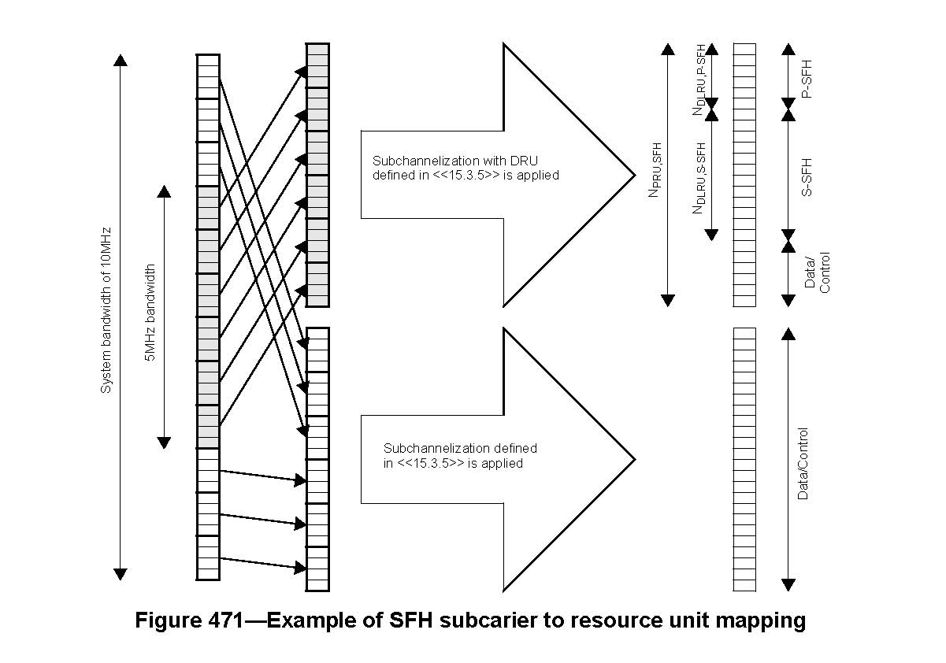

[ ------ Recommended AWD Text Proposal #2 (page 184, line 1) ------]

The PRUs in the SFH frequency partition uses the 2 stream pilot pattern defined in <<15.3.5>>. The PRUs in the SFH frequency partition are permuted to generate N_{PRU,SFH} distributed LRUs.

All PRUs in the SFH subframe have the 2 stream pilot pattern defined in <<15.3.5>> and are permuted to generate distributed LRUs. SHF occupies the first N_{DLRU,SFH} distributed LRUs in the subframe where N_{DLRU,SFH} is no more than 24. The remaining distributed LRUs in the subframe are used for other control and data transmission.
------------------------------- End Text Proposal ---------------------------------------------------

