Project | IEEE 802.16 Broadband Wireless Access Working Group <http://ieee802.org/16>
Title | AWD-15.2.17 On Multiple Paging Groups
Date Submitted | 2009-07-06
Source(s) | Baowei Ji, Zhouyue Pi, Ying Li  Samsung Telecommunication America  Hyunjeong Kang, Jungje Son  Samsung Electronics Co., Ltd.  Anshuman Nigam  Samsung India Software Operation | bji@sta.samsung.com  +1-972-761-7167
Re: | 802.16m AWD: IEEE 802.16m-09/0028r1, “Call for Comments and Contributions on Project 802.16m Amendment Content”
Abstract | To extend the primary-secondary PA design in order to cover various paging scenarios.
Purpose | To be discussed and adopted by TGm for 802.16m amendment working document (AWD)
Notice | This document does not represent the agreed views of the IEEE 802.16 Working Group or any of its subgroups. It represents only the views of the participants listed in the “Source(s)” field above. It is offered as a basis for discussion. It is not binding on the contributor(s), who reserve(s) the right to add, amend or withdraw material contained herein.
Release | The contributor grants a free, irrevocable license to the IEEE to incorporate material contained in this contribution, and any modifications thereof, in the creation of an IEEE Standards publication; to copyright in the IEEE’s name any IEEE Standards publication even though it may include portions of this contribution; and at the IEEE’s sole discretion to permit others to reproduce in whole or in part the resulting IEEE Standards publication. The contributor also acknowledges and accepts that this contribution may be made public by IEEE 802.16.
Patent Policy | The contributor is familiar with the IEEE-SA Patent Policy and Procedures:  <http://standards.ieee.org/guides/bylaws/sect6-7.html#6> and <http://standards.ieee.org/guides/opman/sect6.html#6.3>.  Further information is located at <http://standards.ieee.org/board/pat/pat-material.html> and <http://standards.ieee.org/board/pat>.

On Multiple Paging Groups
Baowei Ji, Zhouyue Pi, Ying Li, Hyunjeong Kang, Jungje Son, Anshuman Nigam
Samsung Electronics

- Introduction
The AWD text regarding the primary-secondary paging scheme allows the network to page an AMS in a staggering manner: first paging in the primary-PA, if no response, then paging in the secondary-PA. Therefore, as shown in Figure 1, the distance between two adjacent paging offset should be long enough so that the MS paged in the first paging offset can inform the network before the start of the next paging message at the next paging offset in the same paging cycle so that the network avoids unnecessary paging the MS.
Figure 1. A proper distance between two consecutive paging offset within one paging cycle

The AWD text includes the primary-secondary paging scheme. However, it is arguable why one of the paging groups should be primary. It is arguable also why an AMS is assigned only one primary and one secondary paging area ---actually it does not specify how an AMS behaves if the current ABS carries two secondary PG-IDs that have been assigned to the AMS.

To make the thing even worse, as illustrated in Figure 2, an extra paging delay could be incurred if the paging offsets of the primary and secondary PAs are not well configured.

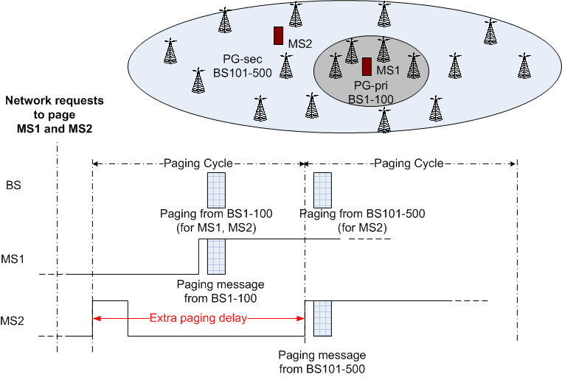
Figure 2. A proper distance between two consecutive paging offset within one paging cycle

- Suggested proposal
We propose:
- The distance between two adjacent paging offset should be long enough so that the AMS paged in the first paging offset can inform the network before the next paging offset in the same paging cycle so that the network avoids unnecessary paging the AMS.
- To support the following scenarios
  - One primary-PA and one secondary-PA
  - One primary-PA and multiple secondary-PAs
  - Multiple secondary-PAs without a primary-PA
- The AMS monitors only one PG-ID at any time.
- If it detects multiple assigned PG-IDs broadcast by the current ABS, the AMS monitors the shortest paging offset, and the network pages an AMS in the increasing order of paging offsets.
Take the case in Figure 3 as an example, MS1 is assigned PG ID_1 and PG ID_3. When MS1 moves into the coverage of BS1-100 (paging group 1) and during all the time it is in this coverage, MS1 monitors only PG ID_1 because all the BSs (i.e., BS1-100) in this paging group carries two PG IDs and PG ID_1 has the shorter paging offset. When MS1 leaves paging group 1 and moves into the coverage of BS101-500, it monitors only PG ID_3 no matter it is in PG_2 or PG_3 because it has not been assigned PG ID_2.
The situation for MS2 is similar. MS2 is assigned PG ID_2 and PG ID_3. When MS2 moves into the coverage of BS101-200 (paging group 2) and during all the time it is in this coverage, MS2 monitors only PG ID_2 because all the BSs (i.e., BS101-200) in this paging group carries two PG IDs and PG ID_2 has the shorter paging offset. When MS2 leaves paging group 2 and moves into the coverage of BS1-100 and BS201-500, it monitors only PG ID_3 no matter it is in PG_1 or PG_3 because it has not been assigned PG ID_1. Note that both PG ID_1 and PG ID_2 can use the same paging offset because their coverage are not overlapped.
MS3 is assigned only PG ID_3, and as shown in the bottom of Error: Reference source not found, it monitors only this PD ID no matter it is in PG_1, PG_2, or PG_3.

Figure 3. An AMS monitoring the paging message at the shortest paging offset

The network conducts paging through groups of BSs in the order of increased paging offsets until either the MS has successfully responded to the paging, or all the paging groups have been exhausted in the current paging cycle. In which case, the paging will restart in the next paging cycle.

- Text to change in AWD

------------------------------- Text Start ---------------------------------------------------

[Page 94, line 37, Section 15.2.17]
15.2.17 Idle mode
An ABS may be a member of one or more paging groups that may have different cycle and offset. When AMS operating in legacy mode select the mixed ABS as a preferred ABS, AMS may stay in the Lzone and perform the legacy Idle Mode operation. If an idle mode AMS in the Lzone of a mixed mode ABS decides to move to the Mzone of the ABS, in which case the AMS shall perform location update. When an AMS is paged in the Lzone of a mixed mode ABS, the AMS shall perform the network re-entry in the LZone of the ABS and may switch to the MZone of the ABS.
An AMS may be assigned one or more paging groups. If an AMS has multiple paging groups, it may be assigned multiple paging offsets within a paging cycle. The distance between two adjacent paging offset should be long enough so that the MS paged in the first paging offset can inform the network before the next paging offset in the same paging cycle so that the network avoids unnecessary paging the MS in the next paging offset. The AMS is not required to perform location update when it moves within its assigned paging groups. The assignment of multiple paging offsets to an AMS allows the AMS to monitor paging message at different paging offset when the AMS is located in one of its paging groups. The AMS is required to monitor only one paging offset at each paging cycle.
When an AMS is assigned to more than one paging groups, one of the MS’s paging groups is may be called primary paging group and rest of the assigned paging group is called secondary paging group. Otherwise, all the paging groups are called secondary paging group. When an AMS is assigned to one paging group, the paging group is considered as a primary paging group.
When multiple paging offsets are assigned to AMS, those paging offsets shall be associated with either the primary or secondary paging groups. An ABS may carry multiple PG IDs. If the current ABS carries the primary PG ID, AMS in the primary paging group shall monitor the paging message transmitted at the associated paging offset associated with the primary PG ID. If the current ABS does not carry the primary PG ID but carry multiple secondary PG IDs, the AMS shall monitor the paging message transmitted at the shortest paging offset. If the current ABS carries only one PG ID, If AMS leaves the primary paging group and enters a secondary paging group, AMS shall monitor the paging message at the paging offset associated with the PG IDsecondary paging group.

[Page 102, line 23, Section 15.2.17.4.1.1]
15.2.17.4.1.1 Paging group based update
An AMS shall perform Location Update process when an AMS detects a change in the paging groups. The AMS shall detect the change of the paging groups by monitoring the PG IDs, which are transmitted in the PGID information by the preferred ABS during the paging listening interval. If none of the PG ID(s), to which the AMS belongs, is detected, the AMS shall determine that the paging group(s) has changed.
ABSs and Idle Mode AMSs may belong to multiple paging groups. In case an AMS belongs to multiple paging groups and there is a primary paging group assigned and a Paging Group Location Update Timer is given, it starts Paging Group Location Update Timer (PG_LU_TIMER) when it leaves the primary paging group. An AMS performs the paging group location update after when PG_LU_TIMER expires and the AMS has not returned to its primary paging group. and may inform its mobility (slow, medium, fast) to ABS. Based on the AMS mobility information, the ABS may assign new paging group(s) of different size(s) to AMS.
If the AMS returns to the primary paging group before the expiration of PG_LU_TIMER, it releases the timer and does not perform location update.

------------------------------- Text End ---------------------------------------------------

