Project | IEEE 802.16 Broadband Wireless Access Working Group <http://ieee802.org/16>
Title | Corrections to Tables 700 and 701 (DL 8Tx codebook)
Date Submitted | 2009-07-06
Source(s) | David Mazzarese, Hokyu Choi, Heewon Kang  Samsung Electronics | d.mazzarese@samsung.com  *<http://standards.ieee.org/faqs/affiliationFAQ.html>
Re: | Category: AWD comments / Area: Chapter 15.3.7 (DL-MIMO)
Abstract | Implementation issue relative to comment 286 in database 80216m-09_0023r3, where contribution C80216m-09/0944r1 was accepted.
Purpose | To be discussed and adopted by TGm for the 802.16m amendment
Notice | This document does not represent the agreed views of the IEEE 802.16 Working Group or any of its subgroups. It represents only the views of the participants listed in the “Source(s)” field above. It is offered as a basis for discussion. It is not binding on the contributor(s), who reserve(s) the right to add, amend or withdraw material contained herein.
Release | The contributor grants a free, irrevocable license to the IEEE to incorporate material contained in this contribution, and any modifications thereof, in the creation of an IEEE Standards publication; to copyright in the IEEE’s name any IEEE Standards publication even though it may include portions of this contribution; and at the IEEE’s sole discretion to permit others to reproduce in whole or in part the resulting IEEE Standards publication. The contributor also acknowledges and accepts that this contribution may be made public by IEEE 802.16.
Patent Policy | The contributor is familiar with the IEEE-SA Patent Policy and Procedures:  <http://standards.ieee.org/guides/bylaws/sect6-7.html#6> and <http://standards.ieee.org/guides/opman/sect6.html#6.3>.  Further information is located at <http://standards.ieee.org/board/pat/pat-material.html> and <http://standards.ieee.org/board/pat>.

Corrections to Tables 700 and 701 (DL 8Tx codebook)
David Mazzarese et Al.
Samsung Electronics

Introduction
This is an editorial implementation issue relative to comment 286 in database 80216m-09_0023r3, where contribution C80216m-09/0944r1 was accepted.

The text proposed below reflects the changes of C80216m-09/0944r1 that were not correctly implemented in section “15.3.7.2.6.6.2.3 Base codebook for eight transmit antennas”. Minor editorial changes have been made to the text originally accepted in C80216m-09/0944r1.

References
[1] IEEE 802.16m-09/0010r2, “IEEE 802.16m Amendment Working Document (AWD)”, 2009-06-31.
[2] IEEE 802.16m-07/002r8, “802.16m System Requirements”, 2009-01-15.
[3] IEEE 802.16m-08/003r9a, “The Draft IEEE 802.16m System Description Document”, 2009-05-31.
[4] IEEE 802.16m-08/004r5, “The IEEE 802.16m Evaluation Methodology Document”, 2009-01-15.
[5] IEEE 802.16m-08/043, “Style guide for writing the IEEE 802.16m amendment”, 2008-09-18.

Text proposal for inclusion in the 802.16m amendment

<Modify section “15.3.7.2.6.6.2.3 Base codebook for eight transmit antennas” on line 53 page 252 as follows>
------------------------------- Text Start ---------------------------------------------------
15.3.7.2.6.6.2.3 Base codebook for eight transmit antennas
15.3.7.2.6.6.2.3.1 SU-MIMO base codebook
The base codebook is constructed from two matrices V8(:,:,1) and V8(:,:,2), which are constructed as described below.
Define
(1)
(2)
The two rank-8 matrices used for rank-2 to rank-8 transmission for SU-MIMO are

(3)
(4)

The third base matrix, V8(:,:,3), is used for rank-1 transmission for MU-MIMO. The j-th column vector of the base matrix V8(:,:,3) is given by
where the set θ_{j}, j=1,...,16, is given by
The 4bits 8Tx base codebook is constructed from the three 8×8 base matrices and is specified in Table 700 and Table . Note that only the column indices of the corresponding base matrices are shown in Table 7 for brevity.

Table 700 – Rank 1 of SU MIMO 4bit 8Tx base codebook
Codebook Matrix Index (CMI) | Base Matrix | C(8,1,4)
1 | V8(:,:,3) | V8(:,1,3)
2 | V8(:,:,3) | V8(:,2,3)
3 | V8(:,:,3) | V8(:,3,3)
4 | V8(:,:,3) | V8(:,4,3)
5 | V8(:,:,3) | V8(:,5,3)
6 | V8(:,:,3) | V8(:,6,3)
7 | V8(:,:,3) | V8(:,7,3)
8 | V8(:,:,3) | V8(:,8,3)
9 | V8(:,:,3) | V8(:,9,3)
10 | V8(:,:,3) | V8(:,10,3)
11 | V8(:,:,3) | V8(:,11,3)
12 | V8(:,:,3) | V8(:,12,3)
13 | V8(:,:,3) | V8(:,13,3)
14 | V8(:,:,3) | V8(:,14,3)
15 | V8(:,:,3) | V8(:,15,3)
16 | V8(:,:,3) | V8(:,16,3)

The base codebooks of SU-MIMO with eight transmit antennas consist of rank-1 codebook C(8,1,4), rank-2 codebook C(8,2,4), rank-3 codebook C(8,3,4), rank-4 codebook C(8,4,4), rank-5 codebook C(8,5,4), rank-6 codebook C(8,6,4), rank-7 codebook C(8,7,4) and rank-8 codebook C(8,8,4). Table 700 illustrates the rank-1 base codebook, and Table 701 illustrates the ranks 2,3,4,5,6,7,8 base codebooks.
Table 700 – C(8,1,4)
Binary Index | m
Binary Index | m | c₁ | c₂ | c₃ | c₄ | c₅ | c₆ | c₇ | c₈
0000 | 0 | 0.3536 | -0.3051 - 0.1786i | 0.1732 + 0.3082i | 0.0062 - 0.3535i | -0.1839 + 0.3020i | 0.3112 - 0.1677i | -0.3533 - 0.0124i | 0.2987 + 0.1892i
0001 | 1 | 0.3536 | -0.2514 - 0.2486i | 0.0041 + 0.3535i | 0.2456 - 0.2543i | -0.3535 + 0.0082i | 0.2571 + 0.2427i | -0.0123 - 0.3533i | -0.2397 + 0.2599i
0010 | 2 | 0.3536 | -0.1697 - 0.3102i | -0.1907 + 0.2977i | 0.3527 + 0.0244i | -0.1479 - 0.3211i | -0.2107 + 0.2839i | 0.3502 + 0.0486i | -0.1254 - 0.3306i
0011 | 3 | 0.3536 | -0.0614 - 0.3482i | -0.3322 + 0.1210i | 0.1768 + 0.3062i | 0.2708 - 0.2273i | -0.2709 - 0.2272i | -0.1767 + 0.3062i | 0.3323 + 0.1208i
0100 | 4 | 0.3536 | 0.0638 - 0.3478i | -0.3306 - 0.1254i | -0.1830 + 0.3025i | 0.2646 + 0.2345i | 0.2784 - 0.2180i | -0.1642 - 0.3131i | -0.3376 + 0.1050i
0101 | 5 | 0.3536 | 0.1881 - 0.2994i | -0.1534 - 0.3185i | -0.3513 - 0.0395i | -0.2204 + 0.2764i | 0.1168 + 0.3337i | 0.3447 + 0.0786i | 0.2499 - 0.2501i
0110 | 6 | 0.3536 | 0.2892 - 0.2034i | 0.1196 - 0.3327i | -0.0936 - 0.3409i | -0.2727 - 0.2251i | -0.3525 - 0.0272i | -0.3040 + 0.1805i | -0.1449 + 0.3225i
0111 | 7 | 0.3536 | 0.3461 - 0.0721i | 0.3241 - 0.1412i | 0.2885 - 0.2044i | 0.2407 - 0.2590i | 0.1828 - 0.3026i | 0.1172 - 0.3336i | 0.0467 - 0.3505i
1000 | 8 | 0.3536 | 0.3461 + 0.0721i | 0.3241 + 0.1412i | 0.2885 + 0.2044i | 0.2407 + 0.2590i | 0.1828 + 0.3026i | 0.1172 + 0.3336i | 0.0467 + 0.3505i
1001 | 9 | 0.3536 | 0.2892 + 0.2034i | 0.1196 + 0.3327i | -0.0936 + 0.3409i | -0.2727 + 0.2251i | -0.3525 + 0.0272i | -0.3040 - 0.1805i | -0.1449 - 0.3225i
1010 | 10 | 0.3536 | 0.1881 + 0.2994i | -0.1534 + 0.3185i | -0.3513 + 0.0395i | -0.2204 - 0.2764i | 0.1168 - 0.3337i | 0.3447 - 0.0786i | 0.2499 + 0.2501i
1011 | 11 | 0.3536 | 0.0638 + 0.3478i | -0.3306 + 0.1254i | -0.1830 - 0.3025i | 0.2646 - 0.2345i | 0.2784 + 0.2180i | -0.1642 + 0.3131i | -0.3376 - 0.1050i
1100 | 12 | 0.3536 | -0.0614 + 0.3482i | -0.3322 - 0.1210i | 0.1768 - 0.3062i | 0.2708 + 0.2273i | -0.2709 + 0.2272i | -0.1767 - 0.3062i | 0.3323 - 0.1208i
1101 | 13 | 0.3536 | -0.1697 + 0.3102i | -0.1907 - 0.2977i | 0.3527 - 0.0244i | -0.1479 + 0.3211i | -0.2107 - 0.2839i | 0.3502 - 0.0486i | -0.1254 + 0.3306i
1110 | 14 | 0.3536 | -0.2514 + 0.2486i | 0.0041 - 0.3535i | 0.2456 + 0.2543i | -0.3535 - 0.0082i | 0.2571 - 0.2427i | -0.0123 + 0.3533i | -0.2397 - 0.2599i
1111 | 15 | 0.3536 | -0.3051 + 0.1786i | 0.1732 - 0.3082i | 0.0062 + 0.3535i | -0.1839 - 0.3020i | 0.3112 + 0.1677i | -0.3533 + 0.0124i | 0.2987 - 0.1892i

The two rank-8 matrices used for rank-2 to rank-8 transmission for SU-MIMO are
The 4bits 8Tx base codebook for ranks 2 to 8 is constructed from the two 8×8 base matrices and is specified in Table 701. Note that only the column indices of the corresponding base matrices are shown in Table 701 for brevity.

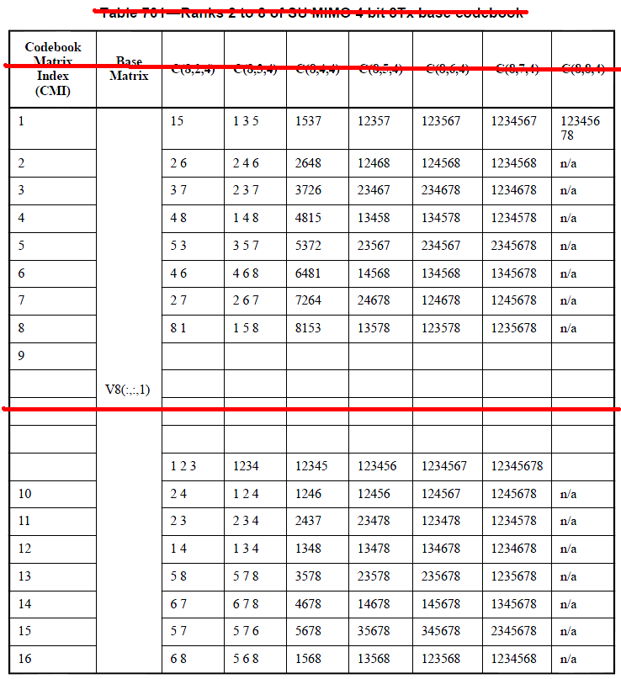

Table 701 – Ranks 2 to 8 of SU MIMO 4bit 8Tx base codebook
Codebook Matrix Index (CMI) | Base Matrix | C(8,2,4) | C(8,3,4) | C(8,4,4) | C(8,5,4) | C(8,6,4) | C(8,7,4) | C(8,8,4)
0 |  | 1 5 | 1 3 5 | 1537 | 12357 | 123567 | 1234567 | 12345678
1 |  | 2 6 | 2 4 6 | 2648 | 12468 | 124568 | 1234568 | n/a
2 |  | 3 7 | 2 3 7 | 3726 | 23467 | 234678 | 1234678 | n/a
3 |  | 4 8 | 1 4 8 | 4815 | 13458 | 134578 | 1234578 | n/a
4 |  | 5 3 | 3 5 7 | 5372 | 23567 | 234567 | 2345678 | n/a
5 |  | 4 6 | 4 6 8 | 6481 | 14568 | 134568 | 1345678 | n/a
6 |  | 2 7 | 2 6 7 | 7264 | 24678 | 124678 | 1245678 | n/a
7 |  | 8 1 | 1 5 8 | 8153 | 13578 | 123578 | 1235678 | n/a
8 |  | 1 3 | 1 2 3 | 1234 | 12345 | 123456 | 1234567 | 12345678
9 |  | 2 4 | 1 2 4 | 1246 | 12456 | 124567 | 1245678 | n/a
10 |  | 2 3 | 2 3 4 | 2437 | 23478 | 123478 | 1234578 | n/a
11 |  | 1 4 | 1 3 4 | 1348 | 13478 | 134678 | 1234678 | n/a
12 |  | 5 8 | 5 7 8 | 3578 | 23578 | 235678 | 1235678 | n/a
13 |  | 6 7 | 6 7 8 | 4678 | 14678 | 145678 | 1345678 | n/a
14 |  | 5 7 | 5 7 6 | 5678 | 35678 | 345678 | 2345678 | n/a
15 |  | 6 8 | 5 6 8 | 1568 | 13568 | 123568 | 1234568 | n/a

The indexes from 1 to 7 and 8 to 15 are not used in 4-bits downlink PMI feedback for M_{t} =8 codebook.

------------------------------- Text End ---------------------------------------------------

