Project | IEEE 802.16 Broadband Wireless Access Working Group <http://ieee802.org/16>
Title | Scanning overhead reduction based on RSSI profiles
Date Submitted | 2009-07-06
Source(s) | Byung Moo Lee, Young Chul Oh,  Jeong-Hwi Kim and Jong-Sik Lee  KT  Sung-Yeop Pyun, Jung-Min Moon and  Dong-Ho Cho  KAIST  Howon Lee, Min Suk Kang  and Bang Chul Jung  KI ITC | E-mail: blee@kt.com  E-mail: psy83@comis.kaist.ac.kr  E-mail: bcjung@kaist.ac.kr
Re: | IEEE 80216m-09_0028r1 Call for contributions on Project 802.16m- “Support for Femtocell BS” in 802.16m amendment working document
Abstract | This contribution proposes IEEE 802.16m AWD on femtocell scanning
Purpose | Proposed to be discussed and adopted by TGm for the 802.16m AWD
Notice | This document does not represent the agreed views of the IEEE 802.16 Working Group or any of its subgroups. It represents only the views of the participants listed in the “Source(s)” field above. It is offered as a basis for discussion. It is not binding on the contributor(s), who reserve(s) the right to activate, amend or withdraw material contained herein.
Release | The contributor grants a free, irrevocable license to the IEEE to incorporate material contained in this contribution, and any modifications thereof, in the creation of an IEEE Standards publication; to copyright in the IEEE’s name any IEEE Standards publication even though it may include portions of this contribution; and at the IEEE’s sole discretion to permit others to reproduce in whole or in part the resulting IEEE Standards publication. The contributor also acknowledges and accepts that this contribution may be made public by IEEE 802.16.
Patent Policy | The contributor is familiar with the IEEE-SA Patent Policy and Procedures:  <http://standards.ieee.org/guides/bylaws/sect6-7.html#6> and <http://standards.ieee.org/guides/opman/sect6.html#6.3>.  Further information is located at <http://standards.ieee.org/board/pat/pat-material.html> and <http://standards.ieee.org/board/pat>.
Scanning overhead reduction based on RSSI profiles
Byung Moo Lee, Young Chul Oh, Jeong-Hwi Kim and Jong-Sik Lee
KT
Sung-Yeop Pyun, Jung-Min Moon and Dong-Ho Cho
KAIST
Howon Lee, Min Suk Kang and Bang Chul Jung
KI ITC

Problem definition
In the operation of MS, there are still plenty of procedures which makes MS keep consuming its power prior being served by accessible femtocells. Figure 1 shows the scanning and handover procedures of MS from macrocell to femtocell. One of the procedures is scanning procedure to provide the opportunity for the MS to perform measurement and obtain necessary system configuration information of the neighboring cells for handover decision. A BS may allocate time intervals to MS for the purpose of MS seeking and monitoring suitability of neighboring femtocell BSs as targets for handover. The MS performs scanning operations during the allocated time intervals as a scanning mode whereas the MS returns to the normal operation mode after the allocated timer interval for scanning operations [1]. To detect accessible femtocell which uses the same or different frequency with the overlay macro BS, the MS may keep scanning for the frequency the femtocell uses and prepare for handover from macro BS to femtocell until the femtocell is found. This scanning operation will waste battery power and hence it is need to minimize unnecessary scanning operations for accessible femtocell.

Figure 1 Scanning and handover procedures to femtocells
A conventional scheme, macrocell ID fingerprint method, uses neighboring macro cell relations for triggering the scanning for accessible femtocell [2]. When a femtocell is installed, it measures neighboring macrocells and records the receivable macro BS IDs as a reference set. The reference set is given to MS. Only when the measured set of macro BS IDs in MS is matched with the reference set, the scanning procedure of MS is triggered for the femtocell. It is recommended as the practical method in 3GPP, but scanning time for the femtocell is still large.

Proposed method
In case that there is no available location information (e.g, GPS), RSSI profile of neighboring macro BSs can be used to narrow down the expected scanning area for an accessible femtocell and reduce unnecessary scanning trials for the femtocell. In order to trigger the scanning of MS when the MS is close enough to detect the femtocell, the MS shall keep measuring RSSI of neighboring macro BSs. The measured RSSIs of a neighboring macro BSs are averaged out against the fluctuating signal variance. Corresponding to RSSI of neighboring macro BSs, each RSSI can be categorized into one of separate RSSI levels as shown in Fig.2 and stored as an RSSI profile of MS. In the same way, a femtocell BS also has its unique RSSI profile, which is used to distinguish from locations of other femtocells . The RSSI profile of femtocell BS is defined as reference RSSI profile.
Figure 2 Example of RSSI levels

The proposed scanning method can be described as follows. Once femtocell is installed, the femtocell measures RSSI of neighboring macro BSs with support of MS. Depending on RSSI of neighboring macro BSs, each RSSI can be categorized into one of divided RSSI levels as a pattern. Categorized RSSI levels of neighboring macro BSs at the femtocell can be stored as the reference RSSI profile and used to trigger scanning of MS for the femtocell. Table 1 shows the example of reference RSSI profile which contains RSSI level of neighboring macro BSs. There are four neighboring macro BSs and A, B, C and D are BS ID of neighboring macro BSs.
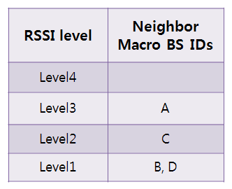
Table 1 Example of the RSSI profile of femtocell BS (reference RSSI profile)
The network provides a scanning profile indication message which contains carrier frequency of the femtocell BS, femtocell BS ID, and the reference RSSI profile to MSs for supporting handover between a macro BS and a femtocell BS (CSG/OGS femtocell BS). In case of CSG femtocell BS, the scanning profile indication message is transferred to MS when the MS which is member of the CSG is initialized. In case of OSG femtocell BS, the macro BSs may unicast or broadcast the scanning profile indication message to MS for scanning of OSG Femtocell BS. An MS may cache this profile indication message for future scanning and handover to the specific Femtocell BS. The format of the scanning profiles indication is shown in Table 3

Table 2 Scanning profile indication format
Syntax | Size | Notes
Scanning Indication () {
Femtocell type | 2 | 00:CSG, 01:OSG
Carrier frequency of femtocell BS | 8 | FA index of femtocell BS
Femtocell BS ID | 24
Number of profiles levels | 8 | The number of RSSI profiles levels(=N)
Maximal number of macro BSs | 8 | The maximal number of macro BSs which are included in a single level
For(j=0;j<Number of levels;j++){
For(i=0;i<Number of macro BSs;i++){
Neighbor BSID | 24 | macro BS ID which is determined as a specific level
}
}

After receiving the scanning profiles indication message, MS may keep measuring the current RSSI profile by sensing the RSSI of neighboring macro BSs and compares it with the reference RSSI profile of accessible femtocell. Table 3 shows the current RSSI profile of MS according to the time t=1, 2 and 3. If the similarity between the current RSSI profile and reference RSSI profile is larger than certain threshold level, the scanning operations for the femtocell is started by exchanging scanning request and response messages between the MS and serving macrocell. Let assume that the similarity of profiles is larger the threshold level only when t =3. If so, the scanning operation of MS for the femtocell is not performed during t=1. and 2. Once t=3, the scanning operation is started. Figure 3 shows the procedure of proposed scanning method.

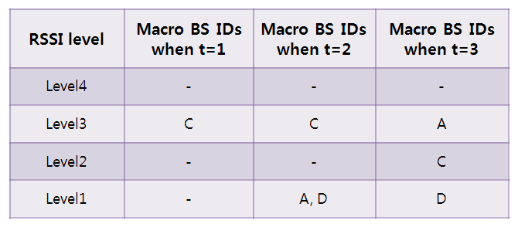
Table 3 Example of the RSSI profile of macro BSs
The followings are the main advantages of the proposed scheme. The scanning area for femtocell can be decreased by using the RSSI profiles which represent the RSSI levels from neighboring macro BSs. Accordingly, scanning time for the fetmto cell is shortened, and then power usage on scanning operations can be saved.

Figure 3 procedure of proposed scanning method

Simulation results
For evaluation of proposed scanning method, we adopt the average scanning area (ASA) as a major performance metric. This metric means scanning area in average on the condition that MS approaches the designated femtocell from macrocell. ASA is directly related to power usage on scanning of MS. The simulation parameters are shown in Table 3 [3]. Also, Fig.3 shows the simulation environment. The interval between macro BSs is 1.5 km. The radius of macro BS coverage is 1.3km. There is a single femtocell and a single MS in the simulation.

Parameter | Setting
Receivable RSSI ranges of macro BSs | -88.5~46 dBm
Standard deviation of log-normal fading | 8 dB
Pathloss model for 2.5GHz
RSSI levels for division | 2~4
Interval between macro BSs | 1.5 km
Radius of macro BS coverage | 1.3 km
Distance between the femtocell and macrocell | 400m and 700m
Table 4 Simulation parameters
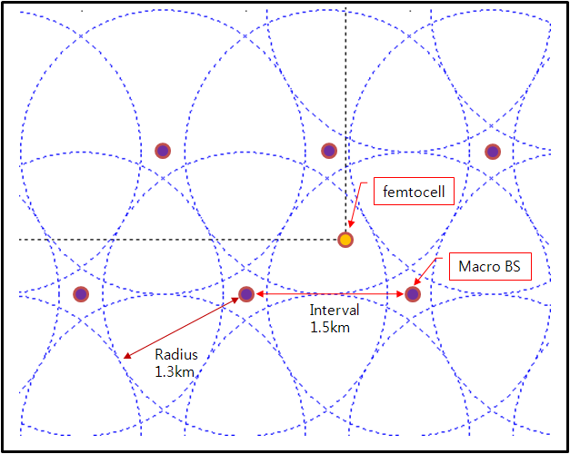
Figure 3 Basic settings of simulation environement
As shown in Fig.4.(a)~(d), the location of a femtocell with crossing horizontal and vertical lines is represented by a single point within the serving macro BS. In Fig. 4. (a)-(b), the scanning area to trigger scanning operation has been estimated when a femtocell is located at 400 m away from the center of the serving macro BS. The scanning area of the conventional scheme is much larger than that of the proposed scheme with 4 RSSI levels although the femtocell is located near to the serving macro BS.

In Fig. 4. (c)-(d), the scanning areas to trigger scanning operations are estimated for the proposed scheme with 2 RSSI levels and conventional scheme when the femtocell is located at 700m away from the center of the serving macro BS. Because the distance between the femtocell and macrocell is larger, the scanning area for the proposed scheme is larger. However, the scanning area is still smaller than that of the conventional scheme. The scanning area of the conventional scheme is still large regardless of the femtocell location.

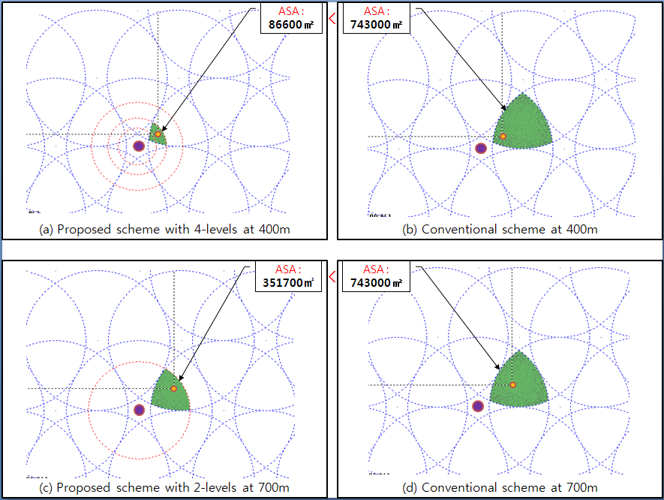
Figure 4 Simulation results of conventional and proposed scheme

References
[1] IEEE Std 802.16e, “Part16: Air Interface for Fixed and Mobile Broadband Wireless Access Systems”, pp.234-235, Feb. 2006.
[2] 3GPP TS23.271, release 7(v7.2.0), Functional Stage 2 Description of Location Services(LCS), Sep. 2005.
[3] IEEE 802.16m-08/004, “Project 802.16m Evaluation Methodology Document”, pp.35-42, Jul. 2008.

Text Proposal for the IEEE 802.16m
============================== Start of Proposed Text =================================

x.1 MAC HO procedures section

15.2.6.1.x Scanning operation for femtocells using RSSI profiles
In order to trigger the scanning of MS when the MS is close enough to detect the femtocell, the MS shall keep measuring RSSI of neighboring macro BSs. The measured RSSIs of a neighboring macro BSs are averaged out against the fluctuating signal variance. Corresponding to RSSI of neighboring macro BSs, each RSSI can be categorized into one of separate RSSI levels as shown in Fig.x.1 and stored as an RSSI profile of MS. In the same way, a femtocell BS also has its unique RSSI profile, which is used to distinguish from locations of other femtocells . The RSSI profile of femtocell BS is defined as reference RSSI profile.
Figure x.1 Example of RSSI levels

Once femtocell is installed, the femtocell measures RSSI of neighboring macro BSs with support of MS. Depending on RSSI of neighboring macro BSs, each RSSI can be categorized into one of divided RSSI levels as shown in Table x.1. Categorized RSSI levels of neighboring macro BSs at the femtocell can be stored as the reference RSSI profile and used to trigger scanning of MS for the femtocell.

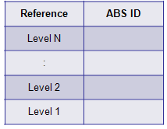
Table x.1 example of RSSI profile
The network provides a scanning profile indication message which contains carrier frequency of the femtocell BS, femtocell BS ID, and the reference RSSI profile to MSs for supporting handover between a macro BS and a femtocell BS (CSG/OGS femtocell BS). In case of CSG femtocell BS, the scanning profile indication message is transferred when the MS which is member of the CSG is initialized. In case of OSG femtocell BS, the macro BSs may unicast or broadcast the scanning profile indication message to MS for scanning of OSG Femtocell BS. An MS may cache this profile indication message for future scanning and handover to the specific Femtocell BS. The format of the scanning profile indication is shown in Table x.2

Table x.2 Scanning profile indication format
Syntax | Size | Notes
Scanning Indication () {
Femtocell type | 2 | 00:CSG, 01:OSG
Carrier frequency of femtocell BS | 8 | FA index of femtocell BS
Femtocell BS ID | 24
Number of profiles levels | 8 | The number of RSSI profiles levels(=N)
Maximal number of macro BSs | 8 | The maximal number of macro BSs which are included in a single level
For(j=0;j<Number of levels;j++){
For(i=0;i<Number of macro BSs;i++){
Neighbor BSID | 24 | macro BS ID which is determined as a specific level
}
}

After receiving the scanning profile indication message, MS may keep measuring the current RSSI profile by sensing the RSSI of neighboring macro BSs and compares it with the reference RSSI profile of accessible femtocell. If the similarity between the current RSSI profile and reference RSSI profile is larger than certain threshold level, the scanning operations for the femtocell is started by exchanging scanning request and response messages between the MS and serving macrocell. Figure x.2 shows the procedure of proposed scanning method.

Figure x.2 procedure of proposed scanning method

============================== End of Proposed Text =================================

