Project | IEEE 802.16 Broadband Wireless Access Working Group <http://ieee802.org/16>
Title | Scanning overhead reduction based on RSSI profiles
Date Submitted | 2009-07-14
Source(s) | Byung Moo Lee, Young Chul Oh,  Jeong-Hwi Kim and Jong-Sik Lee  KT  Sung-Yeop Pyun, Jung-Min Moon and  Dong-Ho Cho  KAIST  Howon Lee, Min Suk Kang  and Bang Chul Jung  KI ITC | E-mail: blee@kt.com  E-mail: psy83@comis.kaist.ac.kr  E-mail: bcjung@kaist.ac.kr
Re: | IEEE 80216m-09_0028r1 Call for contributions on Project 802.16m- “Support for Femtocell BS” in 802.16m amendment working document
Abstract | This contribution proposes IEEE 802.16m AWD on femtocell scanning
Purpose | Proposed to be discussed and adopted by TGm for the 802.16 AWD
Notice | This document does not represent the agreed views of the IEEE 802.16 Working Group or any of its subgroups. It represents only the views of the participants listed in the “Source(s)” field above. It is offered as a basis for discussion. It is not binding on the contributor(s), who reserve(s) the right to activate, amend or withdraw material contained herein.
Release | The contributor grants a free, irrevocable license to the IEEE to incorporate material contained in this contribution, and any modifications thereof, in the creation of an IEEE Standards publication; to copyright in the IEEE’s name any IEEE Standards publication even though it may include portions of this contribution; and at the IEEE’s sole discretion to permit others to reproduce in whole or in part the resulting IEEE Standards publication. The contributor also acknowledges and accepts that this contribution may be made public by IEEE 802.16.
Patent Policy | The contributor is familiar with the IEEE-SA Patent Policy and Procedures:  <http://standards.ieee.org/guides/bylaws/sect6-7.html#6> and <http://standards.ieee.org/guides/opman/sect6.html#6.3>.  Further information is located at <http://standards.ieee.org/board/pat/pat-material.html> and <http://standards.ieee.org/board/pat>.

Scanning overhead reduction based on RSSI profiles
Byung Moo Lee, Young Chul Oh, Jeong-Hwi Kim and Jong-Sik Lee
KT
Sung-Yeop Pyun, Jung-Min Moon and Dong-Ho Cho
KAIST
Howon Lee, Min Suk Kang and Bang Chul Jung
KI ITC

Problem definition
In the operation of an MS, there are still plenty of procedures which make the MS keep consuming its power prior to being served by accessible femtocells. One of the procedures is scanning procedure to provide the opportunity for the MS to perform measurement and obtain necessary system configuration information of the neighboring cells for handover decision. Figure 1 shows the scanning and handover procedures of MS from macrocell to femtocell.

A BS may allocate time intervals to MS for the purpose of seeking and monitoring suitability of neighboring femtocell BSs as targets for handover. The MS performs scanning operations during the allocated time intervals as a scanning mode whereas the MS returns to the normal operation mode after the allocated time interval for scanning operations [1]. To detect accessible femtocell which may use the same or different frequency with the overlay macrocell, the MS may keep scanning for the frequency the femtocell uses until the femtocell is found. This scanning operation will waste battery power and hence it is needed to minimize unnecessary scanning operations for accessible femtocell.

Figure 1 Scanning and handover procedures to femtocells
A conventional scheme, macrocell ID fingerprint method, uses the information of neighboring macrocells to triggering the scanning of MS for accessible femtocell [2]. When a femtocell is installed, it measures the signal strength of neighboring macrocells and records the received macro BS IDs as a reference set. The femtocell reports the reference set to overlay macro BS and the macro BS transmits the reference set to MS. Only when the measured macro BS IDs in MS is matched with the reference set, the scanning procedure of MS is triggered for the femtocell. Since the conventional scheme recognizes the signal strength of neighboring macrocells by on/off, the scanning area of conventional scheme for the femtocell is still large.

Proposed method
In case that there is no available location information of MS (e.g, GPS), RSSI profile of neighboring macrocells can be used to narrow down the expected scanning area for an accessible femtocell and reduce unnecessary scanning operations for the femtocell. In order to trigger the scanning of MS when the MS is close enough to detect the femtocell, the MS shall keep measuring RSSIs of neighboring macrocells. Corresponding to RSSIs of neighboring macrocells, each RSSI can be categorized into one of separate RSSI levels as shown in Figure 2 and stored as an RSSI profile of MS. In the same way, a femtocell also has its unique RSSI profile, which is used to distinguish location of the femtocell from locations of other femtocells. The RSSI profile of femtocell is defined as reference RSSI profile.
Figure 2 Example of RSSI levels
The proposed scanning method can be described as follows. Once a femtocell is installed, the femtocell measures RSSIs of neighboring macrocells. Depending on the RSSIs of neighboring macrocells, each RSSI can be categorized into one of divided RSSI levels. Categorized RSSI levels of neighboring macrocells can be stored as the reference RSSI profile at the location of the femtocell and used to trigger scanning of MS for the femtocell.

The network provides a scanning profile indication message which contains the information of accessible femtocell BS (e.g., carrier frequency, femtocell BS ID, and the reference RSSI profile) to MSs for supporting handover between a macro BS and a femtocell BS (CSG/OGS femtocell BS). In case of CSG femtocell BS, the scanning profile indication message is transferred to MS when the MS which is a member of the CSG is initialized. In case of OSG femtocell BS, the macro BS may unicast or broadcast the scanning profile indication message to MSs for scanning of OSG femtocell BS. An MS may cache this profile indication message for future scanning and handover to the specific femtocell BS. The format of the scanning profile indication is shown in Table 2
Table 2 Scanning profile indication format
Syntax | Size | Notes
Scanning Indication () {
Femtocell type | 2 | 00:CSG, 01:OSG
Carrier frequency of femtocell BS | 8 | FA index of femtocell BS
Femtocell BS ID | 24
Number of profiles levels | 8 | The number of RSSI profiles levels(=N)
Maximal number of macro BSs | 8 | The maximal number of macro BSs which are included in a single level
For(j=0;j<Number of levels;j++){
For(i=0;i<Number of macro BSs;i++){
Neighbor BSID | 24 | macro BS ID which is determined as a specific level
}
}

After receiving the scanning profile indication message, the MS may keep making the current RSSI profile by measuring RSSIs of neighboring macrocells and compares it with the reference RSSI profile of accessible femtocell. If the same macros BS IDs are existed in the same RSSI level of the current RSSI profile and the reference RSSI profile, the similarity between the current RSSI profile and the reference RSSI profile is increased. When the similarity between the current RSSI profile and the reference RSSI profile is larger than certain threshold level, the scanning operations for the femtocell is triggered by exchanging scanning request and response messages between the MS and serving macro BS. Figure 3 shows the procedure of proposed scanning method.

Figure 3 Procedure of proposed scanning method

The example scenario of proposed scanning method is illustrated as shown Figure 4. Four macrocells are deployed in a neighborhood. The BS IDs of macrocells are A, B, C and D, respectively. A femtocell is deployed in the edge of macrocell A whose BS ID is A. An MS is moving from macrocell C to macrocell A in order to scanning and handover to the femtocell according to time t=1, 2 and 3. Table 1 shows the reference RSSI profile at the location of the femtocell which contains RSSI levels of neighboring macrocells. Table 3 shows the current RSSI profile of MS when the time t=1, 2 and 3. Let assume that the similarity between the current RSSI profile and the reference RSSI profile is larger than the threshold level only when t=3. If so, the scanning operation of MS for the femtocell is not triggered when t=1 and t=2. Once t=3, the scanning operation is started for the femtocell when the MS is close enough to detect the femtocell.

The followings are the main advantages of the proposed method. The scanning area for accessible femtocell can be decreased by using the RSSI profile which represents the RSSI levels of neighboring macrocells. Accordingly, scanning time for the fetmtocell is shortened, and then power usage on scanning operations can be saved.

Figure 4 Example scenario of proposed scanning method

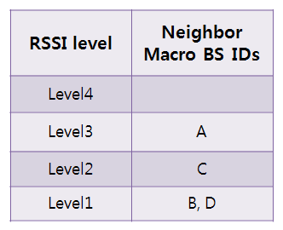
Table 1 Example of reference RSSI profile of femtocell BS
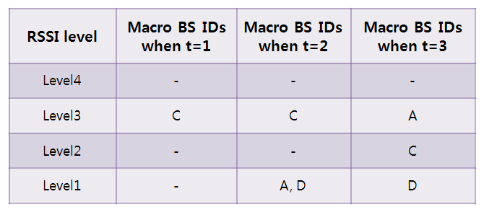
Table 3 Example of the current RSSI profile of MS

Simulation results
For evaluation of proposed scanning method, we adopt the average scanning area (ASA) of femtocell as a major performance metric. When MS is entering the ASA, the scanning operation of MS for the femtocell is triggered. ASA is directly related to power usage in case of scanning of MS. Fig.3 shows the simulation environment and the simulation parameters are shown in Table 4 [3]. The interval between macro BSs is 1.5 km and the radius of macro BS coverage is 1.3km. In the simulation, a single femtocell and a single MS are considered.

Parameter | Setting
Receivable RSSI ranges of macro BSs | -88.5~46 dBm
Standard deviation of log-normal fading | 8 dB
Pathloss model for 2.5GHz
RSSI levels for division | 2~4
Interval between macro BSs | 1.5 km
Radius of macrocell coverage | 1.3 km
Distance between the femtocell and macrocell | 400m and 700m
Table 4 Simulation parameters

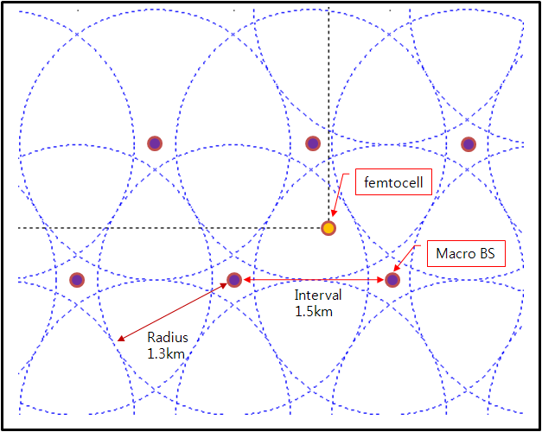
Figure 3 Basic settings of simulation environement
In Figure 4 (a)-(b), the ASA of femocell is illustrated for the conventional scheme and the proposed scheme when the femtocell is located at 400 m away from the overlay macro BS and the number of separate RSSI levels is 4. The scanning area of the conventional scheme is much larger than that of the proposed scheme although the femtocell is located near to the overlay macro BS.

In Figure 4 (c)-(d), the ASA of femocell is illustrated for the conventional scheme and the proposed scheme when the femtocell is located at 700 m away from the overlay macro BS and the number of separate RSSI levels is 2. Since the distance between the femtocell and the macro BS and the number of separate RSSI levels are increased, the ASA of the proposed scheme is also increased. However, the ASA of the proposed scheme is still smaller than that of the conventional scheme. The ASA of the conventional scheme is large regardless of the distance between the femtocell and the macro BS .

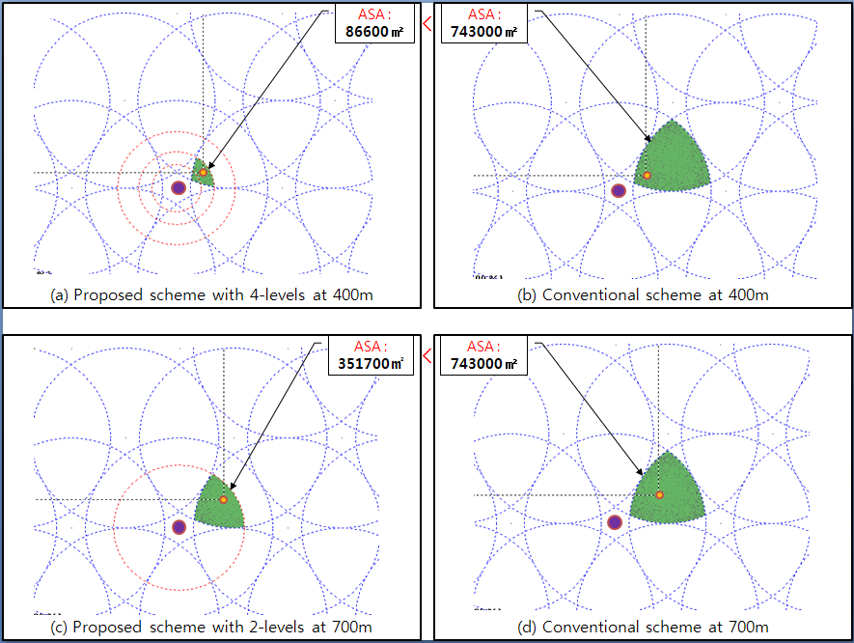
Figure 4 Simulation results of conventional and proposed scheme

References
[1] IEEE Std 802.16e, “Part16: Air Interface for Fixed and Mobile Broadband Wireless Access Systems”, pp.234-235, Feb. 2006.
[2] 3GPP TS23.271, release 7(v7.2.0), Functional Stage 2 Description of Location Services(LCS), Sep. 2005.
[3] IEEE 802.16m-08/004, “Project 802.16m Evaluation Methodology Document”, pp.35-42, Jul. 2008.

Text Proposal for the IEEE 802.16m
============================== Start of Proposed Text =================================

x.1 MAC HO procedures section

15.2.6.1.x Scanning operation for femtocells using RSSI profiles
In order to trigger the scanning of MS when the MS is close enough to detect the femtocell, the MS shall keep measuring RSSIs of neighboring macrocells. Corresponding to RSSIs of neighboring macrocells, each RSSI can be categorized into one of separate RSSI levels as shown in Fig.x.1 and stored as an RSSI profile of MS. In the same way, a femtocell also has its unique RSSI profile, which is used to distinguish location of the femtocell from locations of other femtocells. The RSSI profile of femtocell is defined as reference RSSI profile.
Figure x.1 Example of RSSI levels

Once a femtocell is installed, the femtocell measures RSSIs of neighboring macrocells. Depending on the RSSIs of neighboring macrocells, each RSSI can be categorized into one of divided RSSI levels as shown in Table x.1. Categorized RSSI levels of neighboring macrocells can be stored as the reference RSSI profile at the location of the femtocell and used to trigger scanning of MS for the femtocell.

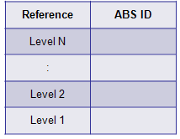
Table x.1 Example of RSSI profile
The network provides a scanning profile indication message which contains the information of accessible femtocell BS (e.g., carrier frequency, femtocell BS ID, and the reference RSSI profile) to MSs for supporting handover between a macro BS and a femtocell BS (CSG/OGS femtocell BS). In case of CSG femtocell BS, the scanning profile indication message is transferred to MS when the MS which is a member of the CSG is initialized. In case of OSG femtocell BS, the macro BS may unicast or broadcast the scanning profile indication message to MSs for scanning of OSG femtocell BS. An MS may cache this profile indication message for future scanning and handover to the specific femtocell BS. The format of the scanning profile indication is shown in Table x.2.

Table x.2 Scanning profile indication format
Syntax | Size | Notes
Scanning Indication () {
Femtocell type | 2 | 00:CSG, 01:OSG
Carrier frequency of femtocell BS | 8 | FA index of femtocell BS
Femtocell BS ID | 24
Number of profiles levels | 8 | The number of RSSI profiles levels(=N)
Maximal number of macro BSs | 8 | The maximal number of macro BSs which are included in a single level
For(j=0;j<Number of levels;j++){
For(i=0;i<Number of macro BSs;i++){
Neighbor BSID | 24 | macro BS ID which is determined as a specific level
}
}

After receiving the scanning profile indication message, the MS may keep making the current RSSI profile by measuring RSSIs of neighboring macrocells and compares it with the reference RSSI profile of accessible femtocell. When the similarity between the current RSSI profile and the reference RSSI profile is larger than certain threshold level, the scanning operations for the femtocell is triggered by exchanging scanning request and response messages between the MS and serving macro BS. Figure x.2 shows the procedure of proposed scanning method.

Figure x.2 Procedure of proposed scanning method

============================== End of Proposed Text =================================

