Project | IEEE 802.16 Broadband Wireless Access Working Group <http://ieee802.org/16>
Title | Blind scanning
Date Submitted | 2009-07-06
Source(s) | Byung Moo Lee, Do-Young Kwak,  Si Young Heo, Yongjoo Tcha,  Jong-Sik Lee, and Seong-Choon Lee  KT  Sung-Yeop Pyun, Ju-yeop Kim and  Dong-Ho Cho  KAIST  Min Suk Kang, Howon Lee and  Bang Chul Jung  KI ITC | E-mail: blee@kt.com  E-mail: psy83@comis.kaist.ac.kr  E-mail: minsuk.kang@kaist.ac.kr
Re: | IEEE 80216m-09_0028r1 Call for contributions on Project 802.16m- “Support for Femtocell BS” in 802.16m amendment working document
Abstract | This contribution proposes IEEE 802.16m AWD on blind scanning
Purpose | Proposed to be discussed and adopted by TGm for the 802.16m AWD
Notice | This document does not represent the agreed views of the IEEE 802.16 Working Group or any of its subgroups. It represents only the views of the participants listed in the “Source(s)” field above. It is offered as a basis for discussion. It is not binding on the contributor(s), who reserve(s) the right to add, amend or withdraw material contained herein.
Release | The contributor grants a free, irrevocable license to the IEEE to incorporate material contained in this contribution, and any modifications thereof, in the creation of an IEEE Standards publication; to copyright in the IEEE’s name any IEEE Standards publication even though it may include portions of this contribution; and at the IEEE’s sole discretion to permit others to reproduce in whole or in part the resulting IEEE Standards publication. The contributor also acknowledges and accepts that this contribution may be made public by IEEE 802.16.
Patent Policy | The contributor is familiar with the IEEE-SA Patent Policy and Procedures:  <http://standards.ieee.org/guides/bylaws/sect6-7.html#6> and <http://standards.ieee.org/guides/opman/sect6.html#6.3>.  Further information is located at <http://standards.ieee.org/board/pat/pat-material.html> and <http://standards.ieee.org/board/pat>.

Blind Scanning
Byung Moo Lee, Do-Young Kwak, Si Young Heo, Yongjoo Tcha,
Jong-Sik Lee, and Seong-Choon Lee
KT
Sung-Yeop Pyun, Ju-yeop Kim and Dong-Ho Cho
KAIST
Min Suk Kang, Howon Lee and Bang Chul Jung
KI ITC

Problem definition
When a handover is executed from ABS to femtocell BS, there may be a problem to find an appropriate target femtocell BS. Since the coverage of the femtocell is small, it is possible that huge numbers of femtocells are located within the coverage of ABS as shown in Fig. 1. Thus, unlike the conventional cellular systems, there may exist hundreds of candidates for the target femtocell. This may cause a serious problem, because MS should make a great effort to scan for many possible femtocells in the whole bandwidth and consume a lot of resources. This may give a significant impact on handover delay. We define scanning method from ABS to the femtocell BS as a blind scanning when there is no available information on white list, which contains the information of accessible femtocells (e.g., FA index, preamble index). Therefore, hierarchical cellular networks including femtocells need a novel scanning scheme to find the appropriate target femtocells among numerous candidate femtocells in an efficient manner, regardless of the availability of MS white list. There are some cases where blind scanning is necessary.
  - There is no available white list on AMS.
  - When AMS tries to access to unregistered CSG femtocell in the white list.
  - White list is not supported for YMS (MS of 802.16e).

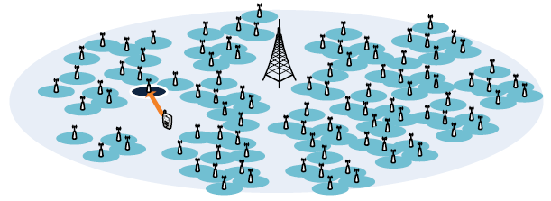
Figure 1 Handover from an ABS to a femtocell

Blind scanning
Proposed blind scanning method consists of two phases as shown in Fig.2. The first phase is to determine the scanning parameter set. The second phase is to scan and handover to the appropriate femtocell. The detail explanation of each phase is described as follows.
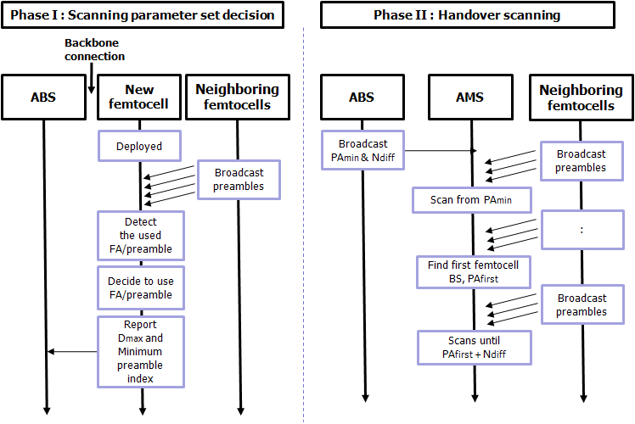
Figure 2 Flowchart for the overall operation of the proposed scheme
Figure 3 Example of deciding preamble set of a newly deployed femtocell

- Phase I: Scanning parameter set decision
When a femtocell is deployed, it decides a scanning parameter set defined by Frequency Assignment (FA) index and preamble index. By scanning all the possible scanning parameter sets, the femtocell can obtain the scanning parameter sets of neighboring cells. First of all, the femtocell decides the preamble index which is the minimal number among the available parameter sets. Then, it decides FA index which is available to be used with the using the minimal preamble index. Here, since preamble indices with minimal values are chosen, given a FA index, the MSs success to scan femtocells quickly starting from the smallest indices of preamble. The example of deciding preamble set of new deployed femtocell is shown in Figure 3.

After deciding the scanning parameter set, for each FA index, the femtocell calculates the maximum difference of the preamble indices used in neighboring cells and minimum preamble index used in cells. Then, the femtocell reports the information which contains the preamble index and FA index the femtocell selects, the maximum difference (D_{max}), and minimum preamble index for each FA index to the overlay ABS over backbone network.

The ABS collects all minimal preamble indices and maximum differences (D_{max}) for all FA indices from femtocells within coverage of the ABS. Then, for each FA index, the ABS chooses the smallest value used in the femtocells (PA_{min}) and the largest value among the collected set of maximum difference (N_{diff}), respectively. The ABS may unicasts, multicasts or broadcasts the blind scanning indication which contains PA_{min} and N_{diff} for all FA indices to AMS/YMS. The format of the blind scanning indication is shown in Table x.1.

Table x.1 Blind scanning indication format
Syntax | Size(bit) | Notes
Blind Scanning Indication () {
Number of FA | 8 | Number of FA indices
For(i=0; i< Number of FA; i++){
FA index | 8 | Frequency Assignment Index
PA_{min} |  | For a given FA index, the smallest preamble value among the minimal preamble indices reported by the femtocells within the coverage of ABS
N_{diff} |  | For a given FA index, the largest difference value among the maximal difference values reported by the femtocells within the coverage of ABS.
}
}|

- Phase II: sHandover scanning
After receiving the blind scanning indication which contains PA_{min} and N_{diff}, for a given FA index, MS starts to scan femtocells from the lowest preamble index (PA_{min}) to the highest preamble index. Since the femtocell BSs tends to select preamble index of lowest value, MSs can quickly succeed to scan a femtocell BS starting from the lowest index. After finding first femtocell BS whose preamble index is PA_{first}, the MS scans for preamble indeces from PA_{first} + 1 to PA_{first} + N_{diff} then stops scanning. By the proposed scanning parameter set decision, the other neighbor femtocells are likely to use preamble whose index is not different from PA_{first} by N_{diff} for a given FA index, so the MS does not need to scan preamble indices bigger than PA_{first} + N_{diff}. Once the MS detects the target femtocell and handover conditions are met, MS tries to handover from the serving ABS to the target femtocell BS.

Advantages of proposed method
The followings are the main advantages of the proposed method. Since femtocell BSs choose the preamble and FA index smartly and the MS can omit to scan for the preambles that are unlikely to be used by the neighboring femtocell BSs, the number of scanning can be effectively kept small. This results in saving of consumption in MS and reducing of handover delay.

Simulation results
To simplify the performance evaluation, we assumed that all femtocells use same FA. We use the indoor channel model in [1]. The simulation parameters are set as follows. We assume that four-story building which has 32 rooms in each floor. Five buildings are deployed in the coverage of ABS and femtocell BSs are deployed in the room of building. The number of preamble indices is set to 40 (1~40) and the number of neighboring ABSs is 6.
We compared proposed blind scanning to the different types of scanning schemes. As conventional schemes, we introduce a full scanning scheme and scanning scheme based on neighboring information. The full scanning scheme does scanning from the lowest to the highest preamble. The other conventional scheme is based on neighboring information which is broadcasted by the serving ABS.

As shown in Fig.4, full scanning shows the worst performance. In case of the other schemes, the number of scanning increases as the number of femto cells increases, because MSs tend to scan more preamble indices. In addition, the number of scanning does not increase much in case of many femtocell BSs, because the number of used preamble does not increase much due to preamble reuse. The proposed scheme outperforms the two conventional schemes, which means that the proposed scheme brings performance improvement in view of handover delay and power consumption due to scanning.

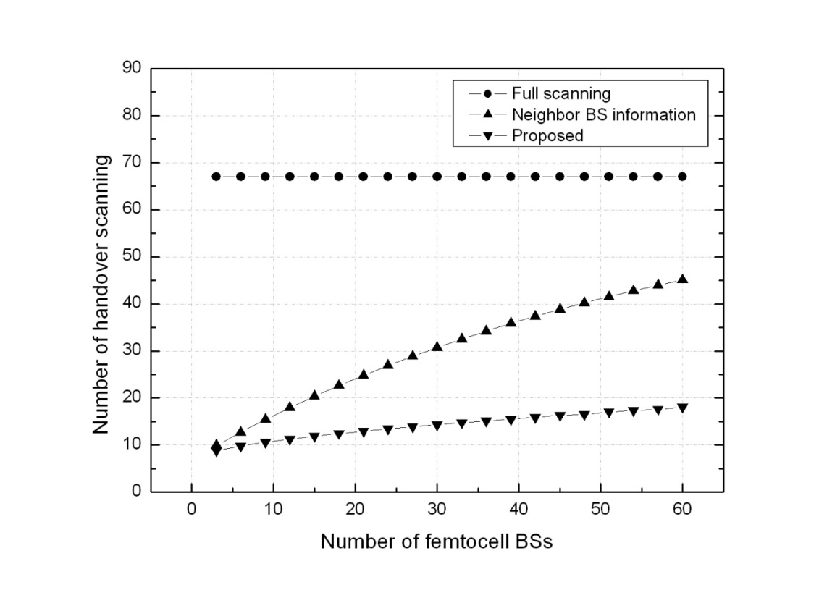
Figure 4 Simulation results of blind scanning

References

[1] IEEE 802.16m-08/004, “Project 802.16m Evaluation Methodology Document”, March 2008.

Text Proposal for the IEEE 802.16m
============================== Start of Proposed Text ================================

x.1 Scanning

x.x.1 Blind scanning
802.16m shall support blind scanning that is a scanning method from ABS to Femtocell BS when there is no available information on white list. Blind scanning may be used in the following cases.
- When there is no available white list on AMS.
- When AMS tries to access to unregistered CSG femtocell in the white list.
- White list is not supported for YMS (MS of 802.16e).

x.x.2 Procedure of Blind scanning
Blind scanning consists of scanning parameter set decision and handover scanning phases as shown in Figure x.1. In the phase of scanning parameter set decision, when a femtocell is deployed, it decides a scanning parameter set defined by FA index and preamble index. By scanning all the possible scanning parameter sets, the femtocell may obtain the scanning parameter sets of neighboring cells. First, the femtocell decides the preamble index which is the minimal number among the available parameter sets. Then, it decides FA index which is available to be used with the using the minimal preamble index. After deciding the scanning parameter set, for each FA index, the femtocell calculates the maximum difference of the preamble indices used in neighboring cells and minimum preamble index used in cells. Then, the femtocell may report the information which contains the preamble index and FA index the femtocell selects, the maximum difference (D_{max}), and minimum preamble index for each FA index to the overlay ABS over backbone network.

The ABS may collect all minimal preamble indices and maximum differences (D_{max}) for all FA indices from femtocells within coverage of the ABS. Then, for each FA index, the ABS may choose the smallest value used in the femtocells (PA_{min}) and the largest value among the collected set of maximum difference (N_{diff}), respectively. The ABS may unicasts, multicasts or broadcasts the blind scanning indication which contains PA_{min} and N_{diff} for all FA indices to AMS/YMS. The format of the blind scanning indication is shown in Table x.1.

Table x.1 Blind scanning indication format
Syntax | Size(bit) | Notes
Blind Scanning Indication () {
Number of FA | 8 | Number of FA indices
For(i=0; i< Number of FA; i++){
FA index | 8 | Frequency Assignment Index
PA_{min} |  | For a given FA index, the smallest preamble value among the minimal preamble indices reported by the femtocells within the coverage of ABS
N_{diff} |  | For a given FA index, the largest difference value among the maximal difference values reported by the femtocells within the coverage of ABS.
}
}|

In the phase of handover scanning, after receiving the blind scanning indication which contains PA_{min} and N_{diff}, for a given FA index, MS may start to scan femtocells from the lowest preamble index (PA_{min}) to the highest preamble index. After finding first femtocell BS whose preamble index is PA_{first}, the MS may scan for preamble indices from PA_{first} + 1 to PA_{first} + N_{diff} then stops scanning. Once the MS detects the target femtocell and handover conditions are met, MS may try to handover from the serving ABS to the target femtocell BS.
\
Figure x.1 Flowchart for the overall operation of blind scanning
============================== End of Proposed Text =================================

