Project | IEEE 802.16 Broadband Wireless Access Working Group <http://ieee802.org/16>
Title | Blind scanning
Date Submitted | 2009-07-14
Source(s) | Byung Moo Lee, Do-Young Kwak,  Si Young Heo, Yongjoo Tcha,  Jong-Sik Lee, and Seong-Choon Lee  KT  Sung-Yeop Pyun, Ju-yeop Kim and  Dong-Ho Cho  KAIST  Min Suk Kang, Howon Lee and  Bang Chul Jung  KI ITC | E-mail: blee@kt.com  E-mail: psy83@comis.kaist.ac.kr  E-mail: minsuk.kang@kaist.ac.kr
Re: | IEEE 80216m-09_0028r1 Call for contributions on Project 802.16m- “Support for Femtocell BS” in 802.16m amendment working document
Abstract | This contribution proposes IEEE 802.16m AWD on blind scanning
Purpose | Proposed to be discussed and adopted by TGm for the 802.16 AWD
Notice | This document does not represent the agreed views of the IEEE 802.16 Working Group or any of its subgroups. It represents only the views of the participants listed in the “Source(s)” field above. It is offered as a basis for discussion. It is not binding on the contributor(s), who reserve(s) the right to add, amend or withdraw material contained herein.
Release | The contributor grants a free, irrevocable license to the IEEE to incorporate material contained in this contribution, and any modifications thereof, in the creation of an IEEE Standards publication; to copyright in the IEEE’s name any IEEE Standards publication even though it may include portions of this contribution; and at the IEEE’s sole discretion to permit others to reproduce in whole or in part the resulting IEEE Standards publication. The contributor also acknowledges and accepts that this contribution may be made public by IEEE 802.16.
Patent Policy | The contributor is familiar with the IEEE-SA Patent Policy and Procedures:  <http://standards.ieee.org/guides/bylaws/sect6-7.html#6> and <http://standards.ieee.org/guides/opman/sect6.html#6.3>.  Further information is located at <http://standards.ieee.org/board/pat/pat-material.html> and <http://standards.ieee.org/board/pat>.

Blind Scanning
Byung Moo Lee, Do-Young Kwak, Si Young Heo, Yongjoo Tcha,
Jong-Sik Lee, and Seong-Choon Lee
KT
Sung-Yeop Pyun, Ju-yeop Kim and Dong-Ho Cho
KAIST
Min Suk Kang, Howon Lee and Bang Chul Jung
KI ITC

Problem definition
When a handover is executed from an macro ABS (Advanced Base station) to a femtocell BS, there may be a problem to find an appropriate target femtocell BS. Since the coverage of the femtocell is small, it is possible that huge numbers of femtocells are located within the coverage of macro ABS as shown in Fig. 1. Thus, unlike conventional cellular systems, there may exist hundreds of candidates for the target femtocell. This may cause a serious problem, because an MS should make a great effort to scan for many possible femtocells in the whole bandwidth and consume a lot of resources. This may give a significant impact on handover delay. We define scanning method from macro ABS to the femtocell BS as a blind scanning when there is no available information on CSG (Closed Subscriber Group) white list, which contains the information of accessible CSG femtocells (e.g., FA index, preamble index). Therefore, hierarchical cellular networks including femtocells need a novel scanning scheme to find the appropriate target femtocells among numerous candidate femtocells in an efficient manner, regardless of the availability of CSG white list. There are some cases where blind scanning is necessary.
  - When there is no available CSG white list on AMS (Advanced Mobile Station).
  - When AMS tries to access to unregistered CSG femtocell in the CSG white list.
  - White list is not supported for YMS (Yardstick Mobile Station).

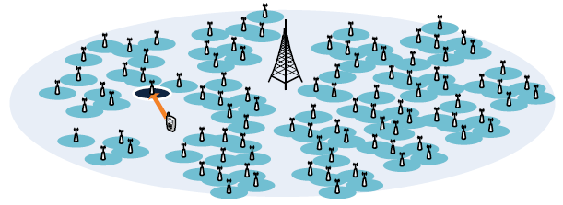
Figure 1 Handover from an ABS to a femtocell

Blind scanning
Proposed blind scanning method consists of two phases as shown in Fig.2. The first phase is to determine scanning parameter set. The second phase is to scan and handover to an appropriate femtocell. The detail explanation of each phase is described as follows.
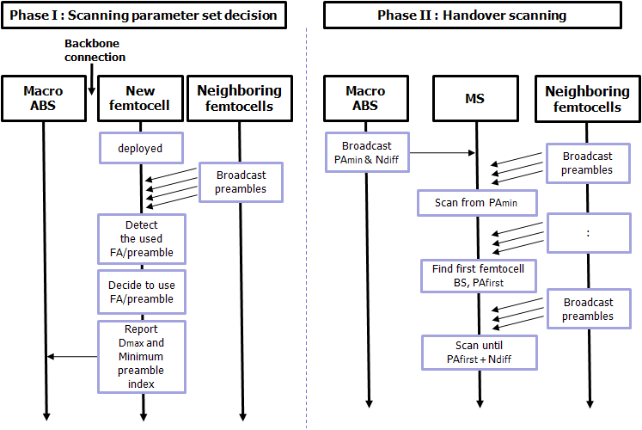
Figure 2 Flowchart for overall operation of proposed scheme

- Phase I: Scanning parameter set decision
When a femtocell is newly deployed, it decides a scanning parameter set defined by FA (Frequency Assignment) index and preamble index. By scanning all the possible scanning parameter sets, the femtocell can obtain the scanning parameter sets of neighboring femtocells. First of all, the femtocell decides the preamble index which is the minimal number among the available parameter sets which are not used by the neighboring femtocells. Then, the femtocell selects FA index the decided preamble index belongs to. Here, since preamble indices with minimal values are chosen, given an FA index, the MSs succeed to scan neighboring femtocells quickly by starting from the smallest indices of preamble. The example of deciding preamble set of new deployed femtocell is shown in Figure 3.

After deciding the scanning parameter set, for each FA index, the femtocell calculates the maximum difference of the preamble indices used in neighboring femtocells and minimum preamble index used in the neighboring femtocells. Then, the femtocell reports the information which contains the preamble index and FA index the femtocell decided, the maximum difference (D_{max}), and minimum preamble index for each FA index to the overlay macro ABS over backbone network.
Figure 3 Example of deciding preamble set of a newly deployed femtocell

For all FA indices, the macro ABS collects all maximum differences (D_{max}) and minimal preamble indices from femtocells within coverage of the macro ABS. Then, for each FA index, the ABS chooses the smallest preamble index (PA_{min}) used in all the femtocells and the largest value (N_{diff}) among the collected maximum differences, respectively. The ABS may unicast, multicast or broadcast the blind scanning indication which contains PA_{min} and N_{diff} for each FA index to AMS/YMS. The format of the blind scanning indication is shown in Table 1.

Table 1 Blind scanning indication format
Syntax | Size(bit) | Notes
Blind Scanning Indication () {
Number of FA | 8 | Number of FA indices
For(i=0; i< Number of FA; i++){
FA index | 8 | Frequency Assignment Index
PA_{min} |  | For a given FA index, the smallest preamble index among the minimum preamble indices reported by the femtocells within the coverage of ABS
N_{diff} |  | For a given FA index, the largest difference value among the maximal difference values reported by the femtocells within the coverage of ABS.
}
}|

- Phase II: Handover scanning
After receiving the blind scanning indication which contains PA_{min} and N_{diff}, for a given FA index, MS may start to scan femtocells from the smallest preamble index (PA_{min}) to the highest preamble index. Since the femtocell BSs tend to select preamble index of lowest value, MSs can quickly succeed to scan the first femtocell BS. After finding the first femtocell BS whose preamble index is PA_{first}, the MS scans only for preamble indices from PA_{first} + 1 to PA_{first} + N_{diff} then stops scanning. By the proposed scanning parameter set decision, the other neighboring femtocells are likely to use the preamble index within the range between PA_{first} and PA_{first} + N_{diff}. Therefore, the MS does not need to scan preamble indices bigger than PA_{first} + N_{diff}. Once the MS detects the target femtocell and handover conditions are met, the MS tries to handover from the serving macro ABS to the target femtocell BS.

Advantages of proposed method
The followings are the main advantages of the proposed method. Since femtocell BSs choose the preamble and FA index smartly and the MS can omit to scan for the preambles that are unlikely to be used by the neighboring femtocell BSs, the number of scanning can be effectively kept small. This results in saving of consumption in MS and reducing of handover delay.

Simulation results
To simplify the performance evaluation, we assumed that all femtocells use same FA. We use the indoor channel model in [1]. The simulation parameters are set as follows. We assume the four-story building which has 32 rooms in each floor. Five buildings are deployed in the coverage of macro ABS and femtocell BSs can be deployed in the room of building. The number of preamble indices is set to 40 (1~40) and the number of neighboring macro ABSs is 6.
We compared proposed blind scanning with the different types of scanning schemes. As conventional schemes, we introduce a full scanning scheme and scanning scheme based on neighboring information. The full scanning scheme does scanning from the lowest to the highest preamble index. The other conventional scheme is based on neighboring information which is broadcasted by the serving macro ABS.

As shown in Fig.4, full scanning shows the worst performance. In case of the neighboring information based and the proposed schemes, the number of scanning increases as the number of deployed femtocells increases, because MSs tend to scan more preamble indices. In addition, the number of scanning does not increase much in case that a number of femtocells are deployed. That is, the number of unused preamble indices does not decrease much due to spatial preamble reuse. The proposed scheme outperforms the two conventional schemes, which means that the proposed scheme brings performance improvement in view of handover delay and power consumption of MS in the scanning for neighboring femtocells.

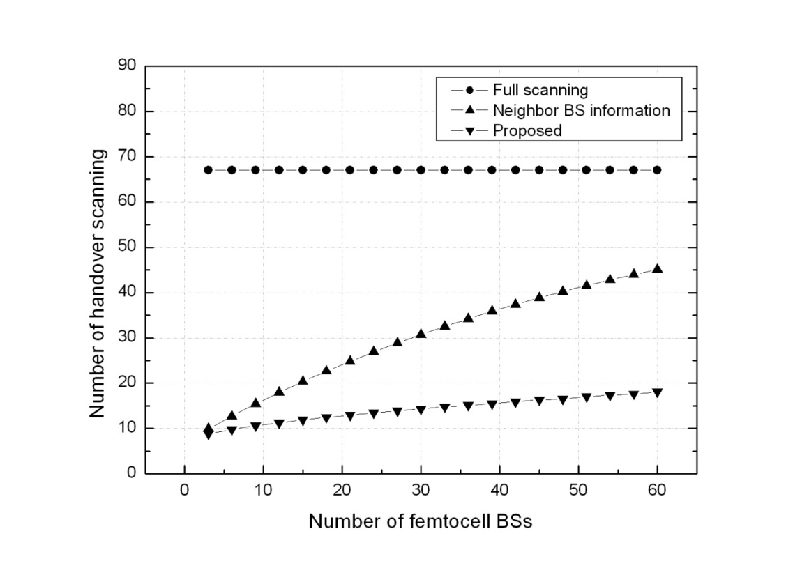
Figure 4 Simulation results of blind scanning

References

[1] IEEE 802.16m-08/004, “Project 802.16m Evaluation Methodology Document”, March 2008.

Text Proposal for the IEEE 802.16m
============================== Start of Proposed Text ================================

x.1 Scanning

x.x.1 Blind scanning
802.16m shall support blind scanning that is a scanning method from macro ABS to femtocell BS when there is no available information on CSG white list. Blind scanning may be used in the following cases.
- When there is no available CSG white list on AMS.
- When AMS tries to access to unregistered CSG femtocell in the CSG white list.
- White list is not supported for YMS.

x.x.2 Procedure of Blind scanning
Blind scanning consists of scanning parameter set decision and handover scanning phases as shown in Figure x.1. In the phase of scanning parameter set decision, when a femtocell is newly deployed, it decides a scanning parameter set defined by FA index and preamble index. By scanning all the possible scanning parameter sets, the femtocell may obtain the scanning parameter sets of neighboring femtocells. First, the femtocell decides the preamble index which is the minimal number among the available parameter sets which are not used by the neighboring femtocells. Then, the femtocell selects FA index the decided preamble index belongs to. After deciding the scanning parameter set, for each FA index, the femtocell calculates the maximum difference of the preamble indices used in neighboring femtocells and minimum preamble index used in the neighboring femtocells. Then, the femtocell may report the information which contains the preamble index and FA index the femtocell decided, the maximum difference (D_{max}), and minimum preamble index for each FA index to the overlay macro ABS over backbone network.

For all FA indices, the macro ABS may collect all maximum differences (D_{max}) and minimal preamble indices from femtocells within coverage of the macro ABS. Then, for each FA index, the ABS may choose the smallest preamble index (PA_{min}) used in all the femtocells and the largest value (N_{diff}) among the collected maximum differences, respectively. The ABS may unicast, multicast or broadcast the blind scanning indication which contains PA_{min} and N_{diff} for each FA index to AMS/YMS. The ABS may unicast, multicast or broadcast the blind scanning indication which contains PA_{min} and N_{diff} for all FA indices to AMS/YMS. The format of the blind scanning indication is shown in Table x.1.

Table x.1 Blind scanning indication formatSyntax | Size(bit) | Notes
Blind Scanning Indication () {
Number of FA | 8 | Number of FA indices
For(i=0; i< Number of FA; i++){
FA index | 8 | Frequency Assignment Index
PAmin |  | For a given FA index, the smallest preamble index among the minimum preamble indices reported by the femtocells within the coverage of ABS
Ndiff |  | For a given FA index, the largest difference value among the maximal difference values reported by the femtocells within the coverage of ABS.
}
}|

In the phase of handover scanning, after receiving the blind scanning indication which contains PA_{min} and N_{diff}, for a given FA index, MS may start to scan femtocells from the smallest preamble index (PA_{min}) to the highest preamble index. After finding the first femtocell BS whose preamble index is PA_{first}, the MS may scan only for preamble indices from PA_{first} + 1 to PA_{first} + N_{diff} then stops scanning. Once the MS detects the target femtocell and handover conditions are met, the MS tries to handover from the serving macro ABS to the target femtocell BS.

Figure x.1 Flowchart for overall operation of blind scanning
============================== End of Proposed Text =================================

