Project | IEEE 802.16 Broadband Wireless Access Working Group <http://ieee802.org/16>
Title | Fast Device Capability Negotiation for IEEE 802.16m Systems
Date Submitted | 2009-07-06
Source(s) | Muthaiah Venkatachalam  Sassan Ahmadi  Intel | E-mail: muthaiah.venkatachalam@intel.com
Re: | IEEE 802.16m-09/0028r1 Call for Comments and Contributions on Project IEEE 802.16m  Amendment Content
Abstract | This contribution proposes a method to simplify device capability negotiation (SBC) procedures in IEEE 802.16m.
Purpose | To be discussed and adopted by TGm for IEEE 802.16m AWD
Notice | This document does not represent the agreed views of the IEEE 802.16 Working Group or any of its subgroups. It represents only the views of the participants listed in the “Source(s)” field above. It is offered as a basis for discussion. It is not binding on the contributor(s), who reserve(s) the right to add, amend or withdraw material contained herein.
Release | The contributor grants a free, irrevocable license to the IEEE to incorporate material contained in this contribution, and any modifications thereof, in the creation of an IEEE Standards publication; to copyright in the IEEE’s name any IEEE Standards publication even though it may include portions of this contribution; and at the IEEE’s sole discretion to permit others to reproduce in whole or in part the resulting IEEE Standards publication. The contributor also acknowledges and accepts that this contribution may be made public by IEEE 802.16.
Patent Policy | The contributor is familiar with the IEEE-SA Patent Policy and Procedures:  <http://standards.ieee.org/guides/bylaws/sect6-7.html#6> and <http://standards.ieee.org/guides/opman/sect6.html#6.3>.  Further information is located at <http://standards.ieee.org/board/pat/pat-material.html> and <http://standards.ieee.org/board/pat>.

Fast Device Capability Negotiation for IEEE 802.16m Systems

Muthaiah Venkatachalam, Sassan Ahmadi
Intel

- Introduction
The unnecessary capability negotiation procedures and bulky MAC management messages that are currently included and exchanged in IEEE Std 802.16-2009 between the MS and BS during system entry (or re-entry) can be simplified and the access state processing can be made faster and more efficient by following the proposed method, resulting in more reliability and robustness and lower network entry latency (Control-Plane Latency and Call Setup Time)
In fact, the field test results from operator trails and networks suggest that the extended capability negotiations between the BS and MS could result in extremely long delays and potentially inability of system access for mobile stations in the cell edge due to channel errors. Therefore, the capability negotiations must be shortened and made more efficient.

- Proposed solution
This contribution proposes a simple solution for capability negotiation between mobile station (MS) and base station (BS) during network entry (re-entry). The TLV-coded MAC management messages exchanged during capability negotiations (see Pages 333-336 of [1]) are performed irrespective of the required MS or BS capabilities to ensure proper interoperability.

Immediately after completion of ranging, the MS informs the BS of its basic capabilities by transmitting an SBC-REQ message (SS basic capability request) with its capabilities set to “on” (see Figure 75 of [1]). The BS responds with an SBC-RSP message (SS basic capability response) with the intersection of the MS’s and the BS’s capabilities set to “on” (see Figure 76 and Figure 77 of [1]).

Instead, if we assume that the MS by default supports a basic set of features or configuration parameters (probably mandated by a system profile or by the standard specification per se), there would be no need to negotiate and configure the basic capabilities.

Proposed text:

-------------------------------------------------Begin Proposed Text-------------------------------------------------------------------

15.2.5.8 SBC_REQ
SBC_REQ is an optional message that can be sent by the MS to the BS. The MS is expected to support some basic capabilities. Therefore, by default the BS can assume that the MS supports basic capabilities and NO SBC MAC management message shall be exchanged, if the MS or BS wishes to operate based on the basic capability feature set.

If the mobile station is capable of supporting higher revisions of Physical Layer (PHY) or Medium Access Control (MAC) layer protocols and further wishes to use enhanced features, then it sends a MAC message to the base station using SBC-REQ only indicating the highest “CAPABILITY_INDEX” that it can support. The CAPABILITY_INDEX = 0 indicates the default capability index and basic feature set or configuration parameters and does not need to be signaled.

The base station upon receipt of the MAC management message containing the “CAPABILITY_INDEX” from the mobile station determines whether it could allow or could support the requested feature set or MAC and/or PHY protocol revisions. If the BS does support or can allow the use of enhanced features, it shall respond with a MAC management message using SBC-RSP to inform the mobile station of its decision. The base station only signals a “CAPABILITY_INDEX” which is numerically smaller than or equal to that requested by the mobile station.

The higher numeric values of “CAPABILITY_INDEX”, the more enhanced features are used. The entire feature set or configuration parameters supported by the standard or the system profile (this includes both mandatory and optional features) shall be classified into different sets called “Capability Class” where “Capability Class 0” denotes the default configuration corresponding to “CAPABILITY_INDEX = 0". The “CAPABILITY_INDEX” values range from 0 to N, where the portioning of the features and the number of Capability Classes depend on the device classes and other considerations taken into account when developing system profiles or the actual specification. The features and configuration parameters included in the baseline class shall be sufficient to meet the minimum performance requirements of the standard.

In case of failure in any stage of operation, the MS and BS shall fall back to “Capability Class 0” and restart negotiations for new “Capability Class”, if necessary.

Figure 1 shows the MAC management messages exchanged over the air-interface, classification of the features into Capability Classes, SBC-REQ and SBC-RSP message formats (taken from IEEE Std 802.16-2009)

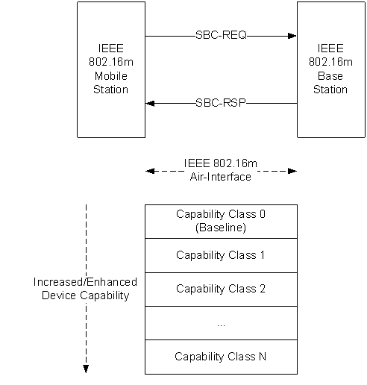

Figure 1: MAC management messages exchanged over the air-interface and feature classification

Management Message Type
CAPABILITY_INDEX

Figure 2: SBC-REQ message parameters

Here the CAPABILITY_INDEX transmitted in the SBC_REQ message refers to the maximum capability class that the MS can support. The exact mappings of the CAPABILITY_INDEX to Capability Class is FFS. The maximum number of Capability Classes are FFS.

15.2.5.8 SBC_RSP

Management Message Type
CAPABILITY_INDEX

Figure 3: SBC-RSP message format

Here the CAPABILITY_INDEX transmitted in the message refers to the maximum capability class that the BS has asked the MS to use during the session with the BS. This value of CAPABILITY_INDEX signaled in the SBC_RSP message is numerically smaller than the CAPABILITY_INDEX signaled in the SBC_REQ message by the MS.

-------------------------------------------------------End Proposed Text-----------------------------------------------------------------

References:

[1] IEEE Std 802.16-2009 specification

