Project | IEEE 802.16 Broadband Wireless Access Working Group <http://ieee802.org/16>
Title | IEEE 802.16m Amendment Text Proposal for Sounding Antenna Selection
Date Submitted | 2009-07-06
Source(s) | Wookbong Lee, Jinyoung Chun, Bin-Chul Ihm  LG Electronics.  Alexei Davydov, Yang-seok Choi  Intel Corporation | wbong@lge.com  alexei.davydov@intel.com
Re: | Category: AWD comments / Area: Chapter 15.3.6 DL control channel and 15.3.9 Uplink control channel  “Comments on AWD 15.3.6 DL CTRL and 15.3.9 UL CTRL”
Abstract | This contribution proposes the antenna selection method for sounding.
Purpose | To be discussed and adopted by TGm for the 802.16m amendment.
Notice | This document does not represent the agreed views of the IEEE 802.16 Working Group or any of its subgroups. It represents only the views of the participants listed in the “Source(s)” field above. It is offered as a basis for discussion. It is not binding on the contributor(s), who reserve(s) the right to add, amend or withdraw material contained herein.
Release | The contributor grants a free, irrevocable license to the IEEE to incorporate material contained in this contribution, and any modifications thereof, in the creation of an IEEE Standards publication; to copyright in the IEEE’s name any IEEE Standards publication even though it may include portions of this contribution; and at the IEEE’s sole discretion to permit others to reproduce in whole or in part the resulting IEEE Standards publication. The contributor also acknowledges and accepts that this contribution may be made public by IEEE 802.16.
Patent Policy | The contributor is familiar with the IEEE-SA Patent Policy and Procedures:  <http://standards.ieee.org/guides/bylaws/sect6-7.html#6> and <http://standards.ieee.org/guides/opman/sect6.html#6.3>.  Further information is located at <http://standards.ieee.org/board/pat/pat-material.html> and <http://standards.ieee.org/board/pat>.

IEEE 802.16m Amendment Text Proposal for Sounding Antenna Selection

Wookbong Lee, Jinyoung Chun, and Bin-Chul Ihm
LG Electronics
Alexei Davydov, Yang-seok Choi
Intel Corporation

- Introduction
In current AWD [1], Sounding command IE for multiple uplink transmit antennas are defined. However, there is some issues related to multiple uplink transmit antenna sounding.
First of all, it is not clear that where to transmit each transmit antennas’ sounding channel. Currently only one unique offset for FDM or one unique cyclic shift for CDM is indicated. However, if there are multiple antennas at MS, we need to indicate multiple sounding channels. So, we propose to assign N contiguous sounding channel index starting from the offset or cyclic shift value, when the number of transmit antennas for sounding of the MS is N.
Second of all, currently MS shall transmit same number of sounding channel as the actual transmit antenna at MS. However, due to the antenna power imbalance, sometimes it is better to turn off some of transmit antennas to reduce uplink power consumption.
Antenna power imbalance is caused by e.g. user hand-gripping or direction of polarized antenna and so on.
So, the power imbalance pattern among the transmit antennas does not change very shortly but slowly.
The following figure shows the impact of antenna power imbalance.
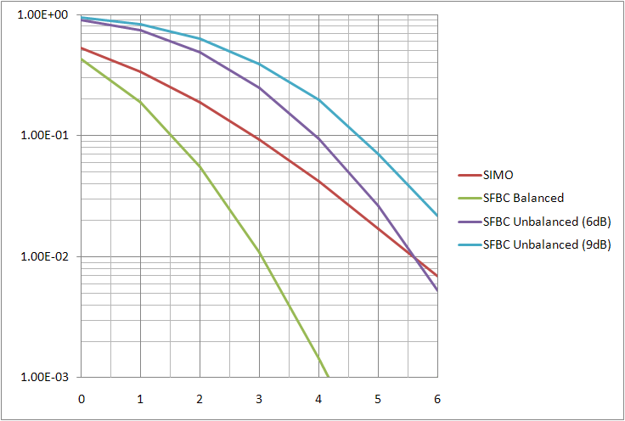
As you can see in the figure, when antenna power imbalance is higher than a certain threshold, single antenna transmission is better than two antenna transmission (SFBC).
So, we propose to adopt antenna selection in uplink transmission. Since uplink sounding is required for determine uplink MCS level or precoder, we further propose to use uplink sounding commend IE to indicate which antenna/antenna group to be selected for transmitting sounding signal or data.
To enable BS to get the other transmit antenna’s channel response, BS may allocate another sounding channel with longer period.
As a place holder, we propose to have multi-antenna index field for further study.

- Reference
[1] 80216m-09/0010r2, “IEEE 802.16m Amendment Working Document”

Remedy #1. Line 50, page 228 to line 47, page 229. Modify SOUNDING Command A-MAP IE as follows;
------------------------------- Text Start ---------------------------------------------------

15.3.6.5.2.11 UL Sounding Command A-MAP IE

Table 684—UL Sounding Command A-MAP IE
Syntax | Size (bits) | Notes
UL Sounding Command IE format () {
A-MAP IE Type | 4
Sounding subframe | 3 | Indicates the sounding subframe [TBD]
Sounding subband bitmap | Variable  [max. 12] | [TBD] FFT size dependant TBD
If (Multiplexing type == 0) {
Decimation offset d | [4] or [5] | Unique decimation offset
} else {
Cyclic time shift n | [4] or [5] | Unique cyclic shift [TBD]
}
Periodicity (p) | 3 | 0b000 = Single command, not periodic, or terminate the periodicy. Otherwise, repeat sounding once per 2^{(np-1)} frames, where np is decimal value of the periodicity field
Multi-antenna sounding | 1 | 0b0: sounding with antenna switching  0b1: sounding from multiple antennas
Multi-Antenna Index (MAI) | [2] | TBD
Antenna Switching | 1 | 0b0: Antenna switching  0b1: No antenna switching
Padding | [TBD] | Padding to reach byte boundary
MCRC | 16 | 16 bit CRC masked by Station ID
}
d: Sounding channel index indicates unique decimation offset
n: Sounding channel index indicates unique cyclic time shift.
Table 684 specifies the fields of UL Sounding Command A-MAP IE used by the ABS to request sounding transmission by the AMS. Decimal equivalent of the sounding subframe indicates the uplink subframe with sounding symbol. The sounding subband bitmap field is used to indicate the sounding subbands used in the sounding allocation. For that purpose, the N_{used} contiguous subcarriers are further subdivided into sounding subbands, where each sounding subband compromises N₁ * N_{sc} adjacent subcarriers with N_{sc} = 18 for N_{FFT} = 512, 1024 and N_{sc} = 36 for N_{FFT} = 2048. For multiplexing type equal to 0 the first subcarrier index (actual decimation offset) of ik^{th} transmit antenna within sounding allocation is determined from g = F(d, k, Frame Index) g = d + i - 1, where function F() is TBD. The three periodicity periodicy bits are used to indicate the MS to periodically repeat the sounding transmission. Setting periodicity periodicy bits to 0b000 indicates a single sounding command or terminates the sounding if periodic sounding command is being performed.
For multi-antenna Antenna Switching flag equals to 0 the MS sounds with antenna switching, while for multi-antenna Antenna Switching flag equals to 1 the MS sounds all transmit antennas. If Antenna Switching field equals to 1 then the i^{th} antenna of the MS corresponds to index = d + i - 1 for multiplexing type 0 or to n + i - 1 for multiplexing type 1.
------------------------------- Text End ---------------------------------------------------

Remedy #2. Line 6-23, page 294. Modify texts as follows;
------------------------------- Text Start ---------------------------------------------------

15.3.9.2.3.2 Multiplexing for multi-antenna and multi-AMS
The uplink sounding channels of multiple AMS and multiple antennas per AMS can be multiplexed through decimation separation or cyclic shift separation in each sounding allocation. Also, in case of multiple UL subframes for sounding, time division separation can be applied by assigning different AMS to different UL subframe. For cyclic shift separation each AMS occupies all subcarriers within sounding allocation and uses the different sounding waveform. For frequency decimation separation each AMS uses decimated subcarrier subset from the sounding allocation set with different frequency offset.
For antenna switching capable AMS and multi-antenna AMS, ABS can command the AMS to switch the physical transmit antenna(s) for sounding transmission. For sounding with antenna switching, the AMS shall transmit sounding symbol with the i-th antenna (0, 1, …, N_{t}-1) on frames nt = j • 2^{(p-1)}T + i, where nt = 0 corresponds to the frame where UL sounding command A-MAP IE is received, Tp is periodicity in UL sounding command A-MAP IE, and j is a running index ( j = 0, 1, 2, … for Tp ≠ 0 and j = 0 for Tp = 0). For sounding with antenna switching and periodical sounding allocation (Tp ≠ 0), the assigned periodicity T2^{(p-1)} shall be larger or equal to the number of AMS transmit antennas N_{t}.
------------------------------- Text End ---------------------------------------------------

