Project | IEEE 802.16 Broadband Wireless Access Working Group <http://ieee802.org/16>
Title | IEEE 802.16m Amendment Text Proposal for UL BW REQ preamble
Date Submitted | 2009-07-06
Source(s) | Jinyoung Chun, Bin-Chul Ihm, Youngsoo Yuk, Heejeong Cho  LG Electronics. | jychun03@lge.com
Re: | Category: AWD comments / Area: Chapter 15.3.9 (Uplink control channel)  “Comments on AWD 15.3.9 Uplink control channel”
Abstract | This contribution proposes UL BW REQ preamble.
Purpose | For member’s review and adoption into P802.16m Amendment Working Document
Notice | This document does not represent the agreed views of the IEEE 802.16 Working Group or any of its subgroups. It represents only the views of the participants listed in the “Source(s)” field above. It is offered as a basis for discussion. It is not binding on the contributor(s), who reserve(s) the right to add, amend or withdraw material contained herein.
Release | The contributor grants a free, irrevocable license to the IEEE to incorporate material contained in this contribution, and any modifications thereof, in the creation of an IEEE Standards publication; to copyright in the IEEE’s name any IEEE Standards publication even though it may include portions of this contribution; and at the IEEE’s sole discretion to permit others to reproduce in whole or in part the resulting IEEE Standards publication. The contributor also acknowledges and accepts that this contribution may be made public by IEEE 802.16.
Patent Policy | The contributor is familiar with the IEEE-SA Patent Policy and Procedures:  <http://standards.ieee.org/guides/bylaws/sect6-7.html#6> and <http://standards.ieee.org/guides/opman/sect6.html#6.3>.  Further information is located at <http://standards.ieee.org/board/pat/pat-material.html> and <http://standards.ieee.org/board/pat>.

IEEE 802.16m Amendment Text Proposal for UL BW REQ preamble
Jinyoung Chun, Bin-Chul Ihm, Youngsoo Yuk, Heejeong Cho
LG Electronics

- Introduction
In Amendment Working Document, the UL BW REQ preamble is not defined. Therefore we propose the sequences and the usage of BW REQ preamble.

- Text proposal for inclusion in the 802.16m amendment
[Add the texts and figures marked in blue and remove the texts and figures marked in red in the IEEE 802.16m-09/0010r2.]

[ Adopt the below changes from page 286.]

--------------------------------------------- Text Start --------------------------------------------------------

15.3.9.1.5 Bandwidth request channel

In the LZone with PUSC, a BW REQ tile is defined as four contiguous subcarriers by six OFDM symbols. The number of BW REQ tiles per BW REQ channel is three or six. Each BW REQ tile carries a BW REQ access sequence only.

In the Mzone, a BW REQ tile is defined as six contiguous subcarriers by six OFDM symbols. Each BW REQ channel consists of three distributed BW-REQ tiles. Each BW REQ tile carries a BW REQ access sequence and a BW REQ quick access message. The AMS may transmit the access sequence only and leave the resources for the quick access message unused.
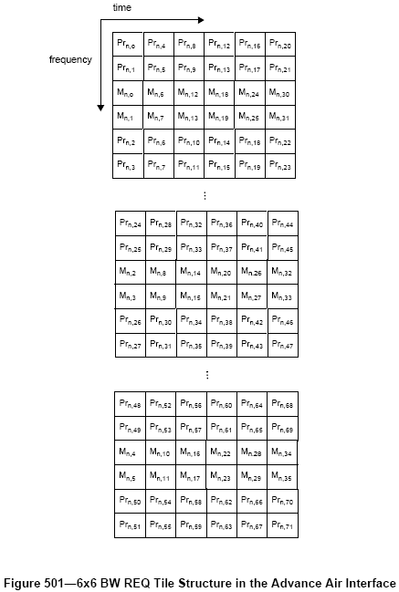

A BW REQ tile in the Advanced Air Interface specifications is defined as 6 contiguous subcarriers by 6 OFDM symbols. As shown in Figure 501, the BW REQ preamble shall be transmitted on a resource that spans 4 subcarriers by 6 OFDM symbols. Additionally, a quick access BW REQ message shall be carried in the data portion of the tile that spans 2 contiguous subcarriers by 6 OFDM symbols. Each BW REQ channel shall comprise of 3 distributed BW REQ tiles for frequency diversity. The procedure for allocation of resources for transmission of UL control information and the formation of DRUs for such transmission is TBD.

BW REQ preamble sequences (Pr) is defined as the below equation using sequences m₀,m₁,…,m₂₃ given by Table 503.
$${\text{Pr}}_{n,i}=1\text{.}−2\text{.}⋅m_{i\text{mod}\text{24}}\begin{matrix}, & \begin{matrix}n=0,1,\text{.}\text{.}\text{.},\text{31}, & i=0,1,\text{.}\text{.}\text{.},\text{71}\end{matrix}\end{matrix}$$
The number of BW REQ preambles is 32. The first 16 sequences are used for quick access message including 4bit information. And the last 16 sequences are used for the transmission of BW REQ preamble only.

Table 503.Sequences for BW REQ preamble
Preamble index (n) | Sequences (m₀,…,m₂₃)
0 | 1, 1, 1, 1, 1, 1, 1, 1, 1, 1, 1, 1, 1, 1, 1, 1, 1, 1, 1, 1, 1, 1, 1, 1
1 | 1, 0, 1, 0, 1, 0, 1, 0, 1, 0, 1, 0, 1, 0, 1, 0, 1, 0, 1, 0, 1, 0, 1, 0
2 | 1, 1, 0, 0, 1, 1, 0, 0, 1, 1, 0, 0, 1, 1, 0, 0, 1, 1, 0, 0, 1, 1, 0, 0
3 | 1, 0, 0, 1, 1, 0, 0, 1, 1, 0, 0, 1, 1, 0, 0, 1, 1, 0, 0, 1, 1, 0, 0, 1
4 | 1, 1, 1, 1, 0, 0, 0, 0, 1, 1, 1, 1, 0, 0, 0, 0, 1, 1, 1, 1, 0, 0, 0, 0
5 | 1, 0, 1, 0, 0, 1, 0, 1, 1, 0, 1, 0, 0, 1, 0, 1, 1, 0, 1, 0, 0, 1, 0, 1
6 | 1, 1, 0, 0, 0, 0, 1, 1, 1, 1, 0, 0, 0, 0, 1, 1, 1, 1, 0, 0, 0, 0, 1, 1
7 | 1, 0, 0, 1, 0, 1, 1, 0, 1, 0, 0, 1, 0, 1, 1, 0, 1, 0, 0, 1, 0, 1, 1, 0
8 | 1, 1, 1, 1, 1, 1, 1, 1, 0, 0, 0, 0, 0, 0, 0, 0, 1, 1, 1, 1, 1, 1, 1, 1
9 | 1, 0, 1, 0, 1, 0, 1, 0, 0, 1, 0, 1, 0, 1, 0, 1, 1, 0, 1, 0, 1, 0, 1, 0
10 | 1, 1, 0, 0, 1, 1, 0, 0, 0, 0, 1, 1, 0, 0, 1, 1, 1, 1, 0, 0, 1, 1, 0, 0
11 | 1, 0, 0, 1, 1, 0, 0, 1, 0, 1, 1, 0, 0, 1, 1, 0, 1, 0, 0, 1, 1, 0, 0, 1
12 | 1, 1, 1, 1, 0, 0, 0, 0, 0, 0, 0, 0, 1, 1, 1, 1, 1, 1, 1, 1, 0, 0, 0, 0
13 | 1, 0, 1, 0, 0, 1, 0, 1, 0, 1, 0, 1, 1, 0, 1, 0, 1, 0, 1, 0, 0, 1, 0, 1
14 | 1, 1, 0, 0, 0, 0, 1, 1, 0, 0, 1, 1, 1, 1, 0, 0, 1, 1, 0, 0, 0, 0, 1, 1
15 | 1, 0, 0, 1, 0, 1, 1, 0, 0, 1, 1, 0, 1, 0, 0, 1, 1, 0, 0, 1, 0, 1, 1, 0
16 | 1, 1, 1, 1, 1, 1, 1, 1, 1, 1, 1, 1, 1, 1, 1, 1, 0, 0, 0, 0, 0, 0, 0, 0
17 | 1, 0, 1, 0, 1, 0, 1, 0, 1, 0, 1, 0, 1, 0, 1, 0, 0, 1, 0, 1, 0, 1, 0, 1
18 | 1, 1, 0, 0, 1, 1, 0, 0, 1, 1, 0, 0, 1, 1, 0, 0, 0, 0, 1, 1, 0, 0, 1, 1
19 | 1, 0, 0, 1, 1, 0, 0, 1, 1, 0, 0, 1, 1, 0, 0, 1, 0, 1, 1, 0, 0, 1, 1, 0
20 | 1, 1, 1, 1, 0, 0, 0, 0, 1, 1, 1, 1, 0, 0, 0, 0, 0, 0, 0, 0, 1, 1, 1, 1
21 | 1, 0, 1, 0, 0, 1, 0, 1, 1, 0, 1, 0, 0, 1, 0, 1, 0, 1, 0, 1, 1, 0, 1, 0
22 | 1, 1, 0, 0, 0, 0, 1, 1, 1, 1, 0, 0, 0, 0, 1, 1, 0, 0, 1, 1, 1, 1, 0, 0
23 | 1, 0, 0, 1, 0, 1, 1, 0, 1, 0, 0, 1, 0, 1, 1, 0, 0, 1, 1, 0, 1, 0, 0, 1
24 | 1, 1, 1, 1, 1, 1, 1, 1, 0, 0, 0, 0, 0, 0, 0, 0, 0, 0, 0, 0, 0, 0, 0, 0
25 | 1, 0, 1, 0, 1, 0, 1, 0, 0, 1, 0, 1, 0, 1, 0, 1, 0, 1, 0, 1, 0, 1, 0, 1
26 | 1, 1, 0, 0, 1, 1, 0, 0, 0, 0, 1, 1, 0, 0, 1, 1, 0, 0, 1, 1, 0, 0, 1, 1
27 | 1, 0, 0, 1, 1, 0, 0, 1, 0, 1, 1, 0, 0, 1, 1, 0, 0, 1, 1, 0, 0, 1, 1, 0
28 | 1, 1, 1, 1, 0, 0, 0, 0, 0, 0, 0, 0, 1, 1, 1, 1, 0, 0, 0, 0, 1, 1, 1, 1
29 | 1, 0, 1, 0, 0, 1, 0, 1, 0, 1, 0, 1, 1, 0, 1, 0, 0, 1, 0, 1, 1, 0, 1, 0
30 | 1, 1, 0, 0, 0, 0, 1, 1, 0, 0, 1, 1, 1, 1, 0, 0, 0, 0, 1, 1, 1, 1, 0, 0
31 | 1, 0, 0, 1, 0, 1, 1, 0, 0, 1, 1, 0, 1, 0, 0, 1, 0, 1, 1, 0, 1, 0, 0, 1

Let b₀,b₁,b₂,...b₁₅ denote a total of 16 bits of information to be carried as the quick access message. 4 bits of the 16 information bits shall be carried in the BW REQ preamble using the preamble index from 0 to 15. The combined resource in the data portions of the three tiles that form the BW REQ channel shall be used to transmit the remaining 12 bits of information,. The construction of the BW REQ preamble for a 6x6 tile structure is TBD.

The 12 bits of information in the quick access message transmitted in the BW REQ channel shall be encoded into 72 bits c0,c1,c2,...c71 using the 1/6 TBCC code described in <<<section 15.3.9.2.1.2.1(channel coding for secondary fast feedback control channel)>>> with parameters L = 12, K_{bufsize} = 60 and M = 72. The 72 coded bits shall then be QPSK modulated as described in Section TBD and scrambled to generate 36 data symbols, v₀,v₁,v₂,...v₃₅ . The combined data portions of the three distributed BW REQ tiles that form the BW REQ channel shall be used to transmit these data symbols.

In order to support operation in the legacy mode, a BW REQ tile shall be defined as 4 contiguous subcarriers by 6 OFDM symbols. As shown in Figure 502, only the BW REQ access sequence or BW REQ preamble shall be transmitted in all 24 subcarriers that form the BW REQ tile. In this case, the BWREQ_PREAMBLE_INDEX shall be randomly selected from all available logical preamble sequences.
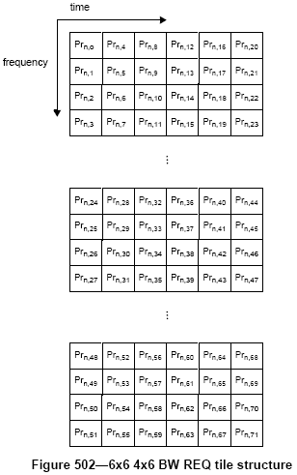

--------------------------------------------- Text End --------------------------------------------------------

- Reference
[1] IEEE 802.16m System Requirements Document, IEEE 802.16m-07/002r8, January 2009.
[2] IEEE 802.16m Evaluation Methodology Document, IEEE 802.16m-08/004r5, January 2009.
[3] IEEE 802.16m Amendment Working Document, IEEE 802.16m-09/0010r2, May 2009.
[4] C80216m-09_1452, “BW REQ preamble”, LG Electronics

