Project | IEEE 802.16 Broadband Wireless Access Working Group <http://ieee802.org/16>
Title | Proposed Message Format for AAI_NBR-ADV (AWD-15.2.5.4)
Date Submitted | 2009-07-06
Source(s) | Yih-Shen Chen, Kelvin Chou, I-Kang Fu  MediaTek Inc.  Yung-Han Chen, Frank Ren  ITRI | yihshen.Chen@mediatek.com, kelvin.Chou@mediatek.com  chenyunghan@itri.org.tw, frank_ren@itri.org.tw  *<http://standards.ieee.org/faqs/affiliationFAQ.html>
Re: | “802.16m amendment working document”:  IEEE 802.16m-09/0028r1, “Call for Comments and Contributions on Project 802.16m
Abstract | This contribution proposes the message format of AAI_NBR-ADV.
Purpose | To be discussed and adopted by TGm for the 802.16m AWD
Notice | This document does not represent the agreed views of the IEEE 802.16 Working Group or any of its subgroups. It represents only the views of the participants listed in the “Source(s)” field above. It is offered as a basis for discussion. It is not binding on the contributor(s), who reserve(s) the right to add, amend or withdraw material contained herein.
Release | The contributor grants a free, irrevocable license to the IEEE to incorporate material contained in this contribution, and any modifications thereof, in the creation of an IEEE Standards publication; to copyright in the IEEE’s name any IEEE Standards publication even though it may include portions of this contribution; and at the IEEE’s sole discretion to permit others to reproduce in whole or in part the resulting IEEE Standards publication. The contributor also acknowledges and accepts that this contribution may be made public by IEEE 802.16.
Patent Policy | The contributor is familiar with the IEEE-SA Patent Policy and Procedures:  <http://standards.ieee.org/guides/bylaws/sect6-7.html#6> and <http://standards.ieee.org/guides/opman/sect6.html#6.3>.  Further information is located at <http://standards.ieee.org/board/pat/pat-material.html> and <http://standards.ieee.org/board/pat>.

Proposed Message Format for AAI_NBR-ADV
Yih-Shen Chen, Kelvin Chou, I-Kang Fu
MediaTek Inc.
Yung-Han Chen, Frank Ren
ITRI
Introduction
This contribution proposes the details of the neighboring advertisement message (AAI_NBR-ADV). The proposed message format is based on the consensus of section 15.2.5.4 [1] and has the following features:
- BSs are sorted according to deployment type and only delta information are transmitted to reduce the message overhead.
- ABS always provides the total number of deployment types and total number of recommended T-ABS for each type. Each AAI_NBR-ADV fragment has corresponding indexes for each deployment type and each neighbor ABS.
- Only minimal set of neighboring cell information is transmitted over AAI_NBR-ADV. As for other network reentry-related necessary information, they can be obtained from SFH.
- Multicarrier configuration information is given to facilitate AMS's scanning of neighbor ABSs' fully configured carriers.

Concept Description
BS periodically broadcasts neighboring cell information message (MOB_NBR-ADV) to announce the network topology. For overhead reduction in 802.16e, it is assumed that parameters with the same value as the serving cell’s are not included in the message. Considering the requirement of 4G wireless communication network, the system should support MSs with different mobility and varieties of service requests. Network structure is highly possible to apply hierarchical or heterogeneous cell deployment. That is, a network would consist of cells with different coverage and characteristic. The volume of information to be broadcasted would be large. Therefore, an efficient neighboring cell advertisement message is required for 802.16m.
It is agreed that, in 802.16m, AAI_NBR-ADV message may sort neighbor BSs (RSs) according to their deployment types. To broadcast the message efficiently, all the cells can be categorized according to the deployment types and transmitted into segments. For each deployment type, a typical cell is chosen as a reference and the parameters of the other cells are only transmitted as delta information (Fig. 1). The deployment type can be:
- BS type (macro, micro, femto, relay, TBD)
- Carrier frequency
- MAC version
- TDD/FDD
- BW, CP info
- Multi-carrier capability and configuration
Another aspect of overhead reduction is to reduce the information types to be carried in AAI_NBR-ADV. System information, such as DCD and UCD contents, are transmitted as optional parameters in MOB_NBR-ADV. However, superframe header (SFH) is designed in 802.16m to periodically broadcast necessary system information for quick network entry. It would be unnecessary to broadcast the same system information twice (i.e., both in SFH and AAI_NBR-ADV). For facilitating prioritization in cell scanning [2], only minimal set information (such as: SCH preamble index, bandwidth, multi-carrier capability, cell loading and etc) are required to be embodied in AAI_NBR-ADV. Note that, SCH and SFH are TDM in a frame structure. It would be possible that MS decodes the system information in SFH while scanning the SCH, as shown in Fig. 2.

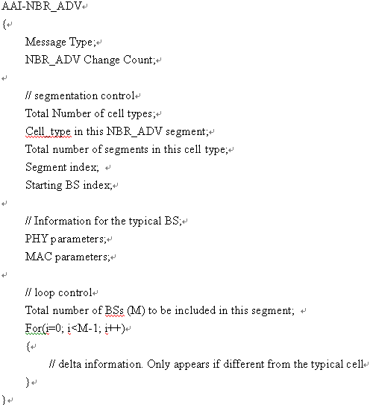
Fig. 1: High-level description of the message format

Fig. 2: Example of decoding SFH during scanning
Proposed AWD Text Changes
Remedy 1
On the 16m AWD 80216m-09_0010r2, page 20, line 15, make the following changes to subsection 15.2.5.4:
-------------------------------------------------- Text Start -----------------------------------------------------------------

15.2.5.4 AAI_NBR-ADV
Table XXX—AAI_NBR-ADV message format
Syntax | Size (bit) | Note
AAI_NBR-ADV_Message_format() { | — | —
Management Message Type = NN | 8 | —
Change Count | 3 | NBR-ADV change count
Number of cell type | 3
Cell type in this message | 3
Total Number of Segments | TBD | Number of segments for this cell type
Segment Index | TBD | Segment index of this message in the specific cell type
Total number of BSs (M) to be included in this segment | TBD
Index of starting BS | TBD | The index of the first BS in the message
FA information | TBD
BW information | 2 | 0b00: 5M, 0b01: 10M, 0b10: 20M, 0b11: Reserved
MAC protocol version | TBD
Duplex Mode | 2 | TDD, FDD, HFDD
BSID | 48
SCH info | TBD
BS EIRP | TBD
Cell load | TBD
HO ranging configuration | TBD
Multicarrier capability indication (MCI) | 1
If (MCI = 1)
{
Number of carriers (NC) | 3 | Multi-carrier info for fully configured carriers
For(i=0; i<NC; i++)
{
Physical Carrier Index | TBD
Center Frequency | TBD
Channel Bandwidth | 2
Duplexing Mode | TBD
Preamble Index | TBD
}
}
for (i=0; i<M; i++) | — | Information for the other BSs
{
BSID | 48
SCH info | TBD
Control_bitmap | TBD
If( Control_bitmap[0] ==1 )
{
BS EIRP | TBD
}
If( Control_bitmap[1] ==1 )
{
Cell load | TBD
}
If( Control_bitmap[2] ==1 )
{
HO ranging configuration | TBD | // ranging info for seamless handover
}
If( Control_bitmap[3] ==1 )
{
Number of carriers (NC) | 3
For(i=0; i<NC; i++)
{
Physical Carrier Index | TBD
Center Frequency | TBD
Channel Bandwidth | 2
Duplexing Mode | 2
Preamble Index | TBD
}
}
} | — | —
} | — | —

------------------------------------------------------ Text End ---------------------------------------------------------------
Reference
[1] IEEE 802.16m-09/0010r2, “Part 16: Air Interface for Fixed and Mobile Broadband Wireless Access Systems (working document)”
[2] IEEE 802.16m-09/003r9a, “IEEE 802.16m System Description Document”

