Project | IEEE 802.16 Broadband Wireless Access Working Group <http://ieee802.org/16>
Title | Proposed AWD Text on the Ranging Channels (AWD-15.3.9.1.4/15.3.9.2.4)
Date Submitted | 2009-07-06
Source(s) | HyunWoo Lee, Jin Sam Kwak, HanGyu Cho, Young-Hyoun Kwon  LG Electronics | Voice: +82-31-450-7902  E-mail: camille@lge.com, samji@lge.com, hgcho@lge.com
Re: | IEEE 80216m-09/0028r1, “Call for Comments and Contributions on Project 802.16m Amendment Content”  AWD-15.3.9.1.4/15.3.9.2.4
Abstract | This contribution proposes the text of ranging channel section to be included in the IEEE 802.16m AWD.
Purpose | To be discussed and adopted by TGm for the IEEE 802.16m AWD
Notice | This document does not represent the agreed views of the IEEE 802.16 Working Group or any of its subgroups. It represents only the views of the participants listed in the “Source(s)” field above. It is offered as a basis for discussion. It is not binding on the contributor(s), who reserve(s) the right to add, amend or withdraw material contained herein.
Release | The contributor grants a free, irrevocable license to the IEEE to incorporate material contained in this contribution, and any modifications thereof, in the creation of an IEEE Standards publication; to copyright in the IEEE’s name any IEEE Standards publication even though it may include portions of this contribution; and at the IEEE’s sole discretion to permit others to reproduce in whole or in part the resulting IEEE Standards publication. The contributor also acknowledges and accepts that this contribution may be made public by IEEE 802.16.
Patent Policy | The contributor is familiar with the IEEE-SA Patent Policy and Procedures:  <http://standards.ieee.org/guides/bylaws/sect6-7.html#6> and <http://standards.ieee.org/guides/opman/sect6.html#6.3>.  Further information is located at <http://standards.ieee.org/board/pat/pat-material.html> and <http://standards.ieee.org/board/pat>.
Proposed AWD Text on the Ranging Channels
(AWD-15.3.9.1.4/15.3.9.2.4)
HyunWoo Lee, Jin Sam Kwak, HanGyu Cho, and Young-Hyoun Kwon
LG Electronics

1. Introduction
This contribution proposes the text of ranging channel section to be included in IEEE 802.16m AWD [1]. The proposed text is developed in order to be readily combined with IEEE Std 802.16-2009 [2]. It is also based on the proposed text in [3-6] as compliant to the 802.16m SRD [7] and the 802.16m SDD [8]. The details of consideration on the ranging channels are addressed in [6].

Reference
[1] IEEE 802.16m-09/0010r2, “IEEE 802.16m Amendment Working Document,” June 2009.
[2] IEEE Std 802.16-2009, “IEEE Standard for Local and metropolitan area networks: Part 16: Air Interface for Broadband Wireless Access Systems,” May 2009.
[3] IEEE C802.16m-09/1091r1, “Considerations on the Non-Synchronized Ranging Channels,” April 2009.
[4] IEEE 802.16m-09/1093, “Proposed AWD Text on the Ranging Codes for Non-synchronized AMSs,” April 2009.
[5] IEEE C802.16m-09/1094, “Proposed AWD Text on the Ranging Configurations for Non-synchronized AMSs,” April 2009.
[6] IEEE C802.16m-09/1501, “Considerations on the Ranging Channels (AWD-15.3.9.1.4/15.3.9.2.4),” July 2009.
[7] IEEE 802.16m-07/002r8, “IEEE 802.16m System Requirements,” January 2009.
[8] IEEE 802.16m-08/003r9a, “IEEE 802.16m System Description Document,” May 2009.

Text proposal for inclusion in the 802.16m amendment

[ ------------------------------------ Text Proposal #1 ---------------------------------- ]
----------------------------------------------------------------------------------------------------------------------------------------------------------------
Black text: current text in the subclause 15.3.9.1.4 Ranging channel Structure for Non-synchronized AMSs of [1]
Red Strike through Text: Deleted
Blue text: new text
[Bracketed Italic text]: Informative
------------------------------------------------------------------------- Text Start --------------------------------------------------------------------------
[Modify the following text in the 15.3.9.1.4.1 Ranging Channel Structure for Non-synchronized AMSs]

Ranging Channel Structure for Non-synchronized AMSs

The ranging channel for non-synchronized AMSs is used for initial network entry and association and for ranging against a target BS during handover.
A physical ranging channel for non-synchronized AMSs consists of the ranging preamble (RP) with length of T_{RP} depending on the ranging subcarrier spacing ∆f_{RP,} and the ranging cyclic prefix (RCP) with length of T_{RCP} in the time domain.
A ranging channel occupies a localized bandwidth corresponding to the 1 subband.
Power control operation described in subclause [TBD] applies to ranging signal transmission.
illustrates the ranging channel structures in the time domain.
(a) Structure 1
(b) Structure 2
- Structure 3
- Structure 4
Figure 500 - The ranging channel structures in the time domain

Error: Reference source not found contains ranging channel formats and parameters.
Table 721 - Ranging Channel Formats and Parameters
Format No. | Ranging Channel Structure | T_{RCP} | T_{RP} | ∆f_{RP}
0 | Structure 1 | T_{g} + k×T_{b} ^{(a)} | 2×T_{b} | ∆f / 2
1 | Structure 3 | T_{g} + k×T_{b} ^{(a)} | 2×T_{b} | ∆f / 2
2 | Structure 2 | m×T_{g} + n×T_{b} ^{(b)} | 2×2×T_{b} ^{(c)} | ∆f / 2
3 | Structure 3 | 7×T_{g} + T_{b} | 8×T_{b} | ∆f / 8
4 | Structure 4 | T_{g} | T_{b} | ∆f
where T_{s}, T_{b}, T_{g} and ∆f are defined in Section 15.3.2.4 Derived parameters.
(a): The T_{RCP} for Formats 0 and 1 depends on OFDMA parameters, subframe types as follows:
N_{sym} is the number of OFDMA symbols in a subframe as defined in Section 15.3.8.1 Physical and logical resource unit. F_{s} and N_{FFT} are defined in Section 15.3.2.4 Derived parameters.
(b): The T_{RCP} for Formats 2 depends on OFDMA parameters, subframe types as follows:
N_{sym} is the number of OFDMA symbols in a subframe as defined in Section 15.3.8.1 Physical and logical resource unit.
(cb): T_{RP} for Format 2 denotes the total length of repeated ranging preamble.

In the ranging channel Format 0, the repeated RCPs and RPs are used as a single time ranging opportunity within a subframe in (a). Format 2 consists of a single RCP and repeated RPs within a subframe. Format 1 consists of a single RCP and RP which is a part of the Format 0. When Format 1 is used, there are two time opportunities within a subframe. Format 3 has the same structure with Forma 1 but its length is different. RP1, RP2, RP3, and RP4 in Format 4 are constructed by the first portion, second portion, third portion, and the last portion of the ranging sequences [the detail is TBD depending on the ranging sequences], respectively.

When the ranging channel format is configured as Format 0, 2, 3, 4, or Format 1 using the first time-opportunity in the time domain, the transmission start time of the ranging channel is aligned with the UL subframe start time at the AMS. For the Format 1 using the second time-opportunity, the transmission of the ranging channel starts at T_{RCP}+T_{RP} in Format 1 after the start time of first time-opportunity.
------------------------------------------------------------------------- Text End ---------------------------------------------------------------------------

------------------------------------------------------------------------- Text End ---------------------------------------------------------------------------

[ ------------------------------------ Text Proposal #2 ---------------------------------- ]
----------------------------------------------------------------------------------------------------------------------------------------------------------------
Black text: current text in the subclause 15.3.9.1.4 Ranging channel of [1]
Red Strike through Text: Deleted
Blue text: new text
[Bracketed Italic text]: Informative
------------------------------------------------------------------------- Text Start --------------------------------------------------------------------------
[add the following text in the bottom of 15.3.9.1.4.1 Ranging Channel Structure for Non-synchronized AMSs]
< Option 1 >
When frame structure is supporting the WirelessMAN-OFDMA MSs in UL PUSC zone by FDM manner as defined in 15.3.3.4, the ranging channel structure for WirelessMAN-OFDMA MSs is used for AMSs with different code set. Within the UL PUSC subchannels allocated for WirelessMAN-OFDMA MSs, the first 2 UL symbols are occupied for the structure in Figure 253 (8.4.7.1 Initial ranging and HO ranging transmissions) for AMS initial/handover ranging and the last 1 symbol is occupied for the structure in Figure 255(8.4.7.2 Periodic ranging and BR transmissions) for AMS periodic ranging. The ranging channel for FDM-based UL PUSC Zone Support is composed of 6 DRUs by using the symbol structure defined in 15.3.8.3.5.1 Basic Symbol Structure for FDM based UL PUSC Zone Support.
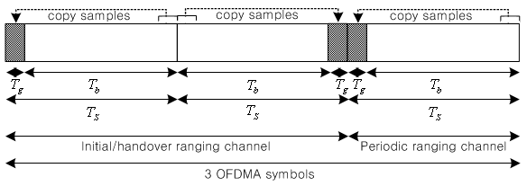
Figure xxx. Ranging channel structures and allocations for FDM-based UL PUSC Zone Support

[Add the following text at the bottom of ‘15.3.9.2.4.1 ranging preamble codes’ (before‘15.3.9.2.4.2 Ranging channel configurations’)]
When frame structure is supporting the WirelessMAN-OFDMA MSs in UL PUSC zone by FDM manner as defined in 15.3.3.4, the ranging codes for WirelessMAN-OFDMA in the 8.4.7.3 Ranging codes are used and assigned for AMSs with different codes in order to distinguish between WirelessMAN-OFDMA MS and AMS. Using the seed of PRBS generator and the last code index used by WirelessMAN-OFDMA MSs, S_{AMS}, is indicated by S-SFH as defined by S_{AMS} = 144×((N+M+L+O+S) mod 256) as described in 8.4.7.3 Ranging codes. The length of ranging code is 144 for FDM-based UL PUSC Zone Support.
— The first N_{AMS} codes produced are for initial ranging. Clock the PRBS generator 144 × (S_{AMS} mod 256) times to 144 × ((S_{AMS} + N_{AMS}) mod 256) – 1 times.
— The next M_{AMS} codes produced are for periodic ranging. Clock the PRBS generator 144 × ((N_{AMS} + S_{AMS}) mod 256) times to 144 × ((N_{AMS} + M_{AMS} + S_{AMS}) mod 256) – 1 times.
— The next O_{AMS} codes produced are for HO ranging. Clock the PRBS generator 144 × ((N_{AMS} + M_{AMS} + S_{AMS}) mod 256) times to 144 × ((N_{AMS} + M_{AMS} + O_{AMS} + S_{AMS}) mod 256) – 1 times.

<Option 2>
When frame structure is supporting the WirelessMAN-OFDMA MSs in UL PUSC zone by FDM manner as defined in 15.3.3.4, the ranging channel for AMSs is allocated in the UL PUSC zone for AMSs. The ranging channel for FDM-based UL PUSC Zone Support is composed of 4 DRUs by using the symbol structure defined in 15.3.8.3.5.1 Basic Symbol Structure for FDM based UL PUSC Zone Support.. Within the allocated subchannels for AMSs, first 4 symbols in a UL subframe are occupied for the initial/handover ranging structure in Figure 254 (8.4.7.1 Initial ranging and HO ranging transmissions). The last 2 symbols in the same UL subframe are occupied for the periodic ranging in Figure 253 (8.4.7.1 Initial ranging and HO ranging transmissions).
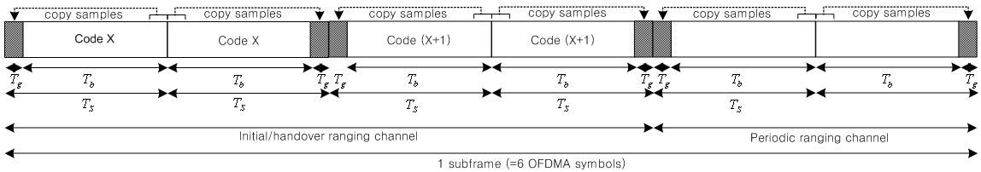
Figure xxx. Ranging channel structures and allocations for FDM based UL PUSC Zone Support

[Add the following text at the bottom of ‘15.3.9.2.4.1 ranging preamble codes’ (before‘15.3.9.2.4.2 Ranging channel configurations’)]
When frame structure is supporting the WirelessMAN-OFDMA MSs in UL PUSC zone by FDM manner as defined in 15.3.3.4, the ranging codes for WirelessMAN-OFDMA in the 8.4.7.3 Ranging codes are used and assigned for AMSs with different codes in order to distinguish between WirelessMAN-OFDMA MS and AMS. Using the seed of PRBS generator and the last code index used by WirelessMAN-OFDMA MSs, S_{AMS}, is indicated by S-SFH as defined by S_{AMS} = 144×((N+M+L+O+S) mod 256) as described in 8.4.7.3 Ranging codes. The length of ranging code is 96 for FDM based UL PUSC Zone Support.
— The first N_{AMS} codes produced are for initial ranging. Clock the PRBS generator 96 × (S_{AMS} mod 256) times to 96 × ((S_{AMS} + N_{AMS}) mod 256) – 1 times.
— The next M_{AMS} codes produced are for periodic ranging. Clock the PRBS generator 96 × ((N_{AMS} + S_{AMS}) mod 256) times to 96 × ((N_{AMS} + M_{AMS} + S_{AMS}) mod 256) – 1 times.
— The next O_{AMS} codes produced are for HO ranging. Clock the PRBS generator 96 × ((N_{AMS} + M_{AMS} + S_{AMS}) mod 256) times to 96 × ((N_{AMS} + M_{AMS} + O_{AMS} + S_{AMS}) mod 256) – 1 times.
------------------------------------------------------------------------- Text End ---------------------------------------------------------------------------

[ ------------------------------------ Text Proposal #3 ---------------------------------- ]
----------------------------------------------------------------------------------------------------------------------------------------------------------------
Black text: current text in the subclause 15.3.9.1.4 Ranging channel of [1]
Red Strike through Text: Deleted
Blue text: new text
[Bracketed Italic text]: Informative
------------------------------------------------------------------------- Text Start --------------------------------------------------------------------------
[Modify the following text in the 15.3.9.1.4.2 Ranging Channel Structure for synchronized AMSs]

Ranging Channel Structure for synchronized AMSs
The ranging channel for synchronized AMSs is used for periodic ranging. Only the AMSs that are already synchronized to the target ABS are allowed to transmit the periodic ranging signal.
The physical structure in the ranging channel for synchronized AMSs is the same with the physical ranging channel for non-synchronized AMSs. The ranging preamble codes in 15.3.9.2.4.1 is used for synchronized AMSs by allocating different codes from non-synchronized AMSs.
Power control operation described in subclause [TBD] applies to ranging signal transmission.
------------------------------------------------------------------------- Text End ---------------------------------------------------------------------------

[ ------------------------------------ Text Proposal #4 ---------------------------------- ]------------------------------------------------------------------------- Text Start --------------------------------------------------------------------------
[Modify the following text in the top of ‘15.3.9.2.4 Ranging channel’.]

Ranging channel

Ranging channel for non-synchronized AMSs
15.3.9.2.4.1.1 Ranging preamble codes
The ranging preamble codes are classified into initial ranging and handover ranging preamble codes. The initial ranging preamble codes shall be used for initial network entry and association. Handover ranging preamble codes shall be used for ranging against a target ABS during handover. For a ranging code opportunity, each AMS randomly chooses one of the ranging preamble codes from the available ranging preamble codes set in a cell.
The Zadoff-Chu sequences with cyclic shifts are used for the ranging preamble codes. The p^{th} ranging preamble code x_{p}(k) is defined by
(xxx)
where
p is the index for p^{th} ranging preamble code which is made as the s^{th} cyclic shifted sequence from the root index r of Zadoff-Chu sequence.
N_{CS} is the unit of cyclic shift according to the cell size and is defined in Table yyy.
N_{RP} is the length of ranging preamble codes and it defined by N_{RP} =139 for ranging channel Format 0, 1, and 2 in Table 721 and N_{RP} =557 for ranging channel Format 3 in Table 721.
Table yyy. The unit of cyclic shift
index | 0 | 1 | 2 | 3 | 4 | 5 | 6 | 7 | 8 | 9 | 10 | 11 | 12 | 13 | 14 | 15
N_{CS} |  |  |  |  |  |  |  |  |  |  |  |  |  |  |  | 0
[Exact values is TBD except the last index (0 denotes no cyclic shift).]

The root index of ZC code, the unit of cyclic shift, and number of code for each purpose (initial, handover, and periodic ranging) are broadcasted by S-SFH. There are N_{TOTAL} (=N_{IN} + N_{HO} + N_{PE}) preamble codes available in a sector where N_{IN}, N_{HO}, and N_{PE} are the number of codes for initial, handover, and periodic ranging, respectively. The code set is found with the root index and available cyclic shifts of ZC code indicated by SFH in the order of increasing cyclic shift from the allocated root index. If N_{TOTAL} preamble codes can not be generated from the index, the remaining code set is found sequentially by using all the available cyclic shifts of a ZC code with the increased root index until the N_{TOTAL} preamble codes are met. When the increased root index is N_{ZC}, the increased root index is set to 1.

[Insert the subclause number as follow:]
15.3.9.2.4.1.2 Ranging channel configurations

[Insert the subclause number as follow:]
15.3.9.2.4.1.3 Ranging signal transmission
<<Eqn. UL- 7>>Equation 243 specifies the transmitted signal voltage to the antenna, as a function of time, during ranging channel format 0, 1, 2 or 3.
…
------------------------------------------------------------------------- Text End ---------------------------------------------------------------------------

[ ------------------------------------ Text Proposal #5 ---------------------------------- ]------------------------------------------------------------------------- Text Start --------------------------------------------------------------------------
[Modify the following text in the middle of ‘15.3.9.2.4 Ranging channel’.]

Ranging channel

Ranging channel for non-synchronized AMSs
15.3.9.2.4.1 Ranging preamble codes
The ranging preamble codes are classified into initial ranging and handover ranging preamble codes. The initial ranging preamble codes shall be used for initial network entry and association. Handover ranging preamble codes shall be used for ranging against a target ABS during handover. For a ranging code opportunity, each AMS randomly chooses one of the ranging preamble codes from the available ranging preamble codes set in a cell.

[Insert the subclause number as follow:]
15.3.9.2.4.2 Ranging channel configurations
The information for ranging time/frequency resource allocation is indicated by the S-SFH. The ranging channel configuration information in the S-SFH consists of the frame-period (P_{F}) and subframe-period (P_{SF}) with subframe-offset (O_{SF}) for ranging resource allocation in the time domain, and the starting subband position (k₀) in the units of subband for ranging allocation in the frequency domain. Within a superframe, the ranging channels are allocated from the P_{F}^{th} frame in every frame (0th, 1st, 2nd, and 3rd frame) if P_{F}=0, at every odd frame (1st, 3rd frame) if P_{F}=1, or at only one frame (2nd frame) if P_{F}=2. Within the allocated frame, (P_{SF}+1) ranging channels are allocated from the O_{SF}^{th} UL subframe with period of P_{SF} in the FDD mode. In the TDD mode, the ranging channels are allocated in the consecutive P_{SF} subframes from the O_{SF}^{th} UL subframe. The start subframe index, S_{SF}, for ranging channel allocation in the frame are obtained by Equation xxx
(xxx)
where N_{SF} is the minimum number of subframes among frames and the number of subframes per frame is defined in the subclause 15.3.3.1. Basic Frame Structure. For the TDD, N_{UL} is the number of UL subframes such as 2, 3, 4, or 5 for 6:2, 5:3, 4:4, or 3:5 DL:UL ratio, respectively.
Table xxx shows the ranging channel configurations, which is indicated by the S-SFH.
Table xxx. Ranging channel configurations
Configuration No. | P_{F} | P_{SF} | No. of ranging channel per superframe
0 | 0 | 0 | 4
1 | 0 | 1 | 8
2 | 1 | 0 | 2
3 | 2 | 0 | 1

The occupied resource for a ranging channel is defined as N_{r1} subframes by N_{r2} subbands. For Format 0, 1, and 2, N_{r1} = 1. For Format 3, N_{r1} = 3. The unit of N_{r2} is 1 subband for all ranging formats. Figure zzz shows an example of ranging channel allocation.
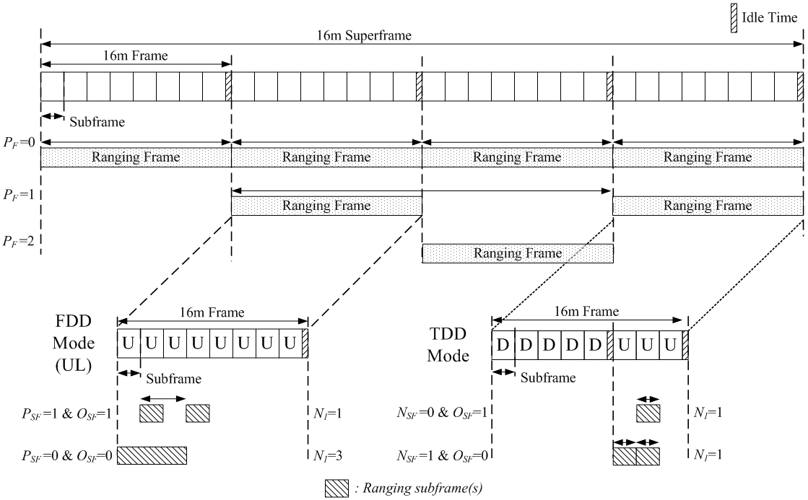
Figure zzz. The example of ranging channel allocation in time domain for FDD and TDD modes.
When the ranging channel is Format 1, each AMS randomly selects one of 2 time opportunities in the subframe. Each AMS randomly selects a code-opportunity from the available ranging code set in a sector defined in Subclause 15.3.9.2.4.1.1 Ranging preamble codes.

[Insert the subclause number as follow:]
15.3.9.2.4.3 Ranging signal transmission
<<Eqn. UL- 7>>Equation 243 specifies the transmitted signal voltage to the antenna, as a function of time, during ranging channel format 0, 1, 2 or 3.
…
------------------------------------------------------------------------- Text End ---------------------------------------------------------------------------

