Project | IEEE 802.16 Broadband Wireless Access Working Group <http://ieee802.org/16>
Title | Proposed AWD Text on the Ranging Channels (AWD-15.3.9.1.4/15.3.9.2.4)
Date Submitted | 2009-07-06
Source(s) | HyunWoo Lee, Jin Sam Kwak, HanGyu Cho, Young-Hyoun Kwon  LG Electronics  Xinrong Wang, Yang-Seok Choi, Xiangying Yang, Jong-Kae Fwu, Hujun Yin  Intel Corporation  Hwasun Yoo, Si-Hyun Park, Jaehee Cho, Heewon Kang  Samsung Electronics  Yih-Shen Chen, Pei-Kai Liao and Paul Cheng  MediaTek Inc.  Yan-Xiu Zheng  ITRI | Voice: +82-31-450-7902  E-mail: camille@lge.com, samji@lge.com, hgcho@lge.com  xinrong.wang@intel.com, yang-seok.choi@intel.com  hwasun.yoo@samsung.com  yihshen.chen@mediatek.com, pk.liao@mediatek.com  zhengyangxiu@itri.org.tw
Re: | IEEE 80216m-09/0028r1, “Call for Comments and Contributions on Project 802.16m Amendment Content”  AWD-15.3.9.1.4/15.3.9.2.4
Abstract | This contribution proposes the text of ranging channel section to be included in the IEEE 802.16m AWD.
Purpose | To be discussed and adopted by TGm for the IEEE 802.16m AWD
Notice | This document does not represent the agreed views of the IEEE 802.16 Working Group or any of its subgroups. It represents only the views of the participants listed in the “Source(s)” field above. It is offered as a basis for discussion. It is not binding on the contributor(s), who reserve(s) the right to add, amend or withdraw material contained herein.
Release | The contributor grants a free, irrevocable license to the IEEE to incorporate material contained in this contribution, and any modifications thereof, in the creation of an IEEE Standards publication; to copyright in the IEEE’s name any IEEE Standards publication even though it may include portions of this contribution; and at the IEEE’s sole discretion to permit others to reproduce in whole or in part the resulting IEEE Standards publication. The contributor also acknowledges and accepts that this contribution may be made public by IEEE 802.16.
Patent Policy | The contributor is familiar with the IEEE-SA Patent Policy and Procedures:  <http://standards.ieee.org/guides/bylaws/sect6-7.html#6> and <http://standards.ieee.org/guides/opman/sect6.html#6.3>.  Further information is located at <http://standards.ieee.org/board/pat/pat-material.html> and <http://standards.ieee.org/board/pat>.
Proposed AWD Text on the Ranging Channels
(AWD-15.3.9.1.4/15.3.9.2.4)

HyunWoo Lee, Jin Sam Kwak, HanGyu Cho, and Young-Hyoun Kwon
LG Electronics

Xinrong Wang, Yang-Seok Choi, Xiangying Yang, Jong-Kae Fwu, Hujun Yin
Intel Corporation

Hwasun Yoo, Si-Hyun Park, Jaehee Cho, Heewon Kang
Samsung Electronics

Yih-Shen Chen, Pei-Kai Liao and Paul Cheng
MediaTek Inc.

Yan-Xiu Zheng
ITRI

1. Introduction
This contribution proposes the text of ranging channel section to be included in IEEE 802.16m AWD [1]. The proposed text is developed in order to be readily combined with IEEE Std 802.16-2009 [2]. It is also based on the proposed text in [3-6] as compliant to the 802.16m SRD [7] and the 802.16m SDD [8]. The details of consideration on the ranging channels are addressed in [6].

Reference
[1] IEEE 802.16m-09/0010r2, “IEEE 802.16m Amendment Working Document,” June 2009.
[2] IEEE Std 802.16-2009, “IEEE Standard for Local and metropolitan area networks: Part 16: Air Interface for Broadband Wireless Access Systems,” May 2009.
[3] IEEE C802.16m-09/1091r1, “Considerations on the Non-Synchronized Ranging Channels,” April 2009.
[4] IEEE 802.16m-09/1093, “Proposed AWD Text on the Ranging Codes for Non-synchronized AMSs,” April 2009.
[5] IEEE C802.16m-09/1094, “Proposed AWD Text on the Ranging Configurations for Non-synchronized AMSs,” April 2009.
[6] IEEE C802.16m-09/1501, “Considerations on the Ranging Channels (AWD-15.3.9.1.4/15.3.9.2.4),” July 2009.
[7] IEEE 802.16m-07/002r8, “IEEE 802.16m System Requirements,” January 2009.
[8] IEEE 802.16m-08/003r9a, “IEEE 802.16m System Description Document,” May 2009.

Text proposal for inclusion in the 802.16m amendment

[ ------------------------------------ Text Proposal #1 ---------------------------------- ]
----------------------------------------------------------------------------------------------------------------------------------------------------------------
Black text: current text in the subclause 15.3.9.1.4 and 15.3.9.2.4 of [1]
Red Strike through Text: Deleted
Blue text: new text
[Bracketed Italic text]: Informative
------------------------------------------------------------------------- Text Start --------------------------------------------------------------------------

[Modify the following text in the 15.3.9.1.4 Ranging Channel]

Ranging Channel Structure for Non-synchronized AMSs
The UL ranging channel is used for UL synchronization. The UL ranging channel can be further classified into ranging channel for non-synchronized and synchronized AMSs. The ranging channel for synchronized AMSs is used for periodic ranging. The ranging channel for non-synchronized AMSs is used for initial access and handover.

Ranging Channel Structure for Non-synchronized AMSs

The ranging channel for non-synchronized AMSs is used for initial network entry and association and for ranging against a target BS during handover.
A physical ranging channel for non-synchronized AMSs consists of the ranging preamble (RP) with length of T_{RP} depending on the ranging subcarrier spacing ∆f_{RP,} and the ranging cyclic prefix (RCP) with length of T_{RCP} in the time domain.
A ranging channel occupies a localized bandwidth corresponding to the 1 subband.
Power control operation described in subclause [TBD]15.3.9.4.3 applies to ranging signal transmission.
illustrates the ranging channel structures in the time domain.
(a) Structure 1
(b) Structure 2
- Structure 3
- Structure 4
Figure 500 - The ranging channel structures in the time domain
Error: Reference source not found contains ranging channel formats and parameters.
Table 721 - Ranging Channel Formats and Parameters
Format No. | Ranging Channel Structure | T_{RCP} | T_{RP} | ∆f_{RP}
0 | Structure 1 | T_{g} + k×T_{b} ^{(a)} | 2×T_{b} | ∆f / 2
10 | Structure 3 | T_{g} + k×T_{b} ^{(a)} | 2×T_{b} | ∆f / 2
2 | Structure 2 | m×T_{g} + n×T_{b} ^{(b)} | 2×2×T_{b} ^{(c)} | ∆f / 2
31 | Structure 3 | 7×3.5×T_{g} + 7×T_{b} | 8×T_{b} | ∆f / 8
4 | Structure 4 | T_{g} | T_{b} | ∆f
where T_{s}, T_{b}, T_{g} and ∆f are defined in Section 15.3.2.4 Derived parameters.
(a): The T_{RCP} for Formats 0 and 1 depends on OFDMA parameters, subframe types as follows:
N_{sym} is the number of OFDMA symbols in a subframe as defined in Section 15.3.8.1 Physical and logical resource unit. T_{g}, F_{s} and N_{FFT} are defined in Section 15.3.2.4 Derived parameters.
(b): The T_{RCP} for Formats 2 depends on OFDMA parameters, subframe types as follows:
N_{sym} is the number of OFDMA symbols in a subframe as defined in Section 15.3.8.1 Physical and logical resource unit.
(c): T_{RP} for Format 2 denotes the total length of repeated ranging preamble.

In the ranging channel Format 0, the repeated RCPs and RPs are used as a single time ranging opportunity within a subframe in (a). Format 2 consists of a single RCP and repeated RPs within a subframe. Format 1 consists of a single RCP and RP which is a part of the Format 0. When Format 10 is used, there are two time opportunities within a subframe. Format 31 has the same structure with Forma 10 but its length is different. RP1, RP2, RP3, and RP4 in Format 4 are constructed by the first portion, second portion, third portion, and the last portion of the ranging sequences [the detail is TBD depending on the ranging sequences], respectively.

Ranging channel for non-synchronized AMSs is allocated in one or three UL subframes for Format 0 or Format 1, respectively. For Format 0, there are two ranging channels allocated within a subframe. A time-domain illustration of the ranging channel allocation is shown in Figure x.1.

- Format 0
- Format 1
Figure x.1. Ranging channel allocations in subframe(s)

When the ranging channel format is configured as Format 10, 2, 3, 4, or Format 10 using the first time-opportunity in the time domain, the transmission start time of the ranging channel is aligned with the UL subframe start time at the AMS. For the Format 10 using the second time-opportunity, the transmission of the ranging channel starts at T_{RCP}+T_{RP} in Format 10 after the start time of first time-opportunity.

Ranging Channel Structure for synchronized AMSs
The ranging channel for synchronized AMSs is used for periodic ranging. Only tThe AMSs that are already synchronized to the target ABS are allowed to transmit the periodic ranging signal. For femtocell, the ranging channel for synchronized AMSs can be used for initial ranging, handover ranging, and periodic ranging.
The physical structure in the ranging channel for synchronized AMSs occupies 72 subcarriers by K OFDMA symbol time. For femtocell, K is equal to 1 and the rest of subcarriers can be used for data transmission.
Power control operation described in subclause [TBD]15.3.9.4.3 applies to ranging signal transmission.

15.3.9.1.4.3. Ranging Channel for FDM-based UL PUSC Zone Support
The ranging channel for FDM-based UL PUSC Zone Support is composed of 6 distributed LRUs by using the symbol structure defined in 15.3.8.3.5.1.
A ranging transmission for non-synchronized AMSs shall be performed during two consecutive symbols same as Figure 253 in 8.4.7.1. The same ranging code is transmitted on the ranging channel during each symbol, with no phase discontinuity between the two symbols. A time-domain illustration of the ranging transmission for non-synchronized AMSs is shown in Figure x.2 (a).
A ranging transmission for synchronized AMSs shall be performed during a symbol same as Figure 255 in 8.4.7.2. A time-domain illustration of the ranging transmission for synchronized AMSs is shown in Figure x.2 (b).
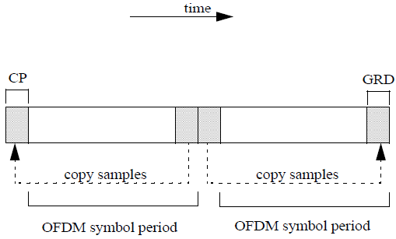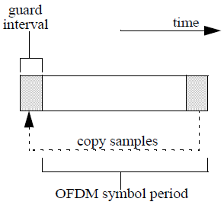
- Ranging channel for non-synchronized AMSs (b) Ranging channel structure for synchronized AMSs
Figure x.2. Ranging channel structure for FDM-based UL PUSC Zone Support
For ranging channel for non-synchronized AMSs, the transmitted signal is according to 15.3.2.5, Equation (173), except that 0≤t≤2T_{s}.
Ranging channels for non-synchronized AMSs and ranging channel for synchronized AMSs are allocated in a UL subframe. Within the allocated ranging subframe, first 4 symbols in a UL subframe are occupied for the ranging structure for non-synchronized AMSs. The last symbol in the same UL subframe is occupied for the ranging channel for synchronized AMSs. A time-domain illustration of the ranging subframe is shown in Figure x.3.

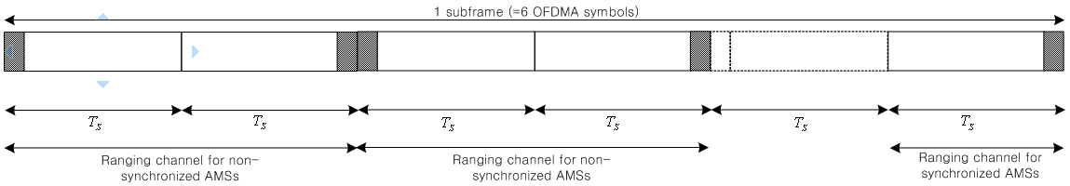
Figure x.3. Ranging channel structures and allocations for FDM based UL PUSC Zone Support

[Modify the following text in the top of ‘15.3.9.2.4 Ranging channel’.]

Ranging channel

Ranging channel for non-synchronized AMSs
15.3.9.2.4.1.1. Ranging preamble codes
The ranging preamble codes are classified into initial ranging and handover ranging preamble codes. The initial ranging preamble codes shall be used for initial network entry and association. Handover ranging preamble codes shall be used for ranging against a target ABS during handover. For a ranging code opportunity, each AMS randomly chooses one of the ranging preamble codes from the available ranging preamble codes set in a cell, except that in the handover ranging case where a dedicated ranging code is assigned, the AMS shall use the assigned dedicated preamble code.
The Zadoff-Chu sequences with cyclic shifts are used for the ranging preamble codes. The p^{th} ranging preamble code x_{p}(k) is defined by
(y.1)
where
p is the index for p^{th} ranging preamble code which is made as the s_{p}^{th} cyclic shifted sequence from the root index r_{p} of Zadoff-Chu sequence.
(y.2)
(y.3)
where r₀ is broadcasted in the S-SFH and . N_{TOTAL} is the total number of initial and handover preamble codes per sector.
N_{CS} is the unit of cyclic shift according to the cell size. It is defined by where M is the number of cyclic shifted codes per ZC root index according to Table z.1.
N_{RP} is the length of ranging preamble codes defined as N_{RP} =139 for ranging channel Format 0 in Table 721 and N_{RP} =557 for ranging channel Format 1 in Table 721.

The number of cyclic shifted codes per root index (M), The root index of ZC code (r_{p}), and the ranging preamble code partition information are broadcasted by S-SFH. The number of cyclic shifted codes per root index is defined in Table z.1. The ranging preamble code partition information indicate the number of initial and handover ranging preamble codes and is defined in Table z.2

Table z.1. The number of cyclic shifted codes per ZC root index, M
index | 0 | 1 | 2 | 3
M | 1 | 2 | 4 | 8

Table z.2. Ranging preamble code partition information table
Partition Index | 0 | 1 | 2 | 3 | 4 | 5 | 6 | 7 | 8 | 9 | 10 | 11 | 12 | 13 | 14 | 15
Number of initial ranging preamble codes | 8 | 8 | 8 | 8 | 16 | 16 | 16 | 16 | 24 | 24 | 24 | 24 | 32 | 32 | 32 | 32
Number of handover ranging preamble codes | 8 | 16 | 24 | 32 | 8 | 16 | 24 | 32 | 8 | 16 | 24 | 32 | 8 | 16 | 24 | 32

15.3.9.2.4.1.2. Ranging channel configurations
The information for ranging time resource allocation is indicated by the S-SFH in a regular allocation. The information of ranging channel allocation consists of the ranging configuration with subframe-offset (O_{SF}) for ranging resource allocation in the time domain. The information for ranging frequency resource allocation, i.e., the subband index for ranging resource allocation is determined by the Cell-ID and the allocated number of subbands K_{SB} according to the Equation (y.4).
I_{SB} = mod( Cell-ID, K_{SB}) (y.4)
where I_{SB} denotes the subband index (0,…, K_{SB}-1) for ranging resource allocation among K_{SB} subbands.,
Table z.3 shows the information of ranging channel allocation in a regular allocation, which is indicated by the S-SFH.
Table z.3. Ranging channel allocations by S-SFH
Configurations | The subframe allocating Ranging channel ⁽¹⁾
0 | O_{SF}^{th} UL subframe in every frame
1 | O_{SF}^{th} UL subframes in the first frame in every superframe
2 | O_{SF}^{th} UL subframe in the first frame in every other superframe
3 | O_{SF}^{th} UL subframe of the first frame in every 4 superframes
(1) It indicates the subframe allocating ranging channel for Format 0 and 1. For Format 1, it indicates the starting subframe for allocating ranging channel subframe in contiguous 3 subframes.
The ranging channel for handover ranging can also be allocated by AMAP based on ABS scheduling decision in any subframe, except the subframe that has already been used for a regular allocation.

15.3.9.2.4.1.3. Ranging signal transmission
<<Eqn. UL- 7>>Equation 243 specifies the transmitted signal voltage to the antenna, as a function of time, during ranging channel format 0, or 1, 2 or 3.
(243)
where
t is the elapsed time since the beginning of the subject ranging channel.
N_{RP} is the length of ranging preamble code in frequency domain.
x_{p}(n) is the p-th ranging preamble code with length N_{RP}.
K_{offset} is the parameter related to the frequency position and is defined by
N_{PRU} is the total number of PRUs as defined 15.3.8.2.1 Subband partitioning.
k₀ is the lowest PRU index of the assigned ranging channel.is logical ranging channel parameter in the frequency domain as units of N1, where N1 is the number of the adjacent PRUs within a subband as defined 15.3.8.2.1 Subband partitioning.
P_{sc} is the number of the consecutive subcarriers within a PRU in frequency domain as defined 15.3.8.1 Physical and logical resource unit.
△f_{RP} is the ranging subcarrier spacing.
T_{offset} is the parameter related to the length of ranging cyclic prefix and is defined by
The transmitted signal voltage to the antenna in Format 4 is generated by the equation (173).

15.3.9.2.4.2. Ranging channel for synchronized AMSs
Padded Zadoff-Chu code is applied for ranging preamble code, which is defined by
(y.5)
where
r is the root index of Zadoff-Chu sequence.
m is the parameter related to the cyclic shift.
N_{RP} is the length of ranging preamble codes defined as N_{RP} =71.

15.3.9.2.4.3. Ranging Channel for FDM-based UL PUSC Zone Support
When frame structure is supporting the WirelessMAN-OFDMA MSs in UL PUSC zone by FDM manner as defined in 15.3.8.3.5, the ranging codes for WirelessMAN-OFDMA in the 8.4.7.3 are used for AMSs.
The binary codes are the pseudonoise codes produced by the PRBS described in Figure x.4, which implements the polynomial generator . The PRBS generator shall be initialized by the seed b14...b0 = 0,0,1,0,1,0,1,1,s0,s1,s2,s3,s4,s5,s6, where s6 is the LSB of the PRBS seed, and s6:s0 = UL_PermBase, where s6 is the MSB of the UL_PermBase.

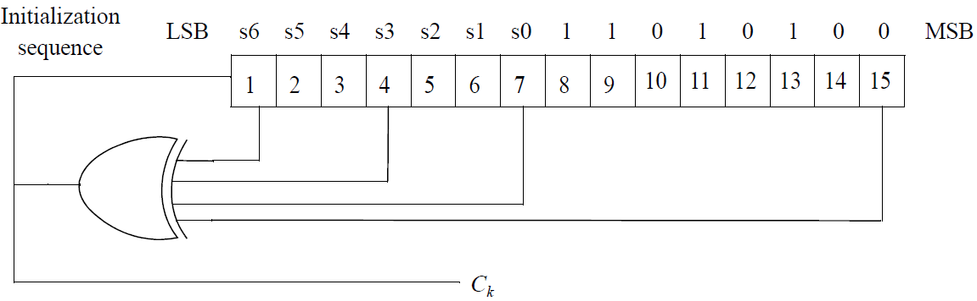
Figure x.4. PRBS generator for ranging code generation

The binary ranging codes are subsequences of the pseudonoise sequence appearing at its output C_{k}. The length of each ranging code is 144 bits. These bits are used to modulate the subcarriers in a group of six adjacent distributed LRUs, where distributed LRUs are considered adjacent if they have successive LRU numbers. The bits are mapped to the subcarriers in increasing frequency order of the subcarriers so that the lowest indexed bit modulates the subcarrier with the lowest frequency index and the highest indexed bit modulates the subcarrier with the highest frequency index. The six distributed LRUs are called a ranging LRU.

The number of available codes is 256, numbered 0, ... , 255. Each ABS uses a subgroup of these codes, where the subgroup is defined by a number S, 0≤S≤255. The group of codes shall be between S and ((S + O + N + M) mod 256).
— The first N codes produced are for initial ranging. Clock the PRBS generator 144 × (S mod 256) times to 144 × ((S + N) mod 256) – 1 times.
— The next O codes produced are for handover ranging. Clock the PRBS generator 144 × ((S + N) mod 256) times to 144 × ((S + N + O) mod 256) – 1 times.
— The next M codes produced are for periodic ranging. Clock the PRBS generator 144 × ((S + N + O) mod 256) times to 144 × ((S + N + O + M) mod 256) – 1 times.
------------------------------------------------------------------------- Text End ---------------------------------------------------------------------------

