Project | IEEE 802.16 Broadband Wireless Access Working Group <http://ieee802.org/16>
Title | Multiple Handover Parameters for Handover between Macro ABS and Macro Hot-zone ABS
Date Submitted | 2009-07-07
Source(s) | Youngbo Cho, Jaehee Cho, Jaehyuk Jang  Samsung Electronics. | Voice: +82-31-9530-7093  Fax:  youngbo.cho@samsung.com
Re: | “Call for Contributions on Project 802.16m Amendment Working Document (AWD) Content”.
Abstract | This contribution proposes the mechanism for handover between macro BS and macro hot-zone BS to be included in the 802.16m amendment working document.
Purpose | To be discussed and adopted by TGm for 802.16m amendment working document.
Notice | This document does not represent the agreed views of the IEEE 802.16 Working Group or any of its subgroups. It represents only the views of the participants listed in the “Source(s)” field above. It is offered as a basis for discussion. It is not binding on the contributor(s), who reserve(s) the right to add, amend or withdraw material contained herein.
Release | The contributor grants a free, irrevocable license to the IEEE to incorporate material contained in this contribution, and any modifications thereof, in the creation of an IEEE Standards publication; to copyright in the IEEE’s name any IEEE Standards publication even though it may include portions of this contribution; and at the IEEE’s sole discretion to permit others to reproduce in whole or in part the resulting IEEE Standards publication. The contributor also acknowledges and accepts that this contribution may be made public by IEEE 802.16.
Patent Policy | The contributor is familiar with the IEEE-SA Patent Policy and Procedures:  <http://standards.ieee.org/guides/bylaws/sect6-7.html#6> and <http://standards.ieee.org/guides/opman/sect6.html#6.3>.  Further information is located at <http://standards.ieee.org/board/pat/pat-material.html> and <http://standards.ieee.org/board/pat>.

Multiple Handover Parameters for Handover between Macro ABS and Macro Hot-zone ABS
Youngbo Cho, Jaehee Cho, Jaehyuk Jang
Samsung Electronics.

Introduction
This contribution proposes the text of handover between macro BS and macro hot-zone BS to be included in the IEEE 802.16m amendment [1]. The technical text is inherited from the IEEE 802.16m SRD [2], SDD [3], and IEEE P802.16 Rev2/D9 [4].

Introduction

Definition of macro hot-zone
A macro hot-zone ABS is a macro ABS with smaller transmission power and possibly overlaid under the coverage of another macro ABS’s with larger transmission power. A macro hot-zone has following properties:
- A macro hot-zone us macro ABS with low transmit power and smaller coverage.
- A macro hot-zone may provide public access for all active AMSs.
- A macro hot-zone ABS operates in the different or same operating frequency of the macro ABS.
- A macro hot-zone ABS may be installed in heavy traffic area.
- A macro hot-zone may provide full functions of IEEE 802.16m ABS.

A macro hot-zone is a good and simple solution to increase coverage and enhance system capacity. Capacity enhancement was evaluated in terms of throughput as shown in Table 1. Table 2 shows simulation parameters for SLS. The reference (100% in Table 1 means the throughput in macro only system) for comparing throughput performance is set to macro only system. Table 1 shows SLS results of hierarchical cell structure with one macro hot-zone ABS which is located in 0.75R from the macro ABS, where R is cell radius of macro ABS coverage. To evaluate throughput performance, interference from ABSs is considered. The number of active users in macro cell and macro hot-zone are 20, respectively.
Simulation results show that DL throughput of macro cell is slightly degraded when macro hot-zone ABS is located compared to macro only case. However, the total system DL throughput with macro hot-zone ABS is increased. Moreover, the UL throughput of macro ABS and total system throughput is greatly increased.

Table 1. SLS results
 | Macro |  | Macro hot-zone
 | Edge | Sector | Edge | Sector
DL/UL throughput in macro only | 100.0% | 100.0% | - | -
DL throughput with macro hot-zone | 95.1% | 98.1% | 168.9% | 179.4%
UL throughput with macro hot-zone | 111.4% | 112.8% | 560.8% | 159.1%

Table 2. Simulation parameters for SLS
Parameters | Value | Parameters | Value
Cell layout | (UL) Wrap around,  (DL) Center cell,  3 sectors/cell | Operating frequency | 2.5 GHz
ISD | 1.5 km | Channel bandwidth | 10 MHz
No. of MSs per sector/HZ | 20 | Tx. method | SIMO
ABS total Tx. power | 46 dBm | Frame duration | 5 ms
ABS antenna gain | 17 dBi [6] | MAP overhead | 0.2
ABS ant. 3dB beam width | 70 deg | Macro UL IoT control | Load control
MS Tx. power | 23 dBm | Outer loop power control | Yes
MS ant. Gain | 0 dBm (omni) | Target PER | 0.1
HZ ant. Gain | 0 dBm (omni) | Max no. of ReTx | 3
Cable loss (BS) | 2 dB | Channel model | ITU channel Ped-B
Path loss model (macro) | 130.19+37.6log10(R) [6] | MS speed | 3 km
Path loss model (macro hot-zone) | Urban micro cell [6] | BS noise figure | 5.0 dB
Shadowing std. dev. | 8.0 dB | MS noise figure | 7.0 dB
ABS shadowing correlation | 0.5 | Thermal noise density | -174 dBm/Hz

Requirement for Fast HO to macro hot-zone
In the hierarchical cell structure shown as Figure 1, the received signal strength level from a macro hot-zone ABS on the AMS becomes high rapidly when the AMS goes near to the macro hot-zone coverage. On the AMS connected with macro ABS, DL interference level from macro hot-zone ABS is dramatically increased at the coverage of macro hot-zone. Moreover, as shown in Figure 2, severe uplink interference is occurred on the macro hot-zone ABS due to the UL signal from macro AMSs at the coverage edge of the macro hot-zone. In macro hot-zone ABS, received signal power level between macro hot-zone AMS and macro AMS near to macro hot-zone coverage are vastly different. Therefore, it is important that fast HO to macro hot-zone ABS is carried out because seamless communication is interrupted without this fast HO.
Figure 1. DL received signal strength from macro ABS and macro hot-zone ABS on an AMS

Figure 2. DL interference to AMS and UL interference to macro hot-zone ABS in hierarchical structure

In order to realize fast and accurate HO, it is important to optimize parameters in measuring received signal levels, averaging them and comparing them. If insufficient HO parameters are applied, the HO qualities such as HO delay, ping-pong effect are degraded. As shown in Figure 1, the physical characteristics of the received signal (path-loss, shadowing, etc) from macro hot-zone ABS is very distinct from that from macro ABS.
Figure 3 shows the difference of received signal strength on an AMS with accordance to distance from the serving ABS. Figure 3(a) and (b) show the cases when the AMS moves from macro ABS to macro ABS and to macro hot-zone ABS, respectively. When the AMS moves 20 meters from the cross point (the cross point means the point when the received signal measures from the serving ABS and target ABS are same), the difference of received signal strength from macro ABSs is 0.34dB and that between macro ABS and macro hot-zone ABS is 3.52dB.

Proposed Scheme

Possible enhancement of HO process time
Proposed solution for fast HO is based on reducing HO decision delay. As shown in Figure 4, HO decision delay (cross to hysteresis margin time) consists of an averaging delay and a hysteresis margin delay. In the case of a moving average, the averaging duration with T seconds would have a constant T/2 delay because each averaged value has been made from past samples of T. On the other hand, the hysteresis margin delay depends on the hysteresis margin and variation of averaged values.

Multiple HO parameters and Preamble partitioning
From the feature of HO parameters described above, we can naturally derive a solution for HO criterion for both macro cells and macro hot-zones. As shown in Figure 5, AMS can decide HO to macro hot-zone rapidly by
- Reduction average duration of measured signal strength
  - The measurement from the macro hot-zone is robust to fast fading because signal strength increment from the macro hot-zone is faster than that from macro.
  - Unnecessary HO due to reduction average duration can be constrained by large hysteresis margin.
- Attainment time to hysteresis margin is faster than that to macro ABS
  - Because signal strength increment from the macro hot-zone is faster than that from macro.
For accurate and stable HO in both the macro cell and the macro hot-zone, a multiple HO parameters are required. This solution relies on the assumption that AMS can know whether the target ABS is macro or macro hot-zone. If cell IDs for macro and macro hot-zone are distinctive, AMS can recognize during cell search process.

- In the HO case from macro to macro ABS
- In the HO case from macro to macro hot-zone ABS
Figure 3. CINR variation in accordance with averaging duration

Figure 4. HO decision delay (Cross-to-hysteresis margin time)

Figure 5. Fast HO conditions for HO to macro hot-zone

There are 2 remedies to apply this solution in IEEE 802.16m.
- The ABS may define multiple trigger conditions by including multiple Trigger TLV encodings in DCD.
  - The trigger conditions for HO to macro and macro hot-zone shall be defined in ‘Trigger TLV for macro’ and ‘Trigger TLV for macro hot-zone’, respectively.
- Preamble partitioning for distinguish the ABS type
  - This solution relies on the assumption that an AMS can distinguish the ABS type of the target ABS.
  - Therefore, preamble sequences shall be partitioned and each partition is dedicated to specific base station type like Macro ABS, Macro Hot-zone ABS, OSG Femto ABS, CSG Femto ABS and etc.
  - The partition information of preamble set is broadcasted in the extended system information.
  - The AMS can differentiate the ABS type of target ABS during search process.

The ABS may define multiple trigger conditions by including Trigger TLV for corresponding ABS type in the same compound TLV, i.e., Trigger TLV for macro, Trigger TLV for macro hot-zone and Trigger TLV for femto, etc. The Trigger TLV for macro and Trigger TLV for macro hot-zone are encoded using the description in Table 3. AMS obtains trigger condition from the Trigger TLV for target ABS type. In the each Trigger TLV, trigger value, trigger averaging durations for serving ABS and target ABS are described, respectively.
The process of obtaining HO parameters is as follow:
- Serving ABS defines multiple trigger conditions.
- If the serving ABS is macro ABS,
  - Trigger TLV for macro contains the trigger condition for HO from macro to macro ABS.
  - Trigger TLV for macro hot-zone contains the trigger condition for HO from macro to macro hot-zone ABS.
- If the serving ABS is macro hot-zone ABS
  - Trigger TLV for macro contains the trigger condition for HO from macro hot-zone to macro ABS.
  - Trigger TLV for macro hot-zone contains the trigger condition for HO from macro hot-zone to macro hot-zone ABS.
- Trigger averaging duration for serving ABS may be included in the Trigger TLV for corresponding serving ABS type.
- The AMS obtains the HO parameters from the serving ABS via DCD. It includes the multiple Trigger TLVs for difference ABS types (Trigger TLV for macro, Trigger TLV for macro hot-zone, etc).
  - If the target ABS is macro, the AMS applies HO parameters which described in Trigger TLV for macro (‘ABS type’ is ‘Macro’ in Table 3).
  - If the target ABS is macro hot-zone, the AMS applies HO parameters which described in Trigger TLV for macro hot-zone (‘ABS type’ is ‘Macro Hot-zone’ in Table 3).

Table 3. Trigger TLV for ABS type description
Name | Type | Length (Bytes) | Value
ABS type | xx.1 | 1 | ABS type of target ABS for this Trigger TLV:  (Macro ABS, Macro Hot-zone ABS, Femto ABS, etc)
Type/Function/Action | xx.2 | 1 | See Table 4-for description
Trigger Value | xx.3 | 1 | Trigger value is the value used in comparing measured metric for determining a trigger condition from serving ABS to target ABS (which is defined in ABS type).
Trigger averaging duration for serving ABS | xx.4 | 1 | Trigger averaging duration for serving ABS is the time measured in number of frames over which the metric measurements are averaged.
Trigger averaging duration for target ABS | xx.5 | 1 | Trigger averaging duration for target ABS (which is defined in ABS type) is the time measured in number of frames over which the metric measurements are averaged.

The Type/function/action byte field of the trigger description in Table 3 is described in Table 4.

Table 4-Trigger; Type/Function/Action Description
Name | Length (Bits) | Value
Type | 2(MSB) | Trigger metric type:  0x0: CINR metric  0x1: RSSI metric  0x2: RTD metric  0x3: Number of missed frames metric
Function | 3 | Computation defining trigger condition:  0x0: Reserved  0x1: Metric of neighbor BS is greater than absolute value  0x2: Metric of neighbor BS is less than absolute value  0x3: Metric of neighbor BS is greater than serving BS metric by relative value  0x4: Metric of neighbor BS is less than serving BS metric by relative value  0x5: Metric of serving BS greater than absolute value  0x6: Metric of serving BS less than absolute value  0x7: Reserved  NOTE-0x1-0x4 not applicable for RTD trigger metric  NOTE-When type 0x1 is used together with function 0x3 or 0x4, the threshold value shall range from -32 dB (0x80) to +31.75 dB (0x7F). When type 0x1 is used together with function 0x1, 0x2, 0x5 or 0x6, the threshold value shall be interpreted as an unsigned byte with units of 0.25 dB, such that 0x00 is interpreted as -103.75 dBm and 0xFF is interpreted as -40 dBm  NOTE-Type 0x3 can only be used together with function 0x1 or function 0x2
Action | 3(LSB) | Action performed upon reaching trigger condition:  0x0: Reserved  0x1: Respond on trigger with AAI_SCN-RSP  0x2: Respond on trigger with AAI_HO-REQ  0x3: Respond on trigger with AAI_SCN-REQ  0x4: Declare ABS unreachable: If this ABS is the serving ABS, AMS sends AAI_HO-IND with code 0x03 to the serving ABS. If this ABS is a target ABS, the AMS needs not take immediate action when this trigger condition is met for a single ABS. The AMS shall act only when this condition is met for all target ABSs included in AAI-HO-CMD during HO execution.  0x5: Cancel HO  0x6 and 0x7: Reserved  NOTE-0x3 is not applicable when neighbor BS metrics are defined (i.e., only Function values 0x5 or 0x6 are applicable).

The process of AMS is described in Figure 6. The AMS obtains the Trigger TLV for each ABS type and the preamble partitioning information via DCD message and extended system information, respectively. If the AMS detects the preamble during cell search process, the AMS measures the signal strength for serving ABS and target ABS.
For serving ABS, the received signal strength is averaged with the value of ‘Trigger averaging duration for serving ABS’ in Trigger TLV for corresponding serving ABS type. For target ABS, the received signal strength is averaged with the value of ‘Trigger averaging duration for target ABS’ in Trigger TLV for corresponding target ABS type.
The AMS decides HO to target ABS when the Trigger condition which is described in Trigger TLV for corresponding target ABS type (for example, the signal strength measurement of the target ABS is higher than that of the serving ABS over ‘Trigger Value’) is met.

Figure 6. Flow of process on AMS

Simulation Results
Simulation result of HO was evaluated in terms of the probability of unnecessary HO and HO decision delay (which is the summation of averaging delay and hysteresis margin delay). Figure 7 shows the simulation environment (Figure 7 (a) shows the HO from macro ABS to macro ABS and Figure 7 (b) shows the HO from macro ABS to macro hot-zone ABS). The AMS connected with serving macro ABS moves to macro ABS or macro hot-zone ABS on a straight line. Table 5 shows simulation parameters. The path-loss model and shadowing factor are referred from 802.16m EMD document [6].

Table 5. Simulation parameters
Parameters | Value | Parameters | Value
Cell radius of macro ABS (R) | 866 m | Location of macro hot-zone ABS | 0.75R
Transmit power of macro ABS | 46 dBm | Transmit power of macro hot-zone ABS | 3 dBm
Shadowing std. dev. Of macro ABS | 8.0 dB [6] | Shadowing std. dev. Of macro hot-zone ABS | 4.0 dB [6]
ABS shadowing correlation | 0.5 | MS speed | 100 km/h
Path loss model (macro) | 130.19+37.6log10(R) [6]
Path loss model (macro hot-zone) | Urban micro cell model [6]

- Simulation environment of HO from macro ABS to macro ABS

- Simulation environment of HO from macro ABS to macro hot-zone ABS
Figure 7. Simulation environment

HO from macro ABS to macro ABS
The average durations of RSSI (Received Signal Strength Indication) from serving and target ABS are same and values of 50, 200, 500 ms are used. Hysteresis margin varies from 0.5 to 7.5 dB. Figure 7 shows simulation results in accordance with averaging durations and hysteresis levels. To evaluate throughput HO performance, the probability of unnecessary HO and cross-to-hysteresis margin time (HO decision delay) is considered. After proper HO from the serving macro to the target macro hot-zone ABS, additional HO attempts can be occurred unnecessarily due to ping-pong effect which is caused by fast fading. The unnecessary HO means these additional HO attempts. As shown in Figure 4, cross-to-hysteresis margin time is the delay from the time when the path-loss of serving and target ABS are crossed to the time when the trigger condition is met. When the probability of unnecessary HO is limited to 0.1, adequate HO parameters is selected as averaging duration of 500 ms and hysteresis level of 6.5 dB.
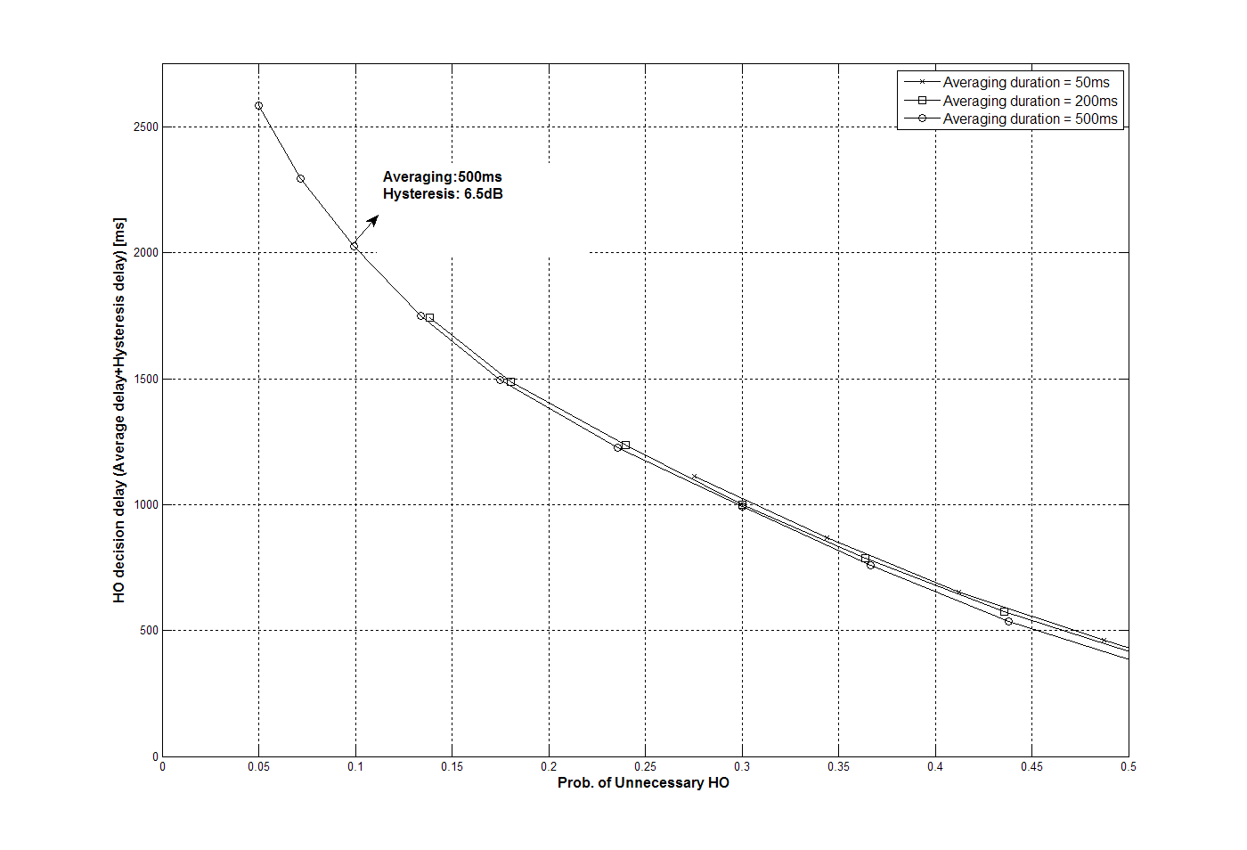
Figure 7. Simulation result for HO from macro ABS to macro ABS

HO from macro ABS to macro hot zone ABS
The average duration of RSSI (Received Signal Strength Indication) from serving ABS is fixed to 500 ms and values of 50, 200, 500 ms are used for target ABS. Hysteresis margin varies from 0.5 to 7.5 dB. Figure 8 shows simulation results in accordance with averaging durations and hysteresis levels.
When the probability of unnecessary HO is limited to 0.1, adequate averaging durations of target ABS and serving ABS are selected to 50 ms and 500 ms, respectively, hysteresis level is selected to 6 dB. When those parameters are used, the cross-to-hysteresis margin time is 490 ms on average. We designate the location of the AMS at this time to ‘HO decision point A’.
When the same HO parameters for macro ABS (averaging duration of 500 ms, hysteresis margin of 6.5 dB) are used, cross-to-hysteresis margin time is delayed about 220ms (the location of the AMS at this time to ‘HO decision point B’).
If cross-to-hysteresis margin time is delay from HO decision point A (when HO parameters optimized for HO to macro hot-zone are used) to HO decision point B (when HO parameters are same as HO to macro case), the CINR of serving ABS is degraded about 1.2 dB as shown in Figure 9. It causes the severe degradation of channel quality and may interrupt seamless communication.
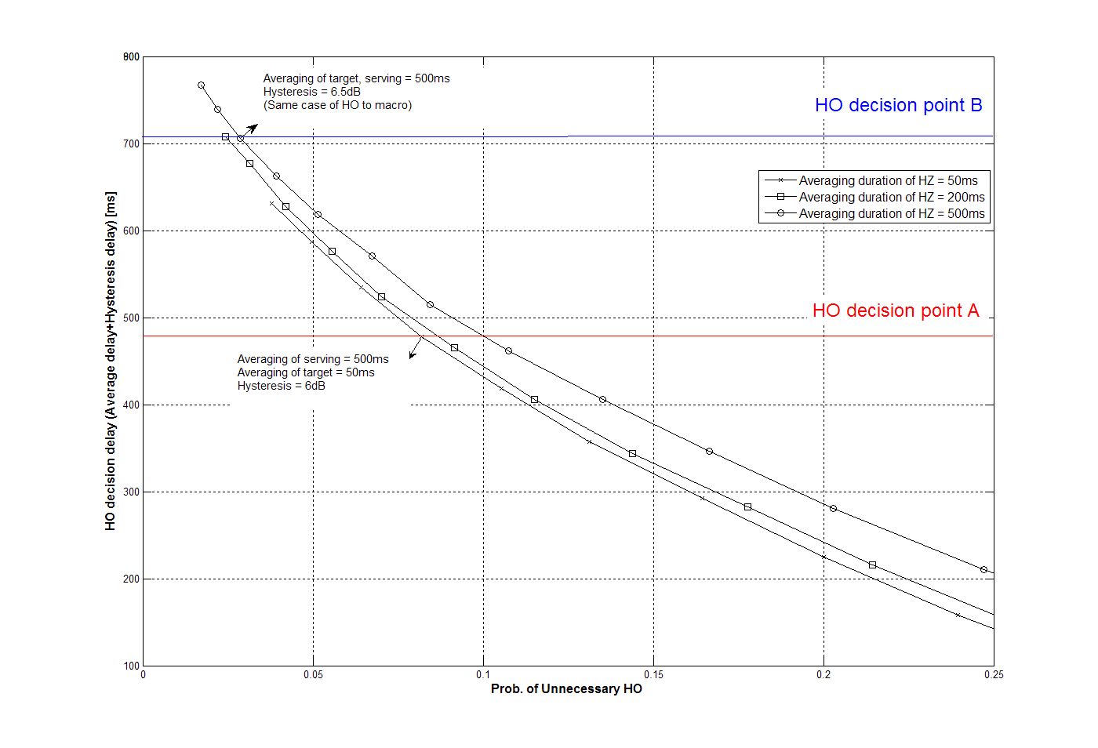
Figure 8. Simulation result for HO from macro ABS to macro hot-zone ABS

Figure 9. DL CINR degradation when HO decision is delayed

Text Proposal
---------------------------------------------------------Start of the Text----------------------------------------------------------
[Insert the following section 3 in IEEE 80216m-09_0010r2]

3.xxx macro hot-zone: A macro ABS with smaller transmission power and possibly overlaid under the coverage of another macro ABS’s with larger transmission power

[Insert and modify the following section 15.2.6.2 in IEEE 80216m-09_0010r2]

15.2.6.2 Trigger condition definitions
The S-ABS may define trigger conditions for the following action:
- Conditions that define when the AMS shall initiate scanning procedure
- Conditions that define when the AMS shall report scanning measurement results to the serving ABS
- Conditions that defines when AMS shall initiate HO by sending AAI_HO-REQ
- Conditions for defining when a target ABS is unreachable
- Conditions for defining when AMS is unable to maintain communication with the serving ABS
- Conditions for HO cancellation
The ABS may define multiple trigger conditions by including Trigger TLV for corresponding ABS type, i.e., Trigger TLV for macro, Trigger TLV for macro hot-zone and Trigger TLV for femto, etc. The trigger TLV for ABS type A (ABS type A represent such as macro, macro hot-zone, femto and relay, etc) is encoding using the description in Table XX. AMS obtains trigger condition from the Trigger TLV for target ABS type. In the each Trigger TLV, trigger value, trigger averaging durations for serving ABS and target ABS are described, respectively.
Table XX-Trigger TLV for ABS type Description
Name | Type | Length (Bytes) | Value
ABS type | xx.1 | 1 | ABS type of target ABS for this Trigger TLV (Macro ABS, Macro Hot-zone ABS, Femto ABS, etc)
Type/Function/Action | xx.2 | 1 | See Table YY-for description
Trigger Value | xx.3 | 1 | Trigger value is the value used in comparing measured metric for determining a trigger condition from serving ABS to target ABS (which is defined in ABS type).
Trigger averaging duration for serving ABS | xx.4 | 1 | Trigger averaging duration for serving ABS is the time measured in number of frames over which the metric measurements are averaged.
Trigger averaging duration for target ABS | xx.5 | 1 | Trigger averaging duration for target ABS (which is defined in ABS type) is the time measured in number of frames over which the metric measurements are averaged.

The Type/function/action byte field of the trigger description in Table XX and XY is described in Table YY.

Table YY-Trigger; Type/Function/Action Description
Name | Length (Bits) | Value
Type | 2(MSB) | Trigger metric type:  0x0: CINR metric  0x1: RSSI metric  0x2: RTD metric  0x3: Number of missed frames metric
Function | 3 | Computation defining trigger condition:  0x0: Reserved  0x1: Metric of neighbor BS is greater than absolute value  0x2: Metric of neighbor BS is less than absolute value  0x3: Metric of neighbor BS is greater than serving BS metric by relative value  0x4: Metric of neighbor BS is less than serving BS metric by relative value  0x5: Metric of serving BS greater than absolute value  0x6: Metric of serving BS less than absolute value  0x7: Reserved  NOTE-0x1-0x4 not applicable for RTD trigger metric  NOTE-When type 0x1 is used together with function 0x3 or 0x4, the threshold value shall range from -32 dB (0x80) to +31.75 dB (0x7F). When type 0x1 is used together with function 0x1, 0x2, 0x5 or 0x6, the threshold value shall be interpreted as an unsigned byte with units of 0.25 dB, such that 0x00 is interpreted as -103.75 dBm and 0xFF is interpreted as -40 dBm  NOTE-Type 0x3 can only be used together with function 0x1 or function 0x2
Action | 3(LSB) | Action performed upon reaching trigger condition:  0x0: Reserved  0x1: Respond on trigger with AAI_SCN-RSP  0x2: Respond on trigger with AAI_HO-REQ  0x3: Respond on trigger with AAI_SCN-REQ  0x4: Declare ABS unreachable: If this ABS is the serving ABS, AMS sends AAI_HO-IND with code 0x03 to the serving ABS and proceeds as specified in section 15.2.5.2.4. If this ABS is a target ABS, the AMS needs not take immediate action when this trigger condition is met for a single ABS. The AMS shall act only when this condition is met for all target ABSs included in AAI-HO-CMD during HO execution. The specific actions are described in section 15.2.5.2.4.  0x5: Cancel HO  0x6 and 0x7: Reserved  NOTE-0x3 is not applicable when neighbor BS metrics are defined (i.e., only Function values 0x5 or 0x6 are applicable).

[Modify the following 15.3.6.12 in IEEE 80216m-09_0010r2]

15.3.6.1.2 Secondary advanced preamble (SA-Preamble)

SA-Preamble sequences are partitioned and each partition is dedicated to specific base station type like Macro ABS, Macro hot-zone ABS, OSG Femto ABS, CSG Femto ABS and etc. The partition information is broadcasted in the extended system information.
---------------------------------------------------------End of the Text----------------------------------------------------------

Reference
[1] IEEE P802.16 Rev2/D9, “Draft IEEE Standard for Local and Metropolitan Area Networks: Air Interface
for Broadband Wireless Access,” Jan. 2009.
[2] IEEE 802.16m-07/002r8, “802.16m System Requirements”
[3] IEEE 802.16m-08/003r8, “The Draft IEEE 802.16m System Description Document”
[4] IEEE 802.16m-08/043, “Style guide for writing the IEEE 802.16m amendment”
[5] IEEE 802.16m-09/0010r2, “Part 16: Air Interface for Fixed and Mobile Broadband Wireless Access Systems – Advanced Air Interface (working document)”
[6] IEEE 802.16m-08/004r5, “IEEE 802.16m Evaluation Methodology Document (EMD)”

