Project | IEEE 802.16 Broadband Wireless Access Working Group <http://ieee802.org/16>
Title | Proposed Text for Cooperative Relaying - CDD-based ARQ transmission (Relay)
Date Submitted | 2009-08-29
Source(s) | Ping-Heng Kuo, Yu-Tao Hsieh,  Pang-An Ting  ITRI | Email:  pinghengkuo@itri.org.tw
Re: | P802.16m/D1 Relay
Abstract | This contribution proposes the text for the cooperative relaying techniques.
Purpose | To be discussed and adopted by Relay DG
Notice | This document does not represent the agreed views of the IEEE 802.16 Working Group or any of its subgroups. It represents only the views of the participants listed in the “Source(s)” field above. It is offered as a basis for discussion. It is not binding on the contributor(s), who reserve(s) the right to add, amend or withdraw material contained herein.
Release | The contributor grants a free, irrevocable license to the IEEE to incorporate material contained in this contribution, and any modifications thereof, in the creation of an IEEE Standards publication; to copyright in the IEEE’s name any IEEE Standards publication even though it may include portions of this contribution; and at the IEEE’s sole discretion to permit others to reproduce in whole or in part the resulting IEEE Standards publication. The contributor also acknowledges and accepts that this contribution may be made public by IEEE 802.16.
Patent Policy | The contributor is familiar with the IEEE-SA Patent Policy and Procedures:  <http://standards.ieee.org/guides/bylaws/sect6-7.html#6> and <http://standards.ieee.org/guides/opman/sect6.html#6.3>.  Further information is located at <http://standards.ieee.org/board/pat/pat-material.html> and <http://standards.ieee.org/board/pat>.

Proposed Text for Cooperative Relaying - CDD-based ARQ transmission
Ping-Heng Kuo, Yu-Tao Hsieh, Pang-An Ting
ITRI

1. Introduction
The support for multi-hop relay has been included in the current 16m SDD [1]. In particular, it is clearly indicated that cooperative relaying techniques shall be supported in 802.16m standards. In this contribution, we propose a cooperative relaying transmission technique that is to be integrated into ARQ mechanism.

2. ARQ with Cyclic Delay Diversity
According to the text description of cooperative relaying in the current SDD, ARS and ABS/AMS can cooperate to create virtual antenna arrays, so that the benefits of MIMO transmission/receptions can be exploited. For example, Figure 1 shows a typical topology of a cooperative relaying downlink scenario, where the ARS shares the antenna with the ABS to form a transmit antenna array.
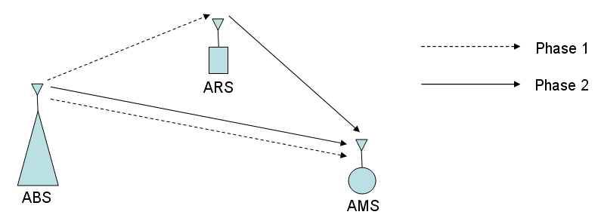
Figure 1: A typical topology for cooperative relaying in downlink scenario.
The transmission is usually segmented into two phases. In phase 1, the ARS needs to know the original message in order to cooperate with the ABS. In phase 2, both ABS and ARS could perform joint transmission to the AMS. Thus, the AMS may or may not need to hear the message transmitted by the ABS in phase 1.
In this contribution, we propose a scheme which combines cooperative relaying and ARQ mechanism. To be specific, cooperative relaying is only used when retransmission is required. Furthermore, we suggest employing cyclic delay diversity (CDD) as the retransmission technique.
CDD is a simple and robust technique for transmit diversity, in which different cyclically delayed copies of the original signal are transmitted from different antennas. Note that the cyclic shifts are performed before the insertion of cyclic prefix (CP). In other words, CDD artificially creates multi-path diversity and better error performance can be achieved if proper combining is implemented at the receiver.
As mentioned before, cooperative relaying creates a transmit antenna array. Consider a single relay case, we may see the ABS and ARS are two distinct antennas within an array. When CDD is applied, the ARS simply transmits the cyclically delayed version of the original message that it has received from the ABS in Phase 1.
In order to reduce the latency caused by relaying, we suggest that CDD is only applied for the retransmission in ARQ scheme. That is, cooperative relaying with CDD transmission is only used when a NACK feedback is received from the AMS. The basic operation procedure can be summarized as following:

1. ABS sends the data signal to both ARS and AMS.
2. If AMS is not able to decode the signal successfully, AMS sends a “NACK” indication to both ABS and ARS. Otherwise, the signaling is complete.
3. If ABS (as well as ARS) receives “NACK”, ABS and ARS retransmit the original and the cyclically shifted signal to the AMS, respectively.

------------------------------------------- Start of Proposed Amendment Text --------------------------------------------
15.X. Multi-Hop Relays

15.X.1. Cooperative Relaying

15.X.1.X. ARQ with Cyclic Delay Diversity (CDD)

In ARQ scheme, CDD-based cooperative relaying technique can be applied for the retransmission if the receiver is not able to decode the original transmission successfully and notifies the ABS with a NACK message.
In the first transmission, the ABS sends the message to the AMS as in usual operation, and the ARS listens to the original signal.
If the AMS successfully decodes the signal and ACK is received by the ABS, the signaling is completed.
Otherwise, if the AMS fails to decode the signal, NACK message will be received by both ABS and ARS. The retransmission will be jointly carried out by ABS and ARS by performing CDD.
Conversely, the protocol can also be applied in uplink, in which the CDD is performed via the joint transmission of the AMS and ARS to the ABS.

-------------------------------------------- End of Proposed Amendment Text -------------------------------------------

References
[1] IEEE 802.16m-08/003r9, “The Draft IEEE 802.16m System Description Document”.

