Project | IEEE 802.16 Broadband Wireless Access Working Group <http://ieee802.org/16>
Title | Proposed Changes to CTC Encoder Input Sizes (15.3.12.1)
Date Submitted | 2009-08-29
Source(s) | Sung-Eun Park, SungJin Park, Chiwoo Lim, Jaeweon Cho, Jaehee Cho, Heewon Kang, Hokyu Choi  Samsung Electronics Co., Ltd.  Tom Harel, Changlong Xu  Intel Corporation | se.park@samsung.com  tom.harel@intel.com
Re: | Change Request on 802.16m Draft Amendment, IEEE P802.16m/D1  Section: 15.3.12 Channel coding and HARQ
Abstract | The contribution proposes the text changes to the channel coding and HARQ section of the 802.16m draft amendment, IEEE P802.16m/D1.
Purpose | To be discussed and adopted by TGm for the 802.16m amendment.
Notice | This document does not represent the agreed views of the IEEE 802.16 Working Group or any of its subgroups. It represents only the views of the participants listed in the “Source(s)” field above. It is offered as a basis for discussion. It is not binding on the contributor(s), who reserve(s) the right to add, amend or withdraw material contained herein.
Release | The contributor grants a free, irrevocable license to the IEEE to incorporate material contained in this contribution, and any modifications thereof, in the creation of an IEEE Standards publication; to copyright in the IEEE’s name any IEEE Standards publication even though it may include portions of this contribution; and at the IEEE’s sole discretion to permit others to reproduce in whole or in part the resulting IEEE Standards publication. The contributor also acknowledges and accepts that this contribution may be made public by IEEE 802.16.
Patent Policy | The contributor is familiar with the IEEE-SA Patent Policy and Procedures:  <http://standards.ieee.org/guides/bylaws/sect6-7.html#6> and <http://standards.ieee.org/guides/opman/sect6.html#6.3>.  Further information is located at <http://standards.ieee.org/board/pat/pat-material.html> and <http://standards.ieee.org/board/pat>.
Proposed Changes to CTC Encoder Input Sizes (15.3.12.1)

Sung-Eun Park, SungJin Park, Chiwoo Lim, Jaeweon Cho, Jaehee Cho, Heewon Kang, Hokyu Choi
Samsung Electronics Co., Ltd.
Tom Harel, Changlong Xu
Intel Corporation

- Introduction
The convolutional turbo code (CTC) used for 802.16e FEC scheme is adopted as a mandatory channel coding scheme for data channel in the current IEEE 802.16m draft amendment [1]. The almost regular permutation (ARP) interleaver [2] is used as a CTC interleaver. The ARP interleaver is one of the contention free interleaver that can allow efficient parallelization of the CTC decoder for high data rates. The order of parallelism depends on the input size of the interleaver/encoder, so the encoder input sizes should be carefully chosen to meet the requirements on data throughput with efficient implementation.
The CTC encoder has 39 different input sizes ranging from 48 bits to 4800 bits. To satisfy the required data throughput, at least parallelism order 4 should be supported for the CTC encoder input sizes that are larger than some threshold length. As some of current CTC encoder input sizes larger than 1024 bits cannot support parallelism order 4, new CTC encoder input sizes that can support parallelism order 4 are proposed with related CTC interleaver parameters and subblock interleaver parameters.

- Problem of the current FEC encoder input sizes
Table 1 shows the part of current CTC encoder input sizes (N_{FB}) and their possible parallelism orders. All the CTC encoder input sizes larger than 2400 bits can support parallelism order up to 8. But some middle sizes of CTC input shown with yellow background in the table cannot support even parallelism order 4, thus these sizes will degrade the CTC decoder throughput.

Table 1. CTC encoder input sizes and possible parallelism orders
Index | N_{FB} | N_{FB} / 2 | Parallelism Orders
26 | 1024 | 512 | 1, 2, 4, 8, 16, 32, 64, 128
27 | 1160 | 580 | 1, 5, 29, 145
28 | 1312 | 656 | 1, 2, 4, 41, 82, 164
29 | 1448 | 724 | 1, 181
30 | 1640 | 820 | 1, 5, 41, 205
31 | 1864 | 932 | 1, 233
32 | 2096 | 1048 | 1, 2, 131, 262
33 | 2328 | 1164 | 1, 3, 97, 291
34 | 2624 | 1312 | 1, 2, 4, 8, 41, 82, 164, 328
35 | 2944 | 1472 | 1, 2, 4, 8, 16, 23, 46, 92, 184, 368
36 | 3328 | 1664 | 1, 2, 4, 8, 13, 16, 26, 32, 52, 104, 208, 416
37 | 3776 | 1888 | 1, 2, 4, 8, 59, 118, 236, 472
38 | 4224 | 2112 | 1, 2, 3, 4, 6, 8, 11, 12, 16, 22, 24, 33, 44, 48, 66, 132, 176, 264, 528
39 | 4800 | 2400 | 1, 2, 3, 4, 5, 6, 8, 15, 20, 24, 25, 30, 40, 75, 150, 200, 300, 600

In this contribution, we propose to change the CTC encoder input sizes with CTC interleaver parameters and subblock interleaver parameters as shown in chapter 5 so that all the CTC encoder input sizes larger than 1000 bits can support parallelism order 4. CTC interleaver parameters are borrowed from [3].

- Simulation results
Figure 1 to Figure 6 show the BLER performance comparison between the current N_{FB} sizes and the proposed N_{FB} sizes. The Max-log-MAP algorithm with 8 iterations is used for the rate 1/3 CTC decoder under the AWGN channel environment. According to the simulation results, the performance of the proposed N_{FB} sizes is similar to that of the current N_{FB} sizes. This means that the CTC interleaver parameters and the subblock interleaver parameters are well-designed and that the proposed N_{FB} sizes can support larger parallelism order without any performance loss.
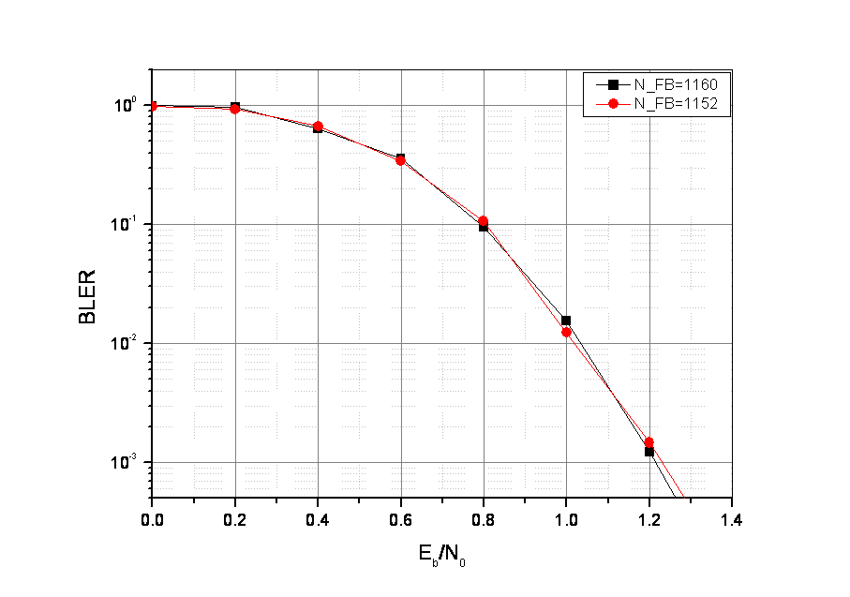
Figure 1 BLER performance comparison: N_{FB}=1160 vs N_{FB}=1152
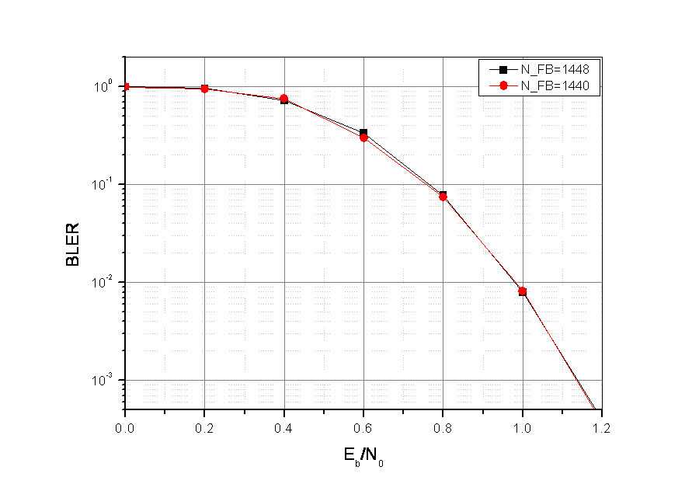
Figure 2 BLER performance comparison: N_{FB}=1448 vs N_{FB}=1440
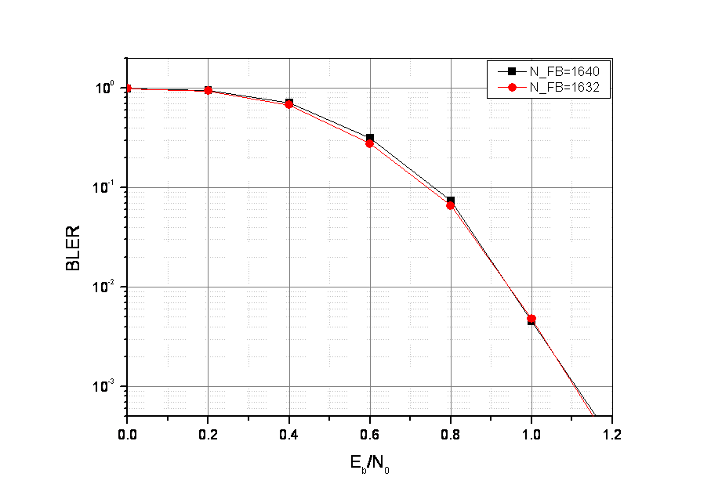
Figure 3 BLER performance comparison: N_{FB}=1640 vs N_{FB}=1632

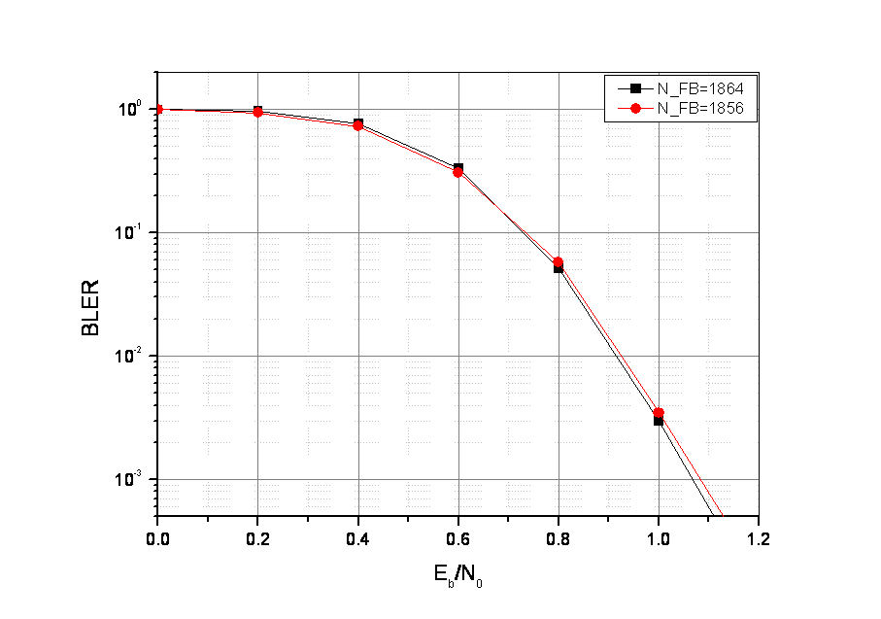
Figure 4 BLER performance comparison: N_{FB}=1864 vs N_{FB}=1856
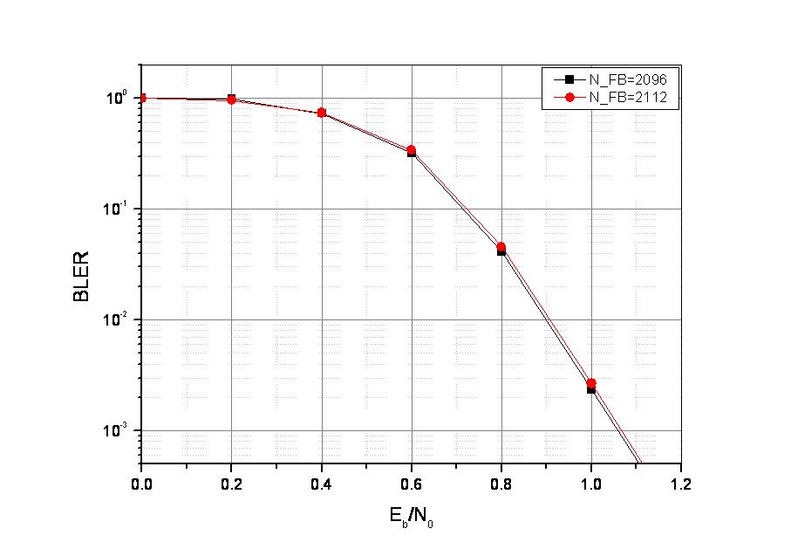
Figure 5 BLER performance comparison: N_{FB}=2096 vs N_{FB}=2112
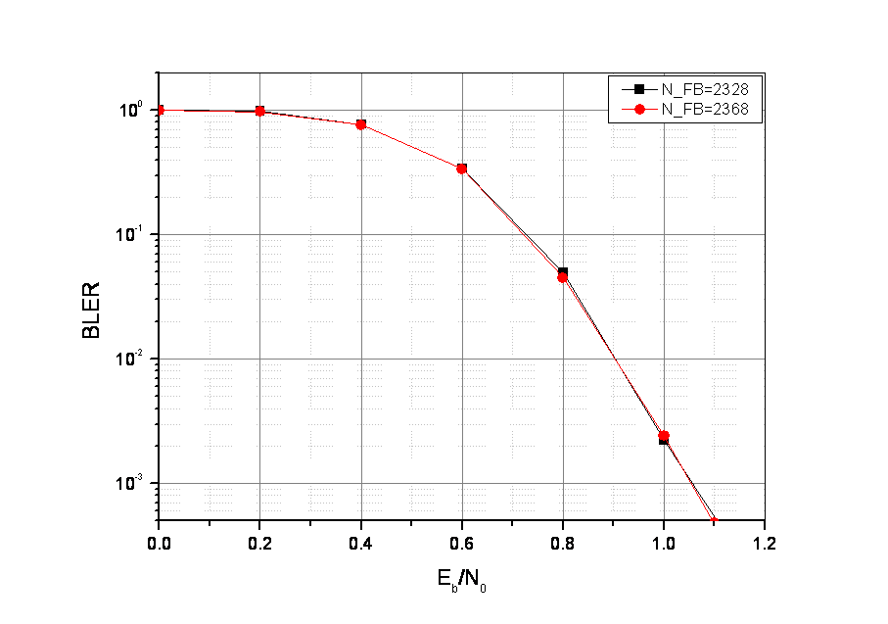
Figure 6 BLER performance comparison: N_{FB}=2328 vs N_{FB}=2368

- References
[1] IEEE P802.16m/D1, “Draft Amendment to IEEE Standard for Local and Metropolitan Area Networks- Part 16: Air Interface for Broadband Wireless Access Systems,” July 2009.
[2] C. Berrou, Y. Saouter, C. Douillard, S. Kerouédan, and M. Jézéquel, “Designing good permutations for turbo codes: towards a single model,” IEEE International Conference on Communications, pp.341-345, June 2004.
[3] IEEE C802.16m/0313, “IEEE 802.16m CTC block sizes and interleaver,” January 2009.

- Proposed changes for 802.16m draft amendment

--------------------------------------------------- Text Start ---------------------------------------------------
<Modify Table 764 as follows>

Table 764─Burst size
idx | N_{DB} (byte) | K_{FB} | idx | N_{DB} (byte) | K_{FB} | idx | N_{DB} (byte) | K_{FB}
1 | 6 | 1 | 23 | 90 | 1 | 45 | 1200 | 2
2 | 8 | 1 | 24 | 100 | 1 | 46 | 1416 | 3
3 | 9 | 1 | 25 | 114 | 1 | 47 | 1584 | 3
4 | 10 | 1 | 26 | 128 | 1 | 48 | 1800 | 3
5 | 11 | 1 | 27 | 145144 | 1 | 49 | 1888 | 4
6 | 12 | 1 | 28 | 164 | 1 | 50 | 2112 | 4
7 | 13 | 1 | 29 | 181180 | 1 | 51 | 2400 | 4
8 | 15 | 1 | 30 | 205204 | 1 | 52 | 2640 | 5
9 | 17 | 1 | 31 | 233232 | 1 | 53 | 3000 | 5
10 | 19 | 1 | 32 | 262264 | 1 | 54 | 3600 | 6
11 | 22 | 1 | 33 | 291296 | 1 | 55 | 4200 | 7
12 | 25 | 1 | 34 | 328 | 1 | 56 | 4800 | 8
13 | 27 | 1 | 35 | 368 | 1 | 57 | 5400 | 9
14 | 31 | 1 | 36 | 416 | 1 | 58 | 6000 | 10
15 | 36 | 1 | 37 | 472 | 1 | 59 | 6600 | 11
16 | 40 | 1 | 38 | 528 | 1 | 60 | 7200 | 12
17 | 44 | 1 | 39 | 600 | 1 | 61 | 7800 | 13
18 | 50 | 1 | 40 | 656 | 2 | 62 | 8400 | 14
19 | 57 | 1 | 41 | 736 | 2 | 63 | 9600 | 16
20 | 64 | 1 | 42 | 832 | 2 | 64 | 10800 | 18
21 | 71 | 1 | 43 | 944 | 2 | 65 | 12000 | 20
22 | 80 | 1 | 44 | 1056 | 2 | 66 | 14400 | 24

<Modify Table 767 as follows >

Table 767─Interleaver Parameters
Index | N_{FB} | P₀ | P₁ | P₂ | P₃ | Index | N_{FB} | P₀ | P₁ | P₂ | P₃
1 | 48 | 5 | 0 | 0 | 0 | 21 | 568 | 19 | 102 | 140 | 226
2 | 64 | 11 | 12 | 0 | 12 | 22 | 640 | 23 | 84 | 296 | 236
3 | 72 | 11 | 18 | 0 | 18 | 23 | 720 | 23 | 130 | 156 | 238
4 | 80 | 7 | 4 | 32 | 36 | 24 | 800 | 23 | 150 | 216 | 150
5 | 88 | 13 | 36 | 36 | 32 | 25 | 912 | 29 | 14 | 264 | 94
6 | 96 | 13 | 24 | 0 | 24 | 26 | 1024 | 29 | 320 | 236 | 324
7 | 104 | 7 | 4 | 8 | 48 | 27 | 1160  1152 | 31 | 314  534 | 348  372 | 222  246
8 | 120 | 11 | 30 | 0 | 34 | 28 | 1312 | 31 | 214 | 160 | 506
9 | 136 | 13 | 58 | 4 | 58 | 29 | 1448  1440 | 33  41 | 254  288 | 372  556 | 158  672
10 | 152 | 11 | 38 | 12 | 74 | 30 | 1640  1632 | 33  29 | 164  334 | 432  564 | 748  66
11 | 176 | 17 | 52 | 68 | 32 | 31 | 1864  1856 | 33  47 | 504  576 | 444  212 | 664  728
12 | 200 | 11 | 76 | 0 | 24 | 32 | 2096  2112 | 39  43 | 400  96 | 688  720 | 68  980
13 | 216 | 11 | 54 | 56 | 2 | 33 | 2328  2368 | 41  47 | 254  228 | 884  440 | 1054  724
14 | 248 | 13 | 6 | 84 | 46 | 34 | 2624 | 47 | 378 | 1092 | 1250
15 | 288 | 17 | 74 | 72 | 2 | 35 | 2944 | 41 | 338 | 660 | 646
16 | 320 | 17 | 84 | 108 | 132 | 36 | 3328 | 37 | 258 | 28 | 1522
17 | 352 | 17 | 106 | 56 | 50 | 37 | 3776 | 53 | 772 | 256 | 408
18 | 400 | 19 | 142 | 0 | 142 | 38 | 4224 | 59 | 14 | 668 | 1474
19 | 456 | 17 | 184 | 0 | 48 | 39 | 4800 | 53 | 66 | 24 | 2
20 | 512 | 19 | 64 | 52 | 124

<Modify Table 768 as follows >

Table 768─Parameters for the subblock interleavers
Index | N_{FB} | m | J | Index | N_{FB} | m | J | Index | N_{FB} | m | J | Index | N_{FB} | m | J
1 | 48 | 3 | 3 | 11 | 176 | 5 | 3 | 21 | 568 | 7 | 3 | 31 | 1864  1856 | 9 | 2
2 | 64 | 4 | 2 | 12 | 200 | 5 | 4 | 22 | 640 | 7 | 3 | 32 | 2096  2112 | 9 | 3
3 | 72 | 4 | 3 | 13 | 216 | 5 | 4 | 23 | 720 | 7 | 3 | 33 | 2328  2368 | 9 | 3
4 | 80 | 4 | 3 | 14 | 248 | 6 | 2 | 24 | 800 | 7 | 4 | 34 | 2624 | 9 | 3
5 | 88 | 4 | 3 | 15 | 288 | 6 | 3 | 25 | 912 | 8 | 2 | 35 | 2944 | 9 | 3
6 | 96 | 4 | 3 | 16 | 320 | 6 | 3 | 26 | 1024 | 8 | 2 | 36 | 3328 | 9 | 4
7 | 104 | 4 | 4 | 17 | 352 | 6 | 3 | 27 | 1160  1152 | 8 | 3 | 37 | 3776 | 10 | 2
8 | 120 | 5 | 2 | 18 | 400 | 6 | 4 | 28 | 1312 | 8 | 3 | 38 | 4224 | 10 | 3
9 | 136 | 5 | 3 | 19 | 456 | 7 | 2 | 29 | 1448  1440 | 8 | 3 | 39 | 4800 | 10 | 3
10 | 152 | 5 | 3 | 20 | 512 | 7 | 2 | 30 | 1640  1632 | 8 | 4

--------------------------------------------------- Text End ---------------------------------------------------

