Project | IEEE 802.16 Broadband Wireless Access Working Group <http://ieee802.org/16>
Title | Proposed Text for E-MBS Control Structure in 802.16m System (E-MBS)
Date Submitted | 2009-8-30
Source(s) | Chun-Yen Wang, Chun-Yuan Chiu, Fang-Ching (Frank) Ren, Chie-Ming Chou, Yung-Han Chen,  ITRI  Wern-Ho Sheen  Chaoyang University of Technology (CYUT) | Voice:  E-mail: ChunYen@itri.org.tw
Re: | IEEE 802.16m-08/037 - Call for Contributions on Project 802.16m Amendment Content  Topic: P802.16m/D1 E-MBS
Abstract | This contribution proposes a control structure for supporting E-MBS transmission in 802.16m system.
Purpose | For discussion and approval by TGm
Notice | This document does not represent the agreed views of the IEEE 802.16 Working Group or any of its subgroups. It represents only the views of the participants listed in the “Source(s)” field above. It is offered as a basis for discussion. It is not binding on the contributor(s), who reserve(s) the right to add, amend or withdraw material contained herein.
Release | The contributor grants a free, irrevocable license to the IEEE to incorporate material contained in this contribution, and any modifications thereof, in the creation of an IEEE Standards publication; to copyright in the IEEE’s name any IEEE Standards publication even though it may include portions of this contribution; and at the IEEE’s sole discretion to permit others to reproduce in whole or in part the resulting IEEE Standards publication. The contributor also acknowledges and accepts that this contribution may be made public by IEEE 802.16.
Patent Policy | The contributor is familiar with the IEEE-SA Patent Policy and Procedures:  <http://standards.ieee.org/guides/bylaws/sect6-7.html#6> and <http://standards.ieee.org/guides/opman/sect6.html#6.3>.  Further information is located at <http://standards.ieee.org/board/pat/pat-material.html> and <http://standards.ieee.org/board/pat>.

Proposed Text for E-MBS Control Structure in 802.16m System (E-MBS)
Chun-Yen Wang, Chun-Yuan Chiu, Fang-Ching (Frank) Ren, Chie-Ming Chou, Yung-Han Chen,
ITRI
Wern-Ho Sheen
Chaoyang University of Technology (CYTU)

1. Introduction
Based on the IEEE 802.16m system description document (SDD) [1], this contribution provides some AWD text about E-MBS control structure for supporting enhanced multicast and broadcast services (E-MBS) in IEEE 802.16m system.

2. E-MBS Control Structure
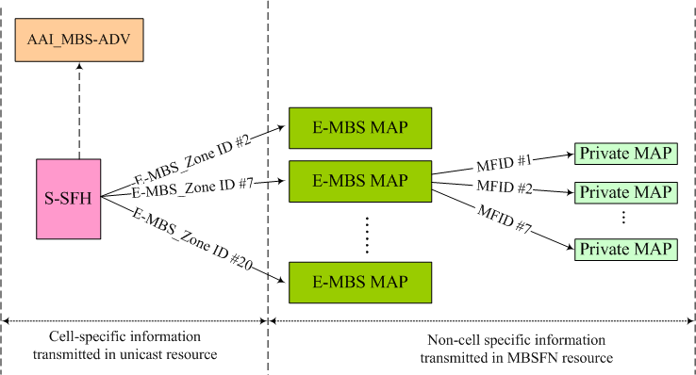
Fig. 1. The E-MBS control structure for MBSFN transmission
The proposed control structure for supporting E-MBS transmission is summarized in Fig. 1. As shown in Fig. 1, E-MBS control parameters are provided by four control messages, including S-SFH, AAI_MBS-ADV, E-MBS MAP, and Private MAP. Among them, SFH and AAI_MBS-ADV provide cell-specific E-MBS control parameters, and are transmitted in unicast resource, while E-MBS MAP and Private MAP contain non-cell specific information, and are transmitted in E-MBS subframes.

An AMS who would like to access an E-MBS session shall follow the indication from S-SFH → E-MBS MAP → Private MAP to get control parameters and the schedule information of the E-MBS data traffic. Afterwards, the AMS can continue the process Private MAP → data → Private MAP → data … to enjoy the E-MBS service. Once the “change indicator” in Private MAP is set or some error happens, the AMS repeats the initial process to update control parameters. Detailed control parameters are described below.

2.1 E-MBS control parameters in S-SFH
The E-MBS control parameters in SFH are provided in S-SFH Sub-packet X [TBD], which contains a pointer for each E-MBS zone to indicate the subframe location of E-MBS MAP. The other cell-specific E-MBS control information is provided in AAI_MBS-ADV. Besides, E-MBS MAP should be transmitted periodically such that AMSs can easily retrieve the E-MBS MAP especially for channel switching.

As a result, the S-SFH Sub-packet X includes the following parameters:

- E-MBS Zone Identity: identifies the E-MBS zone within the context.
- E-MBS MAP MCS: the MCS used in the subframe of the E-MBS MAP.
- E-MBS MAP Periodicity: the occurrence periodicity of the E-MBS MAP.
- E-MBS MAP Superframe Offset: the superframe containing the E-MBS MAP meets the condition: SuperFrameNumber modulo E-MBS MAP Periodicity == E-MBS MAP Subframe Offset.
- E-MBS MAP Frame Offset: defines the frame that are allocated for E-MBS MAP within the superframe defined by the E-MBS MAP Periodicity and E-MBS MAP Superframe Offset.
- E-MBS MAP Subframe Offset: defines the subframe that are allocated for E-MBS MAP within the frame defined by the E-MBS MAP Periodicity, E-MBS MAP Superframe Offset, and E-MBS MAP Frame Offset.
- AAI_MBS-ADV Required: indicates whether further control information in AAI_MBS-ADV is required.

As a result, the message format for S-SFH Subpacket-X can be summarized as below.

S-SFH Subpacket-X information element
-- ASN1START

S-SFH-Subpacket-X ::= SEQUENCE {
...

E-MBSConfigurationList ::= SEQUENCE (SIZE (1..maxMBSzones)) OF E-MBSConfiguration
}

E-MBSConfiguration ::= SEQUENCE {
embs-ZoneId INTEGER (0..ffs),
embs-MAP-MCS ENUMERATED {ffs},
embs-MAP-Periodicity ENUMERATED {ffs},
embs-MAP-SuperFrameOffset INTEGER (0..ffs),
embs-MAP-FrameOffset INTEGER (0..3),
embs-MAP-SubframeOffset INTEGER (0..7),
embs-ADV-Required BOOLEAN
}

-- ASN1STOP

2.2 E-MBS MAP
E-MBS MAP provides non-cell specific control parameters for E-MBS services within the E-MBS zone. For an on-going E-MBS session, E-MBS MAP shall include the MCS parameter and the resource allocation information for the following E-MBS traffic. Resource allocation patterns can be classified into two [FFS] types: Contiguous Allocation and Bitmap Allocation (please refer to section 2.2.1 and 2.2.2). In addition, the location of the Private MAP is also implicitly indicated by the E-MBS MAP. Note that an E-MBS session is ongoing or stopped is not explicitly shown in the E-MBS MAP, but is implicitly indicated by its presence in the E-MBS MAP.

The following parameters are included in E-MBS MAP:

- Multicast Flow Identifier (MFID): a short identifier used to identify an E-MBS session in the E-MBS zone.
- MCS: defines the MCS applied to the E-MBS session.
- E-MBS Resource Allocation: indicates the resource information of the following E-MBS traffic. Please refer to section 2.2.1 and 2.2.2 for further details.

As a result, the message format for E-MBS MAP can be summarized as below.

E-MBS MAP information element
-- ASN1START

E-MBS-MAP ::= SEQUENCE (SIZE (1..maxE-MBS-MAP-IEs)) OF E-MBS-MAP-IE

E-MBS-MAP-IE ::= SEQUENCE {
mfid INTEGER (0..ffs),
mcs ENUMERATED {ffs},
e-mbs-ResourceAllcation CHOICE {
type1 E-MBS-AllocationType1,
type2 E-MBS-AllocationType2
}
}

-- ASN1STOP

E-MBS Allocation Type 1 (Contiguous Allocation)
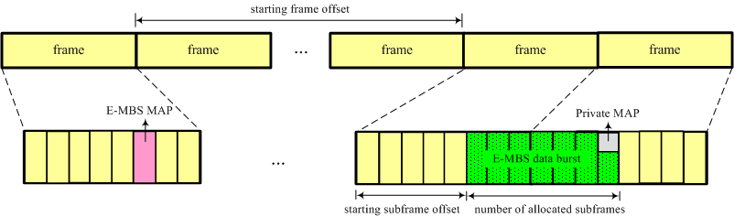
Fig. 2. E-MBS Allocation Type 1 (Contiguous Allocation)

The E-MBS allocation type 1 is used when subframes allocated to the E-MBS are contiguous. This allocation pattern can minimize the waking time of E-MBS users in E-MBS reception so as to save battery consumption. This allocation can be commonly applied especially for E-MBS dedicated carriers. As shown in Fig. 2, E-MBS allocation type 1 should include the following parameters:

- Starting frame offset: identifies the location of the starting frame.
- Starting subframe offset: identifies the location of the starting subframe.
- Number of allocated subframes: the number of subframes allocated for the E-MBS session.

E-MBS Allocation Type 1 information element
-- ASN1START

E-MBS-AllocationType1 ::= SEQUENCE {
startFrameOffset INTEGER (0..ffs),
startSubframeOffset INTEGER (0..7),
numberOfAllocatedSubframes INTEGER (1..ffs),
}

-- ASN1STOP

E-MBS Allocation Type 2 (Bitmap Allocation)
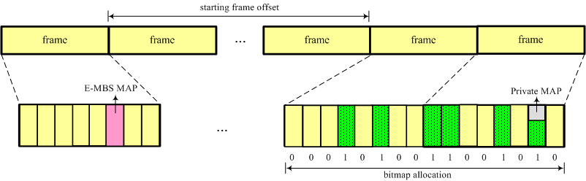
Fig. 3. E-MBS Allocation Type 2 (Bitmap Allocation)

The E-MBS allocation type 2 adopts a bitmap to allocate E-MBS subframes. As shown in Fig. 3, each bit in the bitmap represents whether the corresponding subframe is allocated for the E-MBS transmission. As a result, E-MBS allocation type 2 should include the following parameters:

- Starting frame offset: identifies the location of the starting frame.
- Bitmap Allocation: Field encoded as a bit string, where bit n is set to “1” if the n-th subframe is allocated for the E-MBS session.

E-MBS Allocation Type 2 information element
-- ASN1START

E-MBS-AllocationType2 ::= SEQUENCE {
startFrameOffset INTEGER (0..ffs),
bitmapAllocation BIT STRING (SIZE (ffs))
}

-- ASN1STOP

2.3 Private MAP
Private MAP is a MAC control signalling, which means Private MAP and E-MBS data burst may be multiplexed in the MAC layer, and transmitted together at the same subframe. Private MAP contains the schedule information of an E-MBS session during the next E-MBS scheduling interval, so E-MBS users can continue receiving the following E-MBS traffic in the next scheduling interval without the need to re-read E-MBS MAP. In addition, Private MAP also includes a “change indicator” to indicate that some control parameters are going to change. Once the change indicator is set, E-MBS users who are interested in the E-MBS session shall update the related control parameters.
Resource allocation patterns in Private MAP follow the same message formats defined in Section 2.2.1 and 2.2.2. Two examples are illustrated as below.
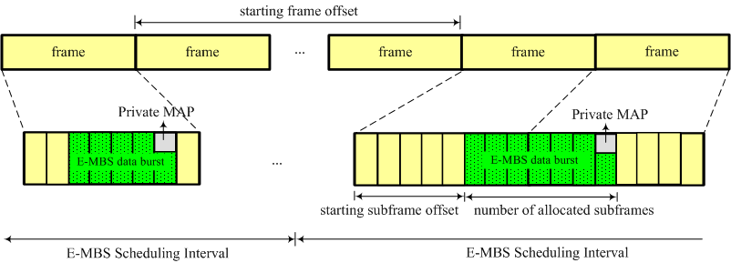 | 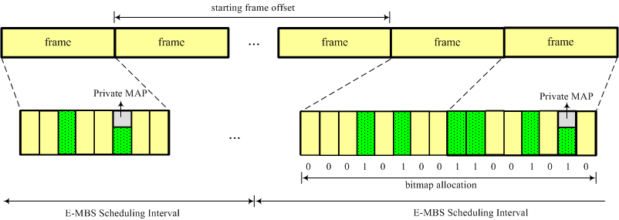
(a) Contiguous allocation | (b) Bitmap allocation
Fig. 4. Resource Allocation Patterns in Private MAP
`
As a result, the message format for Private MAP can be summarized as below.

Private MAP information element
-- ASN1START

Private-MAP ::= SEQUENCE {
changeIndicator BOOLEAN,
e-mbs-ResourceAllcation CHOICE {
type1 E-MBS-AllocationType1,
type2 E-MBS-AllocationType2
}
}

-- ASN1STOP

2.4 AAI_MBS-ADV
AAI_MBS-ADV provides some further cell-specific E-MBS control parameters, such as feedback channel configuration, HARQ retransmission configuration, E-MBS zone ID mapping table, etc. Detailed descriptions can be found in the contribution IEEE C802.16m-09/xxxx [3].

3. Conclusions
In order to support E-MBS transmission, this contribution presents an E-MBS control structure for IEEE 802.16m system. Based on the proposed control structure, E-MBS users are able to retrieve their desired E-MBS services in an efficient way. Therefore, it is suggested to capture the proposed text into the IEEE 802.16m AWD document [2].

References
[1] IEEE 802.16m-09/0034, “IEEE 802.16m System Description Document (SDD)”
[2] P802.16m/D1, “Part 16: Air Interface for Broadband Wireless Access System”
[3] IEEE C802.16m-09/xxxx

Proposed Text

The following text is proposed to be captured in the IEEE 802.16m AWD document.
------------------------------------------------------- Start of the proposed text ------------------------------------------------
[Insert the following text into this section]

15.2.x.y E-MBS control structure
E-MBS control parameters are provided by four control messages, including S-SFH, AAI_MBS-ADV, E-MBS MAP, and Private MAP. Among them, SFH and AAI_MBS-ADV provide cell-specific E-MBS control parameters, and are transmitted in unicast resource, while E-MBS MAP and Private MAP contain non-cell specific information, and are transmitted in E-MBS subframes.

An AMS who would like to access an E-MBS session follows the indication from S-SFH → E-MBS MAP → Private MAP to get control parameters and the schedule information of the E-MBS data traffic. Afterwards, the AMS can continue the process Private MAP → data → Private MAP → data … to enjoy the E-MBS service. Once the “change indicator” in Private MAP is set or some error happens, the AMS repeats the initial process to update the control parameters.

15.2.x.y.1 E-MBS control parameters in S-SFH
The E-MBS control parameters in SFH are provided in S-SFH Sub-packet X [TBD], which contains a pointer for each E-MBS zone to indicate the subframe location of E-MBS MAP. The other cell-specific E-MBS control information is provided in AAI_MBS-ADV.

S-SFH Subpacket-X information element
-- ASN1START

S-SFH-Subpacket-X ::= SEQUENCE {
...

E-MBSConfigurationList ::= SEQUENCE (SIZE (1..maxMBSzones)) OF E-MBSConfiguration
}

E-MBSConfiguration ::= SEQUENCE {
embs-ZoneId INTEGER (0..ffs),
embs-MAP-MCS ENUMERATED {ffs},
embs-MAP-Periodicity ENUMERATED {ffs},
embs-MAP-SuperFrameOffset INTEGER (0..ffs),
embs-MAP-FrameOffset INTEGER (0..3),
embs-MAP-SubframeOffset INTEGER (0..7),
embs-ADV-Required BOOLEAN
}

-- ASN1STOP

E-MBSConfiguration field decriptions
embs-ZoneId
Identifies the E-MBS zone within the context.
embs-MAP-MCS
Defines the MCS used in the subframe of the E-MBS MAP.
embs-MAP-Periodicity
Defines the occurrence periodicity of the E-MBS MAP.
embs-MAP-SuperFrameOffset
Superframes that contain the E-MBS MAP occur when equation SuperFrameNumber mod embs-MAP-Periodicity = embs-MAP-SuperFrameOffset is satisfied.
embs-MAP-FrameOffset
Defines the frame that are allocated for E-MBS MAP within the superframe defined by the embs-MAP-Periodicity and embs-MAP-SuperFrameOffset.
embs-MAP-SubframeOffset
Defines the subframe that are allocated for E-MBS MAP within the radio frame defined by the embs-MAP-Periodicity, embs-MAP-SuperFrameOffset and embs-MAP-FrameOffset.
embs-ADV-Required
Indicates whether further control information in AAI_MBS-ADV is required.

15.2.x.y.2 E-MBS MAP
E-MBS MAP provides non-cell specific control parameters for E-MBS services within the E-MBS zone. For an on-going E-MBS session, E-MBS MAP shall include the MCS parameter and the resource allocation information for the following E-MBS traffic. Resource allocation patterns are classified into two [FFS] types. In addition, the location of the Private MAP is also implicitly indicated by the E-MBS MAP. Note that an E-MBS session is ongoing or stopped is implicitly indicated by its presence in the E-MBS MAP.

E-MBS MAP information element
-- ASN1START

E-MBS-MAP ::= SEQUENCE (SIZE (1..maxE-MBS-MAP-IEs)) OF E-MBS-MAP-IE

E-MBS-MAP-IE ::= SEQUENCE {
mfid INTEGER (0..ffs),
mcs ENUMERATED {ffs},
e-mbs-ResourceAllcation CHOICE {
type1 E-MBS-AllocationType1,
type2 E-MBS-AllocationType2
}
}

-- ASN1STOP

E-MBS-MAP-IE field decriptions
mfid
A short identifier used to identify an E-MBS session in the E-MBS zone.
mcs
Defines the MCS applied to the E-MBS session.
e-mbs-ResourceAllcation
Indicates the resource information of the following E-MBS traffic. Please refer to section 15.2.x.y.2.1 and 15.2.x.y.2.2.

15.2.x.y.2.1 E-MBS Allocation Type 1 (Contiguous Allocation)
Figure AAA⎯ E-MBS Allocation Type 1 (Contiguous Allocation)

As shown in figure AAA, E-MBS allocation type 1 is used when subframes allocated to the E-MBS are contiguous. The message format of Private MAP message type 1 is shown as below.

E-MBS Allocation Type 1 information element
-- ASN1START

E-MBS-AllocationType1 ::= SEQUENCE {
startFrameOffset INTEGER (0..ffs),
startSubframeOffset INTEGER (0..7),
numberOfAllocatedSubframes INTEGER (1..ffs),
}

-- ASN1STOP

E-MBS-AllocationType1 field decriptions
startFrameOffset
Identifies the location of the starting frame.
startSubframeOffset
Identifies the location of the starting subframe.
numberOfAllocatedSubframes
Identifies the number of subframes allocated for the E-MBS session.

15.2.x.y.2.2 E-MBS Allocation Type 2 (Bitmap Allocation)
Figure BBB⎯ E-MBS Allocation Type 2 (Bitmap Allocation)

The E-MBS allocation type 2 adopts a bitmap to allocate E-MBS subframes. As shown in figure BBB, each bit in the bitmap represents whether the corresponding subframe is allocated for the E-MBS transmission. The message format of Private MAP message type 2 is shown as below.

E-MBS Allocation Type 2 information element
-- ASN1START

E-MBS-AllocationType2 ::= SEQUENCE {
startFrameOffset INTEGER (0..ffs),
bitmapAllocation BIT STRING (SIZE (ffs))
}

-- ASN1STOP

E-MBS-AllocationType2 field decriptions
startFrameOffset
Identifies the location of the starting frame.
bitmapAllocation
Field encoded as a bit string, where bit n is set to “1” if the n-th subframe is allocated for the E-MBS session.

15.2.x.y.3 Private MAP
Private MAP is a MAC control signalling, which means Private MAP and E-MBS data burst may be multiplexed in the MAC layer, and transmitted together at the same subframe. Private MAP contains the schedule information of an E-MBS session during the next E-MBS scheduling interval. In addition, Private MAP also includes a “change indicator” to indicate that some control parameters are going to change. Once the change indicator is set, E-MBS users who are interested in the E-MBS session shall update the related control parameters. Resource allocation patterns used in Private MAP follow the same message formats defined in Section 15.2.x.y.2.1 and 15.2.x.y.2.2.

Private MAP information element
-- ASN1START

Private-MAP ::= SEQUENCE {
changeIndicator BOOLEAN,
e-mbs-ResourceAllcation CHOICE {
type1 E-MBS-AllocationType1,
type2 E-MBS-AllocationType2
}
}

-- ASN1STOP

Private-MAP field decriptions
changeIndicator
“True” is used when control parameters related to the E-MBS session are going to change; otherwise, “False” is used.
e-mbs-ResourceAllcation
Indicates resource information of following E-MBS traffic in the next E-MBS scheduling interval. Please refer to section 15.2.x.y.2.1 and 15.2.x.y.2.2.

15.2.x.y.4 AAI_MBS-ADV
The ABS shall transmit AAI_MBS-ADV at a pre-determined location in order to further provide cell-specific control information for E-MBS.

AAI_MBS-ADV message format
-- ASN1START

AAI_MBS-ADV ::= SEQUENCE {

}

-- ASN1STOP

-------------------------------------------------------- End of the text ------------------------------------------------------

