Project | IEEE 802.16 Broadband Wireless Access Working Group <http://ieee802.org/16>
Title | Proposed Text for HARQ Transmission without Feedback (E-MBS)
Date Submitted | 2009-9-20
Source(s) | Chun-Yen Wang, Chun-Yuan Chiu, Fang-Ching (Frank) Ren, Chie-Ming Chou, Yung-Han Chen,  ITRI  Wern-Ho Sheen  Chaoyang University of Technology (CYUT) | Voice:  E-mail: ChunYen@itri.org.tw
Re: | IEEE 802.16m-08/037 - Call for Contributions on Project 802.16m Amendment Content  Topic: P802.16m/D1 E-MBS
Abstract | This contribution provides a proposed text for supporting HARQ Blind transmission in E-MBS.
Purpose | For discussion and approval by TGm
Notice | This document does not represent the agreed views of the IEEE 802.16 Working Group or any of its subgroups. It represents only the views of the participants listed in the “Source(s)” field above. It is offered as a basis for discussion. It is not binding on the contributor(s), who reserve(s) the right to add, amend or withdraw material contained herein.
Release | The contributor grants a free, irrevocable license to the IEEE to incorporate material contained in this contribution, and any modifications thereof, in the creation of an IEEE Standards publication; to copyright in the IEEE’s name any IEEE Standards publication even though it may include portions of this contribution; and at the IEEE’s sole discretion to permit others to reproduce in whole or in part the resulting IEEE Standards publication. The contributor also acknowledges and accepts that this contribution may be made public by IEEE 802.16.
Patent Policy | The contributor is familiar with the IEEE-SA Patent Policy and Procedures:  <http://standards.ieee.org/guides/bylaws/sect6-7.html#6> and <http://standards.ieee.org/guides/opman/sect6.html#6.3>.  Further information is located at <http://standards.ieee.org/board/pat/pat-material.html> and <http://standards.ieee.org/board/pat>.

Proposed Text for HARQ Transmission without Feedback (E-MBS)
Chun-Yen Wang, Chun-Yuan Chiu, Fang-Ching (Frank) Ren, Chie-Ming Chou, Yung-Han Chen,
ITRI
Wern-Ho Sheen
Chaoyang University of Technology

1. Introduction
In IEEE 802.16m system description document (SDD) [1], it has been agreed that
“E-MBS data bursts may be transmitted in terms of several sub-packets, and these sub-packets may be transmitted in different subframe and to allow AMSs combining but without any acknowledgement from AMSs.”
In this contribution, we propose the amendment content to support this property in IEEE 802.16m E-MBS system.

2. HARQ Blind Transmission for E-MBS
One simple method to achieve this function is to adopt HARQ blind transmission. In other words, an E-MBS MAC PDU is transmitted in terms of several HARQ subpackets without ACK/NACK feedbacks from E-MBS users. Furthermore, to save the system complexity, generating HARQ subpackets shall follow the same process defined in Section 15.3.1.12 [2] as unicast traffic. In addition, the transmission rule of HARQ subpackets shall also be standardized. Thus, we propose HARQ subpackets which are labeled 0b00, 0b01, 0b10 and 0b11 shall be sent in a sequential order.

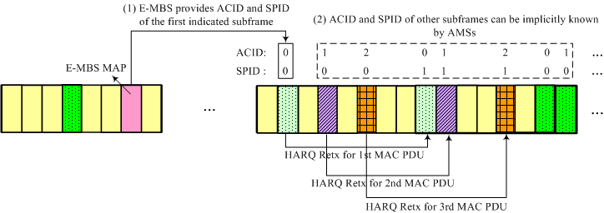
Fig. 1. An example for HARQ blind transmission
Due to the pre-defined transmission rule, the message overhead in E-MBS MAP can be reduced. An example for HARQ blind transmission is shown in Fig. 1, where each E-MBS MAC PDU is transmitted in terms of two HARQ subapckets, and there are three HARQ channels in total. As shown in Fig. 1, ACID and SPID parameters of one E-MBS subframe can be easily derived from the ACID and SPID of previous E-MBS subframes. Therefore, E-MBS MAP can simply provide the ACID and SPID for the first one of following subframes allocated for the E-MBS session, and then ACID and SPID parameters for other E-MBS subframes can be implicitly known by AMSs.
As a result, in addition to parameters about E-MBS subframe allocation as indicated by [3], E-MBS MAP shall further include the following parameters to support HARQ blind transmission.
- Number of HARQ channels: defines the number of HARQ channels for the E-MBS session.
- Number of HARQ subpackets: defines the number of HARQ subpackets for each E-MBS MAC PDU.
- ACID: identifies the HARQ channel identifier of the first one of following subframes allocated for the E-MBS session.
- SPID: identifies the HARQ subpacket identifier of the first one of following subframes allocated for the E-MBS session.

As a result, the message format for E-MBS MAP can be summarized as below.

E-MBS MAP information element
-- ASN1START

E-MBS-MAP ::= SEQUENCE (SIZE (1..maxE-MBS-MAP-IEs)) OF E-MBS-MAP-IE

E-MBS-MAP-IE ::= SEQUENCE {
...

blindHARQ-Config SEQUENCE {
numberOfHARQ-Channels INTEGER (0..ffs),
numberOfHARQ-SubPackets INTEGER (0..ffs),
acid INTEGER (0..ffs),
spid INTEGER (0..ffs)
}
}

-- ASN1STOP

3. Conclusions
In order to increase E-MBS data reliability and save AMS battery consumption in E-MBS reception, this contribution proposes to adopt HARQ blind transmission for E-MBS services. Based on the proposed mechanism, E-MBS users are able to retrieve their desired E-MBS services in an efficient way. Therefore, it is suggested to capture the proposed text into the IEEE 802.16m AWD document.

References
[1] IEEE 802.16m-09/0034, “IEEE 802.16m System Description Document (SDD)”
[2] P802.16m/D1, “Part 16: Air Interface for Broadband Wireless Access System”
[3] IEEE C80216m-09_1775, “Proposed Text for E-MBS Control Structure in 802.16m System (E-MBS)”

Proposed Text

The following text is proposed to be captured in the harmonized contribution from the DG.
------------------------------------------------------- Start of the proposed text ------------------------------------------------
[Insert the following text into this section]

15.8.3.3 HARQ Blind Transmission
An E-MBS MAC PDU can be transmitted in terms of several HARQ subpackets, and these subpackets are transmitted in different subframes in order to allow AMSs to combine packets without acknowledgement from AMSs. HARQ subpackets are generated by the process defined in Section 15.3.1.12. Also, HARQ subpackets which are labeled by 0b00, 0b01, 0b10 and 0b11 are sent in a sequential order.

When HARQ blind transmission is applied, E-MBS MAP shall provide the number of HARQ channels applied to the E-MBS session, and the number of HARQ subpackets generated for each MAC PDU. Besides, E-MBS MAP also contains ACID and SPID of the first one of following subframes allocated for the E-MBS session. Based on these parameters, ACID and SPID of all E-MBS subframes can be implicitly known by AMSs.

E-MBS MAP information element
-- ASN1START

E-MBS-MAP ::= SEQUENCE (SIZE (1..maxE-MBS-MAP-IEs)) OF E-MBS-MAP-IE

E-MBS-MAP-IE ::= SEQUENCE {
...

blindHARQ-Config SEQUENCE {
numberOfHARQ-Channels INTEGER (0..ffs),
numberOfHARQ-Subpackets INTEGER (0..ffs),
acid INTEGER (0..ffs),
spid INTEGER (0..ffs)
}
}

-- ASN1STOP

E-MBS-MAP-IE field decriptions
numberOfHARQ-Channels
Defines the number of HARQ channels for the E-MBS session.
NumberOfHARQ-Subpackets
Defines the number of HARQ subpackets for each E-MBS MAC PDU.
acid
Identifies the HARQ channel identifier of the first one of following subframes allocated for the E-MBS session.
Spid
Identifies the HARQ subpacket identifier of the first one of following subframes allocated for the E-MBS session.

-------------------------------------------------------- End of the text ------------------------------------------------------

Annex (simulation results)
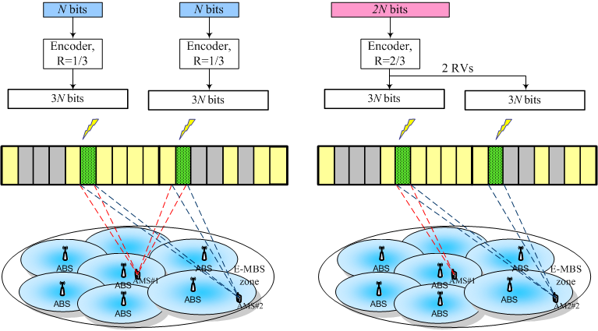
(a) Single transmission | (b) HARQ Blind transmission
Fig. 2. Power saving for HARQ blind transmission
In addition to E-MBS data reliability, another benefit to apply HARQ blind transmission is to save AMSs’ battery consumption in E-MBS reception. As shown in Fig. 2, two E-MBS transmission schemes are considered here. One is single transmission, which means each MAC PDU is transmitted in one E-MBS subframe without any repetition. The other one is HARQ blind transmission scheme, which means that a MAC PDU is transmitted in terms of several HARQ subpackets in several E-MBS subframes without ACK/NACK feedback from AMSs.
In addition, the information bit rate of HARQ blind transmission can be the same as that of single transmission. In other words, a bigger size MAC PDU transmitted with a higher level of MCS is applied in HARQ blind transmission. For example, as shown in Figure 1, we may transmit two MAC PDUs, each with N information bits, by using QPSK-1/3 in single transmission, while transmitting one MAC PDU with 2N information bits by using QPSK-2/3 in HARQ blind transmission with two transmissions.

By using HARQ blind transmission, E-MBS users can receive different number of E-MBS subframes based on their MBSFN signal condition. As illustrated in Fig. 2(b), E-MBS users having good MBSFN signal quality (e.g., AMS #1) may receive only one E-MBS subframe and correctly decode the E-MBS MAC PDU; meanwhile, E-MBS users with bad MBSFN signal quality (e.g., AMS #2) may receive two HARQ subpackets and combine them together to maintain the target BLER. As a result, in this case a half of battery consumption for AMS#1 can be saved. Simulation results are presented as follows.

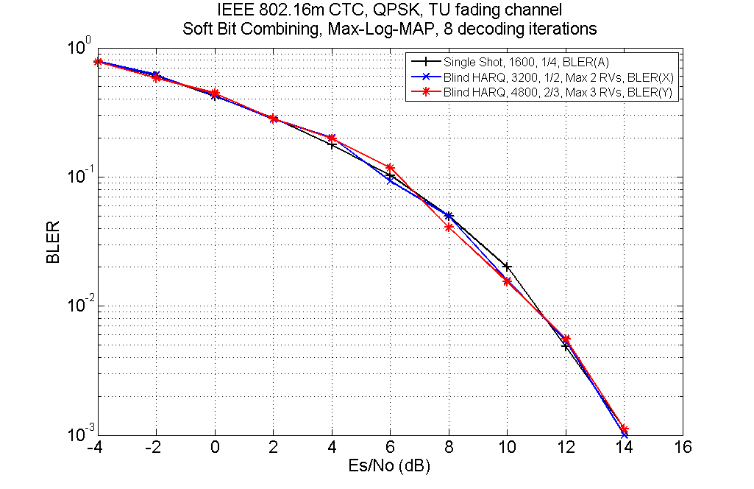
Fig. 3 Comparison between single and HARQ blind transmission (SNR vs. BLER)

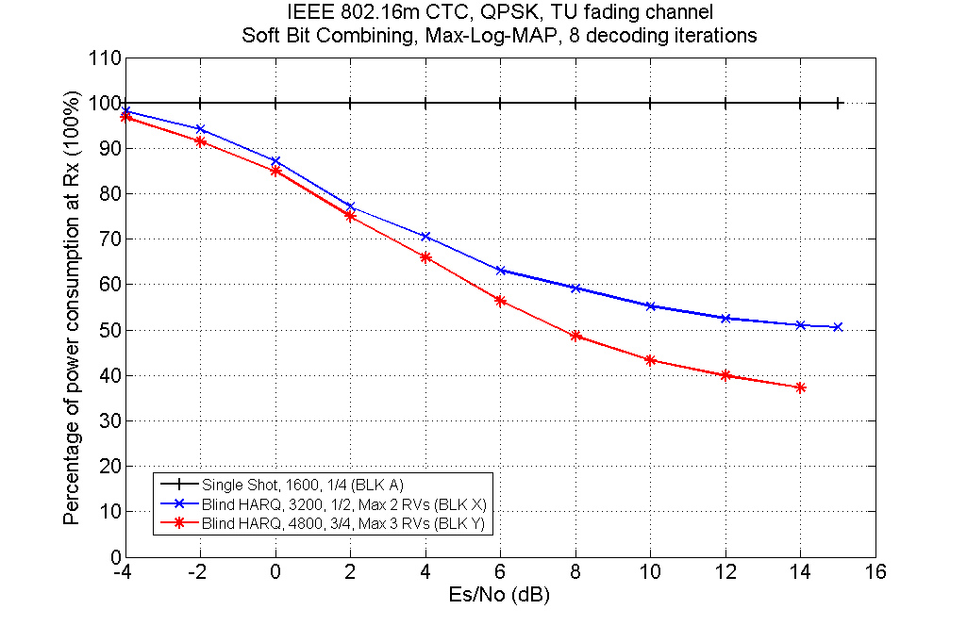
Fig. 4 The relative number of received subframes

In the simulation, we consider the performance comparison among single transmission (QPSK-1/4), HARQ blind with 2 subpackets (QPSK-2/4), and HARQ blind transmission with 3 subpackets (QPSK-3/4). It can be seen from the Fig. 4 that HARQ blind transmission with two subpackets can save about 36% (at 6dB) and 45% (at 10dB) E-MBS reception power; moreover, HARQ blind transmission with three subpackets can save about 43% (at 6dB) and 56% (at 10dB) power in E-MBS reception. Based on above simulation results, we propose HARQ blind transmission should be supported.

