Project | IEEE 802.16 Broadband Wireless Access Working Group <http://ieee802.org/16>
Title | Staggered Femto SFH for Interference Avoidance
Date Submitted | 2009-08-31
Source(s) | Yung-Han Chen, Chie Ming Chou, Fang-Ching (Frank) Ren , Chun-Yen Wang  ITRI  Wern Ho Sheen  Chaoyang University of Technology / ITRI  Zhaohua Lu, Feng Xie, Yang Liu, Mary Chion  ZTE Corporation | chenyunghan@itri.org.tw  whsheen@itri.org.tw  lu.zhaohua@zte.com.cn  *<http://standards.ieee.org/faqs/affiliationFAQ.html>
Re: | IEEE 802.16 Working Group Letter Ballot #30
Abstract | This contribution proposes a staggered SFH method for Femto ABSs to mitigate macro-femto and femto-femto severe interference on SFHs.
Purpose | To be discussed and adopted in IEEE 802.16m draft
Notice | This document does not represent the agreed views of the IEEE 802.16 Working Group or any of its subgroups. It represents only the views of the participants listed in the “Source(s)” field above. It is offered as a basis for discussion. It is not binding on the contributor(s), who reserve(s) the right to add, amend or withdraw material contained herein.
Release | The contributor grants a free, irrevocable license to the IEEE to incorporate material contained in this contribution, and any modifications thereof, in the creation of an IEEE Standards publication; to copyright in the IEEE’s name any IEEE Standards publication even though it may include portions of this contribution; and at the IEEE’s sole discretion to permit others to reproduce in whole or in part the resulting IEEE Standards publication. The contributor also acknowledges and accepts that this contribution may be made public by IEEE 802.16.
Patent Policy | The contributor is familiar with the IEEE-SA Patent Policy and Procedures:  <http://standards.ieee.org/guides/bylaws/sect6-7.html#6> and <http://standards.ieee.org/guides/opman/sect6.html#6.3>.  Further information is located at <http://standards.ieee.org/board/pat/pat-material.html> and <http://standards.ieee.org/board/pat>.
Staggered Femto SFH for Interference Avoidance

Yung-Han Chen, Chie Ming Chou, Fang-Ching (Frank) Ren, Chun-Yen Wang
ITRI

Wern Ho Sheen
Chaoyang University of Technology / ITRI

Zhaohua Lu, Feng Xie, Yang Liu, Mary Chion
ZTE Corporation

1. Descriptions
If a Femto ABS and a Macro ABS are co-channel and close in locations, the SFH of the Femto ABS would suffer severe interference by the SFH of the Macro ABS if the their SHFs are aligned in time domain. It is because the Macro ABS transmits SFH with much larger power than the Femto ABS. The following simulations reveal this problem. In the simulation scenario shown in Figure 1, an apartment with four rooms is considered. Assume that a 10m x 10m apartment is centered at coordinate (0, 0) and the Femto ABS (fBS) is located at (0.1m, 0.1m). The internal wall penetration of apartment is 5dB loss. The distance between Macro ABS (mBS) and fBS is D_{mBS-fBS}. The transmission power of mBS and fBS are 46dBm and 20dBm, respectively.

Figure 1. Simulation scenario

The simulation parameters are listed as follows.

Parameter | Value
Path loss model
Macro cell (Urban), AMS is inside the apartment | PL(dB)=15.3+37.6log₁₀(R)+L_{ow}  R in m, L_{ow} (penetration loss of an outdoor wall) =20 dB
Femto cell | PL(dB)=38.46+20log₁₀(R)+0.7d_{2D,indoor}  +18.3((n+2)/(n+1)-0.46) + q*L_{iw}  R in m  n is the number of penetrated floors  q is the number of walls separating apartment between AMS and femto ABS (fBS)
Shadow loss
σ_{mBS-AMS} | 8 dB
σ_{fBS-AMS} | 4 dB
Note: Model Ref.: 3GPP TSG RAN WG4 #51 R4-092042
mBS: macro ABS
fBS: femto ABS

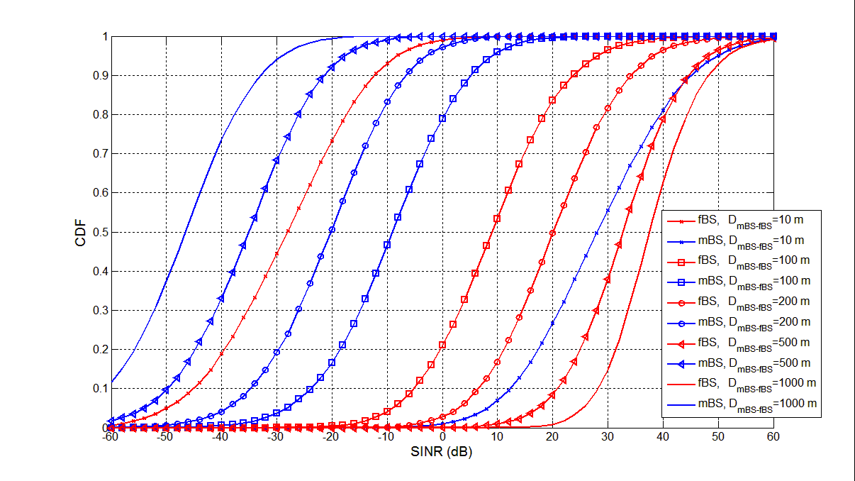
Figure 2. Simulation results

Figure 2 shows the simulation results with different D_{mBS-fBS}. In this figure, red lines are the results that the AMS receives Femto ABS’ SFH (interfered by macro ABS’ SFH), while blue lines are the results that the AMS receives Macro ABS’ SFH (interfered by Femto ABS’ SFH). It can be found that, in the case of D_{mBS-fBS}=100m, there are about 5% probability that the SINR of received Femto SFH is lower than -10dB. The interference over macro ABS SFH is even more severe.

Another simulation scenario shows the interference among Femto cells and macro cell. As Figure 3 shows, a 5x5 grid cell model (25 10mx10m apartments without internal wall) is used and the observation target is the interference result of the central Femto cell, in which AMSs are uniformly distributed. Each other Femto ABS has power-on probability p.
Figure 3. Simulation scenario of 5x5 grid cell model

The simulation parameters are also based on R4-092042 and listed in the following table.
Parameter | Value
Path loss model
Macro cell (Urban), an AMS is inside the apartment. | PL(dB)=15.3+37.6log10(R)+Low  R in m, Low = 20 dB
Femto cell (5*5 grid model) | PL(dB)=127+30log(R/100)  R in m
Shadow loss
σmBS-AMS | 8 dB
σfBS-AMS | 10 dB (simplified model, no internal walls)

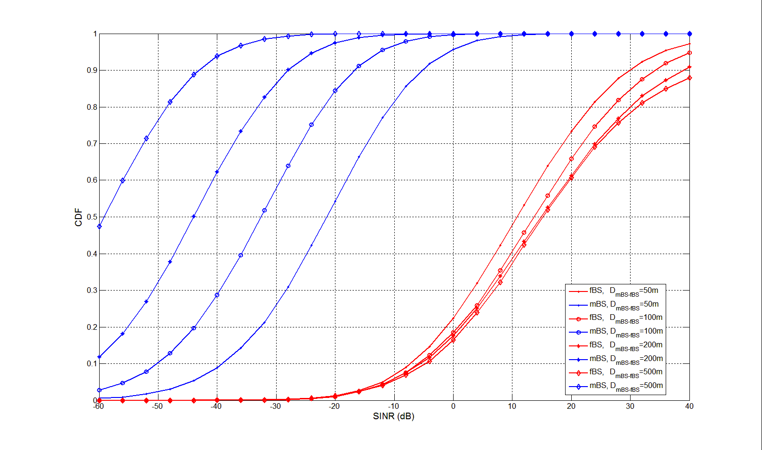
Figure 4. Simulation result (p=0.1)

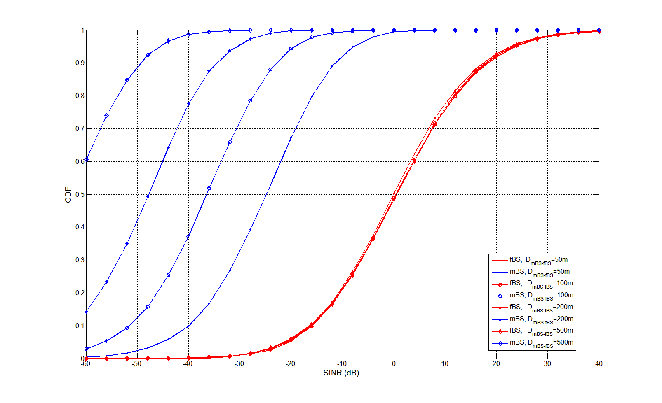
Figure 5. Simulation result (p=0.5)

Figures 4 and 5 show the simulation results when p=0.1 and p=0.5. We can find that the interference impact over Femto SFH is also obvious, and the interference impact over macro SFH is very severe. To solve the mentioned problems of severe mutual interference on SFHs among macro and Femto ABSs, the SFHs of Femto ABSs have to be staggered to other resource blocks. The resource blocks used for staggered SFH of a Femto ABS can be derived by its SA-Preamble index. The macro ABS should also avoid scheduling its traffic over the resource blocks used for staggered SFHs to prevent interference between macro data burst and Femto SFH.

2. Suggested Remedy
-------------------------------------------------------- Text Start ------------------------------------------------------------
15.x Support for Femtocell BS

15.4.11 Interference Avoidance and Interference Mitigation

{Modify the first paragraph and caption of Figure 494 in page 494 as follows}

Femto ABSs shall use different OFDMA symbols for SFH in order to reduce interference among Femto and/or macro ABSs. The SFH of Femto ABSs is located in the first/second frames after PA-Preamble, while all PA-Preambles of Femto and Macro ABSs are aligned in the time domain. To mitigate the severe mutual interference on SFHs between a macro ABS and a Femto ABS or between two neighboring Femto ABSs, the Femto SFH shall be staggered to one of the frames other than the frame containing macro ABS’ SFH. The Femto SFH can be located in the n-th frames after the frame that contains PA-Preamble, where n is derived by

n = ((The Femto ABS’ SA-Preamble index) mod 3) + 1,

where n=3 means that the Femto SFH is not staggered with macro SFH.

The location of the staggered Femto SFH is immediately after the A-Preamble. Figure F2494 shows the staggered SFH locations of Femto and Macro ABSs. The macro ABS should avoid scheduling any DL transmission over the resource used for staggered Femto SFHs to prevent interference. The Femto ABSs with staggered SFH shall not schedule any DL transmission on the resource that the SFH of Macro ABSs is being transmitted.

Figure 494— The Example of staggered SFH location of Femto ABS
-------------------------------------------------------- Text End ------------------------------------------------------------

