Project | IEEE 802.16 Broadband Wireless Access Working Group <http://ieee802.org/16>
Title | A Proposal on Bandwidth Request Compensation;  Proposed text for Bandwidth Request (15.2.11.1)
Date Submitted | 2009-08-30
Source(s) | Masato Okuda, Keiichi Nakatsugawa, Kevin Power  Fujitsu  Jie Hui, Aran Bergman, Xiangying Yang  Intel Corp.  Kanchei (Ken) Loa, Chun-Yen Hsu  Institute for Information Industry  Yih-Shen Chen  MediaTek  Yang Liu, Yuqin Chen  ZTE | E-mail: okuda@jp.fujitsu.com  *<http://standards.ieee.org/faqs/affiliationFAQ.html>  Jie.hui@intel.com  loa@iii.org.tw, hcy@nmi.iii.org.tw  yihshen.chen@mediatek.com  liu.yang8@zte.com.cn, chen.yuqin@zte.com.cn
Re: | “IEEE P802.16m/D1”:  IEEE 802.16-09/0044, “IEEE 802.16 Working Group Working Group Letter Ballot #30”.  Target topic: “Bandwidth Request/Grant”
Abstract | This contribution proposes automatic bandwidth request quantity update due to fragmentation/packing.
Purpose | To be discussed and adopted by TGm for P802.16m/D1.
Notice | This document does not represent the agreed views of the IEEE 802.16 Working Group or any of its subgroups. It represents only the views of the participants listed in the “Source(s)” field above. It is offered as a basis for discussion. It is not binding on the contributor(s), who reserve(s) the right to add, amend or withdraw material contained herein.
Release | The contributor grants a free, irrevocable license to the IEEE to incorporate material contained in this contribution, and any modifications thereof, in the creation of an IEEE Standards publication; to copyright in the IEEE’s name any IEEE Standards publication even though it may include portions of this contribution; and at the IEEE’s sole discretion to permit others to reproduce in whole or in part the resulting IEEE Standards publication. The contributor also acknowledges and accepts that this contribution may be made public by IEEE 802.16.
Patent Policy | The contributor is familiar with the IEEE-SA Patent Policy and Procedures:  <http://standards.ieee.org/guides/bylaws/sect6-7.html#6> and <http://standards.ieee.org/guides/opman/sect6.html#6.3>.  Further information is located at <http://standards.ieee.org/board/pat/pat-material.html> and <http://standards.ieee.org/board/pat>.
A Proposal on Bandwidth Request Update
Masato Okuda, Keiichi Nakatsugawa, Kevin Power
Fujitsu
Jie Hui, Aran Bergman, Xiangying Yang
Intel Corp.
Kanchei (Ken) Loa, Chun-Yen Hsu
Institute for Information Industry
Yih-Shen Chen
MediaTek
Yang Liu, Yuqin Chen
ZTE

Introduction
The AWD specifies that the standalone bandwidth request and the piggybacked bandwidth request represent the number of bytes of MAC PDUs excluding PHY overhead.
When UL bandwidth is allocated, AMS may fragment or pack MAC-PDUs based on the allocated bandwidth resource. If fragmentation and/or packing are performed, the actual number of bytes of MAC-PDUs will differ from the requested one, because extended headers may be added or GMH may be omitted.
The figure 1 shows an example of requested bandwidth change due to fragmentation. In this example, AMS initially requests UL bandwidth for 1502 bytes PDU. However, ABS only allocates BW for 1000Bytes. Therefore, AMS fragments the payload (SDU) of the PDU into two, then The FPEH is attached to both SDUs and GMH is attached to the last SDU to form a MAC PDU. This fragmentation results in increase of 6 bytes for the total amount of MAC PDUs.
Then, ABS allocates remaining request bandwidth (502Byte). However, AMS cannot send the last MAC PDU and fragment PDU again. This second fragmentation adds 4 bytes headers.
As a result of two fragmentation, AMS needs to requests additional 10 bytes. This causes increase of latency and bandwidth waste.

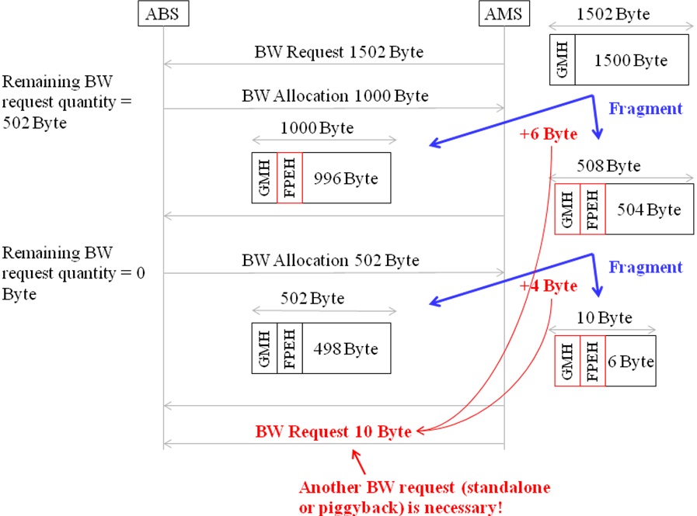
Figure 1 An example of Requested Bandwidth Change

Under certain conditions, the AMS has to pad an allocation since the remaining bytes in the allocation cannot really carry anything. In 16e this can happen if the remaining number of bytes is smaller than 56, if the connection is ARQ enabled, and the block size is 16 bytes on an ARQ-enabled, encrypted connection. This may amount to a considerable number of padding bytes which the BS currently counts as allocated and the MS has to compensate for them and re-send a request to add the required number of bytes (or send an Aggregate BR to synchronize the BS). Figure 2 shows an example of overhead increase due to fragmentation at ARQ block boundary. It would be better in 16m if the ABS would have compensated for these padding bytes without explicit MS signaling.
Figure 2 Overhead due to fragmentation at ARQ block boundary

To resolve the above mentioned problem, we propose a simple rule to update bandwidth request quantity at both ABS and AMS.
- Since ABS can recognize whether the received PDU contains fragmented SDU or packed SDUs, it can easily calculate change of remaining MAC PDU size.
- For example, when ABS detects the first fragment of SDU, one FPEH is additionally inserted in the received PDU and GMH and FPEH is prepended to the remaining SDU. So, additional overhead is one GMH (2) and two FPEH (2x2).
- Padding compensation: The same principle applies to the case when ABS detects padding overhead thus can automatically compensate for the additional BW request needs increase.

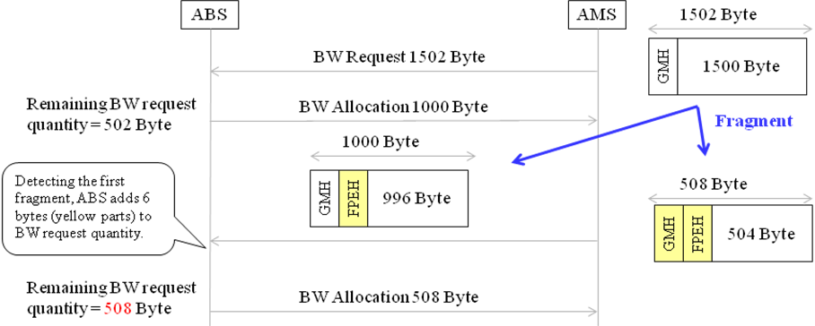
Figure 3 Automatic bandwidth request update

Proposed Text

Add the following text at the end of the first paragraph of 15.2.11.1.
ABS may automatically compensates for BW request quantity change, when it detects additional overhead due to fragmentation, packing or ARQ fragmentation caused padding overhead which is smaller than one MPDU fitting an ARQ sub-block. When ABS successfully receives a fragmented or packed MPDU, AMS needs not to send a BW request (standalone or piggybacked) to accommodate BW request quantity change due to fragmentation, packing or ARQ fragmentation. ABS and AMS negotiate this BW request compensation capability with AAI-REG-REQ/RSP.

Add the following parameter to”AMS capability negotiation parameters” in the table 684 (parameters for AAI_ REG-REQ) as indicated below.
Name | Value
Bandwidth request compensation support | Indicates capability to automatically compensate BW request change due to fragmentation, packing or ARQ fragmentation.

