Project | IEEE 802.16 Broadband Wireless Access Working Group <http://ieee802.org/16>
Title | Cognitive Interference Management for Transparent and Non-Transparent Relays
Date Submitted | 2009-08-28
Source(s) | Sheetal Kalyani, Nadeem Akhtar, Sunil Kaimalettu, J Klutto Milleth  Kiran Kuchi, Bhaskar Ramamurthi  CEWiT, India | Voice:  E-mail: klutto@cewit.org.in  kkuchi@cewit.org.in  *<http://standards.ieee.org/faqs/affiliationFAQ.html>
Re: | IEEE 802.16m-09/0037: Call for Contributions on Project 802.16m Amendment Content on the Topic “Support for Relay”
Abstract | This document contains a contribution and proposed amendment text for the document IEEE P802.16m/D1 related to Relay features for IEEE 802.16m
Purpose | To be circulated for harmonization and review following Session #63 and to  be discussed by the TGm during Session #63.5 for adoption as a text in the document IEEE P802.16m/D1
Notice | This document does not represent the agreed views of the IEEE 802.16 Working Group or any of its subgroups. It represents only the views of the participants listed in the “Source(s)” field above. It is offered as a basis for discussion. It is not binding on the contributor(s), who reserve(s) the right to add, amend or withdraw material contained herein.
Release | The contributor grants a free, irrevocable license to the IEEE to incorporate material contained in this contribution, and any modifications thereof, in the creation of an IEEE Standards publication; to copyright in the IEEE’s name any IEEE Standards publication even though it may include portions of this contribution; and at the IEEE’s sole discretion to permit others to reproduce in whole or in part the resulting IEEE Standards publication. The contributor also acknowledges and accepts that this contribution may be made public by IEEE 802.16.
Patent Policy | The contributor is familiar with the IEEE-SA Patent Policy and Procedures:  <http://standards.ieee.org/guides/bylaws/sect6-7.html#6> and <http://standards.ieee.org/guides/opman/sect6.html#6.3>.  Further information is located at <http://standards.ieee.org/board/pat/pat-material.html> and <http://standards.ieee.org/board/pat>.

Cognitive Interference Management for Transparent and Non-Transparent Relays
Sheetal Kalyani, Nadeem Akhtar, Sunil Kaimalettu, J Klutto Milleth, Kiran Kuchi, Bhaskar Ramamurthi
CEWiT, India

Introduction
Relays are supported in IEEE 802.16m, as a tool for improving cell/sector throughput, extending coverage etc. Relay (ARS) reuses the available spectrum to support both the wireless link to its AMSs, and backhaul link to ABS in TTR relaying mode. Since the same frequency is reused by the Relays, it results in increased interference, which will be severe when the number of relays is large. Relays being out-door devices makes the matter more severe compared to femto-ABS.
In order to reuse the spectrum efficiently, the interference has to be managed. A scheme for reducing the interference due to relays is proposed.

Interference in Relay-based Scenarios
The deployment of in-band relays results in additional interference scenarios when compared to the system without relays.
Case 1:
. When an ARS serves an AMS, it will cause interference to other AMSs served by the ABSs using the same resources, especially to those AMSs that are in the immediate vicinity of the ARS coverage area, as shown in Figure 1.
Figure 1: Interference Case 1
Case 2:
When an ABS serves an AMS, it will cause interference to other AMSs served by the ARSs using the same resources as shown in Figure 2.
Figure 2: Interference Case 2
Case 3:
ARS may cause interference to an AMS being served by another ARS using the same resource as shown in Figure 3.

Figure 3: Interference Case 3
Case 4:
ARSs may also interfere with each other in multi hop relay, or mixed mode deployment of transparent and non-transparent relays scenarios. An ARS receiving from an ABS/ARS is susceptible to interference from another ARS, which is serving one of its AMSs using the same resources is shown in Figure 4.
Figure 4: Interference Case 4
The above four cases will also holds good even when the interference is caused by the ARS/ABS in adjacent cells/sectors.

Cognitive Interference Management
A fixed or semi-static orthogonal resource allocation is relatively easy to implement, but requires fairly accurate prior estimates of the expected traffic load on ARSs. In the absence of such information, it can either lead to under-utilization of resources or can cause congestion. We propose to use dynamic resource allocation method in which the ABS and ARSs are allocated resources that take into account the traffic load as well as the potential to cause interference to each other’s AMSs.
The first step in this approach is to identify the potential victims of interference. Without loss of generality, we have considered only interference within the same cell. Each AMS in the cell is classified as Safe or Victim with respect to each ARS in the cell and the ABS itself. An AMS served by the ABS is considered to be safe w. r. t. a particular ARS, if the ARS is not causing significant interference to the AMS. In all the example Figures 1-6, the region in which the AMSs served by the ABS sees significantly less interference from any ARS is shown in green color, and the AMSs in this region is referred to as a safe AMS. Similarly the regions in which, AMSs served by ARSs, see significantly less interference from other ARS/ABS are shown in yellow color, these AMSs are also classified as safe AMS (a.k.a. as safe relay AMS for illustration). An AMS that is receiving strong interference from an ARS and/or the ABS is tagged as a victim AMS w. r. t. that specific ARS/ABS and the corresponding region is shown in red color.
Figure 5: AMS Classification
A Safe/Victim AMS of an ARS could be associated with the ABS or another ARS within the cell. Taking into account the interference case 4, like safe/victim AMSs, the ARSs can also be classified as safe/victim, ARSs and they shall be treated in the same manner as safe/victim AMS.

The classification is done at the ABS, based on feedback received from the AMSs which measure the signal strength from ARSs/ABS and report back the information (along with the respective ARS identifiers). Using the AMS feedback, the ABS will be able to identify the potential interfering ARS(s)/ABS for each AMS (served by itself or one of the ARSs). Any ARS and the ABS itself will try to use the resources which are orthogonal w. r. t. resources allocated to its Victim AMSs. Assuming that resource R1 is allocated to ARS1, the same resource could be allocated to another ARS, say ARS2, provided that none of its AMSs are victims of ARS1. The ABS itself could use the same resource for those AMSs, which are not victim AMSs w. r. t. ARS1 and ARS2. In this way, interference can be minimized and the spectrum is re-used efficiently.
As an example, let us consider the cell shown in Figure 6. In this scenario, there are two ARSs in the cell and a number of AMSs, of which 3 are being served directly by the ABS whereas each ARS is serving a single AMS. For illustration purpose, we consider interference from relays only.
Figure 6: Example scenario
The AMS classification for this scenario is shown in the table below. Each of the 5 AMSs is labeled as a Victim or Safe w. r. t. ARS1 and ARS2 respectively. For example, AMS2 is a victim of ARS1 whereas AMS3 is a Victim of ARS2. On the other hand, AMS4 is safe from both ARS1 and ARS2. | ARS1 | ARS2
AMS1 | S | S
AMS2 | V | S
AMS3 | S | V
AMS4 | S | S
AMS5 | S | S

Figure 7: Classification Table
Based on the AMS classification, the ABS allocates resources to ARS1 and ARS2 accordingly. Figure 8 shows one snapshot of resource allocation for this scenario. Only a single frame is shown for simplicity. As illustrated in the figure below, ARS1 can transmit to AMS1 using the same resource on which the ABS is transmitting to AMS4. This is possible because AMS4 is safe from interference caused by ARS1. Similarly, ARS2 can transmit to AMS5 using the same resource on which ABS is transmitting to AMS4 since the latter is not a victim of ARS2. The figure also shows the so-called ‘Collision Zones’ for each ARS where they are not allowed to transmit since their respective victims are scheduled to receive from the ABS in that resource.
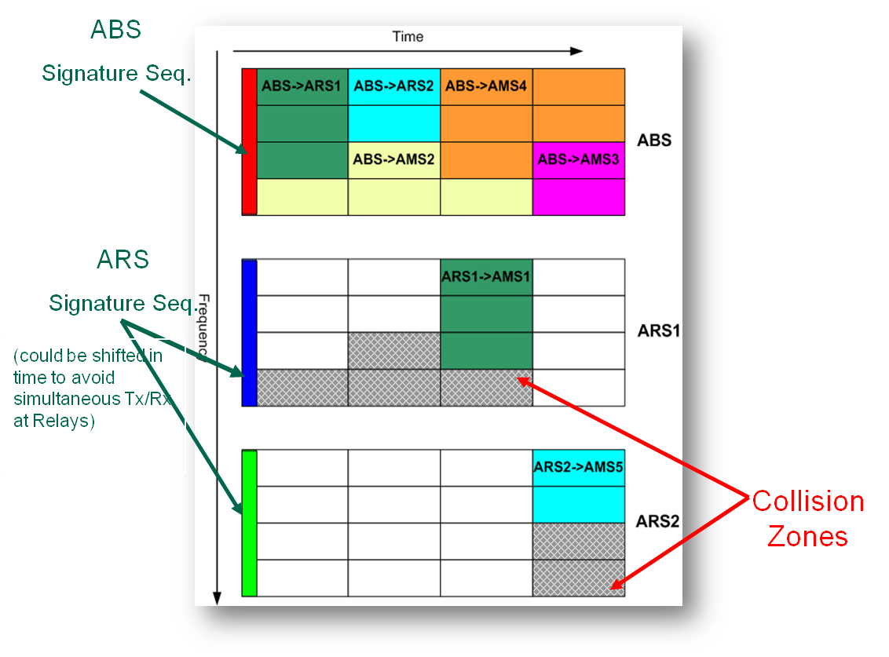
Figure 8: Resource allocation
This example clearly shows how interference in relay-based scenarios can be minimized with the help of dynamic resource allocation. Note that the same approach can be extended to inter-cell case where neighboring ABSs exchange information on interference from each other’s ARSs.

Specification Issues
The interference management scheme described above relies upon feedback from AMSs regarding the received signal strength from different ARSs and the ABS itself. Therefore, in order to make use of this technique, suitable mechanisms for reporting ARS and ABS-related information have to be supported. At the minimum, the received signal strengths from every potential interferer ARS and the ABS itself and their identities have to be reported back to the ABS by the AMS. It is not necessary for the AMSs to report the received signal strength from all the ARSs/ABS. Only those ARS/ABS that can cause significant interference, to an AMS shall be reported by that AMS. The periodicity of reporting will obviously depend on the mobility scenario. In particular, for nomadic and fixed (users) case, the frequency of reporting can be kept quite low (TBD). For ARS identification, a signature sequence has to be transmitted by each relay. Non-transparent relays can use A-preamble like an ABS, however, transparent relays require a signature sequence to enable AMSs to identify them and measure received signal strength, and this could be a Relay-amble transmitted in a predetermined resource orthogonal to the A-Preamble. ABS could assist the AMS/ARS to identify the interferer by advertising the identities of neighboring ARSs, in the AAI_NBR_ADV. AAI_NBR_ADV may include relays from neighboring cells. The control signals present in the 16m for handover support could be reused for interference identification with minor modifications (TBD).
The second aspect that needs to be considered is the indication of resource allocation from ABS to ARSs. Based on the AMS classification table, the ABS has to allocate resources to each ARS and this information has to be signaled to the ARSs. The granularity of such information will depend on the scheduling mode. When centralized scheduling is being used, the ABS has to inform each ARS regarding the allocation for each of its AMSs (i.e. AMSs served by the ARS). However, when distributed scheduling is used, then the ABS only needs to indicate the resources that an ARS can use and then the latter can independently schedule its AMSs within the specified region. The control messages required for such a resource allocation for relays requires support from the standard (TBD).
The third specification issue relates to exchange of information between neighbor ABSs to handle intra cell interference caused by relays (TBD).

Conclusion
Relay is a feature currently being discussed for IEEE 802.16m. Deployment of relays can help improve coverage or enhance cell-edge throughput. However, the presence of relays exacerbates the interference problem, especially if deployed in large numbers. Therefore, interference management becomes a crucial element in relay scenarios. We have presented a dynamic resource allocation scheme based on AMS classification, which helps minimizing interference due to relays and reuse the spectrum efficiently. The specification issues arising out of this proposal are also discussed briefly.

Proposed Text
Interference management with relays
Measurements
While the AMS attached to a IEEE 80216m network and is in active mode, it shall measure path loss and interference power from different ARS (and/or ABS) from their A-Preamble and report their Preamble ID and RSSI to ABS in the AAI_SCN-REP message. This reporting shall be periodic and based on threshold.
The AMS may scan only the ARS/ ABS advertised in AAI_NBR-ADV from the serving BS. The threshold and periodicity of reporting are TBD.
For the purpose of interference measurement all the transparent ARS should transmit a signature for the AMS to be able to identify the interfering transparent ARS. For example, the signature could be the preamble or a relay-amble transmitted in a specific reserved resource.
Classification
Based on the reports received at the ABS, ABS shall classify the AMS with respect to each ARS/ABS (i.e. itself) as
Victim AMS – Sees significantly strong interference from the ARS or the ABS
Safe AMS – All other AMSs (not affected by interference from the ARS or ABS)‏
Interference aware Resource Allocation
Based on the interference measurements, the ABS reserves resources for an ARS to transmit to its AMSs. The ABS permits the ARS to use only those resources, which are orthogonal w. r. t. resources allocated to Victim AMSs of that ARS. In the case of ART relays, ABS may instruct the ARS not to transmit in a region, which is used for Victim AMS of that ARS.
If an ABS/ARS to ARS link sees interference from another ARS similar procedure should be adopted.

