Project | IEEE 802.16 Broadband Wireless Access Working Group <http://ieee802.org/16>
Title | Scanning overhead reduction based on RSSI profiles
Date Submitted | 2009-08-28
Source(s) | Byung Moo Lee, Young Chul Oh,  Jeong-Hwi Kim and Jong-Sik Lee  KT  Sung-Yeop Pyun, Jung-Min Moon and  Dong-Ho Cho  KAIST  Howon Lee, Min Suk Kang  and Bang Chul Jung  KI ITC | E-mail: bmlee73@gmail.com  E-mail: psy83@comis.kaist.ac.kr  E-mail: hwlee81@gmail.com
Re: | Call for Letter Ballot # 30 (15.4. Support for Femto ABS)
Abstract | This contribution provides the Text for Femto ABS
Purpose | Proposed to be discussed and adopted by TGm
Notice | This document does not represent the agreed views of the IEEE 802.16 Working Group or any of its subgroups. It represents only the views of the participants listed in the “Source(s)” field above. It is offered as a basis for discussion. It is not binding on the contributor(s), who reserve(s) the right to activate, amend or withdraw material contained herein.
Release | The contributor grants a free, irrevocable license to the IEEE to incorporate material contained in this contribution, and any modifications thereof, in the creation of an IEEE Standards publication; to copyright in the IEEE’s name any IEEE Standards publication even though it may include portions of this contribution; and at the IEEE’s sole discretion to permit others to reproduce in whole or in part the resulting IEEE Standards publication. The contributor also acknowledges and accepts that this contribution may be made public by IEEE 802.16.
Patent Policy | The contributor is familiar with the IEEE-SA Patent Policy and Procedures:  <http://standards.ieee.org/guides/bylaws/sect6-7.html#6> and <http://standards.ieee.org/guides/opman/sect6.html#6.3>.  Further information is located at <http://standards.ieee.org/board/pat/pat-material.html> and <http://standards.ieee.org/board/pat>.
Scanning overhead reduction based on RSSI profiles
Byung Moo Lee, Young Chul Oh, Jeong-Hwi Kim and Jong-Sik Lee
KT
Sung-Yeop Pyun, Jung-Min Moon and Dong-Ho Cho
KAIST
Howon Lee, Min Suk Kang and Bang Chul Jung
KI ITC

Problem definition
As for an AMS, there are still plenty of operations which make AMS keep consuming its power prior to being served by accessible femto ABSs. Figure 1 briefly illustrates the scanning and handover operations of AMS from a macro ABS to a femto ABS. Scanning operations provide the opportunities for the AMS to perform measurement and obtain necessary system configuration information of the neighboring macro ABSs for handover decisions. The macro ABS may allocate time intervals that AMS seeks and monitors the suitability of neighboring macro ABSs and femto ABSs as targets for handover. The AMS performs scanning operations as a scanning mode during the allocated time intervals whereas the AMS returns to the normal operation mode after the allocated time interval [1].

To detect an accessible femto ABS which uses the assigned frequency, the AMS may keep scanning for the assigned frequency and prepare for handover from a macro ABS to the femto ABS until the femto ABS is found. Through these exclusive scanning operations, power of battery can be inefficiently wasted. Thus, it is need to reduce the number of scanning operations for the accessible femto ABS.

Figure 1 Scanning and handover operations to a femto ABS
A conventional scheme, macro ABS identity scheme, utilizes neighboring macro ABS identities as indices to mark the accessible femto ABS. Only when measured sets of macro ABS identities are matched with reference sets of macro ABS identities, scanning operations will be set off [2]. It is recommended as a practical method in 3GPP, but scanning time for the femto ABS is still large.

Proposed method
In case that there is no available location information (e.g, GPS), RSSI profiles of neighboring macro ABSs can be used to narrow down the expected scanning area for an accessible femto ABS and reduce unnecessary scanning operations for the femto ABS.
We assume that a femto ABS owns self-organizing network (SON) functions such as self-discovery although some functions may be executed by help of an AMS. Basically, the AMS keeps measuring RSSIs of neighboring macro ABSs to monitor the status of neighboring macro ABSs to prepare handoffs between macro ABSs. Here, the AMS averages out the measured values of neighboring macro ABSs to obtain the representative RSSI values of neighboring macro ABSs at a temporary location while on the move.
Each representative RSSI value can be categorized into one of separate RSSI levels as shown in Fig.2 until all RSSI values of neighboring macro ABSs are covered. In the same way, reference RSSI profiles are created from the perspective of the accessible femto ABS. Based on these discrete RSSI levels, our proposed scheme checks the similarity between these RSSI levels from the AMS and the reference RSSI profiles. Only when the similarity goes beyond the defined similarity, the scanning operations will be finally initiated.
Figure 2 Level decisions for RSSIs of neighboring macro ABSs using thresholds
In detail, the proposed scanning scheme can be described as follows. Once a femto ABS is installed, the femto ABS measures the RSSI values of neighboring macro ABSs with support of the AMS. Using the measured RSSIs of neighboring macro ABSs, each RSSI can be translated into one signal level which is bounded between signal strength thresholds as shown in Fig.2. A level translator on RSSI is expressed as follows.
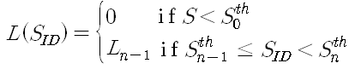
Where represents a level for , an RSSI of a macro ABS which has an identifier ID. Also, denotes a threshold to divide the receivable RSSI which ranges between 1 and n. Therefore, the reference RSSI profiles to represent the location of the femto ABS can be written as a form of set.
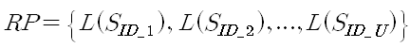
Where RP denotes an RSSI profiles of a specific accessible femto ABS, and an RP consists of collected levels by using the level translator , whose ID is corresponding to the one of all related neighboring macro ABSs.
The obtained RSSI profiles are transferred and stored as reference RSSI profiles in an AMS, and can be used to trigger the scanning operations for the accessible femto ABS. To obtain the more correct value of the RSSI profile, the sampling technique can be applicable in the proposed scheme. For the triggering decision on the scanning operations, the similarity value as mentioned above should be predefined to narrow down the candidate area for the scanning operations.
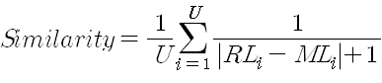
Where denotes the reference level of the I th macro ABS and denotes the measured level of the I th macro ABS. The value of similarity ranges 0 and 1. The value of 1 is the maximal value while that of 0 is the minimal value. The similarity value to be used should be notified of to the AMS too.
The network manages the information on RSSI profiles for the accessible femto ABS. In case of AMS initialization or information update, network can transmit the scanning indication message to the AMS. The scanning profiles indication message contains basic information such as carrier frequency of the femto ABS, femto ABS ID, and the reference RSSI profiles to support handover between a macro ABS and the femto ABS.
For the efficient processes, the AMS may cache the scanning profiles indication message for future scanning and handover operations as long as there is no change in the RSSI profiles. Due to the outnumbered accessible femto ABSs, the size of the scanning profiles indication message may be enlarged. In this case, the number and the candidate of accessible femto ABSs to be transferred at a time should be considered too.
In case of a CSG femto ABS, the diffusion of the scanning profiles information is restricted to the registered AMS when the AMS is initialized on request of macro ABSs or the AMS.
Figure 3 precisely displays the overall working procedures of a proposed scanning scheme. During the network entry of an AMS or information update, the AMS obtains the basic information including RSSI profiles of the accessible femto ABS. This may be provided to the AMS by the femto service provider through the network using messaging that is outside the scope of this standard.
Based on the information, AMS may keep measuring the current RSSI profiles by sensing the RSSIs of neighboring macro ABSs, check the similarity value between the measured and the reference RSSI profiles, and make a decision on the initiation of scanning operations. When the similarity value goes beyond the predefined value, the AMS issues a scanning request message AAI_SCN_REQ to the serving macro ABS. Right after the request message, the serving macro ABS sends back a scanning response message AAI_SCN_RSP. And then, the AMS is permitted to initiate the scanning operations. Before receiving the response message from the serving macro ABS, when the similarity value between the presently measured and the reference RSSI profiles is below the similarity value, the incoming response message may be neglected. Through this procedure, unnecessary scanning operations can be blocked and save the power as much as the number of the scanning operations.
The candidate area for scanning operations is narrowed down by help of the proposed scheme. And, we assume that the scanning operations are performed every constant interval. The estimated number and time of scanning operations for an accessible femto ABS can be calculated. Accordingly, power usage on scanning operations can be saved.
Figure 3 Procedures of a proposed scanning scheme

Simulation results
For evaluation of a proposed scanning scheme, we adopt an average scanning area (ASA) as a major performance metric. This metric means scanning area in average on the condition that an AMS approaches a designated femto ABS from a macro ABS. The ASA is directly related to power usage on scanning operations of AMS. The simulation parameters are shown in Table 2 [3]. Also, Fig.3 shows the simulation environment. The interval between macro ABSs is 1.5 km. The radius of macro ABS coverage is 1.3km. There is a single femto ABS and a single AMS in the simulation.

Parameter | Setting
Receivable RSSI ranges of macro ABSs | -88.5~46 dBm
Standard deviation of log-normal fading | 8 dB
Pathloss model for 2.5GHz
RSSI levels for division | 2~4
Interval between macro ABSs | 1.5 km
Radius of macro ABS coverage | 1.3 km
Distance between a femto and a macro ABS | 400m and 700m
Table 2 Simulation parameters
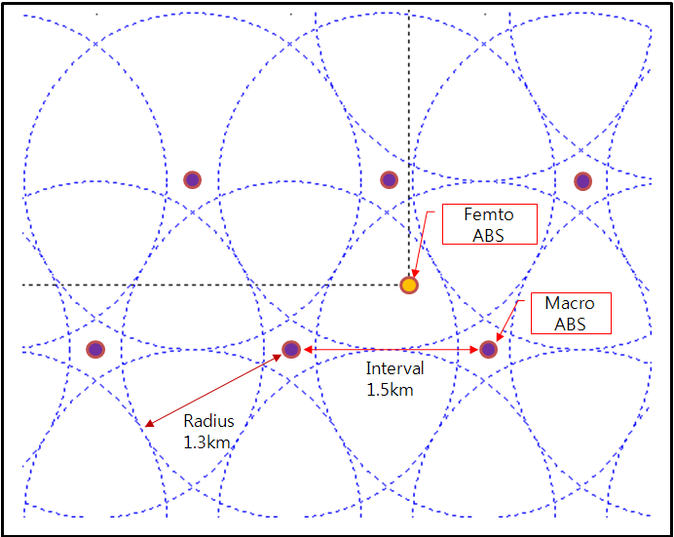
Figure 3 Basic settings of simulation environment
As shown in Fig.4.(a)~(d), the location of a femto ABS with crossing horizontal and vertical lines is represented by a single point within the serving macro ABS. In Fig.4. (a)-(b), the scanning area to trigger scanning operation has been estimated when a femto ABS is located at 400 m away from the center of the serving macro ABS. The scanning area of the conventional scheme is much larger than that of the proposed scheme with 4 RSSI levels although the femto ABS is located near to the serving macro ABS.

In Fig.4.(c)-(d), the scanning areas to trigger scanning operations are estimated for the proposed scheme with 2 RSSI levels and conventional scheme when the femto ABS is located at 700m away from the center of the serving macro ABS. Because the distance between the femto ABS and a macro ABS is larger, the scanning area for the proposed scheme is larger. However, the scanning area is still smaller than that of the conventional scheme. The scanning area of the conventional scheme is still large regardless of the femto ABS location.

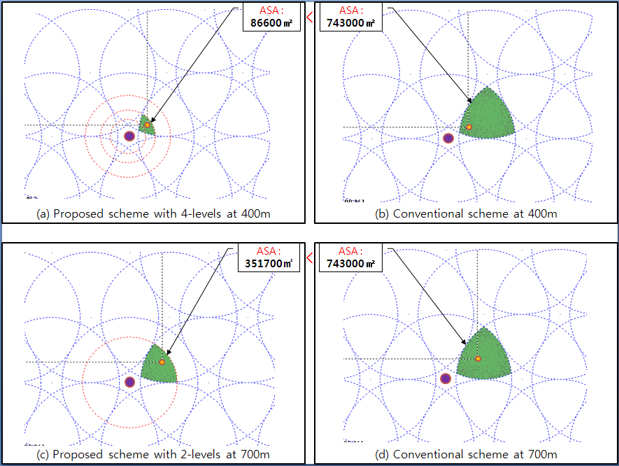
Figure 4 Average scanning area of a conventional and a proposed scheme

References
[1] IEEE Std 802.16e, “Part16: Air Interface for Fixed and Mobile Broadband Wireless Access Systems”, pp.234-235, Feb. 2006.
[2] 3GPP TS23.271, release 7(v7.2.0), Functional Stage 2 Description of Location Services(LCS), Sep. 2005.
[3] IEEE 802.16m-08/004, “Project 802.16m Evaluation Methodology Document”, pp.35-42, Jul. 2008.

Text Proposal for the IEEE 802.16m
============================== Start of Proposed Text ================================

15.4.7 Network Entry

15.4.7.1 Femto ABS detection, identification and selection
The AMS detects the Femto ABS using the PHY identifier (see <<section x>>).
The AMS identifies the Femto ABS using the MAC identifier (ex. BSID, CSGID).
The AMS shall use scanning procedures specified in 15.3.9.2. When a CSG white list is maintained at an AMS, it should select the Femto ABSs according to the white list.
For the scanning operations on femto ABS detection, information on RSSI profiles which are the measured and quantized signal strengths of neighboring ABSs may be used. These information may be provided to the AMS with a CSG white list through the network by the femto service provider.
The AMS selects the target Femto ABS for network entry based on the subscription types of the Femto ABS and the membership to the relevant subscribers groups or accessibility to the service providers network (ex: Cell bar).
============================== End of Proposed Text =================================

