Project | IEEE 802.16 Broadband Wireless Access Working Group <http://ieee802.org/16>
Title | LDO mode for Interference Management based on Femto Grouping
Date Submitted | 2009-08-28
Source(s) | Byung Moo Lee, Byung-Wan Yoon, Jeong-Hwi Kim, Jong-Sik Lee, and Seong-Choon Lee  KT  Sung-Yeop Pyun, Helena W, Yong Jin Kwon and Dong-Ho Cho  KAIST  Howon Lee and Bang Chul Jung  KI ITC | E-mail: bmlee73@gmail.com  E-mail: psy83@comis.kaist.ac.kr  E-mail: hwlee81@gmail.com
Re: | Call for Letter Ballot # 30 (15.4. Support for Femto ABS)
Abstract | Grouping of Femto ABS to achieve reduced interference
Purpose | Proposed to be discussed and adopted by TGm
Notice | This document does not represent the agreed views of the IEEE 802.16 Working Group or any of its subgroups. It represents only the views of the participants listed in the “Source(s)” field above. It is offered as a basis for discussion. It is not binding on the contributor(s), who reserve(s) the right to add, amend or withdraw material contained herein.
Release | The contributor grants a free, irrevocable license to the IEEE to incorporate material contained in this contribution, and any modifications thereof, in the creation of an IEEE Standards publication; to copyright in the IEEE’s name any IEEE Standards publication even though it may include portions of this contribution; and at the IEEE’s sole discretion to permit others to reproduce in whole or in part the resulting IEEE Standards publication. The contributor also acknowledges and accepts that this contribution may be made public by IEEE 802.16.
Patent Policy | The contributor is familiar with the IEEE-SA Patent Policy and Procedures:  <http://standards.ieee.org/guides/bylaws/sect6-7.html#6> and <http://standards.ieee.org/guides/opman/sect6.html#6.3>.  Further information is located at <http://standards.ieee.org/board/pat/pat-material.html> and <http://standards.ieee.org/board/pat>.
LDO mode for Interference Management based on Femto Grouping

Byung Moo Lee, Byung-Wan Yoon, Jeong-Hwi Kim, Jong-Sik Lee, and Seong-Choon Lee
KT
Sung-Yeop Pyun, Helena W, Yong Jin Kwon and Dong-Ho Cho
KAIST
Howon Lee and Bang Chul Jung
KI ITC

Introduction

Since large numbers of Femto ABSs will exist in one macro cell area, interference is an important issue in the Femto deployment. One of the solutions to reduce interference is Low Duty Operation Mode (LDO mode). Low duty operation mode consists of available and unavailable interval. During unavailable interval, the Femto ABS does not transmit on air interface, while during available interval, it may become active on the air interface for synchronization and signaling purposes for the AMSs. The Femto ABS may enter low-duty operation mode either if all MSs attached to the Femto ABS are in idle or sleep mode, or if no AMS is in the service range of the Femto ABS at all. Femto in LDO mode operates based on Low Duty Cycle pattern (LDC pattern). The pattern determines the length of available and unavailable interval. Macrocell/femtocell may broadcast / unicast femtocell FAs and patterns of low duty cycle over the air [1].
Femto ABS is active on available interval for synchronization and signaling purposes by transmitting downlink control information on air interface [2]. Femto ABS announces its existence to AMS by transmitting the control information. If there is an AMS attempts to perform handover or network entry to the Femto, then the control information is used. Therefore, in case of no AMS will perform handover to Femto ABS, available interval is not necessary. Furthermore, it may cause interference to neighboring cells.
An example of this case is for CSG Femto ABS deployed in home, in the day time the usage of Femto ABS will be low or zero, since the users may not present in the house.
Figure 1 Problem of Conventional LDO mode

Considering aforementioned case, we can conclude that in conventional scheme, higher interference may occur due to unnecessary downlink control signal information from Femto ABS in available interval.

Proposed method
In this contribution document, we propose a new scheme for grouping of CSG Femto ABSs in one overlay macrocell. The grouping is applied to CSG Femto ABSs in one neighborhood area. A group consists of a header and members as shown in Fig 3.
The flowchart of grouping method is shown in Fig. 2. Newly installed Femto ABS scans for other Femto ABSs in the surrounding area and reports to macro ABS about the neighbor Femto ABS. Network checks whether there is a header among the neighbor Femto ABSs and signal strength received from header is above a threshold value. If these two requirements are satisfied then the newly installed Femto ABS becomes the member of the group. Otherwise, it becomes a new header and forms a new group.

Figure 2 Grouping method
Figure 3 Grouping example

The LDO operation in the group can be explained as follows. Both header and members Femto ABSs in the group may enter LDO mode either if all AMSs attached to the Femto ABS are in idle or sleep mode, or if no AMS is in the service range of the Femto ABS at all. In LDO mode, Header Femto ABS with no AMS sets the LDC pattern with the available interval changing alternately by unavailable interval as in conventional scheme [1]. The available interval is necessary in the operation of header so that the MS can detect the existence of the group by scanning.
Member Femto ABS with no AMS may set the unavailable interval to a very large value or stay in unavailable interval during LDO mode until the time when there is an AMS tries to perform handover to Femto ABS. In Fig. 4, the operation of proposed and conventional scheme is shown. In the proposed method, the member Femto ABS may stay in unavailable interval while in the conventional scheme, member Femto ABS alternates between available and unavailable interval.
From Fig 4, we can see that the total available interval of member Femto ABS for proposed scheme is smaller than conventional scheme. Since in the available interval, the downlink control signal is transmitted and may cause interference to neighbor cells, then we may conclude that the proposed scheme can further reduce interference compared with conventional scheme.

Figure 4 Proposed and Conventional Scheme Operation

We now will explain the detailed procedures of AMS entering a macrocell area and perform handover to Target Femto ABS. As shown in Figure 6, group of Femto ABSs which consists of Header and Member Femto ABSs exists inside macrocell. The coverage area of one group is called group area. In the group area, AMS does scanning and detects the header of the group. AMS belongs to Target Femto ABS located inside group area. Target Femto ABS is a member of the group and is in unavailable interval during LDO mode.

Figure 6 Scenario of AMS Handover

The following is the procedure of AMS handover to Target Femto ABS inside a group area.

AMS enters macrocell coverage area.
Macro ABS sends the information of group (ABS ID, frequency, and LDC pattern of Header Femto) in which Target Femto ABS is member. AMS will perform scanning to detect the existence of header.
AMS enters a group area.
In the group area, AMS does scanning and detects the header of the group.
AMS informs about the detection of the header to overlay Macro ABS.
Macro ABS sends message to Target Femto ABS to add available interval in LDC pattern via backbone network meanwhile AMS moves towards the coverage of Target Femto ABS.
After Target Femto ABS receives the message, Target Femto ABS adds available interval in LDC pattern.
AMS detects Target Femto ABS and performs handover to Target Femto ABS.

Simulation

In this section, we present the simulation result of reduced interference time by applying the proposed method. The simulation is done based on the assumption that there is no MS in the service range of Target Femto ABS in the group, therefore Target Femto ABS stays in Unavailable Interval. Target Femto ABS is a member of the group.

Table 1 Simulation Parameters
Simulation parameter
Name of parameter | Value | Description
Radius of group (RG) | 50 m
Distance from member to header (r) | 20 m
Macrocell radius | 700 m | Radius of macrocell area
Number of AMS | 1
Velocity of AMS | 1 m/s
Available Interval | 50 ms, 100 ms, 150 ms, 200 ms, 250 ms, 320 ms
Unavailable Interval | 20 ms, 40 ms, 60 ms, 80 ms, 100 ms

Table 2 Simulation Model

Mobility model
Shortest Path to Target Femto ABS
- AMS moves toward Target Femto ABS location without wandering inside macrocell area
- The distance travelled by AMS to arrive at Femto ABS position defined as minimum distance, thus the path is a straight line

Simulation Result

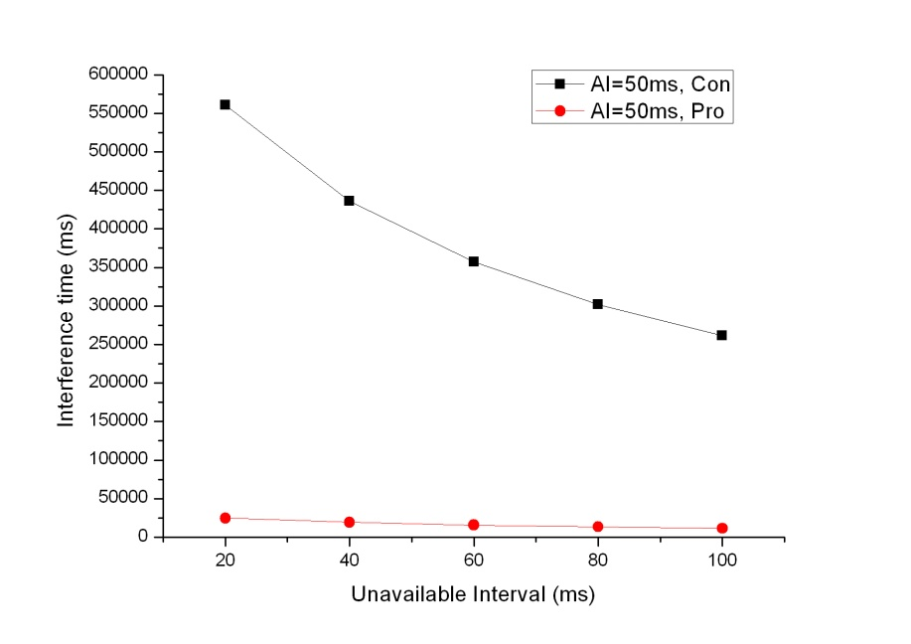 | 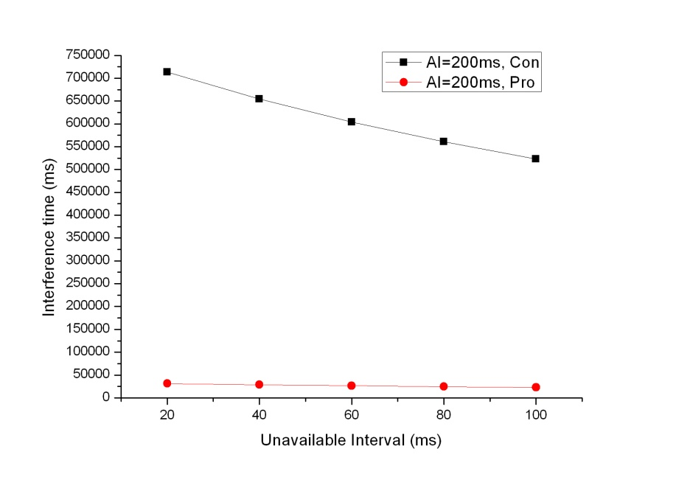
(a) | (b)

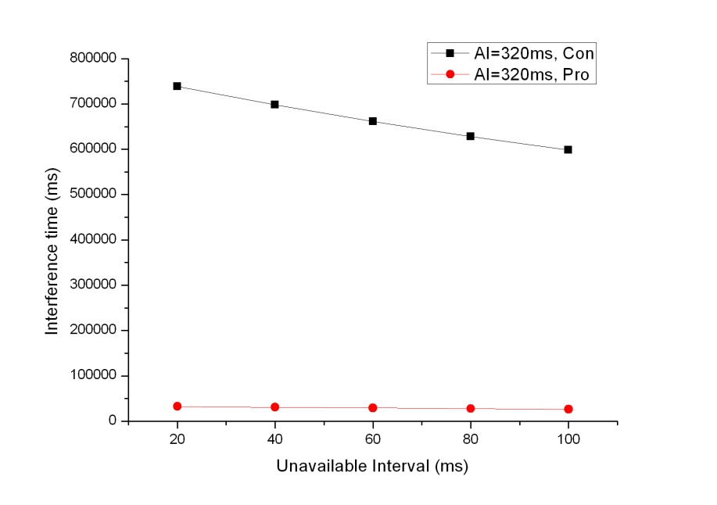
(c)
Figure 6 Comparison of Proposed Method with (a) AI = 50ms, (b) AI=200ms (c) AI=320ms

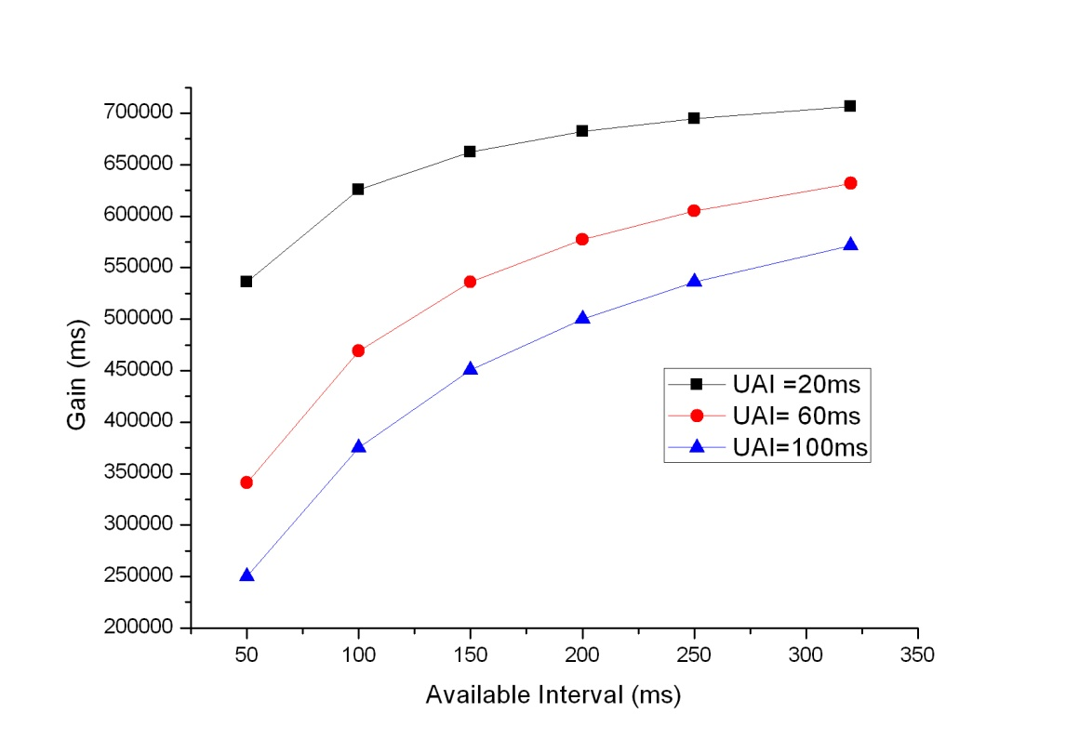
Figure 7 Gain of Proposed Method

The simulation is done with parameters set as in Table 1. The mobility model used in the simulation is shortest path model. The metric used in comparing the performance of proposed and conventional method is interference time. Interference time defined as the total available interval of Femto ABS.
Fig. 6 shows the interference time for each conventional and proposed method. The interference time is compared for different value of unavailable and available interval. As depicted in the Figure 6, the proposed method always has smaller interference time compared to conventional scheme.
In Figure 7, the gain achieved in applying proposed method is shown. Gain is defined as the difference of interference time between conventional and proposed method. The maximum gain is achieved for small value of unavailable interval and large value of available interval. From the simulation, we can conclude that the proposed method can reduce interference time compared to conventional scheme.

References
[1] IEEE 802.16m-09/0034, “IEEE 802.16m System Description Document (SDD)”, 2009-07-27.
[2] IEEE C802.16m-09/1284,” AWD Text Proposal for Femtocell BS Low-Duty Mode”, 2009-07-06

Text Proposal for the IEEE 802.16m

============================== Start of Proposed Text ================================

15.4.10.X LDO mode for Interference Management based on Femto Grouping
Neighbor CSG Femto ABSs in one overlay macrocell area may create groups. New installed CSG Femto ABS scans for other CSG femto ABSs in the surrounding area and reports to macro ABS about the neighbor cells. Network may use this information to form group. In a group, one of CSG Femto ABSs is selected as header, while other CSG Femto ABSs may become members. Header and Member Femto ABSs have different Low Duty Cycle pattern in LDO mode.
Header and Members CSG Femto ABSs in the group enter LDO mode either if all AMSs attached to the CSG Femto ABS are in idle or sleep mode, or if no AMS is in the service range of the CSG Femto ABS at all. Header Femto ABS with no AMS sets the LDC pattern with the available interval changing alternately with unavailable interval. Member Femto ABS may have larger unavailable interval compared to Header Femto or stays in unavailable interval during LDO mode.
AMS may be a member of CSG Femto ABS in the group. At network entry, Macro ABS sends the information of respected group (e.g. ABS ID, frequency, and LDC pattern of Header Femto) to AMS. AMS may use the information in the future to perform scanning. If AMS detects the header of a group at scanning procedure, AMS informs to overlay Macro ABS. Upon receiving the notification, Overlay macro BS sends message to Femto ABS in the group in which AMS is a member to add available interval during LDO mode.

============================== End of Proposed Text =================================

