Project | IEEE 802.16 Broadband Wireless Access Working Group <http://ieee802.org/16>
Title | Proposed Text for the IEEE 802.16m AWD on HARQ Feedback Region (15.3.6)
Date Submitted | 2009-08-28
Source(s) | Yujian Zhang, Yi Hsuan, Hujun Yin  Intel Corporation | +86-10-82611515  {yujian.zhang,yi.hsuan, hujun.yin}@intel.com  *<http://standards.ieee.org/faqs/affiliationFAQ.html
Re: | Category: AWD comments / Area: Chapter 15.3.6 (DL-CTRL) & 15.3.9 (UL-CTRL)  “Comments on AWD 15.3.6 DL-CTRL & 15.3.9 (UL-CTRL)”
Abstract | Proposed text for HARQ Feedback Region in P802.16m Amendment Working Document
Purpose | To be discussed and adopted by TGm for the 802.16m amendment.
Notice | This document does not represent the agreed views of the IEEE 802.16 Working Group or any of its subgroups. It represents only the views of the participants listed in the “Source(s)” field above. It is offered as a basis for discussion. It is not binding on the contributor(s), who reserve(s) the right to add, amend or withdraw material contained herein.
Release | The contributor grants a free, irrevocable license to the IEEE to incorporate material contained in this contribution, and any modifications thereof, in the creation of an IEEE Standards publication; to copyright in the IEEE’s name any IEEE Standards publication even though it may include portions of this contribution; and at the IEEE’s sole discretion to permit others to reproduce in whole or in part the resulting IEEE Standards publication. The contributor also acknowledges and accepts that this contribution may be made public by IEEE 802.16.
Patent Policy | The contributor is familiar with the IEEE-SA Patent Policy and Procedures:  <http://standards.ieee.org/guides/bylaws/sect6-7.html#6> and <http://standards.ieee.org/guides/opman/sect6.html#6.3>.  Further information is located at <http://standards.ieee.org/board/pat/pat-material.html> and <http://standards.ieee.org/board/pat>.

Proposed Text for the IEEE 802.16m AWD on HARQ Feedback Region (15.3.6)

Yujian Zhang, Yi Hsuan, Hujun Yin
Intel Corporation

- Introduction
Indexing for HF-A-MAP and HARQ Feedback Channel has been specified in IEEE P802.16m/D1. One remaining issue is how to handle the situation that HARQ feedback channels in one subframe are associated with transmissions from more than one subframes. In this contribution, the concept of HARQ Feedback Region is introduced to handle the problem.

- HARQ Feedback Region
When HARQ Feedback channels in one subframe are related to transmissions from more thane one subframes, they need to be partitioned and current description of HARQ indexing in P802.16m/D1 can be applied to each region individually. Such region is denoted as HARQ Feedback region in uplink and HF-A-MAP region in downlink. In this contribution, we will use HARQ Feedback region as examples, but all the discussion are applicable to HF-A-MAP region as well. An example is shown in Figure 1 below, for TDD DL:UL=5:3, subframe #0 in UL carries HARQ Feedback Channels for DL subfame #0 and #1. So for UL subframe #0, we define two HARQ Feedback regions, and apply indexing within each region.
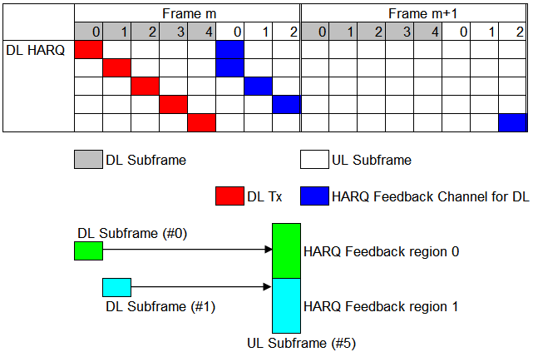
Figure 1 HARQ Feedback Region

The number of HARQ Feedback regions for one particular subframe is only determined from D:U configuration, and the selection of HARQ Feedback region is determined from the subframe index of the transmission. They are not changed with regard to long TTI, or potentially different Rx processing times.
For TDD DL HARQ, refer to Table 725 of P802.16m/D1. For each UL subframe n, assume the indices of associated starting DL subframes are the ordered set$M=\left\{m_{0},m_{1},…,m_{K−1}\right\}$, where $m_{0}<m_{1}<⋯<m_{K−1}$, then
  - The number of HARQ Feedback regions is the size of M.
  - For each DL subframe m_{k}, the index of the associated HARQ Feedback region is the order of m_{k} in set M.
An example for TDD D:U=5:3 is shown in Figure 2 below. UL subframe #0 are associated with DL subframes #0 and #1. For all DL transmissions starting from DL subframe#0, associated feedback is located in HARQ Feedback region 0. Similarly, for all DL transmissions starting from DL subframe#1, associated feedback is located in HARQ Feedback region 1. The relationship does not change when long TTI is used or different processing time is used.

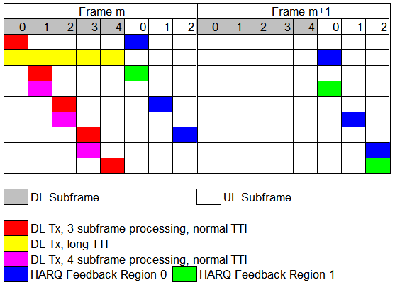
Figure 2 Example for TDD D:U=5:3

------------------------------- Start Text Proposal ---------------------------------------------------

[ ------ Recommended AWD Text Proposal #1 (page 309, Line 50) ------]
In FDD, there is one HF-A-MAP region in each DL subframe. In TDD, with notation in Table 726 in <<15.3.9.2.2.2.2>>, for HF-A-MAP in DL subframe l, the associated UL bursts can start from a set of UL subframe indices denoted by $N=\left\{n_{0},n_{1},…,n_{K−1}\right\}$, where $n_{0}<n_{1}<⋯<n_{K−1}$. The number of HF-A-MAP regions in DL subframe l is equal to the size of set N. For UL bursts starting at UL subframe n_{k}, the index of the associated HF-A-MAP region is the order of n_{k} in set N, with index 0 corresponding to the 1st HF-A-MAP region. Within each HF-A-MAP region, the index for HF-A-MAP channel is calculated as follows.

For persistent allocation, HF-A-MAP resource index is specified in HFA of UL Individual Persistent A-MAP IE or UL Composite Persistent A-MAP IE.

For group resource allocation, HF-A-MAP resource index for the l-th AMS in GRA allocation is$(i_{\text{start}}+\left\lfloor {l∗N_{\text{HF}−A−\text{MAP}}}/{N_{\text{GRA}}}\right\rfloor )\text{mod}N_{\text{HF}−A−\text{MAP}}$, where i_{start} is the ACK Channel Offset in UL group resource allocation A-MAP IE, N_{HF-A-MAP} is the total number of HF-A-MAP configured per HF-A-MAP region, and N_{GRA} is the Use Bit Map Size in UL group resource allocation A-MAP IE.

For resource allocation using UL basic assignment A-MAP, HF-A-MAP resource index is $(M(j)+n)\text{mod}N_{\text{HF}−A−\text{MAP}}$, where j is HF-A-MAP Index Parameter in Non-user specific A-MAP IE, n is HFA in UL basic assignment A-MAP IE, N_{HF-A-MAP} is the total number of HF-A-MAP configured per HF-A-MAP region, M(j) is STID when j=0 and M(j) is lowest LRU index of corresponding UL transmission when j=1.

[ ------ Recommended AWD Text Proposal #2 (page 412, Line 63) ------]
In FDD, there is one HARQ Feedback region in each UL subframe. In TDD, with notation in Table 725 in <<15.3.9.2.2.2.1>>, for HARQ Feedback Channel in UL subframe n, the associated DL bursts can start from a set of DL subframe indices denoted by$M=\left\{m_{0},m_{1},…,m_{K−1}\right\}$, where $m_{0}<m_{1}<⋯<m_{K−1}$. The number of HARQ Feedback regions is equal to the size of set M. For DL bursts starting at subframe m_{k}, the index of the associated HARQ Feedback region is the order of m_{k} in set M, with index 0 corresponding to the 1st HARQ Feedback region. Within each HARQ Feedback region, the index for HARQ Feedback Channel is calculated as follows.

For persistent allocation, index k is specified in HFA of DL Individual Persistent A-MAP IE or DL Composite Persistent A-MAP IE.

For group resource allocation, index k for the l-th AMS in GRA allocation is $(i_{\text{start}}+\left\lfloor {l∗L_{\text{HFB}}}/{N_{\text{GRA}}}\right\rfloor )\text{mod}N_{\text{HFB}}$ $(i_{\text{start}}+\left\lfloor {l∗L_{\text{HFB}}}/{N_{\text{GRA}}}\right\rfloor )\text{mod}L_{\text{HFB}}$, where i_{start} is the ACK Channel Offset in DL group resource allocation A-MAP IE, L_{HFB} is the total number of HFBCH configured per HARQ feedback region, and N_{GRA} is the Use Bit Map Size in DL group resource allocation A-MAP IE.

For resource allocation using DL basic assignment A-MAP, index k is $(M(j)+n)\text{mod}L_{\text{HFB}}$, where j is HFBCH Index Parameter in Non-user specific A-MAP IE, n is HFA in DL basic assignment A-MAP IE, L_{HFB} is the total number of HFBCH configured per HARQ feedback region, M(j) is STID when j=0 and M(j) is lowest LRU index of corresponding DL transmission when j=1.

-------------------------------------- End of Text Proposal -------------------------------------------

