Project | IEEE 802.16 Broadband Wireless Access Working Group <http://ieee802.org/16>
Title | Signaling Support For Inter-ARS Interference Mitigation
Date Submitted | 2009-08-30
Source(s) | Jung-Ryun Lee, Keunhang Heo, Hyunsik Kang, Yeongyeong Park , Sungrae Cho, Ohyoung Song, and Yong Soo Cho  Chung-ang University  221 Heukseok-dong, Dongjak-gu  Seoul, 156-756, Korea  Yong-Hoon Choi  Kwangwoon University  26, Kwangwoon-gil, Nowon-gu  Seoul, 137-701, Korea | Voice: +82-2-940-5590  E-mail: jrlee@cau.ac.kr  E-mail: yhchoi@kw.ac.kr
Re: | A response to a Call for Technical Proposal, http://wirelessman.org/tgm/docs/80216m-09_0037.doc.  P802.16m/D1 Relay
Abstract | The contribution proposes the P802.16m/D1Amendment text for Relay. This contribution proposes signaling support for inter-ARS interference mitigation.
Purpose | To incorporate the proposed text into the P802.16m/D1
Notice | This document does not represent the agreed views of the IEEE 802.16 Working Group or any of its subgroups. It represents only the views of the participants listed in the “Source(s)” field above. It is offered as a basis for discussion. It is not binding on the contributor(s), who reserve(s) the right to add, amend or withdraw material contained herein.
Release | The contributor grants a free, irrevocable license to the IEEE to incorporate material contained in this contribution, and any modifications thereof, in the creation of an IEEE Standards publication; to copyright in the IEEE’s name any IEEE Standards publication even though it may include portions of this contribution; and at the IEEE’s sole discretion to permit others to reproduce in whole or in part the resulting IEEE Standards publication. The contributor also acknowledges and accepts that this contribution may be made public by IEEE 802.16.
Patent Policy | The contributor is familiar with the IEEE-SA Patent Policy and Procedures:  <http://standards.ieee.org/guides/bylaws/sect6-7.html#6> and <http://standards.ieee.org/guides/opman/sect6.html#6.3>.  Further information is located at <http://standards.ieee.org/board/pat/pat-material.html> and <http://standards.ieee.org/board/pat>.
Signaling Support For Inter-ARS Interference Mitigation
JungRyun Lee*, Keunhang Heo*, Hyunsik Kang*, Yeongyeong Park* ,
Sungrae Cho*, Ohyoung Song*, Yong Soo Cho*, Yong Hoon Choi**

* Chung-Ang University
** Kwangwoon University

1. Introduction
This contribution proposes the text for inter-ARS interference mitigation method of the 802.16m DRAFT amendment.

2. Problem Statements

Relay frame structure which is defined in 802.16m system SDD [3], consider the situation that a number of ARS, RS, AMS and MS are located in a cell together. Because of the mobility of ARS, ARS and RS can be temporarily located in a narrow area (for example, condition that cars equipped relay are stopped in a narrow spot). In this case, it would result in high interference among ARSs and RSs given that the relays operate as non-transparent mode and follow distributed scheduling policy, because of the overlapped resource allocations among relays. To resolve this problem, it is needed to extend previously discussed FFR concept for not only cells but also relays supporting mobility. Since interference among relays is time-varying because of the mobility of relays, total traffic amount of each ARS, and the number of users associated with each ARS, it is required for relays to recognize and estimate the amount of resource to be used in neighbor relays, in order to effectively mitigate inter-ARS interference. To flexibly coordinate frequency reuse ratio of inter-ARS, ABS should be able to distinguish 1) which ARSs flock together (RS group) and 2) how much resource is required for each ARS (resource usage factor). In addition, each ARS should recognize the collected information about neighbor ARSs periodically. Thus, we propose some messages which can be used to mitigate inter-ARS interference among ARSs which operate as non-transparent mode.
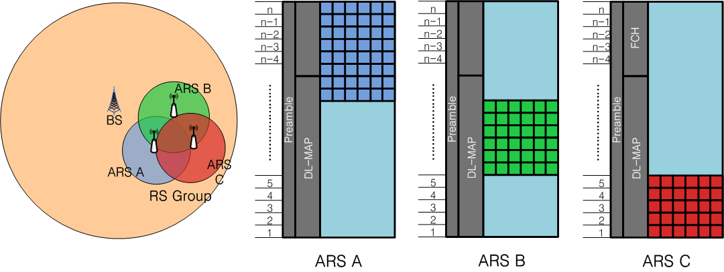

[Fig. 1] Flexible fractional frequency reuse among ARSs

3. Proposal
We propose the following 3 messages to be used for inter-ARS interference mitigation.

- AAI_FFR_info-req
ABS sends this message to ARS in order to request information about resource usage of ARS. This message includes following information.

-Report Period: This information determines how frequently AAI_FFR_info-req message should be sent to ABS. It indicates ‘once’ or ‘periodic’ transmissions of AAI_FFR_info-req message. In case of period transmission, it may indicate interval of periodic transmission.

- AAI_FFR_info-rsp
ARS reports its location information and resource allocation information to ABS. It includes following information.

-Location of ARS: Location information of ARS
-Current MCS level: MCS level of each AMS
-Data rate: Average data rate of each AMS
-Average Resource Usage: Average resource usage ratio per frame

- AAI_ARS_FFR-cmd
This message includes information that FFR ratio of each ARS in RS Group. Detailed resource allocation method is FFS.
Figure 1. Flow Chart of Inter-ARS Interference Mitigation.

4. References
[1] IEEE P802.16j/D9, “Part 16: Air Interface for Fixed and Mobile Broadband Wireless Access Systems” Feb. 2009.
[2] IEEE P802.16m/D1, “Part 16: Air Interface for Fixed and Mobile Broadband Wireless Access Systems” July. 2009.
[3] IEEE 802.16m-09/0034 “System Description Document (SDD)”
[4] IEEE C802.16m-09/0933, “Interference Mitigation using Flexible Fractional Frequency Reuse”

5. Proposed Text Change
---------------------------------------------------------Start of the Text-----------------------------------------------------------
[Create the new text as follows]

15.2.6.x AAI_FFR_info-req
ABS transmit this message to ARS in order to request information related resource usage.
Table xxx—Parameters for AAI_FFR_info-req
Name | Value | Usage
Report Mode | 0b00: Once  0b01: Periodic report  0b10: End periodic report  0b11: Reserved | When ABS needs to receive information about FFR or to terminate periodic AAI_FFR_info-rsp, it shall be included in the AAI_FFR_info-req. The parameter’s size is two bit.  If bits are 0b00, the number of response is once.  If bits are 0b01, response is periodic.  If bits are 0b10, response is terminated.  The other is reserved.
Report Period | Parameter to determine response period | It shall be included in the AAI_FFR_info-req when Report Mode’s bits are 0b01.  Report period in units of frames, a value from 0 to 4905 corresponding to a range of 1 frame to 4906 frame.
Report Type | 0b0: Request for data rate and MCS level of AMS in ARS  0b1:Request for average resource usage of ARS | It shall be included in the AAI_FFR_info-req except that Report Mode’s bits are 0b10 or 0b11.  If bit is 0b0, response must include STID, Data rate, and MCS level of AMS.  If bit is 0b1, response must include Average Resource Usage of ARS.

15.2.6.x AAI_FFR_info-rsp
This message reports location information and resource usage status of ARS to ABS.
Table xxx—Parameters for AAI_FFR_info-rsp
Name | Value | Usage
Location information | Location information of ARS
STID | STID of subordinate station | If report type of AAI_FFR_info-req that ARS received is ‘0b0’, it shall be included in the AAI_FFR_info-rsp. ABS must have the information about each subordinate station’s data rate and MCS level. So this message has to include STID of subordinate station of ARS.
Data rate | Average data rate of each AMS | If report type of AAI_FFR_info-req that ARS received is ‘0b0’, it shall be included in the AAI_FFR_info-rsp in order that ABS estimates quantity of resource allocation of ARS.
MCS level | MCS level of each AMS | If report type of AAI_FFR_info-req that ARS received is ‘0b0’, it shall be included in the AAI_FFR_info-rsp in order that ABS estimate quantity of resource allocation of ARS.
Average Resource Usage | Average resource usage ratio per frame | If report type of AAI_FFR_info-req that ARS received is ‘0b1’, it shall be included in the AAI_FFR_info-rsp.

15.2.6.x AAI_ARS_FFR-cmd
This message includes information about FFR ratio of each ARS in RS group.
ABS calculates FFR parameter based on information of AAI_FFR_info-rsp. Then, ABS transmit AAI_ARS_FFR-cmd. An ARS that received this message changes the parameter related FFR ratio. Detailed resource allocation method is FFS.
.
----------------------------------------------------------End of the Text-----------------------------------------------------------

