Project | IEEE 802.16 Broadband Wireless Access Working Group <http://ieee802.org/16>
Title | Proposed changes to Non-user specific A-MAP IE (15.3.6.5.4.1)
Date Submitted | 2009-08-30
Source(s) | Jeongki Kim, Youngsoo Yuk, Kiseon Ryu, Yongho Kim, Jinsoo Choi  LG Electronics | E-mail: {chegal, sixs, ksryu, ronnykim, emptylie}@lge.com
Re: | P802.16m/D1 Non-user specific A-MAP IE (15.3.6.5.4.1)
Abstract | The contribution proposes texts for the Non-user specific A-MAP IE to be included in the 802.16m/D1.
Purpose | To be discussed and adopted by TGm for the 802.16m amendment.
Notice | This document does not represent the agreed views of the IEEE 802.16 Working Group or any of its subgroups. It represents only the views of the participants listed in the “Source(s)” field above. It is offered as a basis for discussion. It is not binding on the contributor(s), who reserve(s) the right to add, amend or withdraw material contained herein.
Release | The contributor grants a free, irrevocable license to the IEEE to incorporate material contained in this contribution, and any modifications thereof, in the creation of an IEEE Standards publication; to copyright in the IEEE’s name any IEEE Standards publication even though it may include portions of this contribution; and at the IEEE’s sole discretion to permit others to reproduce in whole or in part the resulting IEEE Standards publication. The contributor also acknowledges and accepts that this contribution may be made public by IEEE 802.16.
Patent Policy | The contributor is familiar with the IEEE-SA Patent Policy and Procedures:  <http://standards.ieee.org/guides/bylaws/sect6-7.html#6> and <http://standards.ieee.org/guides/opman/sect6.html#6.3>.  Further information is located at <http://standards.ieee.org/board/pat/pat-material.html> and <http://standards.ieee.org/board/pat>.

Proposed changes to Non-user specific A-MAP IE
Jeongki Kim, Youngsoo Yuk, Kiseon Ryu, Yongho Ronny Kim, Jinsoo Choi
LG Electronics.

Introduction
This contribution includes the proposed text for the Section 15.3.6.5.4.1 Non-user specific A-MAP IE in the IEEE 802.16m DRAFT Amendment [6]. The technical text and ToC are inherited from the 802.16m SRD [1], and the IEEE 802.16m SDD [2], the IEEE 802.16m AWD [5] and the IEEE P802.16 Rev2/D9 [3]. Moreover, this contribution follows the tentative outline and style guide in the IEEE 802.16m Amendment [4].

According to Section 15.3.6.5.4.1 Non-user specific A-MAP IE, if non-user specific A-MAP extension flag is set, non-user specific A-MAP is extended and the extended non-user specific part will contain the resource assignment information to decode broadcast messages such as AAI_PAG-ADV, AAI_TRF-IND, PGID Info, etc. We propose the detailed format of extended non-user specific part as shown Table 1.
Table 1. Extended non-user specific A-MAP IE
Syntax | Size (bit) | Notes
Mode Type Bitmap | 3 | Indicates that the broadcast messages transmitted in a subframe are for which mode  Bit#0: Broadcast messages for Idle mode (AAI-PAG-ADV, PGID Info, )  Bit#1: Broadcast messages for Sleep mode (AAI-TRF-IND)  Bit#2: Other broadcast messages (e.g., SCDs, NBR-ADV, SII-ADV, etc.)
Allocation size | 7 | The number of LRUs allocated for Broadcast messages. DL burst of broadcast messages immediately will be located at the end of the DLRU region, if exists.
Reserved | 2
Mode Type Bitmap is used to reduce the power consumption of connected mode AMSs which should try to decode DL bursts of useless broadcast messages (e.g. AAI_TRF-IND, AAI-PAG-ADV, PGID Info) if there is no message type in the resource allocation information. If Bit#0 is only set to 1, then the broadcast message for idle mode AMSs is only sent in a subframe and AMSs of sleep mode or connected mode shall not decode a broadcast DL burst. If Bit#1 is only set to 1, then the broadcast message for sleep mode AMSs is only sent in a subframe and AMSs of Idle mode or connected mode shall not decode a broadcast DL burst. If Bit#0 and Bit#1 are only set to 1, then the broadcast message for idle mode AMSs and broadcast message for sleep mode AMSs are only sent in a subframe, AMSs of connected mode shall not decode a broadcast DL burst.
And if DL burst of broadcast messages is located at the end of the DLRU region as shown in Figure 1, 7 bits allocation size instead of 11 bits resource index is enough to present the resource assignment information.

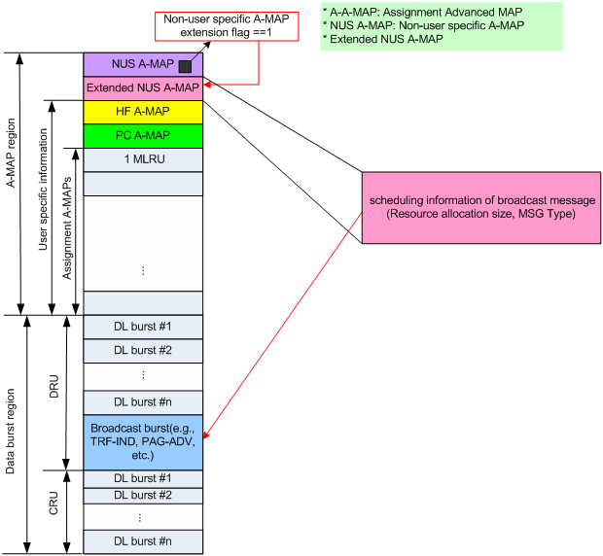
Figure 1. Resource allocation of broadcast messages by Extended non-user specific A-MAP IE

MCS of broadcast message is determined by S-SFH Transmission Format in P-SFH as shown in the Table 679.
Table 679. MCS of broadcast message (The detailed values is FFS)
S-SFH Transmission Format  (Refer to Table 661) | Transmission Format for S-SFH (Repetition) | I_sizeoffset of broadcast message  (Reuse 1) | I_sizeoffset of broadcast message (Power boosted region in Reuse 3) | Number of repetition for broadcast message
0 | 12 | 0 | TBD | 2
1 | 8 | 3 | TBD | 2
2 | 6 | 6 | TBD | 2
3 | 4 | 9 | TBD | 2

References
[1] IEEE 802.16m-07/002r8, “802.16m System Requirements Document (SRD)”
[2] IEEE 802.16m-09/0034, “The Draft IEEE 802.16m System Description Document”
[3] IEEE P802.16 Rev2 / D9, “Draft IEEE Standard for Local and Metropolitan Area Networks: Air Interface
for Broadband Wireless Access,” January. 2009.
[4] IEEE 802.16m-08/043, “Style guide for writing the IEEE 802.16m amendment”
[5] IEEE 802.16m-09/0010r2, “IEEE 802.16m Amendment Working Document”
[6] IEEE P802.16m/D1, “DRAFT Amendment to IEEE Standard for Local and metropolitan area networks”

Text proposal for inclusion in the 802.16m amendment
------------------------------------------- Start of Proposed Text -----------------------------------------------
[Note to Editor: Modify “15.3.6.5.2.1 Non-user-specific A-MAP IE” section as follows:]

15.3.6.5.4.1 Non-user-specific A-MAP IE
Non-user-specific A-MAP IE consists of information that is not dedicated to a specific user or a specific group of users. It includes information required to decode assignment A-MAP IE The number of assignment A-MAPs in each assignment A-MAP group is indicated in the Non-user-specific A-MAP IE. A-MAP IE also includes HF-A-MAP Index Parameter and HFBCH Index Parameter, which are used to indicate which transmission parameter is used to calculate HF-A-MAP index and HFBCH index respectively. The detailed information included in non-user specific information is TBD. The non-user specific A-MAP IE is shown in Table 677. Non-user specific A-MAP IE has [12] bits in total.

Table 677—Non-user specific A-MAP IE
Syntax | Size [bits] | Notes
Assignment A-MAP size | TBD | Indicate the number of assignment A-MAPs in each assignment A-MAP group as shown in <<Table 667.>>
HF-A-MAP Index Parameter | 1 | Indicate which transmission parameter is used to calculate HF-A-MAP index.
HFBCH Index Parameter | 1 | Indicate which transmission parameter is used to calculate HFBCH index.
Non-user specific A-MAP extension flag | 1 | If non-user specific A-MAP extension flag is set, it indicates that non-user specific A-MAP is extended. The extended non-user specific part uses the same PHY structure as the non-user specific A-MAP
Reserved | TBD | Reserved bits

Table 678 [Detailed entry is TBD] shows the number of the assignment A-MAPs in each assignment A-MAP group.

Table 678—The number of assignment A-MAPs in each assignment A-MAP group
Index | Assignment A-MAP group-1 | Assignment A-MAP group-2 | ...
... | ... | ... | ...

The resource allocation for Broadcast messages (e.g., PGID Info, AAI-TRF-IND, AAI-PAG-ADV, and other broadcast) is based on A-MAP_IE or non-user specific A-MAP extension.
If the non-user specific A-MAP extension flag in the non-user specific A-MAP is set, an Extended non-user specific A-MAP IE immediately follows the non-user specific A-MAP IE and the non-user specific A-MAP extension may be used to specify the information used the Extended non-user specific A-MAP IE contains the scheduling information to decode the PGID Info, AAI-TRF-IND, AAI-PAG-ADV, and other broadcast messages. The PHY structure for this extension is the same as the non-user specific A-MAP. There will be present only one broadcast burst at the end of DLRU region in a subframe, if exists. MCS of broadcast message is determined by S-SFH Transmission Format in P-SFH as shown in the Table 679.
Table 679. MCS of broadcast message (The detailed values is FFS)
S-SFH Transmission Format  (Refer to Table 661) | Transmission Format for S-SFH (Repetition) | I_sizeoffset of broadcast message  (Reuse 1) | I_sizeoffset of broadcast message (Power boosted region in Reuse 3) | Number of repetition for broadcast message
0 | 12 | 0 | TBD | 2
1 | 8 | 3 | TBD | 2
2 | 6 | 6 | TBD | 2
3 | 4 | 9 | TBD | 2

Table 680 shows the Extended non-user specific A-MAP IE format.
Table 680. Extended non-user specific A-MAP IE
Syntax | Size (bit) | Notes
Mode Type Bitmap | 3 | Indicates that the broadcast messages transmitted in a subframe are for which mode  Bit#0: Broadcast messages for Idle mode (AAI-PAG-ADV, PGID Info, )  Bit#1: Broadcast messages for Sleep mode (AAI-TRF-IND)  Bit#2: Other broadcast messages (e.g., SCDs, NBR-ADV, SII-ADV, etc.)
Allocation size | 7 | The number of LRUs allocated for Broadcast messages. DL burst of broadcast messages immediately will be located at the end of the DLRU region, if exists.
Reserved | 2

If the broadcast message for idle mode AMSs is only sent in a subframe, AMSs of sleep mode or connected mode shall not decode a broadcast DL burst. If the broadcast message for sleep mode AMSs is only sent in a subframe, AMSs of Idle mode or connected mode shall not decode a broadcast DL burst. If the broadcast message for idle mode AMSs and broadcast message for sleep mode AMSs are only sent in a subframe , AMSs of connected mode shall not decode a broadcast DL burst.

[Note to Editor: Add the following to Table 666]]

Syntax | Size [bits] | Notes
Non-user specific AMAP extension flag | 1 | If non-user specific A-MAP extension flag is set, it indicates that non-user specific A-MAP is extended. The extended non-user specific part uses the same PHY structure as the non-user specific A-MAP

--------------------------------------------- End of Proposed Text ----------------------------------------------

