Project | IEEE 802.16 Broadband Wireless Access Working Group <http://ieee802.org/16>
Title | Proposed Changes to the Physical Ranging Channel for Synchronized AMSs in IEEE P802.16m/D1 (15.3.9.1.4.2)
Date Submitted | 2009-08-29
Source(s) | HyunWoo Lee, Jin Sam Kwak, HanGyu Cho, Young-Hyoun Kwon  LG Electronics | Voice: +82-31-450-7902  E-mail: camille@lge.com, samji@lge.com, hgcho@lge.com
Re: | IEEE 80216m-09/0037, “Call for Contributions on Project 802.16m Amendment Content”  P802.16m/D1 : 15.3.9.1.4.2
Abstract | This contribution proposes the text of ranging channel section to be included in the IEEE P802.16m Draft.
Purpose | To be discussed and adopted by TGm for the IEEE P802.16m Draft
Notice | This document does not represent the agreed views of the IEEE 802.16 Working Group or any of its subgroups. It represents only the views of the participants listed in the “Source(s)” field above. It is offered as a basis for discussion. It is not binding on the contributor(s), who reserve(s) the right to add, amend or withdraw material contained herein.
Release | The contributor grants a free, irrevocable license to the IEEE to incorporate material contained in this contribution, and any modifications thereof, in the creation of an IEEE Standards publication; to copyright in the IEEE’s name any IEEE Standards publication even though it may include portions of this contribution; and at the IEEE’s sole discretion to permit others to reproduce in whole or in part the resulting IEEE Standards publication. The contributor also acknowledges and accepts that this contribution may be made public by IEEE 802.16.
Patent Policy | The contributor is familiar with the IEEE-SA Patent Policy and Procedures:  <http://standards.ieee.org/guides/bylaws/sect6-7.html#6> and <http://standards.ieee.org/guides/opman/sect6.html#6.3>.  Further information is located at <http://standards.ieee.org/board/pat/pat-material.html> and <http://standards.ieee.org/board/pat>.
Proposed Changes to the Physical Ranging Channel for Synchronized AMSs in IEEE P802.16m/D1 (15.3.9.1.4.2)

HyunWoo Lee, Jin Sam Kwak, HanGyu Cho, and Young-Hyoun Kwon
LG Electronics

1. Introduction
The ranging channel structure for synchronized AMSs has not been defined yet. This contribution proposes the text of ranging channel section to be included in IEEE P802.16m/D1 [1].

2. Ranging Channel Structure for Synchronized AMSs
The physical structure in the ranging channel for synchronized AMSs occupies 72 subcarriers by K OFDMA symbol time in [1]. Current structure has some drawbacks due to short length of code, mainly.
- The reused factor is very small.
  - If the cyclic shift is not used, there are only 70 codes.
- The cross-correlation become double compared with that of ranging channel for non-synchronized AMSs.
  - To maintain lower false alarm probability, the detection performance will be worse.

This contribution proposes the using of time-domain covering code for increased reuse factor and enhanced performance.
- Time-domain orthogonal covering in unit of 2- or 3-symbol (basic unit)
  - To increase number of codes (reuse factor)
    - No. of code opportunities = no. of covering code × no. of code per sector
  - To reduce cross-correlation effect by dispreading
- Time-domain repetition of basic unit
  - To increase received energy
  - To obtain time diversity for high mobility

- The basic unit
- Examples in the type-1 subframe (3-times repetitions)
Figure 1 – Ranging channel structure in the time domain

Figure 2 show the performance of proposed ranging channel. Refer to the annex for simulation assumptions. By time-domain covering, the performance is enhanced for lower mobility. Also, by repetition of basic unit, the performance is outperforms that of lower mobility for high mobility.
Figure 2 – Ranging channel performance

Regarding time-domain covering codes, refer to [2] for more details.

Reference
[1] IEEE P802.16m/D1, “Part 16: Air Interface for Broadband Wireless Access Systems : Advanced Air Interface,” July 2009.
[2] IEEE C802.16m-09/2006, “Proposed Changes to the Physical Resource Mapping of Ranging Channel for Synchronized AMSs in IEEE P802.16m/D1 (15.3.9.2.4.2),” August 2009.

Annex: Simulation Assumptions
- False Alarm Probability (PFA) ☞ target PFA = 0.1%
  - (Total no. of false alarm events) / (Total no. of candidate codes(e.g., 32) - total no. of transmitted codes)
  - False alarm event : A code is detected which is not one of transmitted codes.
- Miss-Detection Probability (Pm) ☞ target Pm = 1%
  - (No. of total miss-detection events) / (total no. of transmitted codes)
  - Miss-detection event : The code is not detected which is transmitted code.
Table a.1 Simulation Parameters
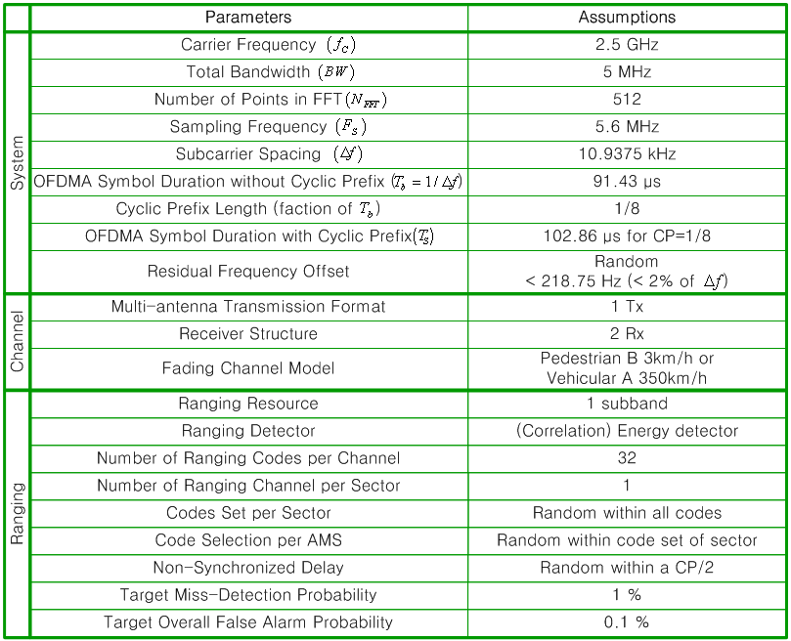

Text proposal for inclusion in the 802.16m amendment
----------------------------------------------------------------------------------------------------------------------------------------------------------------
Black text: current text in the subclause 15.3.9.1.4.2 of [1]
Red Strike through Text: Deleted
Blue text: new text
[Bracketed Italic text]: Informative
------------------------------------------------------------------------- Text Start --------------------------------------------------------------------------
[Modify the following text in the 15.3.9.1.4.2]

Ranging Channel Structure for synchronized AMSs
The ranging channel for synchronized AMSs is used for periodic ranging. The AMSs that are already synchronized to the target ABS are allowed to transmit the periodic ranging signal. For femtocell, the ranging channel for synchronized AMSs can be used for initial ranging, handover ranging, and periodic ranging.
The physical structure in the ranging channel for synchronized AMSs occupies 72 subcarriers by K OFDMA symbol time. K is the largest even number that is same or smaller than N_{sym} where N_{sym} is the number of OFDMA symbols in a subframe as defined in 15.3.8.1. For femtocell, K is equal to 1 and the rest of subcarriers can be used for data transmission.
Figure (f.1) illustrates the basic unit of ranging channel structure in the time domain where T_{g} and T_{b} are defined in 15.3.2.4. The basic unit is repeated K/2 times from the first OFDMA symbol within a subframe. In the basic unit, two type of codes are applied. The basic code, x_{p}(k) is Zadoff-Chu code in frequency domain defined in 15.3.9.2.4 and C_{q}(n) is time-domain covering code defined in 15.3.9.2.4.
- The basic unit
- A example in the type-1 subframe (3-times repetitions)
Figure f.1 – Ranging channel structure for synchronized AMSs in the time domain

Power control operation described in subclause 15.3.9.4.3 applies to ranging signal transmission.
------------------------------------------------------------------------- Text End ---------------------------------------------------------------------------

