Project | IEEE 802.16 Broadband Wireless Access Working Group <http://ieee802.org/16>
Title | Self-organizing Network in a FFR-based Collaborative MIMO Multi-Cell Wireless OFDMA Systems (SON)
Date Submitted | 2009-09-14
Source(s) | Li-Chun Wang, Chu-Jung Yeh  National Chiao Tung University  I-Kang Fu  MediaTek Inc. | teensky.cm93g@nctu.edu.tw  IK.Fu@mediatek.com
Re: | IEEE 802.16m-09/0037, “Call for Contribution on Project 802.16m Amendment Content”  - Support for Self Organizing Networks (SON) (SDD Section 16)
Abstract | Currently both the FFR and Multi-BS MIMO will need SON support. How the SON can make joint coordination needs further clarification.
Purpose | To be discussed and adopted by TGm into P802.16m/D1
Notice | This document does not represent the agreed views of the IEEE 802.16 Working Group or any of its subgroups. It represents only the views of the participants listed in the “Source(s)” field above. It is offered as a basis for discussion. It is not binding on the contributor(s), who reserve(s) the right to add, amend or withdraw material contained herein.
Release | The contributor grants a free, irrevocable license to the IEEE to incorporate material contained in this contribution, and any modifications thereof, in the creation of an IEEE Standards publication; to copyright in the IEEE’s name any IEEE Standards publication even though it may include portions of this contribution; and at the IEEE’s sole discretion to permit others to reproduce in whole or in part the resulting IEEE Standards publication. The contributor also acknowledges and accepts that this contribution may be made public by IEEE 802.16.
Patent Policy | The contributor is familiar with the IEEE-SA Patent Policy and Procedures:  <http://standards.ieee.org/guides/bylaws/sect6-7.html#6> and <http://standards.ieee.org/guides/opman/sect6.html#6.3>.  Further information is located at <http://standards.ieee.org/board/pat/pat-material.html> and <http://standards.ieee.org/board/pat>.
Self-organizing Network in a FFR-based Collaborative MIMO Multi-Cell Wireless OFDMA Systems

Li-Chun Wang, Chu-Jung Yeh
National Chiao Tung University
I-Kang Fu
MediaTek Inc.

- Motivation

The network multiple-input multiple-output (MIMO) technique is a potential deployment in next generation wireless system, which aims to mitigate the inter-cell interference by coordinating the multi-cell transmission among a few geographically separated antennas or base stations (BS). This kind of multi-BS MIMO techniques improves sector throughput and cell-edge throughput through multi-BS cooperative signaling. Multi-BS joint MIMO processing may be enabled by the BS for one or several MSs when joint precoding is applied in the serving and neighboring cells. There are two scenarios: Closed-loop marco Diversity (CL-MD) and Collaborative MIMO (Co-MIMO) transmission (or called network MIMO). For applying CL-MD transmission, a single MS is served jointly by multiple coordinating BSs. For applying Co-MIMO transmission, several AMSs are served jointly by the multiple coordinating BSs through MU-MIMO scheduling and precoding. Although both the concept of FFR and inter-BS coordination already are considered for one of possible inter-cell interference cancellation technique in WiMAX, to our knowledge, combining Co-MIMO with FFR to mitigate inter-cell interference is still an open issue. Additionally, multi-cell system support self-organization is another way to improve system performance. Self-organizing network (SON) functions are intended for BSs to automate the configuration of BS parameters and to optimize network performance. Therefore, our objective is to propose a SON and FFR-based Co-MIMO transmission architecture in multi-cell wireless OFDMA systems.
In this document, our considered DL multi-BS joint MIMO processing mode is the Co-MIMO transmission. Figure 1 shows our considered self-organizing based Co-MIMO multi-cell network architecture. Some cells form a coordinative group to cooperate via SON server. The SON server collects the reported SON measurement from BS/MS to organize the scheduling or resource allocation processing. Usually, the reported SON measurement from BS/MS may include:
  - Signal quality of serving BS and neighbor BSs
  - Interference level from the neighbor BSs
  - Cell information of neighbor BSs
  - Load information of neighbor BS
  - MS location distribution
  - MS UL/DL SINR distribution

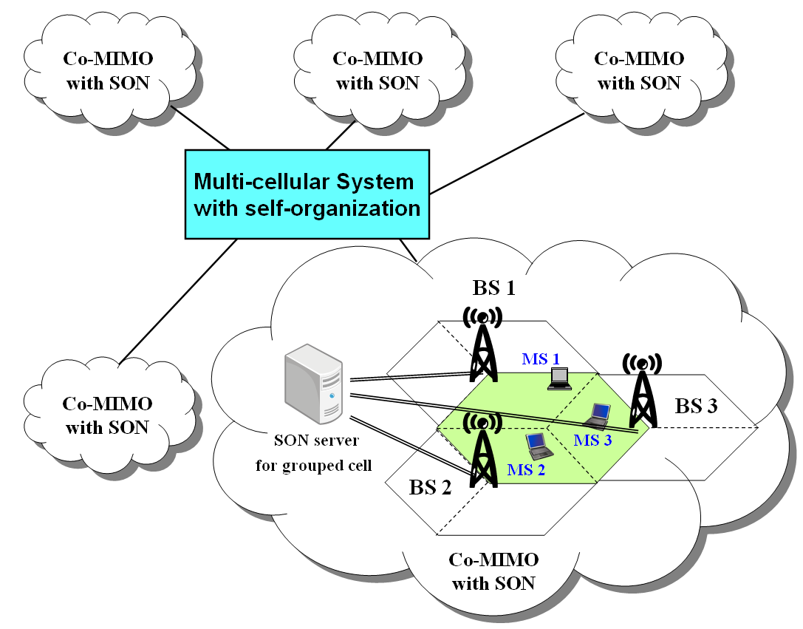

Figure 1. Self-organizing based Co-MIMO multi-cell network architecture.

- Frequency Partition and Co-MIMO Zone

Fractional frequency reuse, also called reuse partition, allows different frequency reuse factors to be applied over different frequency partitions during the designed period for transmission. Figure 2 shows the considered frequency partition for a tri-sector cell. The whole frequency band are partitioned into different zones. That is, the FFR partitions frequency band into inner frequency bands $f_{A}$ for the inner cell region and outer frequency bands $f_{B}$ for the outer cell region, where$f_{B}$ is further partitioned into three subbands $f_{B_{1}}$, $f_{B_{2}}$, and $f_{B_{3}}$. We assume $f_{B_{1}}$, $f_{B_{2}}$, and $f_{B_{3}}$ has equally bandwidth containing $N$ resource units (RU).

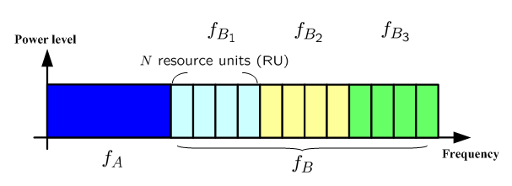
Figure 2. Frequency partition for a tri-sector cell.

In the future, the default number of neighboring BSs coordinated to support Co-MIMO transmission is three. Figure 3 shows the considered three-cell Co-MIMO cell layout. Each BS has three Co-MIMO zones. The corresponding frequency partition and Co-MIMO zone for each cell can be found in Fig. 4.
The coordinated cell group (i.e., Co-MIMO zone) is the logical region which includes several neighboring outer regions or cell edge regions. For the inner cell region, each cell executes resource allocation and scheduling individually. As for the outer cell regions, the resource allocation and scheduling via coordinated transmission among neighboring cells can be considered in each collaborative cell group individually.

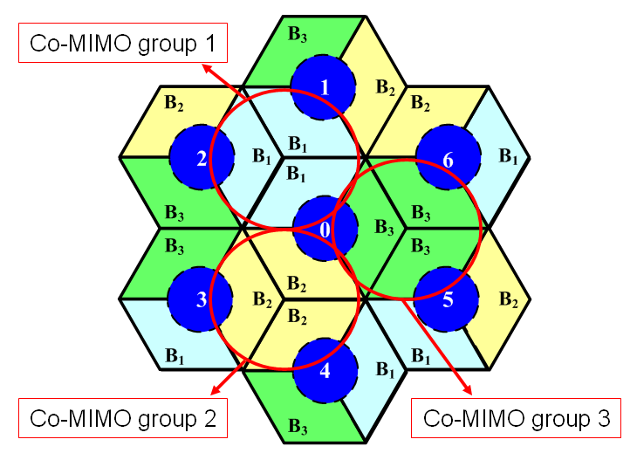

Figure 2. Illustration of the coordinated cell group for Co-MIMO

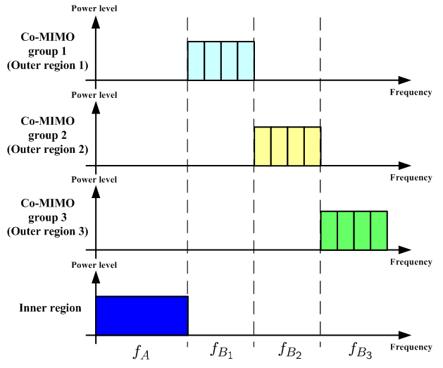
Figure 4. Frequency partition and Co-MIMO zone for each cell

- DL Multi-BS Co-MIMO Transmission

The procedure of DL multi-BS Co-MIMO transmission as shown in Fig. 5 follows the steps below:
1. Determine the frequency partition for each cell. By definite the Co-MIMO groups for each cell, the Co-MIMO zone for each frequency partition allow inter-BS coordination.
2. In multi-BS Co-MIMO, the BSs inform the corresponding MSs the information which BSs will be coordinated.
3. Based on the information of MS location and DL SINR distribution per FFR partition provided by SON, the inner cell radius for each cell should be adjusted after some frame time. For example, the inner cell radius can be adjusted according to MS population distribution for proportional resource allocation. Or given a SINR threshold to define the inner cell radius.
4. Each BS among a group reports its load information to the corresponding SON server, the SON server establishes the active user set to be scheduled. Note that the MSs in the active user set are ordered according to priority.
5. The BSs send the Feedback_Polling_IE to MSs belong to the active user set to request feedback the channel information.
6. Once an MS receives a Feedback_Polling_IE, it sends UL sounding feedback by Sounding_Allocation_IE
7. After receiving UL sounding feedback from active MSs, the Co-MIMO zone perform three-cell based multi-BS transmission among each resource unit.

Note that Steps 4 ~ 7 will be executed in each scheduling frames for supporting Co-MIMO transmissions. After some scheduling services, the inner cell radius for each cell can be adjusted according to past statistical information.

Figure 5. The flowchart of DL Multi-BS Co-MIMO Transmission

- Text Proposal
------------------------------------------------------- Start of the Text------------------------------------------------------------
[Adopt the following text modifications into P802.16m/D1]
15.6 Self Organization Network
Self Organizing Network (SON) functions can automate the configuration of ABS parameters for optimizing network performance, coverage and capacity. The air interface support for SON functions is to perform measurement/reporting of air interface performance metrics and the subsequent adjustments of ABS parameters.
The SON server is assumed be available in backhaul network when SON functions are enabled. The SON server can exchange information among different ABSs through backhaul network for inter-ABS coordination.

15.6.x Support of Multi-BS MIMO
When supporting Multi-BS MIMO operation, the SON server shall be capable to activate the sounding based Co-MIMO operation. The SON server will first select three ABSs a group and assign a Co-MIMO Zone for these ABSs for Co-MIMO transmission (15.3.14.3.3). The Co-MIMO Zone used by the ABSs in the same group is well aligned over the same time-frequency radio resource region. The ABS shall then report the channel estimation results to the SON server from the AMS to be served by each Co-MIMO Zone. The configuration of Co-MIMO transmission can be updated base on the negotiation between ABS and SON server.

------------------------------------------------------- End of the Text------------------------------------------------------------

