Project | IEEE 802.16 Broadband Wireless Access Working Group <http://ieee802.org/16>
Title | Relay security framework (Relay)
Date Submitted | 2009-08-31
Source(s) | Xiangying Yang  Shraga Avishay  Changhong Shan  Jerry Sydir  Intel Corporation  Hyunjeong Kang  Samsung Corporation | E-mail:  avishay.shraga@intel.com  xiangying.yang@intel.com  hyunjeong.kang@samsung.com
Re: | Call for LB #30 on “ P802.16m/D1”:  Target topic: “Relay”
Abstract | This contribution proposes the texts for AMS privacy section to be included in the 802.16m amendment.
Purpose | To be discussed and adopted by TGm for the IEEE 802.16m amendment
Notice | This document does not represent the agreed views of the IEEE 802.16 Working Group or any of its subgroups. It represents only the views of the participants listed in the “Source(s)” field above. It is offered as a basis for discussion. It is not binding on the contributor(s), who reserve(s) the right to add, amend or withdraw material contained herein.
Release | The contributor grants a free, irrevocable license to the IEEE to incorporate material contained in this contribution, and any modifications thereof, in the creation of an IEEE Standards publication; to copyright in the IEEE’s name any IEEE Standards publication even though it may include portions of this contribution; and at the IEEE’s sole discretion to permit others to reproduce in whole or in part the resulting IEEE Standards publication. The contributor also acknowledges and accepts that this contribution may be made public by IEEE 802.16.
Patent Policy | The contributor is familiar with the IEEE-SA Patent Policy and Procedures:  <http://standards.ieee.org/guides/bylaws/sect6-7.html#6> and <http://standards.ieee.org/guides/opman/sect6.html#6.3>.  Further information is located at <http://standards.ieee.org/board/pat/pat-material.html> and <http://standards.ieee.org/board/pat>.

Relay security framework (Relay)
Xiangying Yang, Avishay Shraga, Changhong Shan, Jerry Sydir
Intel
Hyunjeong Kang
Samsung

1. Introduction
Distributed scheduling requires distributed security mode for flexible data forwarding function.

2. Text Proposal

======================== Start of Proposed Text =====================
15.2.5.x Security sublayer in relay operation
In multihop relay system, RS uses the same security architecture and procedures as an AMS to provide privacy, authentication and confidentiality between itself and the ABS.

An access ARS is operating in distributed security mode. The authentication key established between AMS and ABS is distributed to this RS the key agreement is performed as shown in Figure n. An RS operating in this mode relays initial PKM messages between the ABS and AMS. When the MSK for an AMS is established, the ABS and AMS perform key agreement, which is relayed by ARS. At the end of key agreement, ABS shall securely transfer the relevant Authorization Key (AK) and key context associated with the AMS to its access RS. The access RS derives all necessary CMAC and TEK keys if PKMv3 is used, and from now on ARS is responsible for key management until there is handover or re-authentication. During authentication, the Security Association (SA) that contains the security pertaining to an AMS will be created between an SS, an access RS operating in distributed security mode and the ABS. Each AMS shall effectively establish a primary SA with the RS, interacting with the RS as if it were a BS from the AMS’s perspective. ARS uses the set of active keys shared with the AMS to perform encryption/decryption and integrity protection on the access link. The access RS operating in distributed security mode shall establish a primary SA with ABS and may run a secure encapsulation protocol with the ABS. ARS uses the set of active keys shared with ABS to perform encryption/decryption and integrity protection on the relay link.

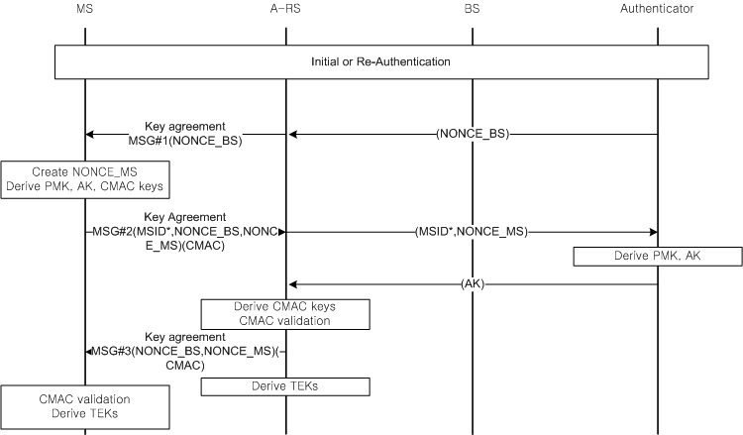
Figure nnn key agreement procedure

15.2.5.x.1 AK transfer
In a distributed security model, upon successful authorization of the AMS, ABS shall send PKMv3 AK Transfer message conveying a set of AK parameters to the relevant Access ARS. AK parameters shall include AK key material, AK Sequence Number, and AK Lifetime. Access ARS shall use them to derive CMAC keys and TEK. Access RS shall send PKMv3 AK Transfer ACK message to ABS in order to acknowledge successful reception of PKMv3 AK Transfer message. For SAs using a ciphersuite employing AES-CCM mode, the TEK used to encrypt the AK Transfer message is AES encrypted using a 128-bit key derived for the Access ARS AK and a 128-bit block size. Authenticator may process key pre-distribution to target RS before AMS handoff occurs. If target RS does not possess AMS’s active AK, ABS may deliver an active AK to the target RS when the RS receives an entry/re-entry request from MS. When RS handover is triggered, i.e. either serving RS or target RS or both are involved in handover, key update from AK level is required following the same procedure in Section 15.2.5.2.4.4.
============================== End of Proposed Text ===============

4. References
[1] IEEE P802.16 Rev2 / D9, “Draft IEEE Standard for Local and Metropolitan Area Networks: Air Interface for Broadband Wireless Access,”
[2] IEEE 802.16m-07/002r8, “802.16m System Requirements Document (SRD)”
[3] IEEE 802.16m-08/003r9, “The Draft IEEE 802.16m System Description Document”
[4] IEEE 802.16m-08/043, “Style guide for writing the IEEE 802.16m amendment”
[5] IEEE 802.16m-09/0010R2, “IEEE 802.16m Amendment Working Document”

