Project | IEEE 802.16 Broadband Wireless Access Working Group <http://ieee802.org/16>
Title | Proposed Text about E-MBS MAP IE for E-MBS DG (E-MBS)
Date Submitted | 2009-09-20
Source(s) | Chun-Yen Wang, Chun-Yuan Chiu, Fang-Ching (Frank) Ren, Chie-Ming Chou, Yung-Han Chen,  ITRI  Wern-Ho Sheen  Chaoyang University of Technology (CYUT) | E-mail: ChunYen@itri.org.tw, ccy@itri.org.tw
Re: | 802.16m AWD: IEEE 802.16m-09/0028r1, “Call for Comments and Contributions on Project 802.16m Amendment Content”
Abstract | This contribution provides a text about E-MBS MAP IE for E-MBS DG
Purpose | To be discussed and adopted by TGm for the 802.16m amendment working document..
Notice | This document does not represent the agreed views of the IEEE 802.16 Working Group or any of its subgroups. It represents only the views of the participants listed in the “Source(s)” field above. It is offered as a basis for discussion. It is not binding on the contributor(s), who reserve(s) the right to add, amend or withdraw material contained herein.
Release | The contributor grants a free, irrevocable license to the IEEE to incorporate material contained in this contribution, and any modifications thereof, in the creation of an IEEE Standards publication; to copyright in the IEEE’s name any IEEE Standards publication even though it may include portions of this contribution; and at the IEEE’s sole discretion to permit others to reproduce in whole or in part the resulting IEEE Standards publication. The contributor also acknowledges and accepts that this contribution may be made public by IEEE 802.16.
Patent Policy | The contributor is familiar with the IEEE-SA Patent Policy and Procedures:  <http://standards.ieee.org/guides/bylaws/sect6-7.html#6> and <http://standards.ieee.org/guides/opman/sect6.html#6.3>.  Further information is located at <http://standards.ieee.org/board/pat/pat-material.html> and <http://standards.ieee.org/board/pat>.
Proposed Text about E-MBS MAP IE for E-MBS DG (E-MBS)
Chun-Yen Wang, Chun-Yuan Chiu, Fang-Ching (Frank) Ren, Chie-Ming Chou, Yung-Han Chen,
ITRI
Wern-Ho Sheen
Chaoyang University of Technology

Proposed Text

The following text is proposed to be captured in the harmonized contribution (C802.16m-09/2166) from the DG.

------------------------------------------------------- Start of the proposed text ------------------------------------------------
15.3.6.5.5 E-MBS Control Information Elements

15.3.6.5.5.1 E-MBS MAP Information Elements
For each on-going E-MBS session within the E-MBS zone, E-MBS MAP shall include the MCS parameter and the resource allocation information for the following E-MBS traffic. Resource allocation patterns are classified into two [FFS] types. In addition, the location of the Private MAP is also implicitly indicated by the E-MBS MAP. Note that an E-MBS session is ongoing or stopped is not explicitly shown in the E-MBS MAP, but is implicitly indicated by its presence in the E-MBS MAP.

E-MBS MAP information element
-- ASN1START

E-MBS-MAP ::= SEQUENCE (SIZE (1..maxE-MBS-MAP-IEs)) OF E-MBS-MAP-IE

E-MBS-MAP-IE ::= SEQUENCE {
mfid INTEGER (0..ffs),
mcs ENUMERATED {ffs},
e-mbs-ResourceAllcation CHOICE {
type1 E-MBS-AllocationType1,
type2 E-MBS-AllocationType2
}
}

-- ASN1STOP

E-MBS-MAP-IE field decriptions
Mfid
A short identifier used to identify an E-MBS session in the E-MBS zone.
mcs
Defines the MCS applied to the E-MBS session.
e-mbs-ResourceAllcation
Indicates the resource information of the following E-MBS traffic. Please refer to section 15.3.6.5.5.1.1 and 15.3.6.5.5.1.2.

15.3.6.5.5.1.1 E-MBS Resource Allocation Type 1 (Contiguous Allocation)
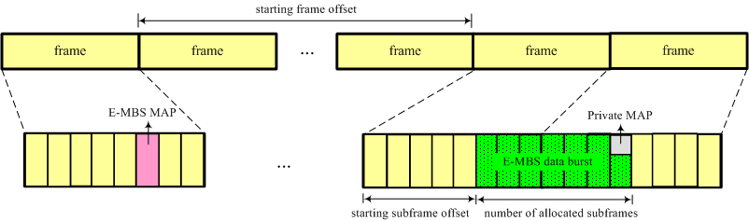
Figure AAA⎯ E-MBS Allocation Type 1 (Contiguous Allocation)

As shown in figure AAA, E-MBS allocation type 1 is used when subframes allocated to the E-MBS are contiguous. The message format of Private MAP message type 1 is shown as below.

E-MBS Allocation Type 1 information element
-- ASN1START

E-MBS-AllocationType1 ::= SEQUENCE {
startFrameOffset INTEGER (0..ffs),
startSubframeOffset INTEGER (0..7),
numberOfAllocatedSubframes INTEGER (1..ffs),
}

-- ASN1STOP

E-MBS-AllocationType1 field decriptions
startFrameOffset
Identifies the location of the starting frame.
startSubframeOffset
Identifies the location of the starting subframe.
numberOfAllocatedSubframes
Identifies the number of subframes allocated for the E-MBS session.

15.3.6.5.5.1.2 E-MBS Resource Allocation Type 2 (Bitmap Allocation)
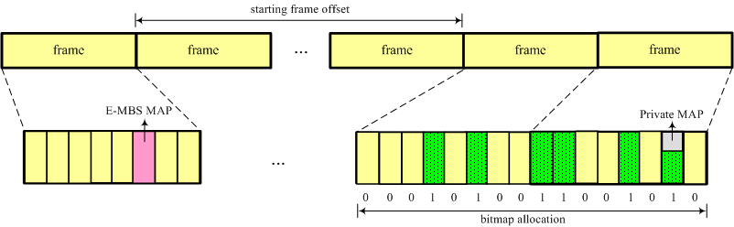
Figure BBB⎯ E-MBS Allocation Type 2 (Bitmap Allocation)

The E-MBS allocation type 2 adopts a bitmap to allocate E-MBS subframes. As shown in figure BBB, each bit in the bitmap represents whether the corresponding subframe is allocated for the E-MBS transmission. The message format of Private MAP message type 2 is shown as below.

E-MBS Allocation Type 2 information element
-- ASN1START

E-MBS-AllocationType2 ::= SEQUENCE {
startFrameOffset INTEGER (0..ffs),
bitmapAllocation BIT STRING (SIZE (ffs))
}

-- ASN1STOP

E-MBS-AllocationType2 field decriptions
startFrameOffset
Identifies the location of the starting frame.
bitmapAllocation
Field encoded as a bit string, where bit n is set to “1” if the n-th subframe is allocated for the E-MBS session.

-------------------------------------------------------- End of the text ------------------------------------------------------

