Project | IEEE 802.16 Broadband Wireless Access Working Group <http://ieee802.org/16>
Title | Proposed Changes to Quantized MIMO Feedback for Closed-Loop Transmit Precoding (15.3.7.2.5.6)
Date Submitted | 2009-11-06
Source(s) | Lei Huang  Panasonic Singapore Laboratories  Isamu Yoshii  Panasonic Corporation | Lei.Huang@sg.panasonic.com  Yoshii.Isamu@jp.panasonic.com
Re: | IEEE 802.16 Working Group Letter Ballot #30a: P802.16m/D2
Abstract | This contribution proposes some modifications on Section 15.3.7.2.5.6 (Quantized MIMO Feedback for Closed-Loop Transmit Precoding)
Purpose | For discussion and adoption by TGm
Notice | This document does not represent the agreed views of the IEEE 802.16 Working Group or any of its subgroups. It represents only the views of the participants listed in the “Source(s)” field above. It is offered as a basis for discussion. It is not binding on the contributor(s), who reserve(s) the right to add, amend or withdraw material contained herein.
Release | The contributor grants a free, irrevocable license to the IEEE to incorporate material contained in this contribution, and any modifications thereof, in the creation of an IEEE Standards publication; to copyright in the IEEE’s name any IEEE Standards publication even though it may include portions of this contribution; and at the IEEE’s sole discretion to permit others to reproduce in whole or in part the resulting IEEE Standards publication. The contributor also acknowledges and accepts that this contribution may be made public by IEEE 802.16.
Patent Policy | The contributor is familiar with the IEEE-SA Patent Policy and Procedures:  <http://standards.ieee.org/guides/bylaws/sect6-7.html#6> and <http://standards.ieee.org/guides/opman/sect6.html#6.3>.  Further information is located at <http://standards.ieee.org/board/pat/pat-material.html> and <http://standards.ieee.org/board/pat>.
Proposed Changes to Quantized MIMO Feedback for Closed-Loop Transmit Precoding (15.3.7.2.5.6)

Lei Huang

Panasonic Singapore Laboratories

Isamu Yoshii

Panasonic Corporation

- Introduction
In [1], Figure 517 shows the hierarchical structure of C(4,1,6) in terms of the chordal distance. In this hierarchical structure, C(4,1,6) should consist of 16 codeword clusters. Each codeword cluster should have a different set of four codewords. However, in Figure 517, it is shown that each cluster has the same set of four codewords. This is obviously incorrect.

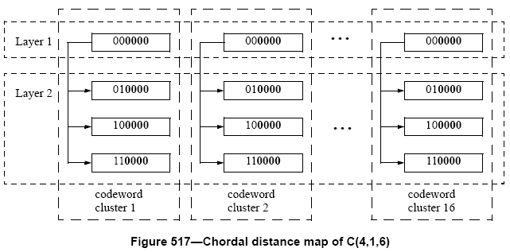
- Reference
- IEEE P802.16m/D2, DRAFT Amendment to IEEE Standard for local and metropolitan area networks - Part 16: Air Interface for Broadband Wireless Access Systems - Advanced Air Interface, October 2009

- Suggested text modification

------------------------------------------------------------Start of the Text--------------------------------------------------------
15.3.7.2.5.6 Quantized MIMO Feedback for Closed-Loop Transmit Precoding

Replacing the Figure 517 in line 35-55, page 427 by the following figure

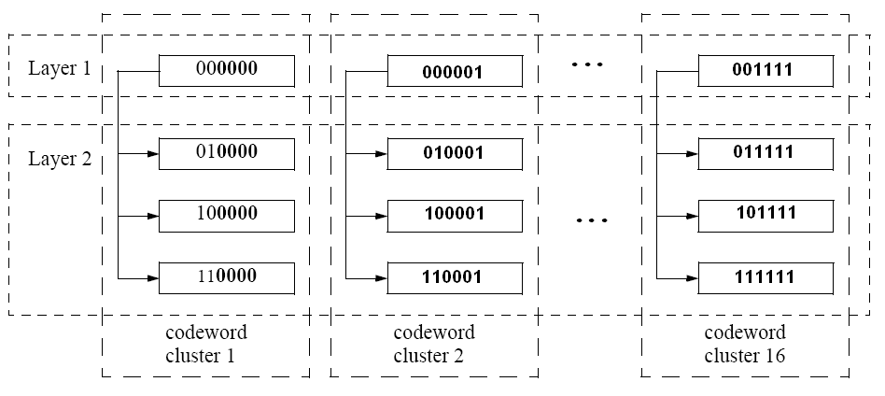
Figure 517 – Chordal distance map of C(4,1,6)

-------------------------------------------------------------End of the Text--------------------------------------------------------

