Project | IEEE 802.16 Broadband Wireless Access Working Group <http://ieee802.org/16>
Title | Proposal for 1-Stream Pilot Pattern for CDR MIMO Mode 5 (15.3.5.4.1)
Date Submitted | 2009-11-06
Source(s) | David Mazzarese, Zhen Wang, Sangheon Kim, Heewon Kang, Hokyu Choi  Samsung Electronics | d.mazzarese@samsun.g.com
Re: | P802.16m/D2 LB30a
Abstract | The contribution proposes the text for the pilot streams for rank-1 precoding with CDR.
Purpose | To be discussed and adopted by TGm for the 802.16m Advanced Air Interface (Draft 2)
Notice | This document does not represent the agreed views of the IEEE 802.16 Working Group or any of its subgroups. It represents only the views of the participants listed in the “Source(s)” field above. It is offered as a basis for discussion. It is not binding on the contributor(s), who reserve(s) the right to add, amend or withdraw material contained herein.
Release | The contributor grants a free, irrevocable license to the IEEE to incorporate material contained in this contribution, and any modifications thereof, in the creation of an IEEE Standards publication; to copyright in the IEEE’s name any IEEE Standards publication even though it may include portions of this contribution; and at the IEEE’s sole discretion to permit others to reproduce in whole or in part the resulting IEEE Standards publication. The contributor also acknowledges and accepts that this contribution may be made public by IEEE 802.16.
Patent Policy | The contributor is familiar with the IEEE-SA Patent Policy and Procedures:  <http://standards.ieee.org/guides/bylaws/sect6-7.html#6> and <http://standards.ieee.org/guides/opman/sect6.html#6.3>.  Further information is located at <http://standards.ieee.org/board/pat/pat-material.html> and <http://standards.ieee.org/board/pat>.

Proposal for 1-Stream Pilot Pattern for CDR MIMO Mode 5 (15.3.5.4.1)

David Mazzarese, Zhen Wang, Sangheon Kim, Heewon Kang, Hokyu Choi
Samsung Electronics

- Introduction
The contribution proposes the text for the 1-stream pilot pattern to be used with CDR (MIMO mode 5) in the open-loop region. CDR requires an even number of data tones between each pilot tone in the same OFDM symbol, which is not the case with the current 1-stream pilot pattern. CDR also requires improved channel estimation since it is targeting improved cell-edge performance, so we propose to increase the pilot density per stream. For that purpose, we propose to reuse the 2-stream interlaced pilot pattern by allocating all pilots of streams 1 and 2 to a single stream (stream 1 in CDR). Simulation results are provided in the companion slides.

Proposed AWD text has been underlined in blue, AWD text that has been deleted has been marked in red and struck through and existing AWD text is shown in black.

- References
[1] P802.16m DRAFT Amendment to IEEE Standard for Local and metropolitan area networks, P80216m/D2, Oct 2009.

- Text proposal for inclusion in the 802.16m AWD

< Insert the text below on page 306 line 49, and correct the Figure number X>

------------------------------- Start of text proposal #1 --------------------------------------------
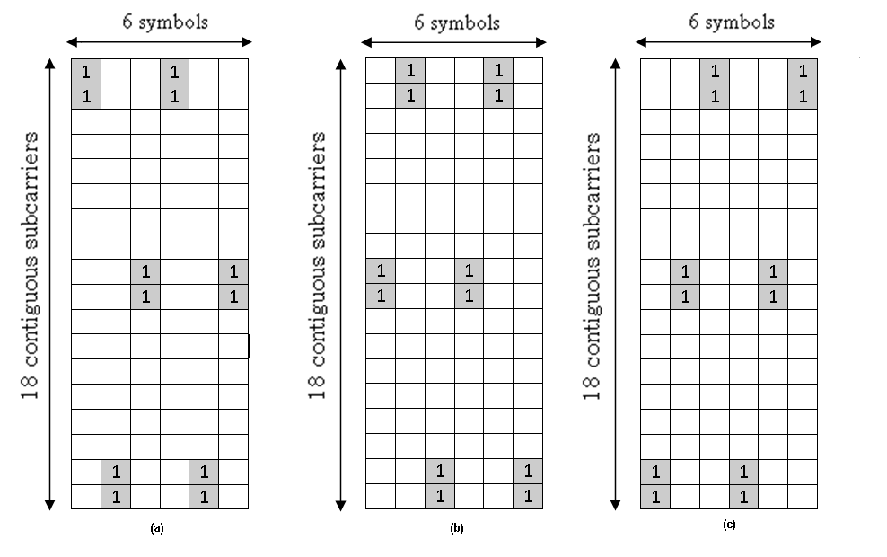
Figure X – Interlaced pilot patterns for 1 pilot stream in the open-loop region

------------------------------- End of text proposal #1 --------------------------------------------

< Modify the paragraph on lines 50-57 on page 305, and correct the Figure number X >

------------------------------- Start of text proposal #2 --------------------------------------------
The interlaced pilot patterns are generated by cyclic shifting the base pilot patterns. The interlaced pilot patterns are used by different BSs for one and two streams. Interlaced pilot patterns for one stream for use outside the open-loop region are is shown in Figure 491, Interlaced pilot patterns for one stream for use inside the open-loop region are shown in Figure X, and interlaced pilot patterns on stream 1 and stream 2 for two streams are shown in Figure 492 and Figure 493, respectively. Each BS chooses one of the three pilot pattern sets (pilot pattern set 0, 1, and 2) as shown in Figure 491 and Figure 492. The index of the pilot pattern set used by a particular BS with Cell_ID = k is denoted by p_{k}. The index of the pilot pattern set is determined by the Cell_ID according to the following equation:
------------------------------- End of text proposal #2 --------------------------------------------

