Project | IEEE 802.16 Broadband Wireless Access Working Group <http://ieee802.org/16>
Title | Frequency Planning for Inter-Cell Interference Reduction in 3-Cell Collaborative MIMO Systems (15.5.2.3)
Date Submitted | 2009-11-05
Source(s) | Li-Chun Wang, Chu-Jung Yeh and I-Kang Fu  NCTU/MediaTek | lichun@cc.nctu.edu.tw  IK.Fu@mediatek.com
Re: | P802.16m/D2
Abstract | Multi-BS MIMO can substantially mitigate the inter-cell interference for enhance the cell coverage. But the cell edge user may or may not support this feature. On the other hand, the system also provides the FFR feature to mitigate the inter-cell interference for cell edge user. How the multi-BS MIMO operation can be integrated with FFR operation should be clarified within standard. So that system operator can have a general assumption when performing coverage and frequency planning for the 16m network equipped with both feature.
Purpose | For TGm discussion and adoption into P802.16m/D2
Notice | This document does not represent the agreed views of the IEEE 802.16 Working Group or any of its subgroups. It represents only the views of the participants listed in the “Source(s)” field above. It is offered as a basis for discussion. It is not binding on the contributor(s), who reserve(s) the right to add, amend or withdraw material contained herein.
Release | The contributor grants a free, irrevocable license to the IEEE to incorporate material contained in this contribution, and any modifications thereof, in the creation of an IEEE Standards publication; to copyright in the IEEE’s name any IEEE Standards publication even though it may include portions of this contribution; and at the IEEE’s sole discretion to permit others to reproduce in whole or in part the resulting IEEE Standards publication. The contributor also acknowledges and accepts that this contribution may be made public by IEEE 802.16.
Patent Policy | The contributor is familiar with the IEEE-SA Patent Policy and Procedures:  <http://standards.ieee.org/guides/bylaws/sect6-7.html#6> and <http://standards.ieee.org/guides/opman/sect6.html#6.3>.  Further information is located at <http://standards.ieee.org/board/pat/pat-material.html> and <http://standards.ieee.org/board/pat>.
Frequency Planning for Inter-Cell Interference Reduction in 3-Cell Collaborative MIMO Systems

Li-Chun Wang, Chu-Jung Yeh and I-Kang Fu
NCTU/MediaTek

- Motivation

The network multiple-input multiple-output (MIMO) technique is a potential deployment in next generation wireless system, which aims to mitigate the inter-cell interference by coordinating the multi-cell transmission among a few geographically separated antennas or base stations (BS). This kind of multi-BS MIMO techniques improves sector throughput and cell-edge throughput through multi-BS cooperative signaling. Multi-BS joint MIMO processing may be enabled by the BS for one or several MSs when joint precoding is applied in the serving and neighboring cells. There are two scenarios: Closed-loop marco Diversity (CL-MD) and Collaborative MIMO (Co-MIMO) transmission (or called network MIMO). For applying CL-MD transmission, a single MS is served jointly by multiple coordinating BSs. For applying Co-MIMO transmission, several AMSs are served jointly by the multiple coordinating BSs through MU-MIMO scheduling and precoding. Although both the concept of FFR and inter-BS coordination already are considered for one of possible inter-cell interference cancellation technique in WiMAX, to our knowledge, combining Co-MIMO with FFR to mitigate inter-cell interference is still an open issue. Additionally, multi-cell system support self-organization is another way to improve system performance. Self-organizing network (SON) functions are intended for BSs to automate the configuration of BS parameters and to optimize network performance. Therefore, our objective is to propose a SON and FFR-based Co-MIMO transmission architecture in multi-cell wireless OFDMA systems.
In this document, our considered DL multi-BS joint MIMO processing mode is the Co-MIMO transmission. Figure 1 shows our considered self-organizing based Co-MIMO multi-cell network architecture. Some cells form a coordinative group to cooperate via SON server. The SON server collects the reported SON measurement from BS/MS to organize the scheduling or resource allocation processing. Usually, the reported SON measurement from BS/MS may include:
  - Signal quality of serving BS and neighbor BSs
  - Interference level from the neighbor BSs
  - Cell information of neighbor BSs
  - Load information of neighbor BS
  - MS location distribution
  - MS UL/DL SINR distribution

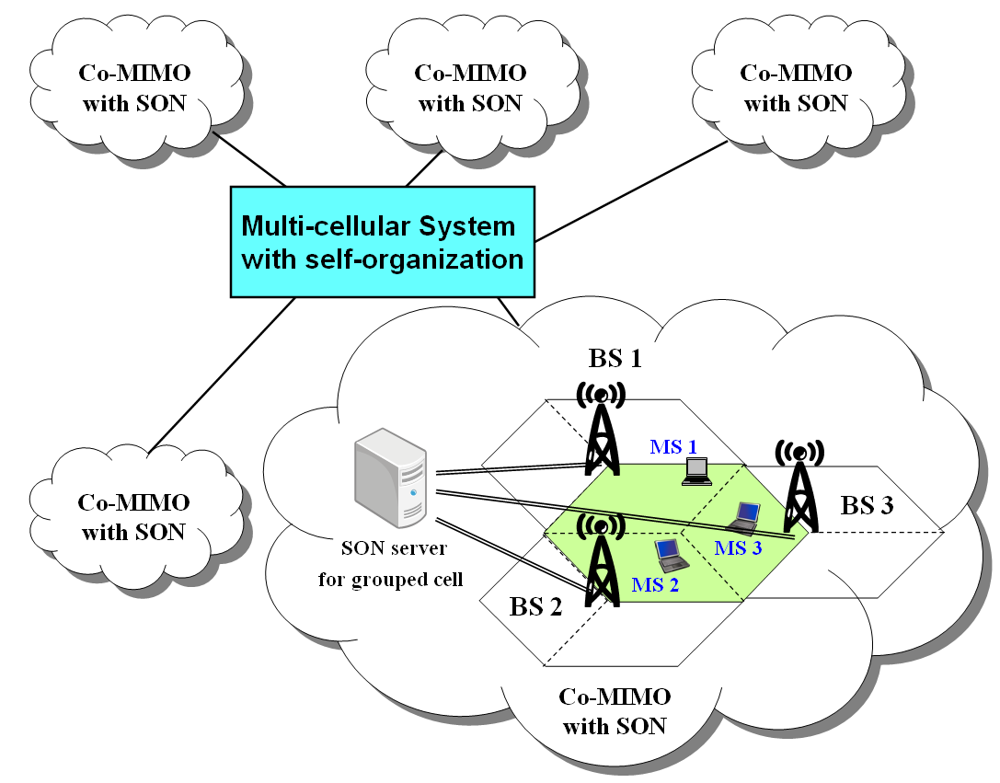

Figure 1. Self-organizing based Co-MIMO multi-cell network architecture.

- Effect of Inter (CO-MIMO) Group Interference

When applying Co-MIMO transmission for grouping coordinated cells in a multi-cell system, the effect of inter (CO-MIMO) group interference should be addressed among coordinated network MIMO group. That is, a group of coordinated cells (each Co-MIMO group as shown in Fig. 1) will still cause interference to neighboring coordinated groups with each other even if the intra-group interference has been eliminated via multi-BS joint MIMO processing transmission.
Figure 2 shows the effect of inter-group interference examples for an omni-directional antenna based multi-cell system with three-cell and seven-cell Co-MIMO transmissions. Here we consider small coordinated values for constructing the Co-MIMO transmissions (i.e., three-cell and seven-cell coordinations) for satisfying realistic implementation. Consider a multi-cell system with two-tier surrounding cells. Assume all cells use the same frequency spectrum or under certain resource unit. Take cell 0 as an example and under the three-cell coordinated Co-MIMO layout, it forms a three-cell Co-MIMO group with cells 4 and 5. The intra-group interferences come from cells 4 and 5 are eliminated via multi-BS joint MIMO processing transmission. However, the remaining surrounding cells still cause interference to cell 0. In this case, the interferers come from the other coordinated Co-MIMO groups where the corresponding cells involved in each group is , , , , ,,, and . There still exist four first-tier interferers (cells surrounded along red circle) and all second-tier interferences (cells surrounded along blue circle). Similarly, with seven-cell coordinated Co-MIMO, the coordinated partners of cell 0 become cells {1, 2, 3, 4, 5, 6}. The intra-group interference from the second-tier cells are still unavoidable even if the interferences from surrounding cells {1, 2, 3, 4, 5, 6 } are eliminated via multi-BS joint MIMO processing transmission.
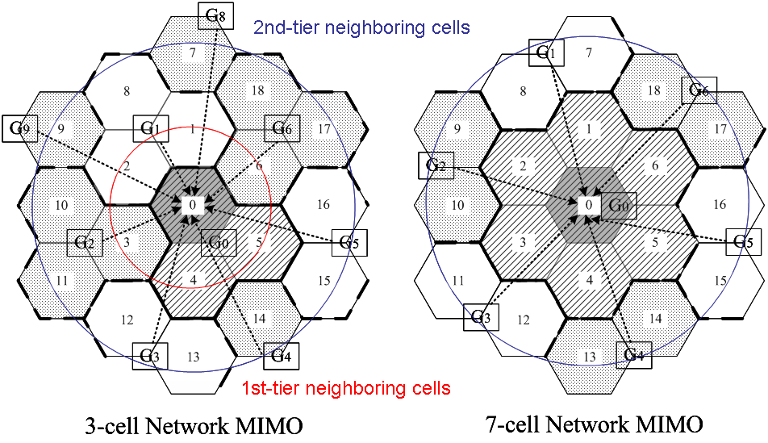
Figure 2. An example of inter-group interference for the three-cell and seven-cell
Co-MIMO systems

Figure 3 shows the effect of inter-group interference for Co-MIMO with ZF-DPC transmission. The whole cells are equipped with omni-directional antennas. The dotted line represents the SINR of cells with universal reuse one (i.e., each cell suffer from full 2-tier interferences). At first, we present seven-cell, and three-cell Co-MIMO transmissions without inter-group interference for solid lines. In this case, the received signal quality is averaged over all coordinated cells. Clearly, the received signal quality is largely improved via Co-MIMO transmissions. However, the outstanding advantage of Co-MIMO transmissions ignores the effect of inter-group interference. The received signal quality will be deeply affected when interferences from the other groups are considered. The dash lines denote the SINRs for three-cell and seven-cell Co-MIMO with inter-group interference as shown in Fig. 2. Note that the received signal quality of the Co-MIMO with small coordinated size 3 is almost equivalent to that of no multi-cell coordination.
Figure 3. Effect of inter-group interference for the three-cell and seven-cell
Co-MIMO systems

- Frequency Partition and Co-MIMO Zone

Fractional frequency reuse, also called reuse partition, allows different frequency reuse factors to be applied over different frequency partitions during the designed period for transmission. Figure 4 shows the considered frequency partition for a tri-sector cell. The whole frequency band is partitioned into different zones. That is, the FFR partitions frequency band into inner frequency bands $f_{A}$ for the inner cell region and outer frequency bands $f_{B}$ for the outer cell region, where$f_{B}$ is further partitioned into three subbands $f_{B_{1}}$, $f_{B_{2}}$, and $f_{B_{3}}$. We assume $f_{B_{1}}$, $f_{B_{2}}$, and $f_{B_{3}}$ has equally bandwidth containing $N$ resource units (RU).

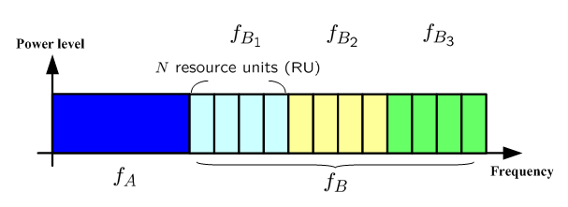
Figure 4. Frequency partition for a tri-sector cell.

In the future, the default number of neighboring BSs coordinated to support Co-MIMO transmission is three. Figure 5 shows the considered three-cell Co-MIMO cell layout. Each BS has three Co-MIMO zones. The corresponding frequency partition and Co-MIMO zone for each cell can be found in Fig. 6.
The coordinated cell group (i.e., Co-MIMO zone) is the logical region which includes several neighboring outer regions or cell edge regions. For the inner cell region, each cell executes resource allocation and scheduling individually. As for the outer cell regions, the resource allocation and scheduling via coordinated transmission among neighboring cells can be considered in each collaborative cell group individually.

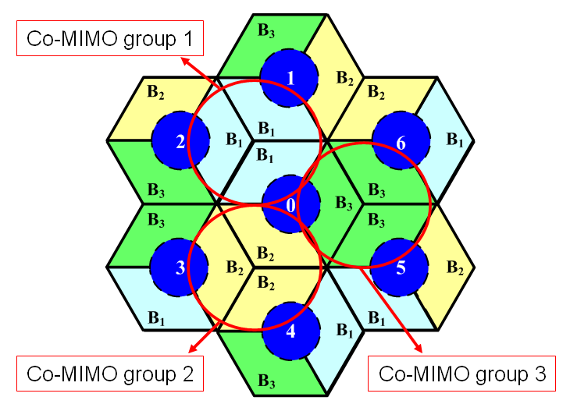

Figure 5. Illustration of the coordinated cell group for Co-MIMO

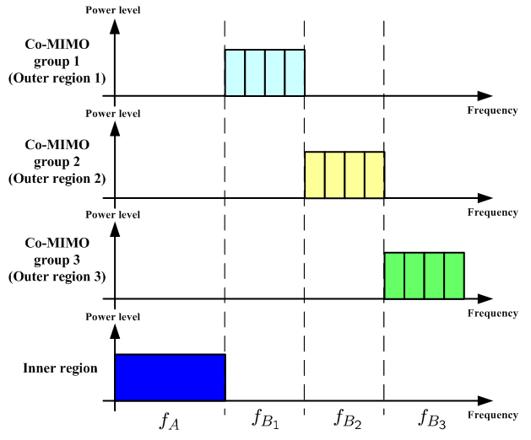
Figure 6. Frequency partition and Co-MIMO zone for each cell

- Inter-Group Interference Elimination by Frequency Partition based Three-cell Co-MIMO architecture

In this section, we propose a novel multi-cell architecture combined FFR with CoMIMO. The frequency partition for the proposed three-cell CoMIMO coordination is shown in Fig. 5. Note that there are totally three kinds of frequency partitions for cell planning. For example, the different frequency partitions for cell 0, cell 1, and cell 2 shown in Fig. 5. We call this kind of cell planning as rearranged frequency partition. After this rearranged frequency partition among a multi-cell system, a cell coordinates with six neighboring cells to form three individually CoMIMO groups for each frequency
partition.
Compared to conventional 19-cell layout, the tri-sector cellular system with rearranged frequency partition can significantly reduce the interference sources, while full utilizing the frequency band at each cell. Here we consider two kinds of cell layout with different directional antennas. The first one is the cell layout with sectoring (or called diamond-shaped sectoring) as shown in Fig. 7. The second one is the cell layout with sectoring (or called clover-leaf-shaped sectoring) as shown in Fig. 8.
Take the mobile user of cell 0 in Fig. 7 as an example, consider certain frequency RU in $f_{B_{1}}$, the interference sources are cells 1, 2, 11, 12, 14, 16, and 17 under the assumption of perfect sectoring by directional antenna. In the conventional systems, the mobile is interfered by all the other 18 cells. Here, we use the Co-MIMO technique to cancel the two most severe interferences. That is, the only two first-tier interferences from cells 1 and 2 (the dotted area in Fig. 7) are cancelled. Ideally, there are only five second-tier interferers for each subband. This cooperation can be applied to all cells not only for a particular cooperated group. Not only the middle cell (cell 0) is coordinated with its neighboring cells, but the cells in the outer layer are also coordinated simultaneously.
Note that actual cell sectorization will not be perfect by using directional antenna pattern. The other cells will also affect the received signal quality of cell 0. However, the harm caused by side lobe and back lobe transmissions (the grid area Fig. 7) is not significant compared to the cell planning with omni-directional transmission by taking advantage of sectoring and cell planning.
For cell planning with sectoring, the interference example can be found in Fig. 8. Similar to cell sectoring, each cell performs three individually three-cell CoMIMO transmissions with its six neighboring cells for different frequency partitions. The two first-tier interferers (the dotted area in Fig. 8) are cancelled via CoMIMO transmissions. This three-cell coordination structure can also be implemented for all cells not only for a particular cell.
Figure 7. Interference example for three-cell FFR-based CoMIMO with cell sectoring (consider cell 0).

Figure 8. Interference example for three-cell FFR-based CoMIMO with cell sectoring (consider cell 0).

Recall that the received signal quality of the Co-MIMO with omni-directional antenna cell planning will be degraded severely by inter-group interference as shown in Fig. 3. This traditional cell planning constraints the potential of using a small coordination sizes (three and seven) in multi-cell systems. Here we show the potential gains of combing frequency partition and CoMIMO under coordination size “three” in Fig. 9. Based on Fig. 9, taking advantage of joint frequency partition and CoMIMO, the proposed frequency partition based three-cell Co-MIMO architecture (for both cell sectorizations) can even outperform conventional “seven-cell” network MIMO system. That is, with the help of frequency partition and directional antenna, the signal quality can be improved using a smaller coordination size. The improvement is about 2dB for sectorized cell planning and 3dB for sectorized cell planning at 90-th percentile of the received SINR. It implies that the potential benefit of designing a small number of coordinated cells is significant.
Figure 9. Performance comparison of proposed FFR-based three-cell CoMIMO
with general three-cell and seven-cell network MIMO systems.

- Text Proposal

---------------------------------------------------------Start of the Text-----------------------------------------------------------

[Adopt the following text modification started from line#38, page#561 in P802.16m/D2]

----------------------------------------------------------End of the Text-----------------------------------------------------------

