Project | IEEE 802.16 Broadband Wireless Access Working Group <http://ieee802.org/16>
Title | Error correction on CRU/DRU allocation text (15.3.5.3.1)
Date Submitted | 2009-11-05
Source(s) | Ji-Yun Seol  Samsung Electronics | jiyun.seol@samsung.com
Re: | IEEE 802.16-09/0057, “IEEE 802.16 Working Group Letter Ballot#30a”  Target topic: “IEEE P802.16m/D2 section 15.3.5.3.1 ”.
Abstract | The contribution proposes an error correction on the text for the CRU/DRU allocation description in the current draft standard 802.16m/D2.
Purpose | To be discussed and adopted by TGm.
Notice | This document does not represent the agreed views of the IEEE 802.16 Working Group or any of its subgroups. It represents only the views of the participants listed in the “Source(s)” field above. It is offered as a basis for discussion. It is not binding on the contributor(s), who reserve(s) the right to add, amend or withdraw material contained herein.
Release | The contributor grants a free, irrevocable license to the IEEE to incorporate material contained in this contribution, and any modifications thereof, in the creation of an IEEE Standards publication; to copyright in the IEEE’s name any IEEE Standards publication even though it may include portions of this contribution; and at the IEEE’s sole discretion to permit others to reproduce in whole or in part the resulting IEEE Standards publication. The contributor also acknowledges and accepts that this contribution may be made public by IEEE 802.16.
Patent Policy | The contributor is familiar with the IEEE-SA Patent Policy and Procedures:  <http://standards.ieee.org/guides/bylaws/sect6-7.html#6> and <http://standards.ieee.org/guides/opman/sect6.html#6.3>.  Further information is located at <http://standards.ieee.org/board/pat/pat-material.html> and <http://standards.ieee.org/board/pat>.

Error correction on CRU/DRU allocation text (15.3.5.3.1)

Ji-Yun Seol
Samsung Electronics

- Introduction
The contribution proposes an error correction on the text for the CRU/DRU allocation description in the current draft standard 802.16m/D2.

- References
[1] IEEE P802.16m/D2, October 2009

- Proposed Text Changes
Blue/Underline: Text Added
Red/Strikeout: Text Deleted
[Change 1: Modify the last paragraph in page 299, line 35 ~ 43 (section 15.3.5.3.1) as follows]
- - - - - - - - - - - - - - - - - - - - - - - - - - - Begin Proposed Text - - - - - - - - - - - - - - - - - - - - - - - -
Figure 488 presents an example to illustrate the various steps of subband partitioning, miniband permutation, frequency partitioning, and CRU/DRU allocation for the case of 10 MHz system bandwidth. For this example, K_{SB} = DSAC = 7, FPCT = 4, FPS_{i} = 12 (for i ≥ 0), DFPSC = 2, DCAS_{SB,0} = 1, DCAS_{MB,0} = 21, and DCAS_{i} = 2.
Table 777 presents a summary of the parameters used to configure the DL PHY structure.
- - - - - - - - - - - - - - - - - - - - - - - - - - - End Proposed Text - - - - - - - - - - - - - - - - - - - - - - - - -

[Change 2: Modify the last paragraph in page 456, line 29 ~ 43 (section 15.3.8.3.1) as follows]
- - - - - - - - - - - - - - - - - - - - - - - - - - - Begin Proposed Text - - - - - - - - - - - - - - - - - - - - - - - -
The mapping of PRU_{FPi} to DRU_{FPi} is given by Equation (249):
DRU_{FPi}[j] = PRU_{FPi} [k+L_{SB,FPi}], 0 ≤ j < L_{DRU,FPi} DRU_{FPi}[j] = PRU_{FPi} [k+L_{SB-CRU,FPi}], 0 ≤ j < L_{DRU,FPi} (249)
where k = s[j + L_{CRU,FPi} -L_{SB-CRU,FPi}].
Figure 488522 presents an example to illustrate the various steps of subband partitioning, miniband permutation, frequency partitioning, and cell-specific resource mapping (CRU/DRU allocation) for the case of 10 MHz system bandwidth. For this example, K_{SB} = USAC = 7, FPCT = 4, FPS_{i} = 12 (for i ≥ 0 ), UFPSC = 2, UCAS_{SB,0} = 1, UCAS_{MB,0} = 21, and UCAS_{i} = 2.
Table 867 presents a summary of the parameters used to configure the UL PHY structure.
- - - - - - - - - - - - - - - - - - - - - - - - - - - End Proposed Text - - - - - - - - - - - - - - - - - - - - - - - - -

[Change 3: Modify Figure 488, page 301 as follows]
- - - - - - - - - - - - - - - - - - - - - - - - - - - Begin Proposed Text - - - - - - - - - - - - - - - - - - - - - - - -
K_{SB}=7, FPCT=4, FPS₀=FPS_{i}=12, DFPSC=2,
DCAS_{SB,0} = 1, DCAS_{MB,0} = 21, DCAS_{i}=2, and IDCell=2.
Figure 488—Frequency partition for BW=10 MHz
- - - - - - - - - - - - - - - - - - - - - - - - - - - End Proposed Text - - - - - - - - - - - - - - - - - - - - - - - - -

[Change 4: Modify Figure 522, page 458 as follows]
- - - - - - - - - - - - - - - - - - - - - - - - - - - Begin Proposed Text - - - - - - - - - - - - - - - - - - - - - - - -
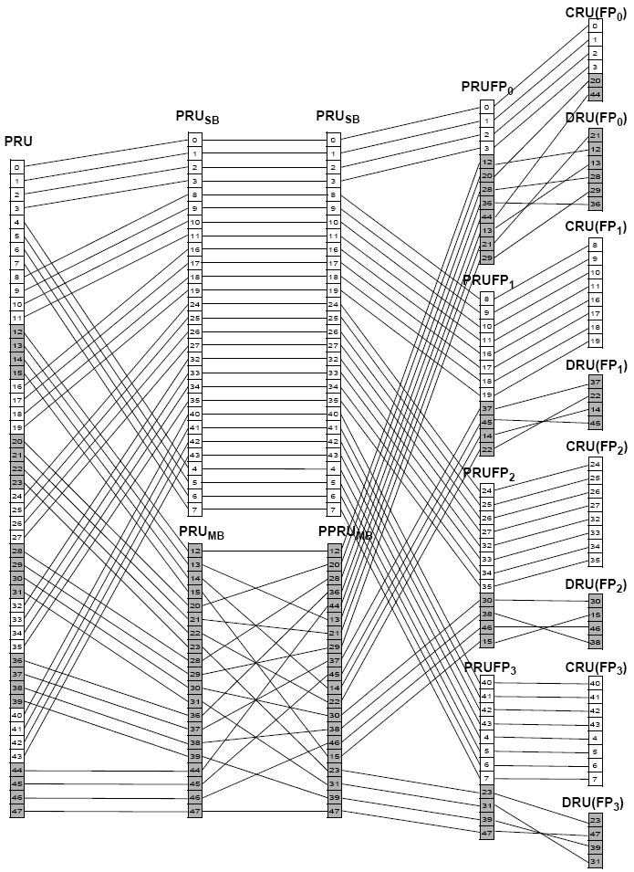
BW=10 MHz, KSB=7, FPCT=4, FPS0=FPSi=12, UFPSC=2,
UCASSB,0 = 1, UCASMB,0 = 21, UCASi=2, and IDCell=2.
Figure 522—Frequency partition for BW=10 MHz.
- - - - - - - - - - - - - - - - - - - - - - - - - - - End Proposed Text - - - - - - - - - - - - - - - - - - - - - - - - -

