Project | IEEE 802.16 Broadband Wireless Access Working Group <http://ieee802.org/16>
Title | A Ranging Procedure for ARS supporting systems - Triggered Ranging (15.6.2.11.3)
Date Submitted | 2009-11-06
Source(s) | Byung Moo Lee, Sanghun Kim, Jong-Sik Lee, Seong-Choon Lee  KT | E-mail: blee@kt.com
Re: | IEEE P802.16m/D2 ( IEEE Letter Ballot Recirc #30a) (15.6 Support for Relay)
Abstract | The contribution proposes the P802.16m/D2 Amendment text of a ranging procedure for ARS
Purpose | Proposed to be discussed and adopted by TGm for the P802.16m/D2Amendment text
Notice | This document does not represent the agreed views of the IEEE 802.16 Working Group or any of its subgroups. It represents only the views of the participants listed in the “Source(s)” field above. It is offered as a basis for discussion. It is not binding on the contributor(s), who reserve(s) the right to activate, amend or withdraw material contained herein.
Release | The contributor grants a free, irrevocable license to the IEEE to incorporate material contained in this contribution, and any modifications thereof, in the creation of an IEEE Standards publication; to copyright in the IEEE’s name any IEEE Standards publication even though it may include portions of this contribution; and at the IEEE’s sole discretion to permit others to reproduce in whole or in part the resulting IEEE Standards publication. The contributor also acknowledges and accepts that this contribution may be made public by IEEE 802.16.
Patent Policy | The contributor is familiar with the IEEE-SA Patent Policy and Procedures:  <http://standards.ieee.org/guides/bylaws/sect6-7.html#6> and <http://standards.ieee.org/guides/opman/sect6.html#6.3>.  Further information is located at <http://standards.ieee.org/board/pat/pat-material.html> and <http://standards.ieee.org/board/pat>.

A Ranging Procedure for ARS supporting systems- Triggered Ranging
Byung Moo Lee, Sanghun Kim, Jong-Sik Lee, Seong-Choon Lee
KT

Introduction
It is well-known that UL synchronization is initially acquired by initial ranging, after that, tracked by periodic ranging. If UL timing offset is occurred during the interval of periodic ranging, data loss would be happened until reach the next periodic ranging. This kind of problem is usually happened, especially in the repeater equipped systems. And also it is highly possible that the similar situation could be happened in ARS supporting systems.
The reason can be explained as described in Figure 1 and Figure 2.

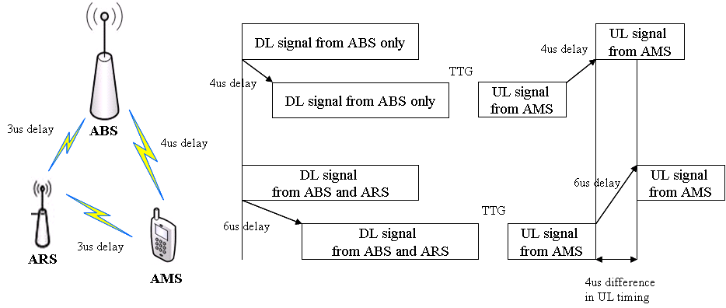
Figure 1. UL timing delay in ARS supporting systems

UL timing delay difference between ABS-AMS and ABS-ARS-AMS could be very large depending on the location of ARS and AMS. Figure 1 shows an example of delay difference between direct path and relay path. If this delay is not properly compensated, it causes UL blocking due to lack of UL timing alignment and data loss would be happened.
Figure 2 shows unexpected UL timing offset case of ARS supporting systems. When AMS is moving fast in a cell and more than two ARSs for the AMS are installed in the cellular network, the probability of UL timing offset becomes higher due to sudden UL propagation path change.
One of the easiest ways to solve this problem is reducing the periodic ranging interval. However, this procedure could cause a lot of burden to both ABS and AMS.

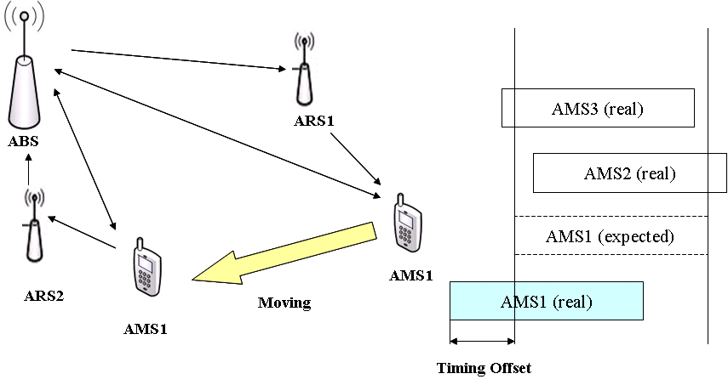
Figure 2. UL timing offset of ARS supporting systems

Proposed Method
In this situation, to minimize the timing offset problem and/or data loss between the periodic rangings with little burden, we propose triggered ranging.
Triggered ranging indicates that if AMS expects any SYNC malfunction of uplink, in other words, if a pre-defined triggered condition is satisfied in AMS, the AMS sends AAI_RNG-REQ regardless of periodic ranging. The next procedure of the triggered ranging is the same as periodic ranging. Triggered condition could be anything that induces satisfactory performance with little system burden.
AMS performs a dominant job in triggered ranging procedure, thus the only thing ABS/ARS shall do is following the same procedure with periodic ranging whenever the ABS/ARS receives the AAI_RNG-REQ.
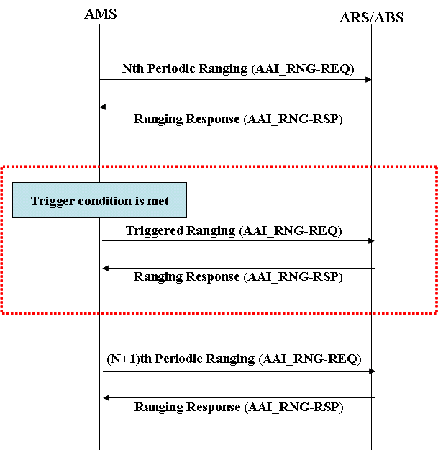
Figure 3. An example of triggered ranging

Simulation Result
To verify the validity of the proposed scheme, we performed both Lab and field tests.
In this contribution, we show the lab test setup and simulation results of the proposed uplink triggered ranging which are described in Figure 4 and Figure 5.

Figure 4. Triggered ranging test setup

In the test setup, we connected BS, MS, and repeater through cables with appropriate attenuators. We made 5 usec compulsory time advance/delay to the DL/UL signal which through the repeater to simulate the UL timing offset. The triggered condition we pre-defined here is DL time shifting of more than 0.5usec in MS. We used the DU meter to show the performance difference.

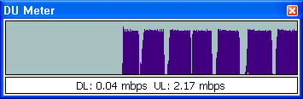
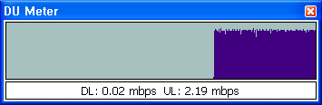
Figure 5. Comparison of UL performance without (upper) and with (lower) triggered ranging

As we can see from Figure 4, if we use the triggered ranging, the UL timing offset effect is mitigated, thus performance can be significantly improved.
The proposed triggered ranging should not cause any malfunction of BS because of sudden unexpected ranging. To verify this, we also performed the field test in the area of commercial mobile WiMAX system of Korea, namely KT WiBro. After several field tests of the proposed scheme, we concluded that there is no side effect in this scheme.
In overall, besides initial ranging and periodic ranging, triggered ranging is also needed to cope with sudden UL unsynchronized situations.

Text Proposal for the IEEE 802.16m
< Insert section 15.6.2.11.3 on page 571 as follows >
============================== Start of Proposed Text ================================

15.6.2.11 Ranging

15.6.2.11.3 AMS Triggered Ranging
Triggered ranging is an optional ranging procedure to adjust sudden UL timing offset maintaining AMS UL communications with ABS and ARS.
Following AMS initial ranging, AMS may send AAI_RNG-REQ regardless of periodic ranging whenever a pre-defined trigger condition is satisfied for fast recovery from UL timing offset and/or minimizing data loss. The trigger condition could be any kind of condition inducing satisfactory performance with little system burden.

============================== End of Proposed Text =================================

References
- IEEE P802.16m/D2, Oct. 2009

