Project | IEEE 802.16 Broadband Wireless Access Working Group <http://ieee802.org/16>
Title | Functional Overview of SON (15.7.1 /Annex Q)
Date Submitted | 2009-11-06
Source(s) | Byung Moo Lee, Byung Wan Yoon, Young Chul Oh, Jeong-Hwi Kim, Jong-Sik Lee, Seong-Choon Lee  KT  Feng Xie  ZTE Corporation | E-mail: blee@kt.com
Re: | IEEE P802.16m/D2 ( IEEE Letter Ballot Recirc #30a) (15.7 Support for Self-Organization)
Abstract | The contribution proposes the P802.16m/D2 Amendment text for SON
Purpose | Proposed to be discussed and adopted by TGm for the P802.16m/D2Amendment text
Notice | This document does not represent the agreed views of the IEEE 802.16 Working Group or any of its subgroups. It represents only the views of the participants listed in the “Source(s)” field above. It is offered as a basis for discussion. It is not binding on the contributor(s), who reserve(s) the right to activate, amend or withdraw material contained herein.
Release | The contributor grants a free, irrevocable license to the IEEE to incorporate material contained in this contribution, and any modifications thereof, in the creation of an IEEE Standards publication; to copyright in the IEEE’s name any IEEE Standards publication even though it may include portions of this contribution; and at the IEEE’s sole discretion to permit others to reproduce in whole or in part the resulting IEEE Standards publication. The contributor also acknowledges and accepts that this contribution may be made public by IEEE 802.16.
Patent Policy | The contributor is familiar with the IEEE-SA Patent Policy and Procedures:  <http://standards.ieee.org/guides/bylaws/sect6-7.html#6> and <http://standards.ieee.org/guides/opman/sect6.html#6.3>.  Further information is located at <http://standards.ieee.org/board/pat/pat-material.html> and <http://standards.ieee.org/board/pat>.

Functional Overview of SON
Byung Moo Lee, Byung Wan Yoon, Young Chul Oh, Jeong-Hwi Kim Jong Sik Lee, Seong-Choon Lee
KT
Feng Xie
ZTE Corporation

Introduction
The contribution proposes including a specific example of SON diagram in 15.7.2 and Annex of P802.16m/D2 [1].

Text Proposal for the IEEE 802.16m
----------------------------------------------------------- Text Start ---------------------------------------------------------------

15.7.1 Self-Organization State functional Diagram
ABS could perform self-organizing procedures to automate the configuration of ABS parameters and optimize network performance, coverage and capacity optimization. Self-Organization consists of two states modules, self-configuration and self-optimization, as illustrated in figure x1 580.
The construction of a MAC PDU is illustrated in Figure 390.

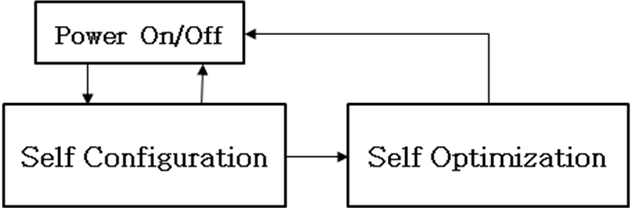

Figure 580. State Functional Transition Diagram of Self-Organization

Annex Q
(Informative)
Support for Self-organization Networks
Q.1 Functional Overview of SON
This annex provides a functional example of SON which is described in Figure 580. The SON operation may contain a Self configuration and Self optimization module as illustrated in Figure Q1. On ABS Power-On, it enters the Self-Configuration. In this module, in turn, neighbor discovery, cell initialization, initial operation may be performed. After finishing, it enters self-optimization. In this module, neighbor list update, coverage and capacity optimization, interference management and optimization, load management and balancing, self-optimizing FFR may be performed.
Power On/off
Neighbor Discovery
Cell Initialization
Initial Operation
Coverage & Capacity Optimization
Self Configuration
Self Optimization
Interference Management & Optimization
Load Management & Balancing
Self-optimizing FFR
Neighbor ABS information Update

Figure Q1. Functional overview of SON

---------------------------------------------------------------Text End ------------------------------------------------------------

References
- IEEE P802.16m/D2, Oct. 2009

