Project | IEEE 802.16 Broadband Wireless Access Working Group <http://ieee802.org/16>
Title | Dynamic Multicast Service Support for the IEEE 802.16m E- MBS (15.9.4)
Date Submitted | 2009-11-06
Source(s) | Yongjoo Tcha, Byung Moo Lee, Se-Jun Park, Seong-Choon Lee  KT | E-mail: yjtcha@kt.com
Re: | IEEE P802.16m/D2 ( IEEE Letter Ballot Recirc #30a) (15.9 Support for Enhanced Multicast Broadcast Service)
Abstract | The contribution proposes the P802.16m/D2 Amendment text for E-MBS
Purpose | Proposed to be discussed and adopted by TGm for the P802.16m/D2Amendment text
Notice | This document does not represent the agreed views of the IEEE 802.16 Working Group or any of its subgroups. It represents only the views of the participants listed in the “Source(s)” field above. It is offered as a basis for discussion. It is not binding on the contributor(s), who reserve(s) the right to activate, amend or withdraw material contained herein.
Release | The contributor grants a free, irrevocable license to the IEEE to incorporate material contained in this contribution, and any modifications thereof, in the creation of an IEEE Standards publication; to copyright in the IEEE’s name any IEEE Standards publication even though it may include portions of this contribution; and at the IEEE’s sole discretion to permit others to reproduce in whole or in part the resulting IEEE Standards publication. The contributor also acknowledges and accepts that this contribution may be made public by IEEE 802.16.
Patent Policy | The contributor is familiar with the IEEE-SA Patent Policy and Procedures:  <http://standards.ieee.org/guides/bylaws/sect6-7.html#6> and <http://standards.ieee.org/guides/opman/sect6.html#6.3>.  Further information is located at <http://standards.ieee.org/board/pat/pat-material.html> and <http://standards.ieee.org/board/pat>.
Dynamic Multicast Service Support for the IEEE 802.16m E-MBS
Yongjoo Tcha, Byung Moo Lee, Se-jun Park, Seong-Choon Lee
KT

Problem definition

In current E-MBS, the contents are always transmitted through one or more MBS connections that would have been pre-established prior to the user(s) join and leave a MBS session at one or more MBS zone. It is defined as Static multicast service by WiMAX Forum. The Static multicast has strong points for mobility and macro diversity gain. But it is not efficient to manage radio resource; because the radio resources for MBS are pre-allocated and are always transmitted over the air regardless of existence of MS in a cell.
Figure 1 shows the static multicasting with one MBS zone. All cells in the MBS zone transmit their MBS bursts even though the numbers of MBS users are small and they are distributed in 4 of total 24 cells.

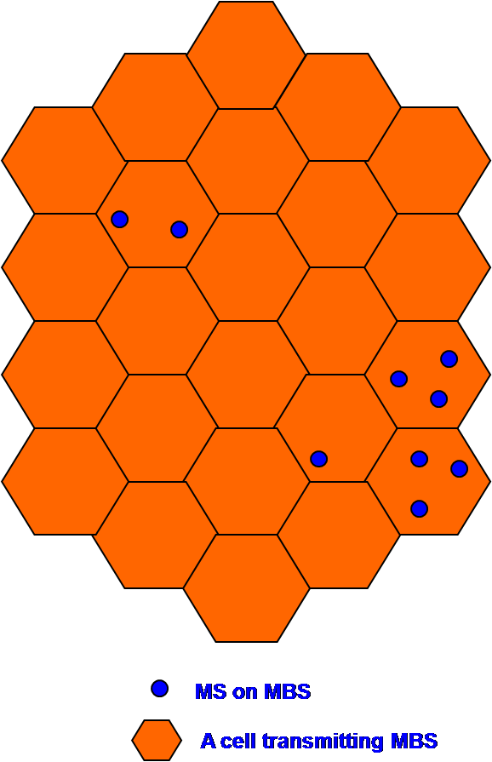
Figure 1 Example of static multicasting in an MBS zone

Compare to Static multicast, in Dynamic multicast, the contents are only transmitted through one or more MBS connections that would have been joined by the user(s) after user’s subscription at one or more MBS zone. The Dynamic multicast has a strong point for radio resource management for MBS. But it has some problem to support user’s mobility among cells in an MBS zone. And inter cell interference might be happen if a neighbor cell does not transmit MBS bursts or allocates the Bursts to other traffic uses as well as macro-diversity could not be provided. Figure 2 illustrates some problem in existing dynamic multicast service. Even though 4 cells out of total 24 cells transmit MBS bursts, it might be difficult to support mobility and macro diversity.
Therefore, some mechanism to solve the problems happening in dynamic multicast is needed.

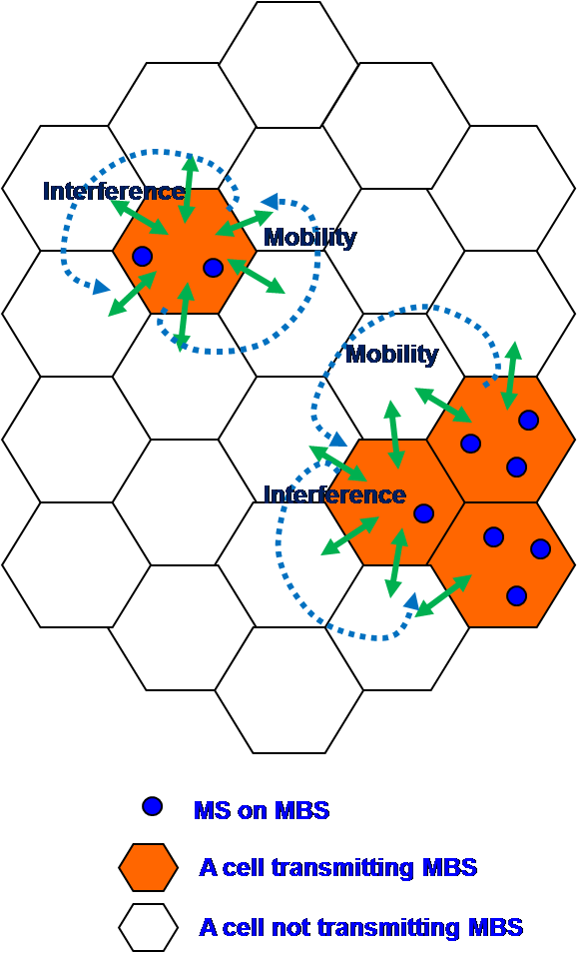
Figure 2 Example of existing dynamic multicasting in an MBS zone

Dynamic multicast depending on MBS status of neighboring cells
In this contribution, we propose a dynamic multicasting method which a cell decides on its MBS transmission according to the MBS status of neighbor cells.
In traditional dynamic multicast, a BS transmitting MBS bursts monitors whether there are MSs receiving MBS in its cell or not. If there is no MS receiving MBS, the BS will stop transmitting MBS burst. But, in the proposed dynamic multicast, a BS transmitting MBS bursts monitors the existence of MS receiving MBS in neighbor cells as well as in its own cell. Figure 3 is a state diagram for a BS transmitting MBS bursts. If there is no MS receiving MBS in its cell, the BS has to check the MS in its neighbor cells before stop MBS transmitting. Then there is no MS in its neighbor cells regardless of their transmitting MBS, the BS can stop its MBS burst and use another use in its cell.
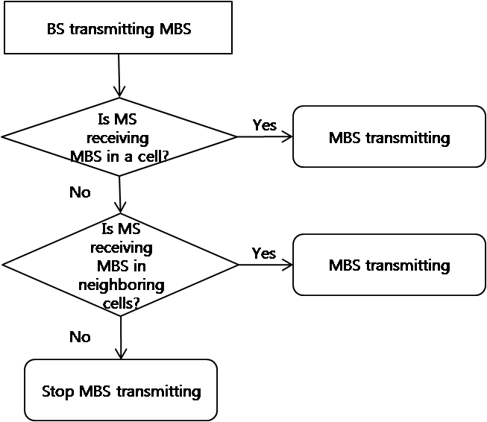
Figure 3 State Diagram of BS transmitting MBS

In case of BS not transmitting MBS, if there is an MS moving into one of its neighboring cells or an MS powering on in the cell, the BS has to start MBS burst as Figure 4.

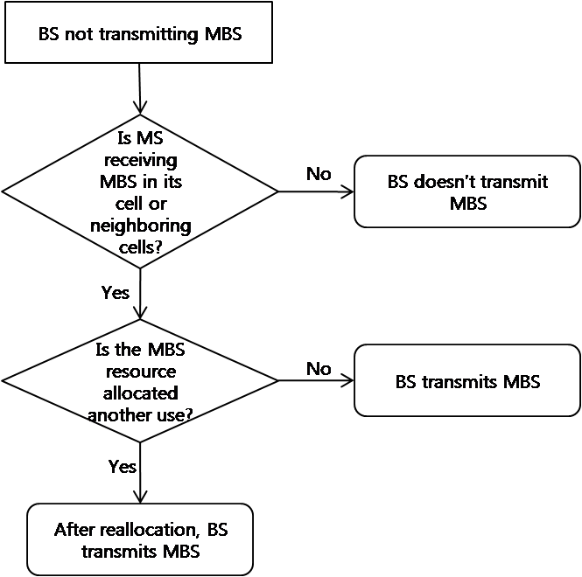
Figure 4 State Diagram of BS not transmitting MBS

As the result, the effect of proposed dynamic multicast can be illustrated as Figure 5.

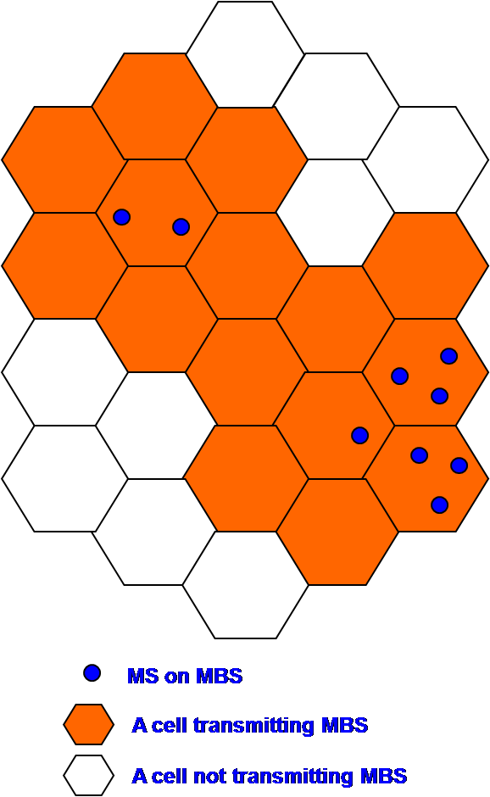
Figure 5 An example to illustrate proposed dynamic multicasting effect

We can save 9 cells out of total 24 cells (37.5%) using dynamic multicast considering neighbor cells’ service status. In addition to the effect of radio resource use, the proposed dynamic multicast can support mobility and macro diversity like static multicast does. And there is no interference among cell edges within MBS zone also.

To adopt the method, BS has to monitor the existence of MS for MBS in neighboring cells as well as in the cell. BS can also calculate the number of MS receiving MBS from handover or location update process in the cell and maintain it, but we suggest some messages to monitor;
AAI_RNG_REQ message is modified as appending Raging Purpose Indication bits and (STID+FID) for MBS.
Message to inform of MBS status to its neighbor BSs is performed through the backhaul network.

Text Proposal for the IEEE 802.16m
----------------------------------------------------------- Text Start ---------------------------------------------------------------

15.9 Support for Enhanced Multicast Broadcast Service

15.9.4 Support for Dynamic Multicast Service
In order to improve the efficiency of radio resource utilization, dynamic multicast service may be supported, in which the transmission of the multicast service data is decided based on the number of the AMSs for the dynamic multicast service within the ABS and its neighboring ABSs. ABS shall update the AMSs which join and leave dynamic multicast groups through the AAI_DSx control message transactions. The transmission of dynamic multicast service may be turned on or off according to the number of AMSs receiving the dynamic multicast service within the ABS and its neighboring ABSs. AAI_RNG_REQ or Handover or location update signaling is used for the ABS to count the number of the AMSs and a management message is used for neighboring ABS to inform its MBS status, which are in connected state and in idle mode, respectively. If the zone indication is included in AAI_SCD message, the ABSs shall broadcast it to inform the AMSs about whether the dynamic multicast service is available or not.

15.9.4.1 Dynamic Multicast Operation in Connected State
The connected state AMS receiving dynamic multicast data may refer to the handover process to get information when it moves into another ABS without E-MBS zone change. The target ABS may support the dynamic multicast or not depending on the number of AMSs in the group, which may be informed to the AMS via its handover process. Or the AMS may get the information from AAI_SCD if the zone indication is included in AAI_SCD. The target ABS shall inform its neighboring cells of new AMS for MBS moving into the cell. As soon as an ABS receives the message, it shall start transmitting the E-MBS data in the next E-MBS frame if it has stopped transmitting E-MBS data. The ABS shall (re)start transmitting E-MBS data if there is a new AMS for MBS within one of neighboring cells or within the cell.
If there is no AMS in a cell, the ABS shall not stop transmitting E-MBS data before it find out that there is no AMS for MBS in all its neighboring cells. The ABS shall stop transmitting E-MBS data only if there is no AMS for MBS within all its neighboring cells as well as within the cell.

15.9.4.1 Dynamic Multicast Operation in Idle State
The idle state AMS receiving dynamic multicast data shall perform location update process when it moves into another ABS by sending AAI_RNG-REQ message to notify its movement to the serving ABS. The AMS is expected to obtain the updated E-MBS service flow management encodings whether the E-MBS zone is changed or not. If the target BS which is not transmitting the dynamic E-MBS data receives AAI_RNG-REQ message from an AMS to request dynamic multicast data transmission, it may start transmitting the E-MBS data in the next E-MBS frame according to the number of AMSs which need the dynamic service. This can be informed to the AMS via AAI_RNG-RSP. Or the AMS may get this information from the AAI_SCD when the zone indication is included in AAI_SCD.

15.2.3.1 AAI_RNG_REQ

Table 674 – Parameters for AAI_RNG_REQ
Name | Value | Usage
……
Ranging Purpose Indication | If bit #7 is set to 1, it indicates that the AMS is receiving dynamic E-MBS | It shall be included when the AMS is attempting to perform reentry, HO or location update
……
STID+FID | Indicates E-MBS identification | It shall be included when the AMS is receiving dynamic E-MBS
……

----------------------------------------------------------- Text End ---------------------------------------------------------------

