Project | IEEE 802.16 Broadband Wireless Access Working Group <http://ieee802.org/16>
Title | Proposed text for network coding based retransmission for EMBS
Date Submitted | 2009-11-09
Source(s) | Xianwei Gong, Jin Xu, Robert Xu, Kaiying Lv, Bo Sun, Huiying Fang  ZTE Corporation | E-mail: gong.xianwei@zte.com.cn, xu.jin7@zte.com.cn, sun.bo1@zte.com.cn  *<http://standards.ieee.org/faqs/affiliationFAQ.html>
Re: | P802.16m/D2 E-MBS topic
Abstract | The contribution proposes text for network coding based retransmission for EMBS
Purpose | For discussion and approval by IEEE 802.16m TG
Notice | This document does not represent the agreed views of the IEEE 802.16 Working Group or any of its subgroups. It represents only the views of the participants listed in the “Source(s)” field above. It is offered as a basis for discussion. It is not binding on the contributor(s), who reserve(s) the right to add, amend or withdraw material contained herein.
Release | The contributor grants a free, irrevocable license to the IEEE to incorporate material contained in this contribution, and any modifications thereof, in the creation of an IEEE Standards publication; to copyright in the IEEE’s name any IEEE Standards publication even though it may include portions of this contribution; and at the IEEE’s sole discretion to permit others to reproduce in whole or in part the resulting IEEE Standards publication. The contributor also acknowledges and accepts that this contribution may be made public by IEEE 802.16.
Patent Policy | The contributor is familiar with the IEEE-SA Patent Policy and Procedures:  <http://standards.ieee.org/guides/bylaws/sect6-7.html#6> and <http://standards.ieee.org/guides/opman/sect6.html#6.3>.  Further information is located at <http://standards.ieee.org/board/pat/pat-material.html> and <http://standards.ieee.org/board/pat>.
Proposed text for network coding based retransmission for EMBS
Xianwei Gong, Jin Xu, Robert Xu, Kaiying Lv, Bo Sun, Huiying Fang
ZTE Corporation

1. Introduction
In the SDD document[1], An ABS may use a network-coding based retransmission scheme that does not require a feedback channel. Other schemes requiring feedback channels are being studied. In this contribution, we propose a new network coding scheme based E-MBS retransmission to improve E-MBS transmission performance.

In known network coding schemes based E-MBS retransmission, the scheme in [2] is implemented easily, but the scheme of generating redundant packets by XORing several contiguous original packets makes not good E-MBS transmission performance easily, The scheme in [3] has good performance, but it needs more space to store original packets for generating the first transmitting packets, relative to redundant packets.

This contribution proposes a new network coding scheme based E-MBS retransmission. It needs few space to store original packets for generating the first transmitting packets, and has better performance.

2. Proposed network coding based retransmission for EMBS without Feedback

2.1 Introduction of Proposed Network Coding scheme
It is assumed that there are K original packets ,,…,, and M redundant packets can be transmitted, where .

The K first transmitted packets ,,…,, and M redundant packets ,,…, are generated by using the proposed network coding scheme as following:
1, the K first transmitted packets ,,…, are generated by XORing original packets ,,…, with the following steps:
(1) = ;
(2) , for , where “” is XORing.
2, the M redundant packets ,,…, are generated by XORing original packets ,,…, with the following steps:
(1) ;
(2) , , where and .

For example, there are 8 original packets ,,…,, and 4 redundant packets can be transmitted. So the 8 first transmitted packets ,,…, , and 4 redundant packets ,,, are generated by using the above network coding scheme, and the results shows in the figure 1.

Figure 1 8 first transmitted packets and 4 redundant packets generated
by XORing 8 original packets with proposed network coding scheme

2.2 Feature of the proposed scheme
1, it needs a little space to store original packets for generating transmitting packets;
2, it has low complexity;
3, it does not need feedback channel;
4, it has better performance.

2.3 Performance evaluation
We compare the proposed network coding scheme with Motorola network coding scheme in [2] and NTU-ITRI network coding scheme in [3].

The simulation scenario is:
X-axis: retransmission overhead (redundant packets number / original packets number);
Y-axis: loss packet rate ( (original packets number – successful decoding packets ) / original packets number );

It notes that loss packet rate is ratio of error packets number, after receiver decoding the packets with network coding, to original packets number. And the erasure rate of the following table is the number of lost packets during transmission in channel.

And the simulation condition is:
index | original packets number | erasure rate | redundant packets number | batch number
1 | 20 | 0.05 | 1,3,5,7,9,11 | 10000
2 | 30 | 0.05 | 1,4,7,10,13,16 | 10000
3 | 12 | 0.08 | 1,2,3,4,5,7 | 10000
4 | 30 | 0.08 | 1,4,7,10,13,16 | 10000

The simulation results are:
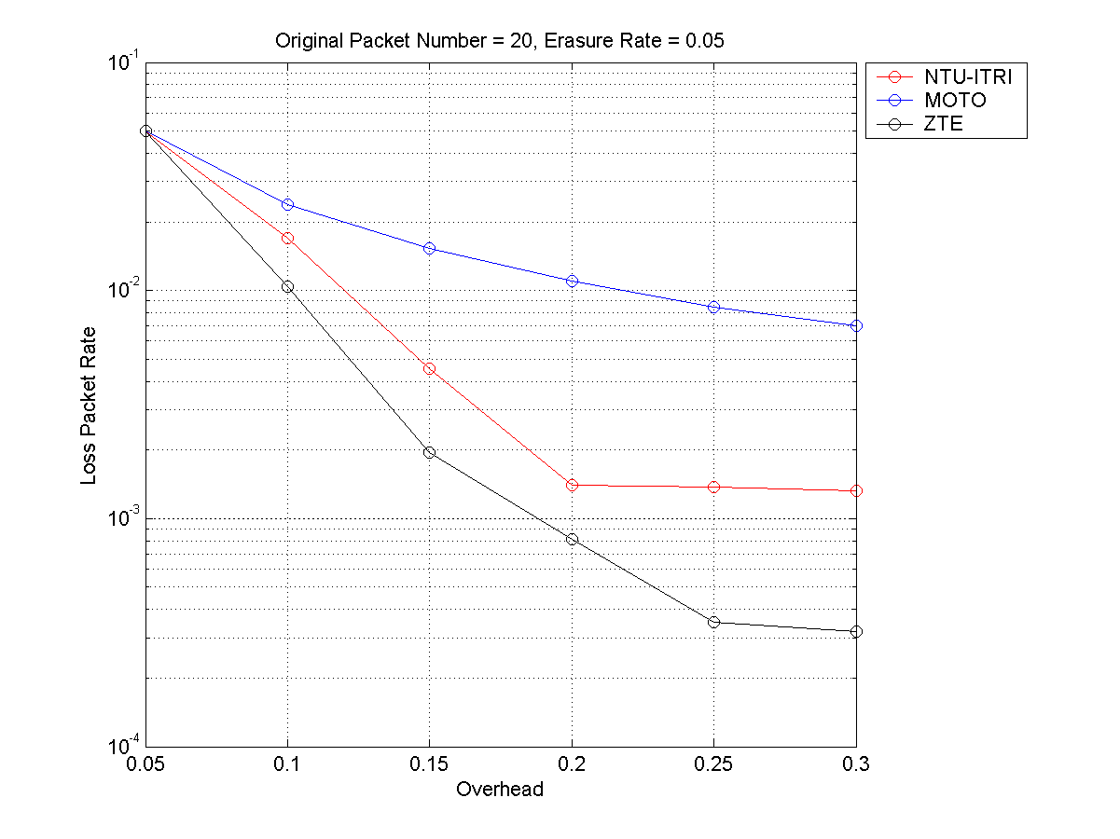
Figure 2 the result with simulation condition in index 1
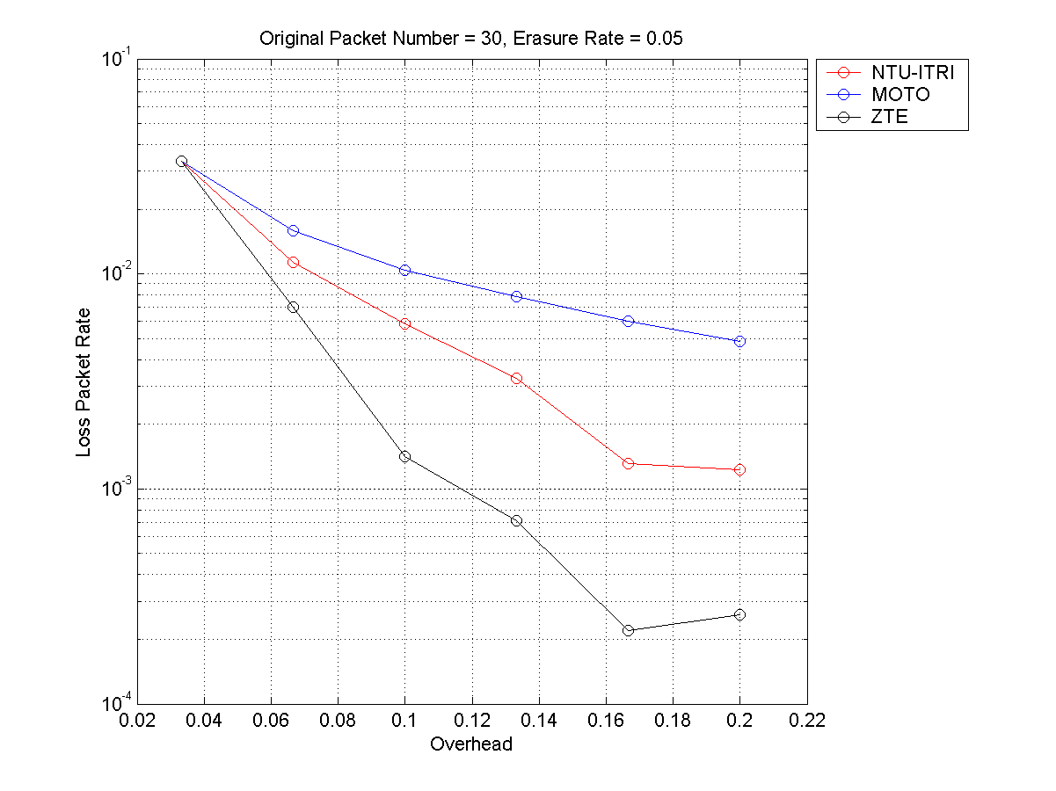
Figure 3 the result with simulation condition in index 2

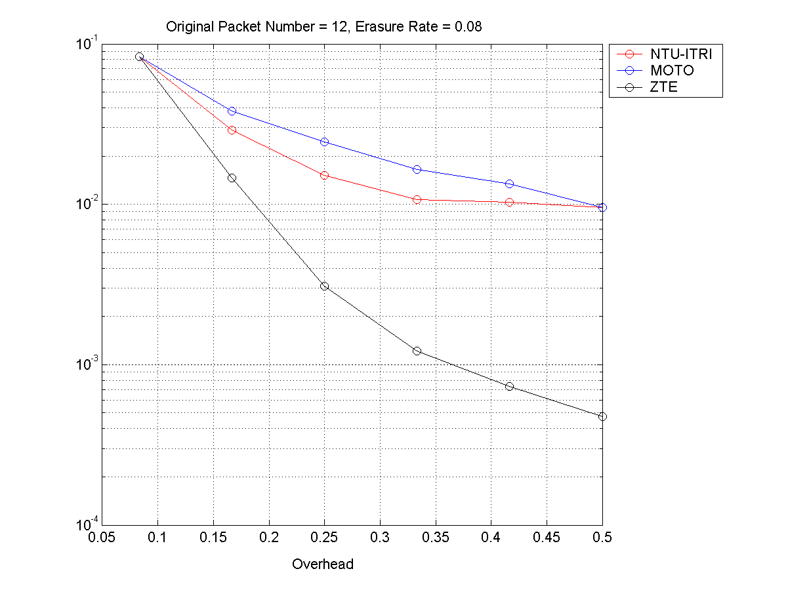
Figure 4 the result with simulation condition in index 3
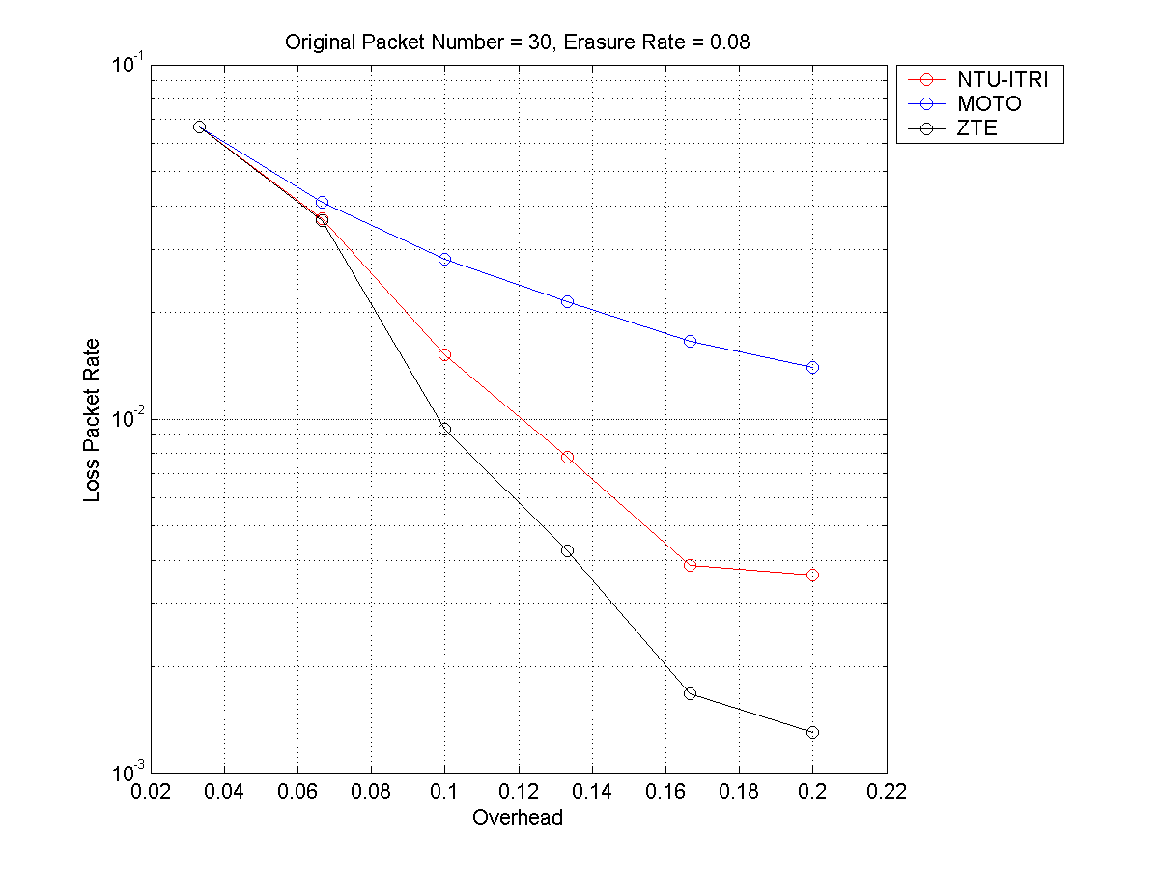
Figure 5 the result with simulation condition in index 4

2.4 Conclusion
From simulation results, the proposed network coding scheme has better performance than Motorola network coding scheme in [2] and NTU-ITRI network coding scheme in [3]. So the proposed network coding scheme should be adopted.

Proposed Text to P802.16m Amendment Working Document
- - - - - - - - - - - - - - - - - - - - - - - - - - - Begin Proposed Text - - - - - - - - - - - - - - - - - - - - - -

15.9.2 E-MBS Operation

15.9.2.x E-MBS Operation with Retransmission

15.9.2.x.x Network Coding based Transmission without Feedback
It is assumed that there are K original packets ,,…,, and M redundant packets can be transmitted, where .
The K first transmitted packets ,,…,, and M redundant packets ,,…, are generated by using the proposed network coding scheme as following:
1, the K first transmitted packets ,,…, are generated by XORing original packets ,,…, with the following steps:
(1) = ;
(2) , for , where “” is XORing.
2, the M redundant packets ,,…, are generated by XORing original packets ,,…, with the following steps:
(1) ;
(2) , , where and .

- - - - - - - - - - - - - - - - - - - - - - - - - - - End Proposed Text - - - - - - - - - - - - - - - - - - - - - -

3. Reference
[1] IEEE 802.16m-09_0034r2, SDD text section 13.3.3, P129, 2009-09-24
[2] Hua Xu, Steven Xu , Naveen Arulselvan , Suresh Kalyanasundaram , Motorola, Network coding-based retransmission schemes for E-MBS with and without MS feedback, C802.16m-09/0072r1, 2009-01-13
[3] Ching-Chun Chou, Hung-Yu Wei, Cheng-Chih Chao, Chun-Yen Wang, Frank Ren, NTU, ITRI, Proposed Text for IEEE P802.16m/D1: Network Coding based E-MBS Retransmission, C802.16m-09/1682, 2009-08-30

