Project | IEEE 802.16 Broadband Wireless Access Working Group <http://ieee802.org/16>
Title | Resource Reservation for Interference Mitigation in Femto Cells (15.4.11)
Date Submitted | 2009-11-06
Source(s) | Yung-Han Chen, Chie Ming Chou, Fang-Ching (Frank) Ren , Chun-Yen Wang  ITRI  Wern Ho Sheen  Chaoyang University of Technology / ITRI | chenyunghan@itri.org.tw  whsheen@itri.org.tw  *<http://standards.ieee.org/faqs/affiliationFAQ.html>
Re: | IEEE 802.16 Working Group Letter Ballot #30a
Abstract | This contribution proposes essential messages and procedures of resource reservation for interference mitigation between a femto ABS and a macro ABS.
Purpose | To be discussed and adopted in IEEE 802.16m draft
Notice | This document does not represent the agreed views of the IEEE 802.16 Working Group or any of its subgroups. It represents only the views of the participants listed in the “Source(s)” field above. It is offered as a basis for discussion. It is not binding on the contributor(s), who reserve(s) the right to add, amend or withdraw material contained herein.
Release | The contributor grants a free, irrevocable license to the IEEE to incorporate material contained in this contribution, and any modifications thereof, in the creation of an IEEE Standards publication; to copyright in the IEEE’s name any IEEE Standards publication even though it may include portions of this contribution; and at the IEEE’s sole discretion to permit others to reproduce in whole or in part the resulting IEEE Standards publication. The contributor also acknowledges and accepts that this contribution may be made public by IEEE 802.16.
Patent Policy | The contributor is familiar with the IEEE-SA Patent Policy and Procedures:  <http://standards.ieee.org/guides/bylaws/sect6-7.html#6> and <http://standards.ieee.org/guides/opman/sect6.html#6.3>.  Further information is located at <http://standards.ieee.org/board/pat/pat-material.html> and <http://standards.ieee.org/board/pat>.
Resource Reservation for Interference Mitigation in Femto Cells (15.4.11)

Yung-Han Chen, Chie Ming Chou, Fang-Ching (Frank) Ren, Chun-Yen Wang
ITRI

Wern Ho Sheen
Chaoyang University of Technology / ITRI

1. Descriptions
An operator may allow co-channel operation of macro cells and femto cells due to limited licensed bandwidth and possible large amount of femto ABSs depolyment. When the same carrier frequency is used by the macro ABS and femto ABS, serious interference may be introduced. There are two worst cases:

(1) When the location of a femto ABS is close to a macro ABS, the DL signal power from the macro ABS may be large enough to interfere with the DL signal in the femto cell. For example in Figure 1, AMS1 served by femto ABS1 may suffer strong interference from macro ABS (the signal transmitted to AMS2). This case can be detected during femto ABS’s initialization.

(2) When an AMS served by a macro ABS is near to a femto ABS, its UL signal may interfere with the UL signal of the femto. For example in Figure 1, AMS3 served by the macro ABS will cause UL interference to the femto ABS. Besides, an AMS served by the macro ABS may also generate significant UL interference to the femto ABS even thought it is not near to the femto, especially when the AMS is far from the macro ABS and has to increase transmission power. This case could happen dynamically and could be dependent on the location of AMS served by the overlaid macro ABS.
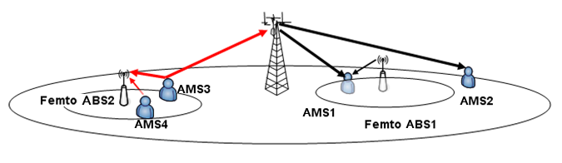
Figure 1. Interference when femto ABS uses the same carrier frequency with macro ABS

To well support interference avoidance and mitigation, we propose a flexible radio resource reservation and sharing method to achieve optimum resources utilization.

2. Proposed Method
The concept of reserving radio resources from macro cell for femto ABS’s usage is proposed to reduce the interference between a macro ABS and a femto ABS. Such radio resource reservation, named the femto zone, is a resource region originally used by a macro ABS. When a newly deployed or operating femto ABS finds that there is no clear channel to provide a good transmission for its serving AMSs or serving AMSs feed back the complaint messages about interference, the femto ABS will request overlaid macro ABS to reserve its resource (femto zone) for femto ABS’s transmission/reception. Once the macro ABS agrees to grant this femto zone to the femto ABS, the macro ABS would not allocate the resource to its serving AMSs in the femto zone. On the other hand, a femto ABS could start to schedule the transmission in this femto zone after receiving the grant. The femto zone might be shared with multiple femto ABSs to acquire the spatial multiplexing benefit. If there is no AMS under femto ABS’s coverage or interference problem has been solved, then the femto zone could be released to macro ABS.
A femto ABS places indicators in its S-SFH to indicate the allocation of femto zone. This can avoid AMS reading signaling from other ABSs. In the femto zone, an associated A-MAP will be given to specify the corresponding data allocation for individual AMSs. From AMS’s point of view, it reads the S-SFH first and knows the presence and location of femto zone. Then the AMS could decode and acquire its individual data based on the A-MAP in the Femto zone. Figure 2 is an example of control structure of femto zone.

Figure 2. The control structure example of Femto zone

Figure 3 shows an example procedure of femto zone request/grant. Once the femto ABS requires a femto zone for interference mitigation, it sends a femto zone request to the macro ABS. The requesting amount of resource is based on the BR from the AMS served by the femto ABS. If the macro ABS grants the femto zone request, it sends a grant message to the femto ABS with subframe numbers and ratios of bandwidth allocated for DL and UL femto zones. Then the femto ABS will indicate the subframe number and ratio of bandwidth allocated for DL femto zone in its SFH. For example, a 2-bit ratio indicator is defined in SFH to indicate the ratio of bandwidth allocated for DL femto zone. The ratio indicator=0, 1, 2 represent the highest 1/4, 1/2, 3/4 bandwidth is allocated, respectively. The example in Figure 2 is the case of ratio indicator=2 in DL femto zone. Once a femto AMS obtains femto SFH, it can know the starting point of the DL femto zone in this femto cell.
Figure 3. Example – procedure of femto zone request

Furthermore, during femto ABS’s SON or configuration phase, a femto ABS may coordinate with macro ABS to reserve a radio resource region for transmitting broadcast control messages.
Figure 4 and 5 show the example diagrams of initiating femto zone reservation in DL and UL. If the threshold of number of DL/UL re-scheduling timer is zero, the femto ABS will skip the re-scheduling of interference avoidance and directly request to reserve the femto zone. The macro ABS and other neighboring Femto ABSs will not schedule their data traffic in the reserved femto zone.

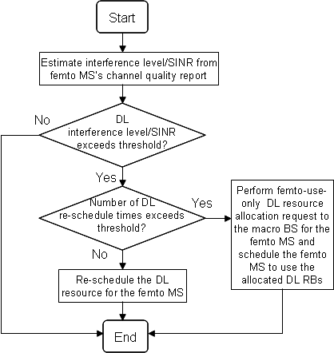
Figure 4. The diagram of initiating femto zone reservation in DL

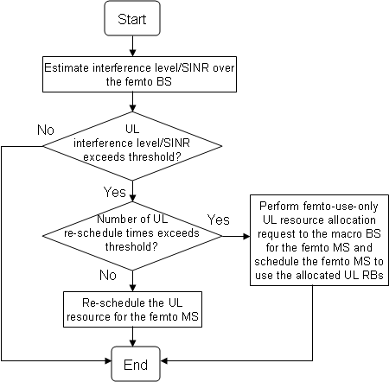
Figure 5. The diagram of initiating femto zone reservation in UL

2. Suggested Remedy
-------------------------------------------------------- Text Start ------------------------------------------------------------
15.4 Support for Femto ABS

15.4.11 Interference Avoidance and Interference Mitigation

{ Insert the following text and figures in line 38, page 551}
A femto ABS may request the macro ABS to reserve resource, called femto zone, for the femto ABS’s transmissions/receptions. Once the macro ABS grants the femto zone for the femto ABS, the macro ABS shall avoid scheduling its serving AMSs to use the femto zone. The femto ABS may schedule the transmissions/receptions in the granted femto zone(s). The subframe number and bandwidth ratio allocated for DL femto zone are indicated in S-SFH of the femto ABS. In the Femto ABS, the position of DL femto zone granted for the femto ABS is indicated in S-SFH by using a 5-bit subframe number indicator and a 2-bit bandwidth ratio indicator. The bandwidth ratio indicator=0, 1, 2, and 3 represent the highest 1/4, 1/2, 3/4, and the entire bandwidth is allocated for femto zone, respectively. In the femto zone, an A-MAP of the femto ABS shall be given to specify the data allocations for the serving AMSs. In addition, the femto zone may be shared with multiple femto ABSs to acquire the spatial multiplexing benefit. The femto zone shall be released to macro ABS when the femto ABS does not need it for interference mitigation. The frame structure of femto zone reservation and the procedure are shown in Figure XX1 and Figure XX2.

Figure XX1 – The frame structure of femto zone reservation

Figure XX2 – The procedure for Femto zone request, grant, and indication

-------------------------------------------------------- Text End ------------------------------------------------------------

